**Shri R. L. T. College of Science, Akola**

**Department of Physics**

**Annual Report**

**2023-24**

The department of Physics is well equipped, renovated and spacious in the campus of this college. In the current year 160, 140 and 132 students are admitted in B.Sc. I B.Sc. II and B.Sc. III and in Postgraduation 10 students admitted in M.Sc. I and 13 students admitted in M.Sc. II. All the students actively participate in the departmental activity such as seminar/ Group discussions, Project Assignment , Practical Assignments, Unit Test and Tutorials. B.Sc. II Student Vidhi Pathak selected for University level Aavishkar festiwal -2023-24 and Prof. S. R. Jaiswal awarded by Ph.D. degree in 2023-24. Departmental teaching staff actively Presented research papers in National International conferences and published his research work in reputed journals.

Photons Club, Department of Physics, Shri R. L. T. College of Science, Akola had organised Guest Lecture on "An Introduction to Theory of Everything". The events were organised in collaboration with IQAC on Saturday 21st October 2023. The principal of the college Dr. V. D. Nanoty sir was present as a President and Inaugurator. Dr. Y. S. Tamgadge, Asst. Professor, Dept. of Physics, Shri Shivaji ACS college, Motala, Dist. Buldana was a Guest of Speaker of the program. Dr. V. D. Nanoty sir inaugurated the Photons Club in the academic session 2023-24 by cutting the ribbon. He also motivated the students regarding curriculum activities under NEP-2020. After that Dr. Y. S. Tamgadge Sir gave the detailed information about the theory of everything in his lecture.

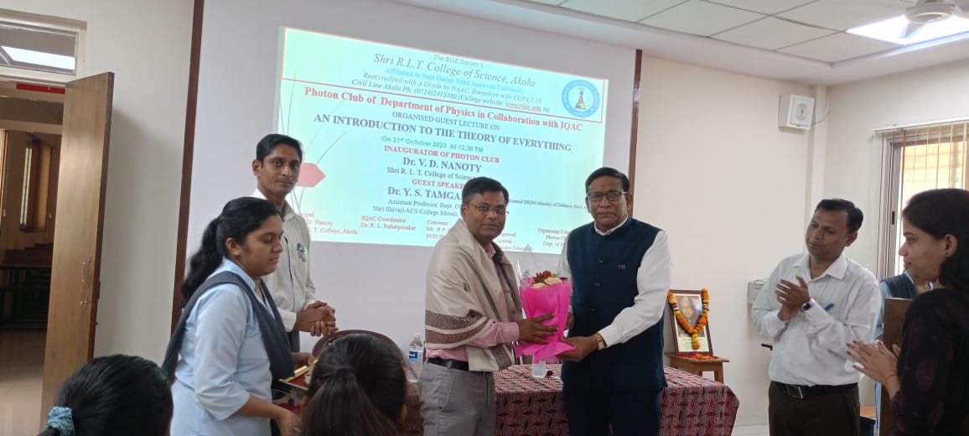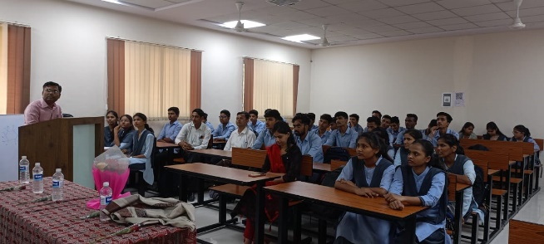

The Photon Club, PG Department of Physics in collaboration with IIC, Shri R. L. T. College of Science, Akola had organised Guest Lecture (Self Driven Activity) on "Introduction to Plasma Physics" on 24th December 2023 at PG Department of Physics, Shri R. L. T. College of Science, Akola. Dr. Swapnil Arsad, Assistant Professor, Shri Shivaji Science College, Amravati was a speaker of the program. The activity was conducted under MOUs (faculty exchange) between the department of Physics, Shri R. L. T. College of Science, Akola and Shri Shivaji Science College, Amravati. Dr. Arsad also donates his book "Introduction to Plasma Physics" (10 copies) to the departmental library.

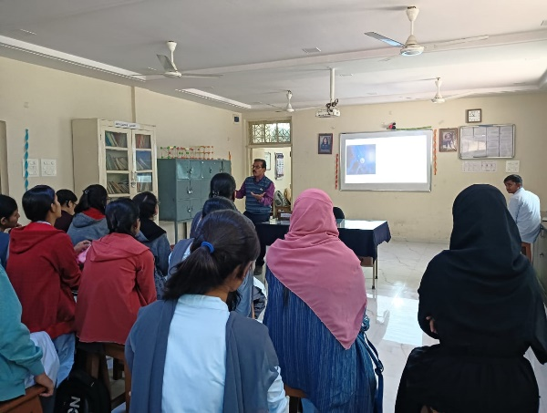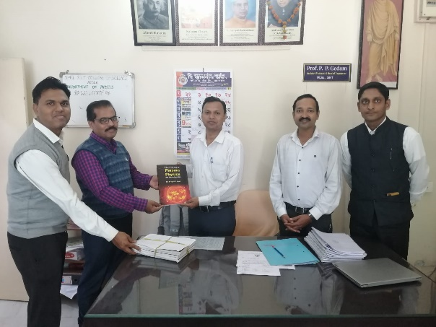

On the occasion of National Science Day, department of Physics in collaboration with Department Computer Science organised Poster Exhibition competition for the all students. Students actively participated in the poster exhibition and make this programme successful.



HOD Physics