Shri R.L.T College of Science, Akola.
BOTANY DEPARTMENT REPORT
2022-23
Department of Botany is always ahead in participating & conducting various curricular and co-curricular activities during the academic session.
Departmental Activity
Academic activities like Quiz, Projects, Group discussion & Seminars, Class Test were conducted for B. Sc. I Yr., II Yr.& III Yr. as well as M. Sc. I & II yr. Students
Remedial coaching classes were conducted for B. Sc. I year on 3/11/2023.
1stjuly 2022 “Krushi Divas” was celebrated by Poster Exhibition on “Importance of soil in Agriculture” in collaboration with Environment cell in presence of Principal Dr. V. D. Nanoty Sir. All the staff members of Botany, Environment cell &Non-Teaching staff were present..
On` Independance Day,15/8/2022, Dept of Botany & Environment cell has organised Tree plantation of Medicinal plants in campus in presence of Principal Dr. V. D. Nanoty sir. All the staff members of Botany, Environment cell &Non-Teaching staff were present.
On 17 Feb 2023 our Alumni Prof. O. S. Sarate, former Scientist of Birbal Sahani Institute of Palaeosciences has visited our Dept & guided the students.

The Achievment of Staff Members are listed below.

1. Mrs. V.N. Badgujur
- She has worked as co-ordinator of PG Admission committee.
- she has presented Research paper in International Interdisciplinary virtual conference on “Recent Advancement in Computer Science Management and Information Technology (RACSMTT-2023) ) 15th March 2023.
- She has wok as convenor of University level poster level competition on Fungal Diversity.

2. Dr. P.M. Khadse
- He is promoted as Associate Professor on 30/07/2022.
- He has published two research papers in International journals.
- Vidyabharati International Interdisciplinary research journal.
- International journal of Research and Analytical Reviews (IJRAR).
- He has worked as co-officer for Summer-2023 SGBAU University Examination.

3. Dr. A.A. Sangole:-
- She has wok as co-ordinator of University level poster level competition on Fungal Diversity.
- She has participate & published Research paper Vidyabharti International Interdisciplinary Research journal.
- Similarly she published paper in International Interdisciplinary virtual conference on “Recent Advancements in computer Science Management Information Technology (RACSMT-2023) 15th March 2023.

4. Mr. S. V. Madavi
- He hasCompleted Refresher Course in Life-Science 22/08/2022 to 05/09/2022 UGC-HRDC Guru Ghasidas Vishvavidhyalaya, Bilaspur (C.G.)
- Worked as a Resource Person in Short Term Course in Disaster Management 20/12/2022 And 21/12/2022 UGC-HRDC Sant Gadge Baba Amravati University, Amravati
- He has Worked as GC-HRDC Sant Gadge Baba Amravati University, Amravati.
- Worked as Resource Person and Delivered lecture on First Aid and Bandaging in Disaster Management Training Program 20/02/2023 RUSA Sponsored, Sophia College (Autonomous) Mumbai.
- Worked as Resource Person and Delivered lecture on ‘International Year of Millets 2023’ in District Youth Neighborhood Parliament 20/03/2023 Neharu Yuva Kendra, Akola in collaboration with Shri R. L. T. College of Science, Akola.
- He has Completed MS-DEED Level 1 In-person Workshop on 'Introduction to Innovative Pedagogies for College Teachers' 13/03/2023 to 15/03/2023 Shri Shivaji College of Arts, Commerce and Science, Akola, in collaboration with Indian Institute of Science Education and Research (IISER) Pune.
- He has Published Research paper in International Journal of Advanced Research in Biological Sciences March 2023 .
- He has delivered lecture on Disaster Management in various NSS Residential Camps .

Similarly All teachers of Botany Dept participated in One day workshop on CBCS-NEP Execution Training programme on 17thsept 2022,at Laxmibai Radhakisan Toshniwal College of commerce, Akola.
Our contract teacher Miss Pratiksha Salunke was felicitated for qualifying SET & GATE Exam on Achievement Day celebration, 26 Jan. 2023.

Holy Basil Club Activity Report 2023
Today Department of Botany Shri R.L.T. College of Science, Akola organizes Educational visit to Vitthal Mushroom Industry Amanatpur, Akola. 54 students took part in this visit. As the Part Of SEM the students got direct Experience of the cultivation of Edible Mushroom commonly called as Button Mushrooms on Industrial level.
All the faculty members Mrs.V. N.Badgujar, Dr.P.M.Khadse,Dr.A. A.Sangole, Mr.S.V.Madavi with Non Teaching Staff Mr. R.S. Dandnaik, Mr.H.U.Umbarkar. & Mr.Satish Shirsat were present.
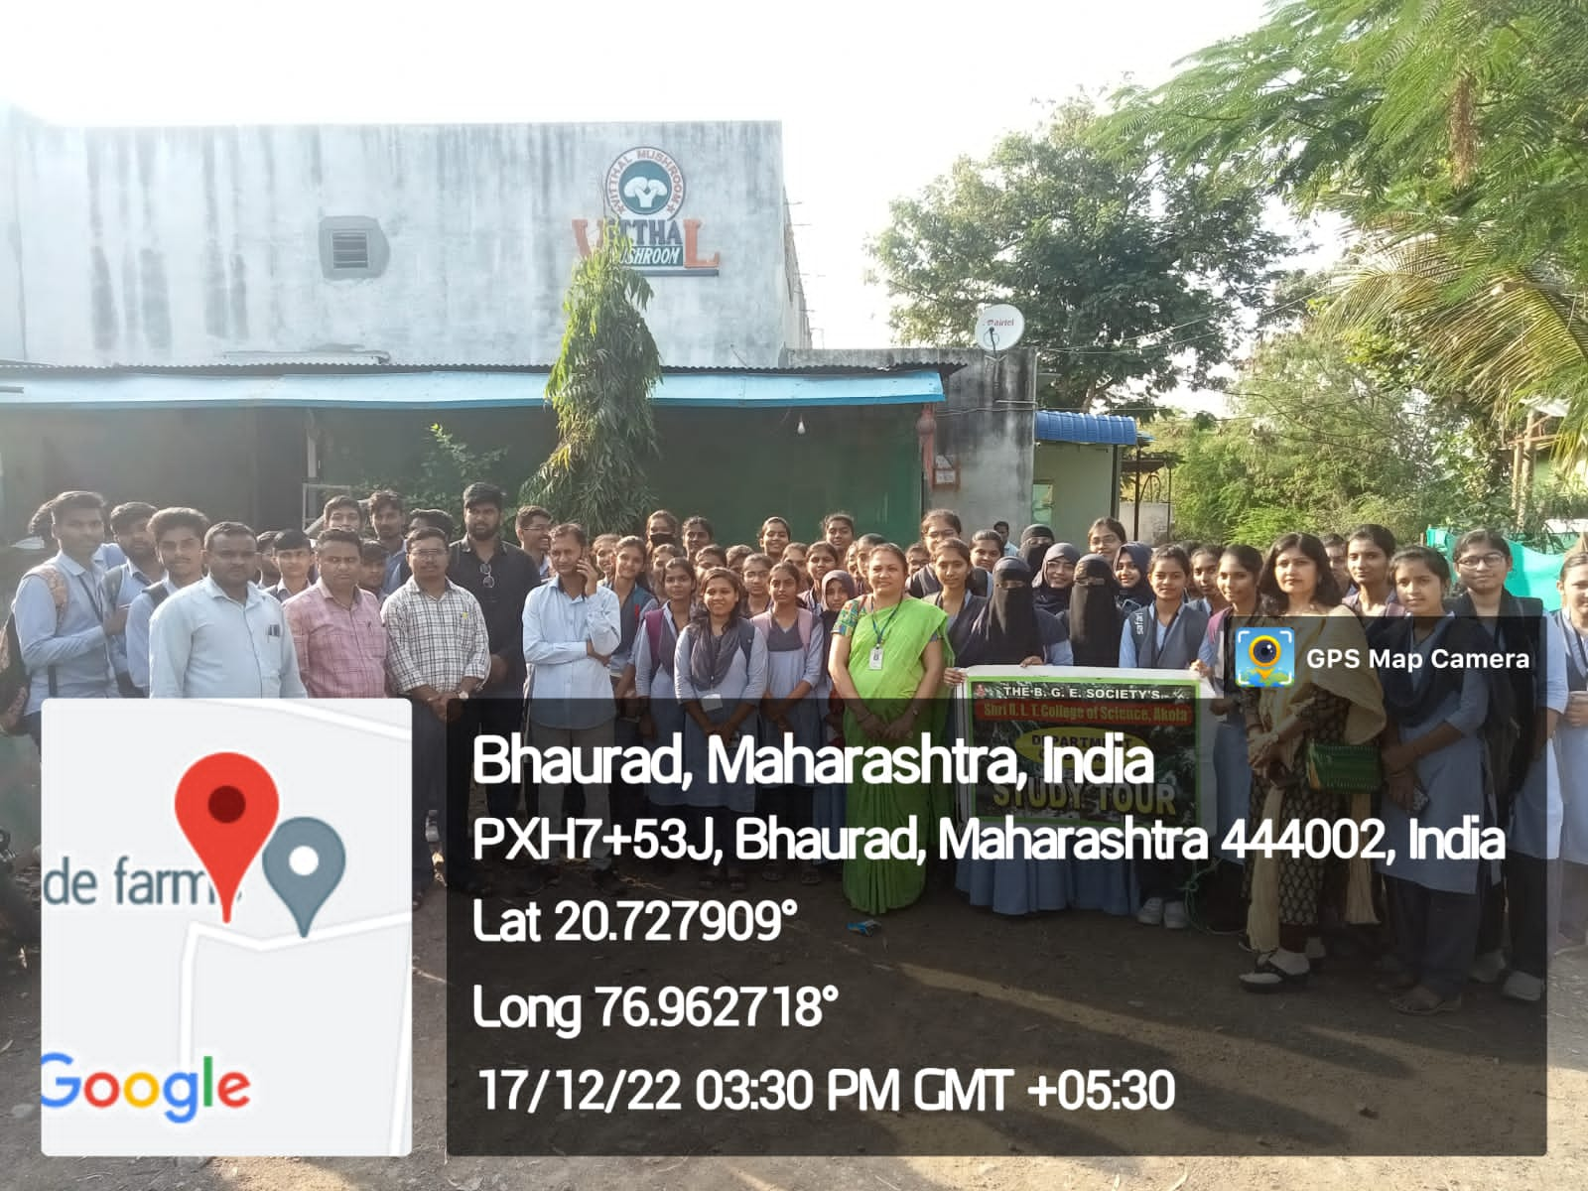
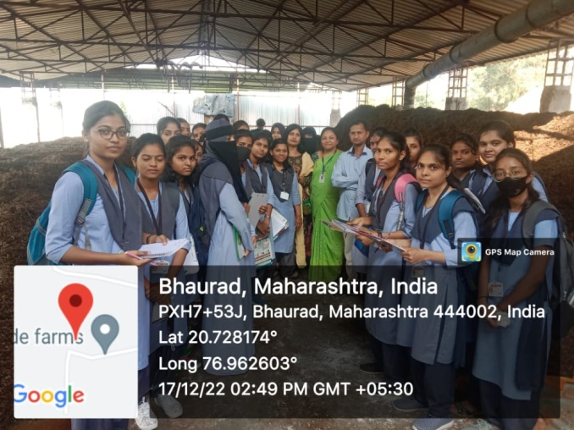
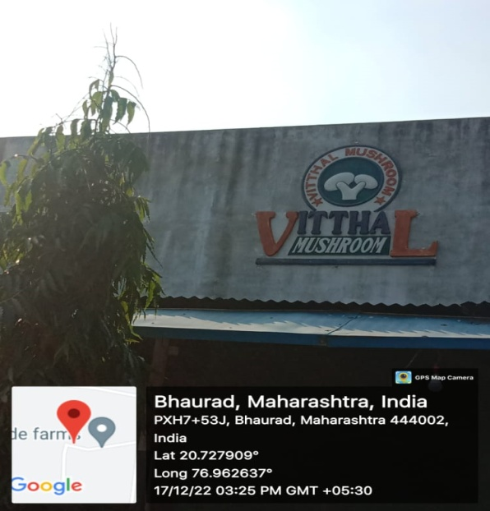

Holy Basil Club Activity Report 2023
Visit to Plant Exhibition of Akola Garden Club

Students of B.Sc.I Yr Dept. of Botany Holy basil Club visited to Plant Exhibition organised by Akola Garden Club, Akola. In this Exhibition students got knowledge about floriculture & various plants variety like Ornamental, Epiphytes, Succulents, Indoor plants, Xerophytes etc.
On this Occasion, they are also having interaction with Great Taxonomist of Maharashtra, Res. Dr.S.P.Rothe Sir.
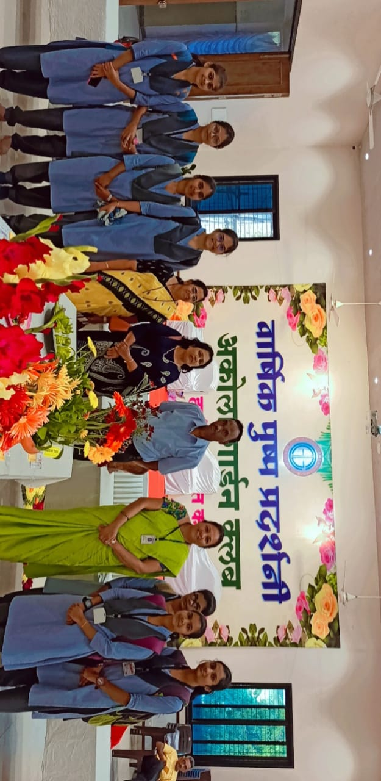
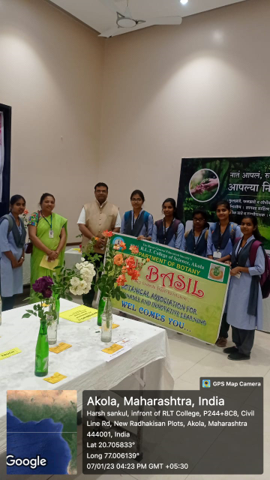

Shri R.L.T College of Science, Akola
(PG Activity Report)
Educational Tour to Ajanta Caves Aurangabad
As a part of curriculum, PG Department of Botany organized one day (short) tour to Ajanta Caves, Aurangabad on 02/12/2022.Total 38 students from M. Sc. I and M.Sc. II Yr.participated in this tour. The journey was started at 06.30 am with the permission of Principal from college campus.
The participants were reach to destination at 11.30 am. Student participants have observed diversity of Angiosperm plants at the site. They observed various plants and collected material for specimens and herbarium preparation. They collected plants like Tectona grandis, Sterculia urens, Hardwickia binata, Species of Ficus, Agave, Mitragyna parvifolia, Helecteris irosa, Terminalia arjuna, T. alata, Ipomea nil, I. hederifolia, Speranthus acmela, Erythrina indica, Butea monosperma, Zizyphus mauritiana, Z. jujube etc. Students also collected Algal material from streams and rivers. Number of fungal and plant pathologic material was also collected by students. Students also enjoyed architectural and monumental sculptures form Ajanta caves. The caves were designated a UNESCO World Heritage site in 1983. The tour was organized with the permission and guidance of Principal Dr. V. D. Nanoty sir. Head of Department Mrs. V. N. Badgujar and P.G. in-charge Dr. P. M. Khadse took efforts to organize and participate in tour. Dr.Anjali A. Sangole helped for organization of tour. Mr.S. V. Madavi worked as co-ordinator of the tour. The Botanical Society of Department of Botany, President Bilal Khan, Vice-president Mohini Mendhe, Treasurer Vaishnavi Bundele, Rishabh Ingole, Kunal Raut, Swapnil Thorat and all members of Botanical Society actively worked for organization of this tour. Secretary Vaishnavi Gaikwad, Joint secretary Mrunal Patil, Tour Organizer Sakshi Jalamkar and Sonal Khandare plays crucial role in the organization of this one day tour. From the non-teaching staff Mr.Gajanan Sharma, Mr. Rajesh Dandnaik, Mr. Harish Umbarkar and Mr.Satish Shirsat help for organization and actively participated in the tour.

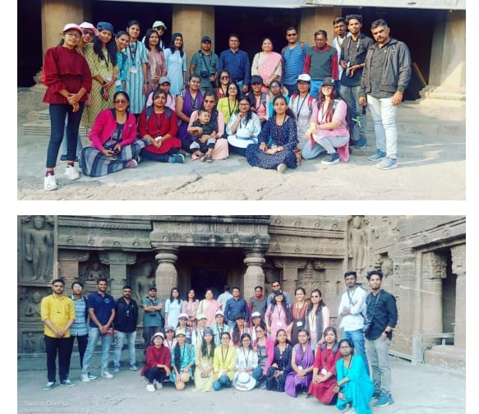

Release of E-Flora of RLT College
Shri R. L. T. College of Science, Akola run by The B. G. E. Society, Akola. As per vision and mission, college strives hard to percolate scientific temperament in society. Considering this mission in mind we have prepared E-Flora (Digital Flora) of this college campus. Aim of this flora is to propagate scientific as well as applicable knowledge of varieties of plants in the campus.
This flora aware about Identification of plant with Botanical Names and common names, also the Morphology and differentiating characters of plants as well as importance for mankind. This book also contains information in local (Marathi) language, so that the non-biological person can also learn information about the plant.
This flora was release on 10th October 2022 by the hands of Dr.Vedprakashji Mishra, Pro-Chancellor, Datta Meghe Institute of Medical Science (Deemed-to-be University), Nagpur, in the gracious presence of Hon’ble Dr.Tushar R. Deshmukh, Registrar, S.G.B. Amravati University, Amravati, Adv. M. G. Mohata Sir, President, The B.G.E. Society, Akola, Shri Pawanji Maheshwari, Hon. Secretary, The B.G.E. Society, Akola, Dr. V. D. Nanoty Sir, Principal and All executive members of The B.G.E. Society, Akola. The activity was coordinated by Mr.S. V. Madavi, with Mrs. V. N. Badgujar, HOD, Botany, Dr. P. M. Khadse, Dr. Anjali A. Sangole and all students and staffs of Botany Department. Link of Book- E-flora-of-RLT-For-Website.pdf (rltsc.edu.in) Complete Book QR Code-
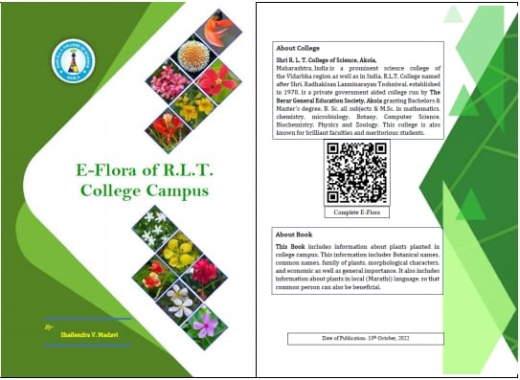

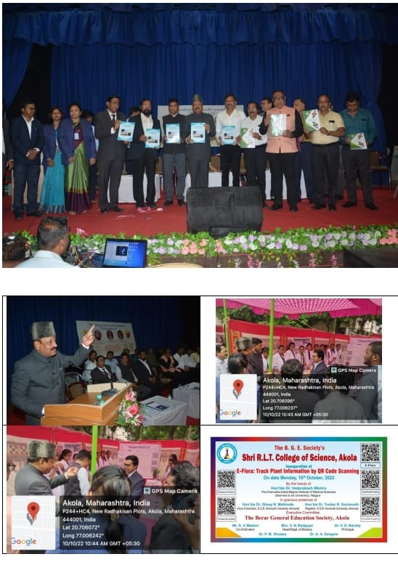

Shri R. L. T. College of Science, Akola
Department of Botany
Fungi Week
On the occasion of World Fungi Week (27th September to 2nd October) Department of Botany, Shri R. L. T. College of Science, Akola in collaboration with Mycological Society of India, Amravati Unit celebrated Fungi Awareness Week by organizing University Level Poster Presentation Competition on 1st October 2022 at 12.00pm.
Theme of this competition was Diversity of Fungi for Sustainable Agriculture. In this competition total 54 PG students from various colleges were participated. Large number of posters were on diversity of fungi percolating Scientific awareness among the students and society about role of fungi in agriculture. Three winners were selected among the participants by jury members. The 1st Prize of Rs. 1000/- and Certificate was awarded to Group- Dhyaneshwar Dhore, Janhavi Rayat, Rutuja Lale, Shri Shivaji Science College Akola. The 2nd Prize Rs. 700/- and Certificate was awarded to Ms .Poonam Bais, Shri R.L.T. College of Science Akola. Group of Vedika Warankar, Vaishnavi Pophale, Divya Jangole, Shri Shivaji Science College Akola awarded with 3 rd Prize of Rs. 500/- and Certificate. Mr.Rushabh Ingole and Ms.Vijaya Kalaskar received consolation prize. All the participants were awarded with certificate.
The president and inaugurator of this competition was Dr. V. D. Nanoty Sir, Principal, Shri R.L.T. College of Science, Akola and Dr. D. V. Hande, President, MSI, Amravati Unit, Principal, Shri Pundalik Maharaj Mahavidhyalaya, Nandura (Rl.) was the chief guest. IQAC Co-ordinator Dr. R. L. Rahatgaonkar, Asst. Prof., Dept. of Zoology, Shri R. L. T. College of Science, Akola were present for the inaugural function. Dr. S. W. Suradkar, Assist. Prof. & Head Dept. of Botany, Gulamnabi Azad College, Barshitakli Dist. Akola serve as Jury member of this competition. Prof. V. N. Badgujar Assist. Prof.& Head, Dept. of Botany was Convenor of the competition. The Co-Convenor was Dr. P. M. Khadse Assot. Prof.& PG
In-charge, Botany. Organizer of this competition was Dr. Anjali A. Sangole Assist. Professor, Botany. While Mr.S. V. Madavi Assist. Professor, Botany worked as Organizing Secretary. Mr. C. J. Mounas, Ms. P. D. Salunke and All Teaching, Non-teaching Staff and PG & UG Students Department of Botany worked for the success of program.

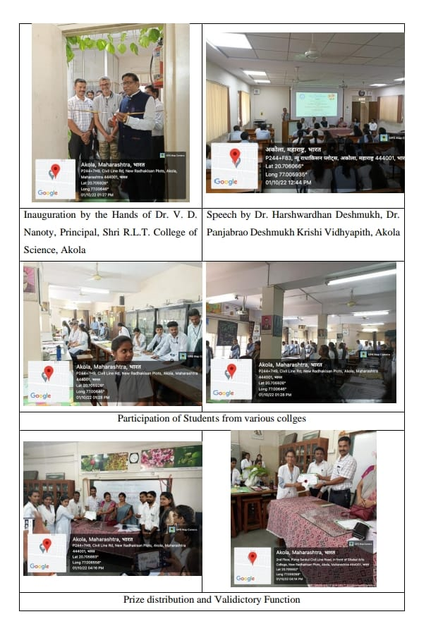
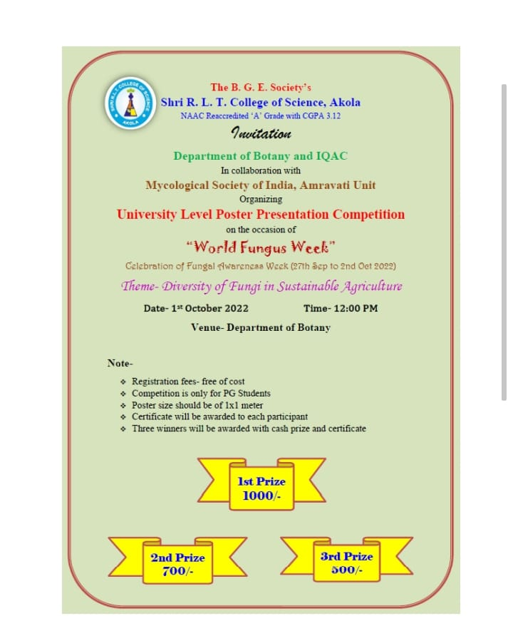

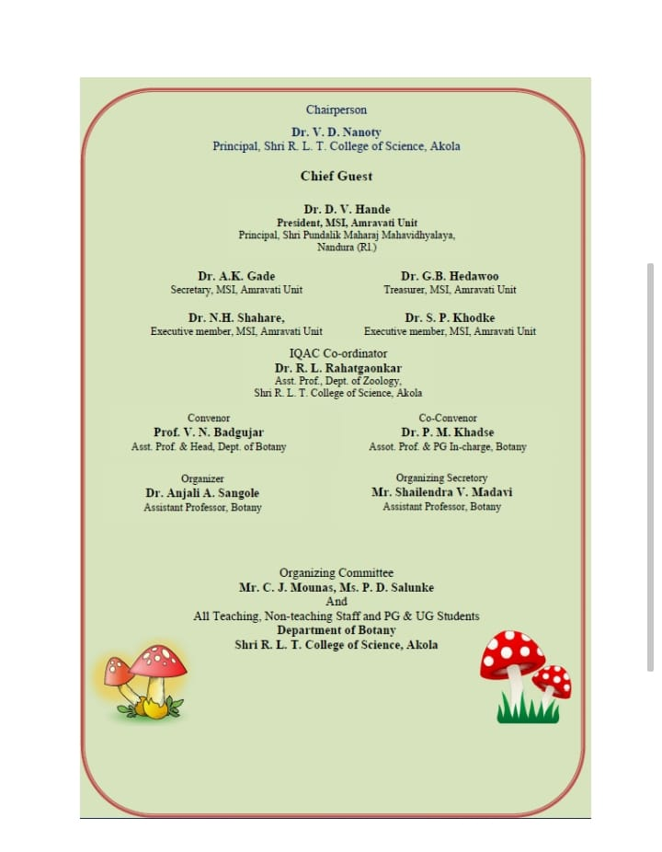

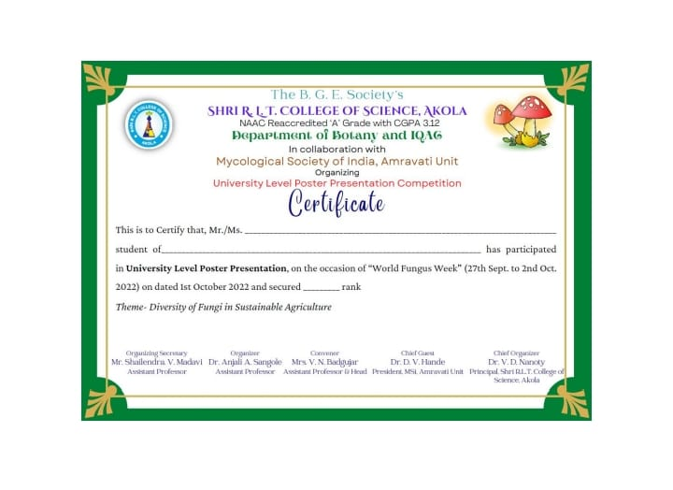

HOD
Department of Botany
( Mrs. V.N. Badgujar )

