The Department of Languages
Annual Report 2022-23

The academic year 2022-23 has been a sensational ,full of academic activities throughout the year starting right from August 2022 to April 2023 .Moreover it was a year of NAAC assessment too, in which the college has been newly promoted to the CGPA 3.16 maintaining ‘A’ grade by assuring the quality education to students of UG ,PG and research .
The total strength of the students in Bsc part one was 489 including all subject combinations. The Department of languages has conducted a range of activities throughout the year .CBCS system has been launched to avail students with more opportunities .Field visits were arranged as a part of skill enhancement module as per which the students were divided in groups and later they visited State Bank of India,Bank of Maharashhtra,Head post office,Akola, Shivay supershoppee, Gajanan supermarket,Bus stand ,Railway station,Bakery,medical shop and so on ..After vistit students submitted the detailed report of visit .Students of Marathi ,Hindi and English conducted the interviews of dignitaries and submitted the reports .Skill enhancement module that aimed at enhancing better communication skill among students in English , Hindi and Marathi .
In second semester, seminar and assignment were the activities in which students participated enthusiastically.
This year Digital language lab has been started in IT lab which could be beneficial to students in learning language .

Hindi Divas was celebrated on 14.09.2022 at Shri R.L.T. College of Science, Akola. Honourable Principal Dr Nanoty Sir, Teachers and students were present in the celebration. Students expressed themselves with best pieces of Hindi Literature.Marathi Bhasha divas was celebrated on 27 th February 2023.
In so far as the achievements of the literary competitions are concerned, this session proved to be blissful as Ku Vidhi Rajeshwar Pathak and ku Vaishnavi Vinod Rathod and Ms Mrunmayee Galphade won various prizes in elocution competitions .Whereas Chaitali lanjudkar won prize in essay writing competition.
This year the theme of the creative writing competition was Aazadi ka Amrit Mohotsav which got good response as many students submitted their creative write-ups and participated in the competition.

Activities at a glance:
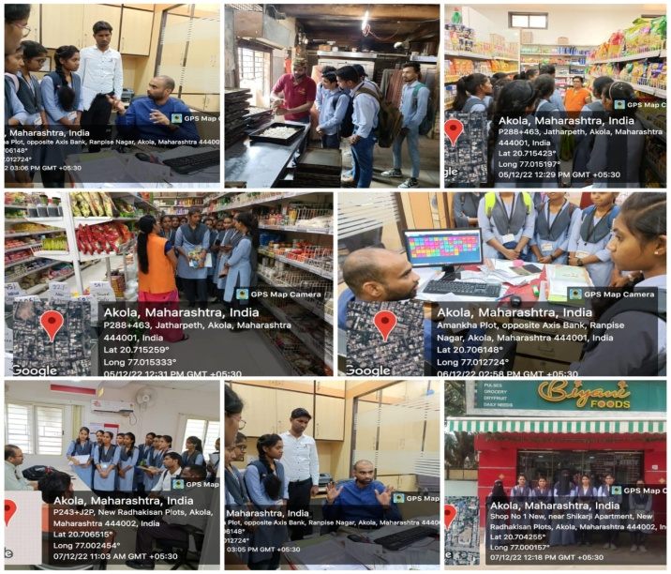 | 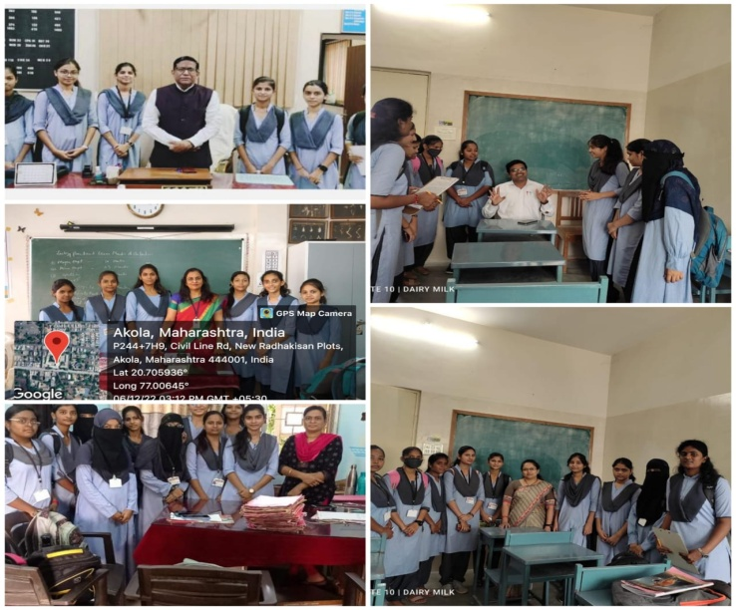
Field visits | Interview of dignitaries

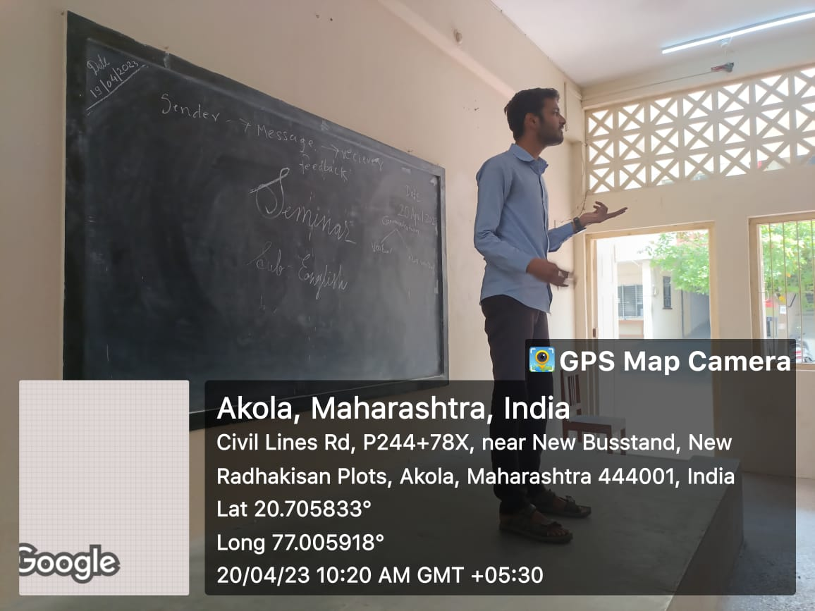 | 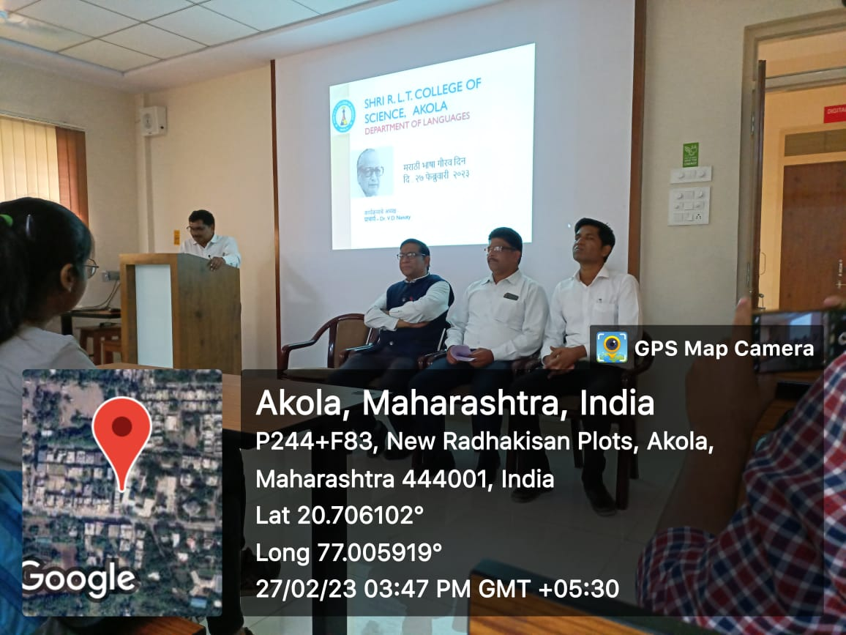
Seminar | Marathi Bhasha Divas celebration

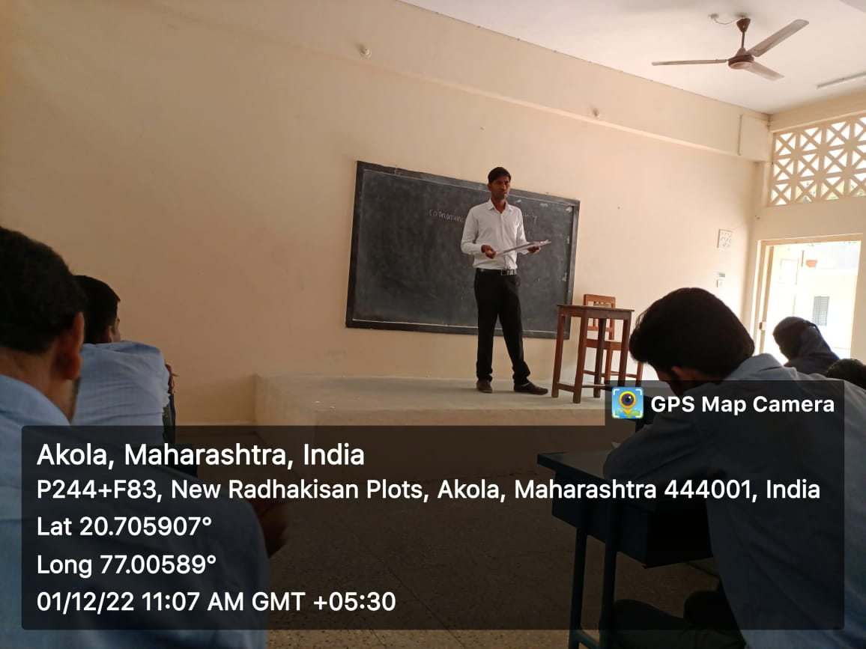
Workshop on communication skills | Seminar presentation

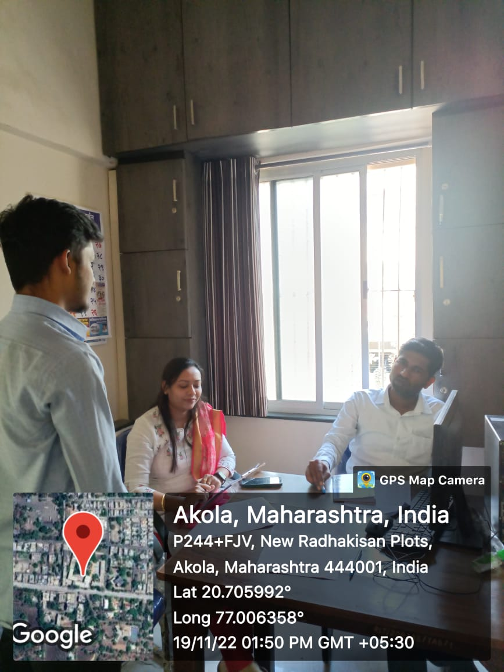 | 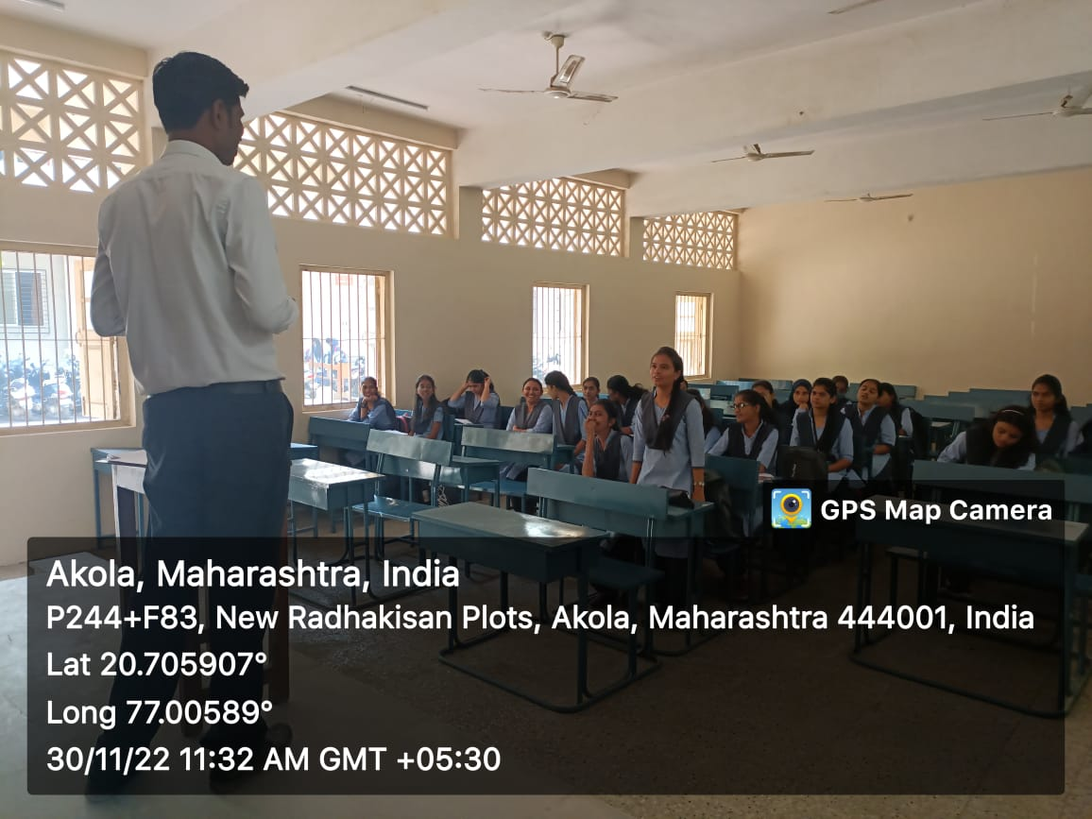
Viva- voce | Ability enhancement course

Mr A. B. Khedkar
Assistant professor and head
Department of languages

