Personal Profile
Name: | Mr. A. B. Khedkar |  | 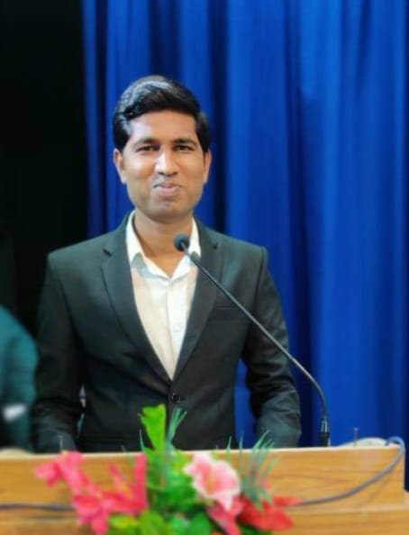
Designation: | Assistant Professor in English and Head department of Languages
Qualification | M.A. NET, SET, B.Ed.
Department: | Languages
Mobile No: | 9767717376
Mail: | arunkhedkar@gmail.com
Teaching Experience | 05 Years
Teaching Expertise: | American Literature, Indian Writings in English Diaspora’British literature’ Grammar
E-Content Channel: | https://www.youtube.com/channel/UCqIr-MLcfDejHF_D2410psg
Research Experience: | 05 years
Area of Research: | Diaspora writings
Research Platform Link:
Positions Held: | 1. Coordinator: Head ,Department of Languages
 | 2.Editorial member ,college magazine Pratibimb
 | 3. Member of NAAC Criteria-VII
 | 4. Member of Admission Committee.
 | 5. Member cultural committee.
 | 6 Member prospectus committee
 | 7 co-ordinator literary ,co- curricular activities debate,elocution,poetry,quiz article ,essay and other .
Academic Contribution: | Invited Talks / Guest Lectures:
 | Books / Articles Published OR Edited:

Research Publication | 1.) poems published in’ Langlit ‘ International Peer reviewed open access journal
 | 2.) Diaspora and Identity crisis in the Novels of Bharati Mukherjee Published in ‘Langlit ‘ International Peer reviewed open access journal
 | 3.) The Role of technology in teaching and learning English language . Published in Aayushi International Interdisciplinary Research Journal. Published in NCMRST 2020
8. Organizing Committee Member of National Conference on MRST-2020.
(24th January 2020)
Research  Contribution: | Research Publications: Published– 03; Presented - 01
 | Patent: 01
Other Significant Contribution: | 1. member of Mock-Poll Process for students under state election  commission and collector office, Akola (25th September 2019)
 | 2. Guidance to literary activities debate,elocution,essay writing,quiz competitions
. Organizing Committee Member of the one-day workshop of EUREKA
(23rd March 2019) and 2017-18
Other:

