Workshop on Awareness programme of Mobile Radiation
Department of electronics and alumni association, Environment cell in collaboration with IQAC organised workshop on awareness programme on mobile radiation dated 30 september2021 in digital classroom in our college. the Guest of honour our alumna Mrs. Renuka Digamber, Nagpur gives us the lecture in our college for teaching and non-teaching staff members with slides shows and videos about the radiation of mobile harmful for our human body.
She has then given us how to prevents that radiation by using MODI Care Chip on your mobile. then that radiation converts into other form of waves that are not harmful to our body.
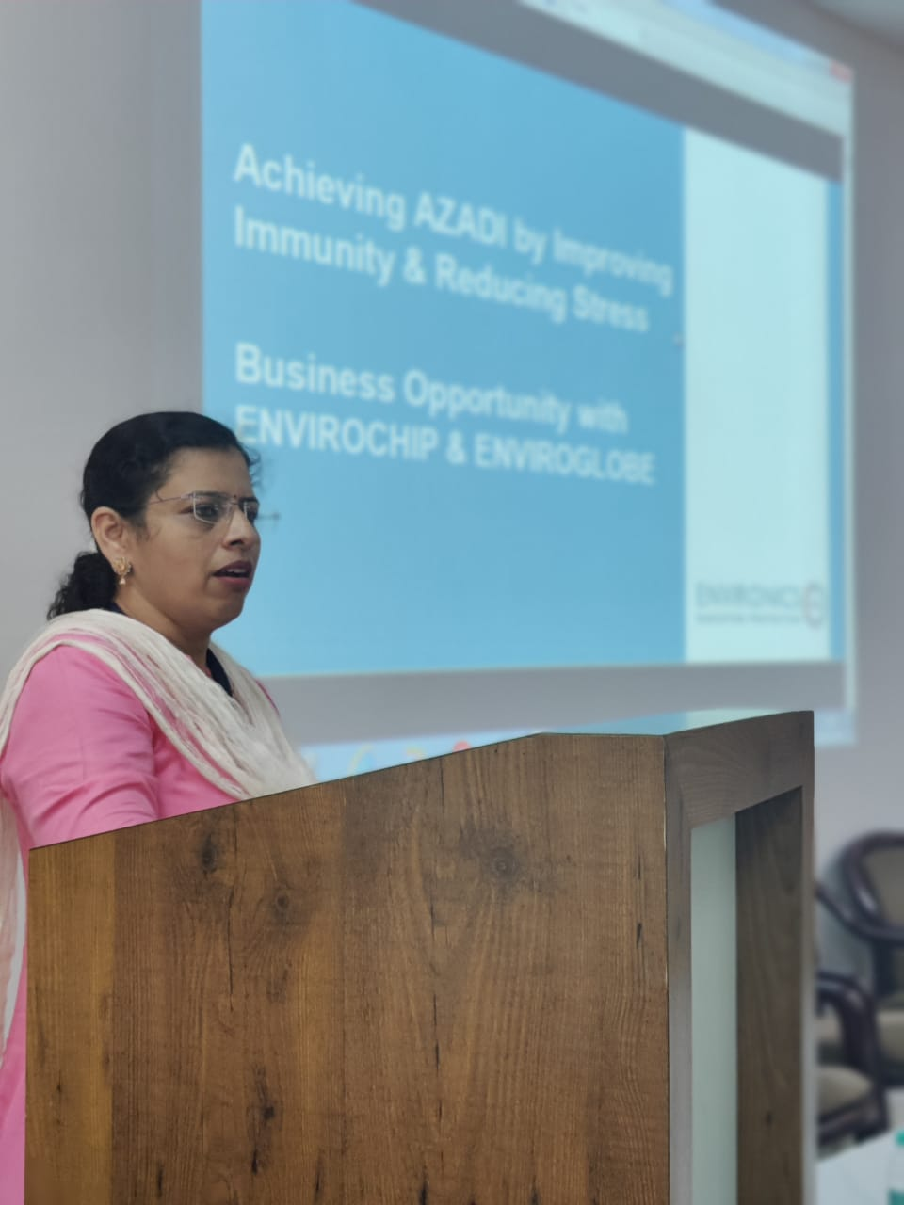
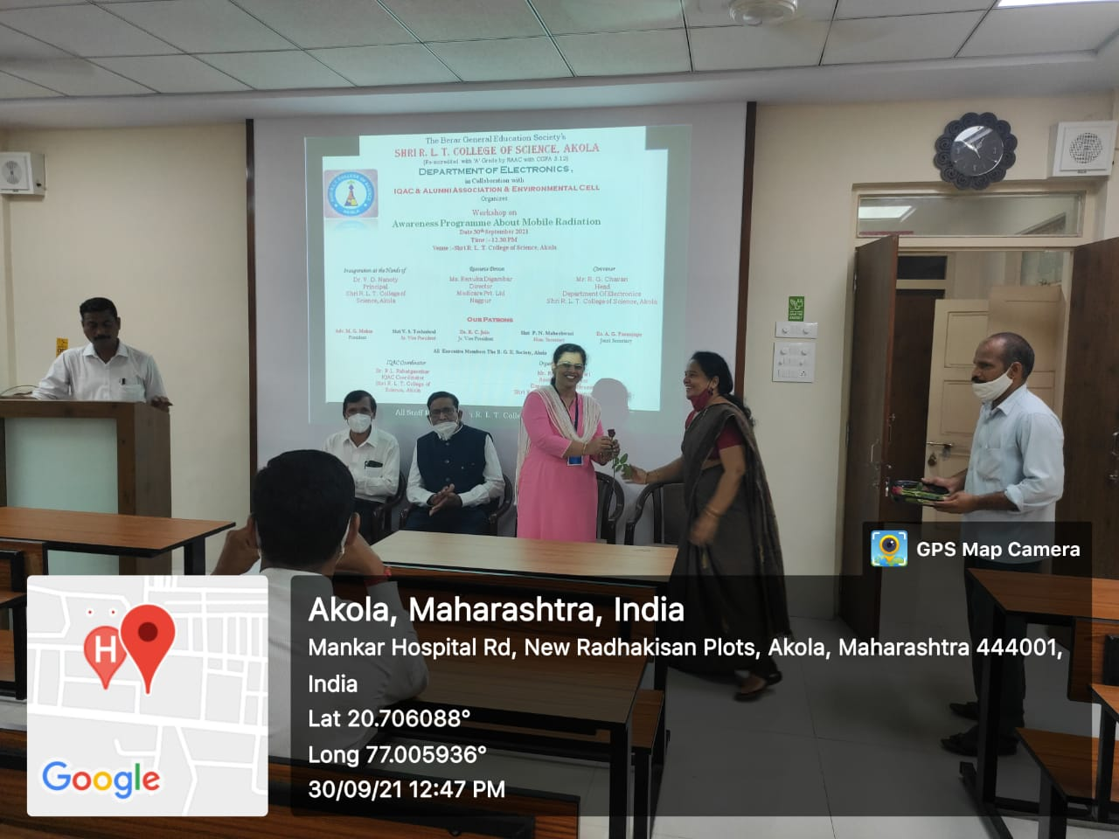
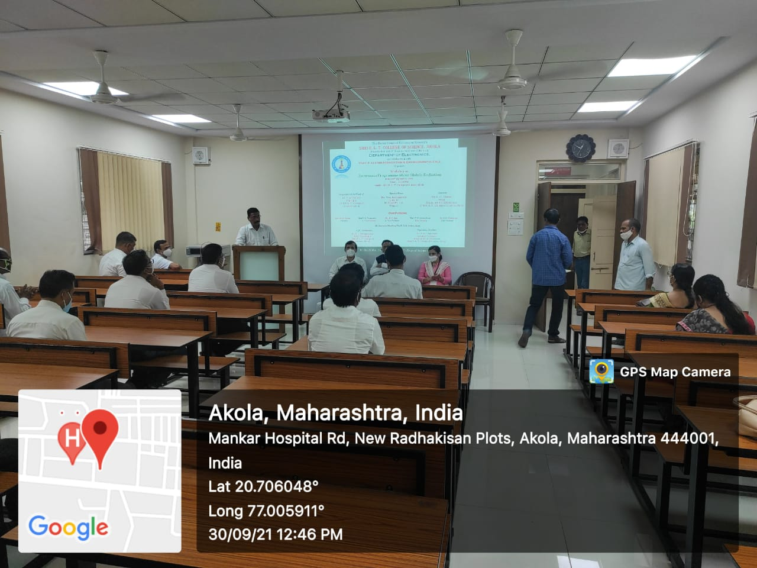
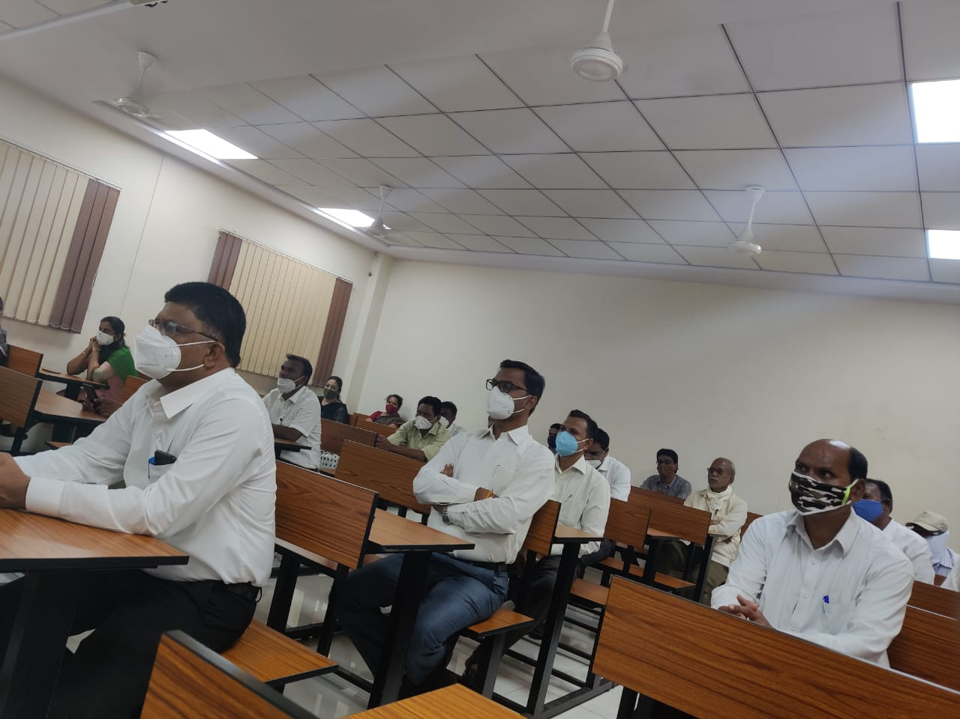
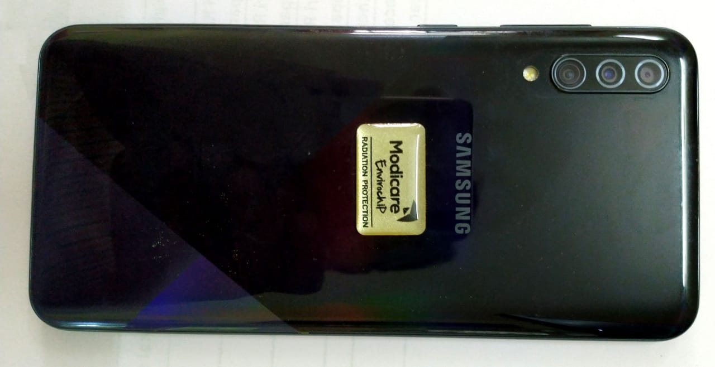

Co Ordinator Principal
(Mr.R.D.Chaudhari ) (Dr.V.D. Nanoty )

