Shri R. L. T. College of Science, Akola

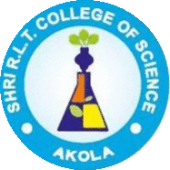

ALUMNI COMMITTEE REPORT
SESSION- 2021-2022

Prof. R.D. Chaudhari Chairman
Prof. R.G. Chavan Alumni Sr.Member
Dr. P. T. Agrawal Member
Prof. R. B. Ghayalkar Member

Contents
Sr. No. | Activities
1 | Permanent Registration Number
2 | Registered Alumni Committee
3 | Objective of the Alumni Association
4 | Account details, statement,Donor
5 | Guest Lecture by Alumni
6 | Blood Donation on 24th Dec.2020.
7 | Felicitation of Alumni
8 | Alumni activity Distribution of mask, sanitizer and books
9 | National workshop on “IPR and Patent filing”
10 | Meeting of Alumna Association

Chairman Principal

Permanent RegistrationNo. F-20205

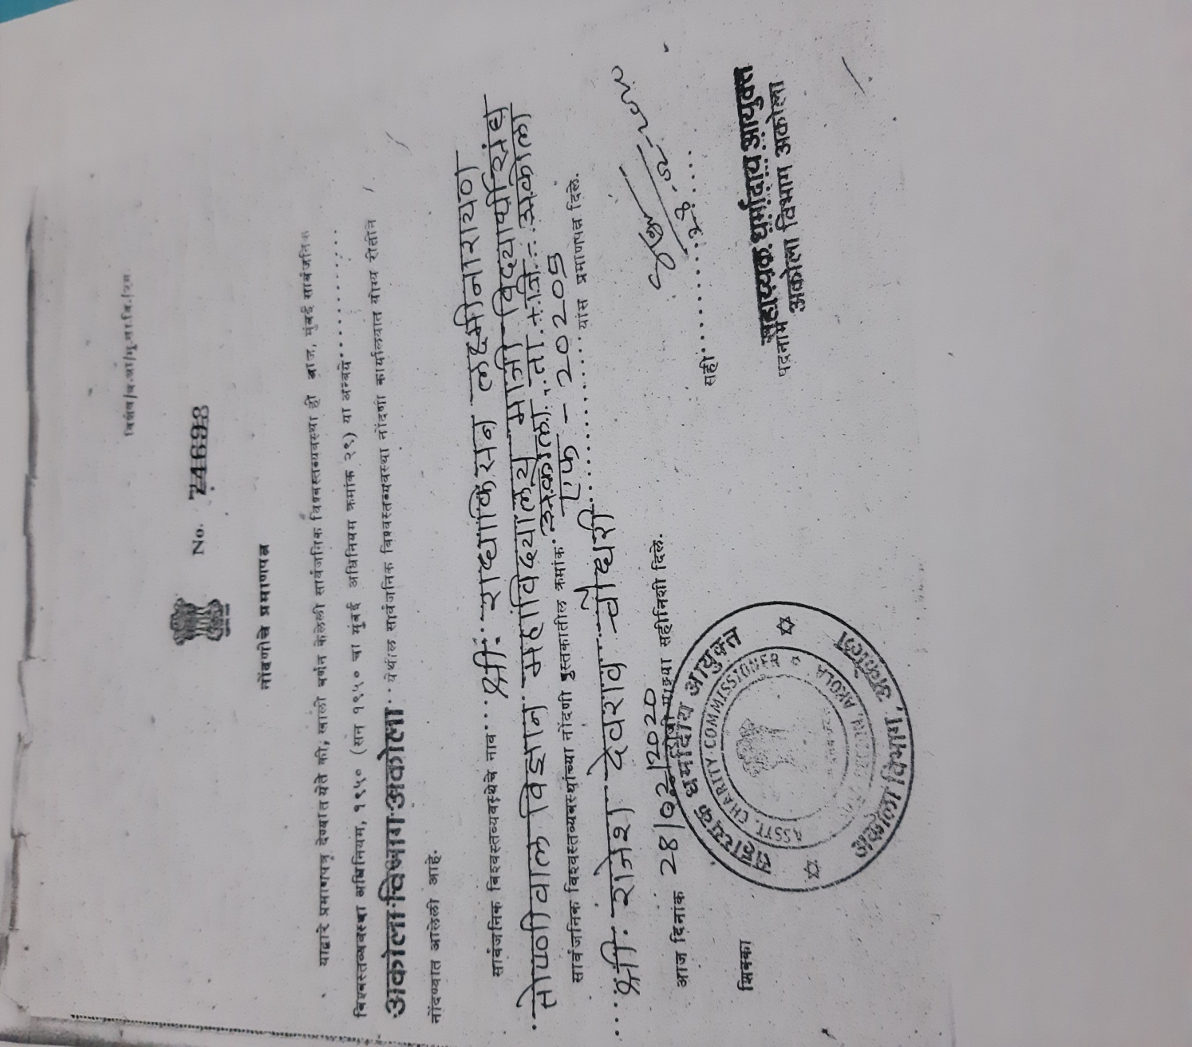

Registered Alumni Committee Members
Reg. No. F - 20205

- Shri Deepak Mayee – President

2)Shri Prashant Bule – Vice –President

- Shri R.D. Chaudhari – Secretary

- Dr.V.D.Nanoty – Member /Principal

- Shri R.G.Chavan – Member

- Dr. R.L. Rahatgaokar –Member

- Dr. Poonam T. Agrawal –Member

- Shri Sunil T. Patil – Member

- Shri Sunil M . Jadhao – Member
\
- Dr. Jayshree V. Bhale – Member

- Dr.AshiviniS.Morwal– Member

Objective of the Registered Alumni

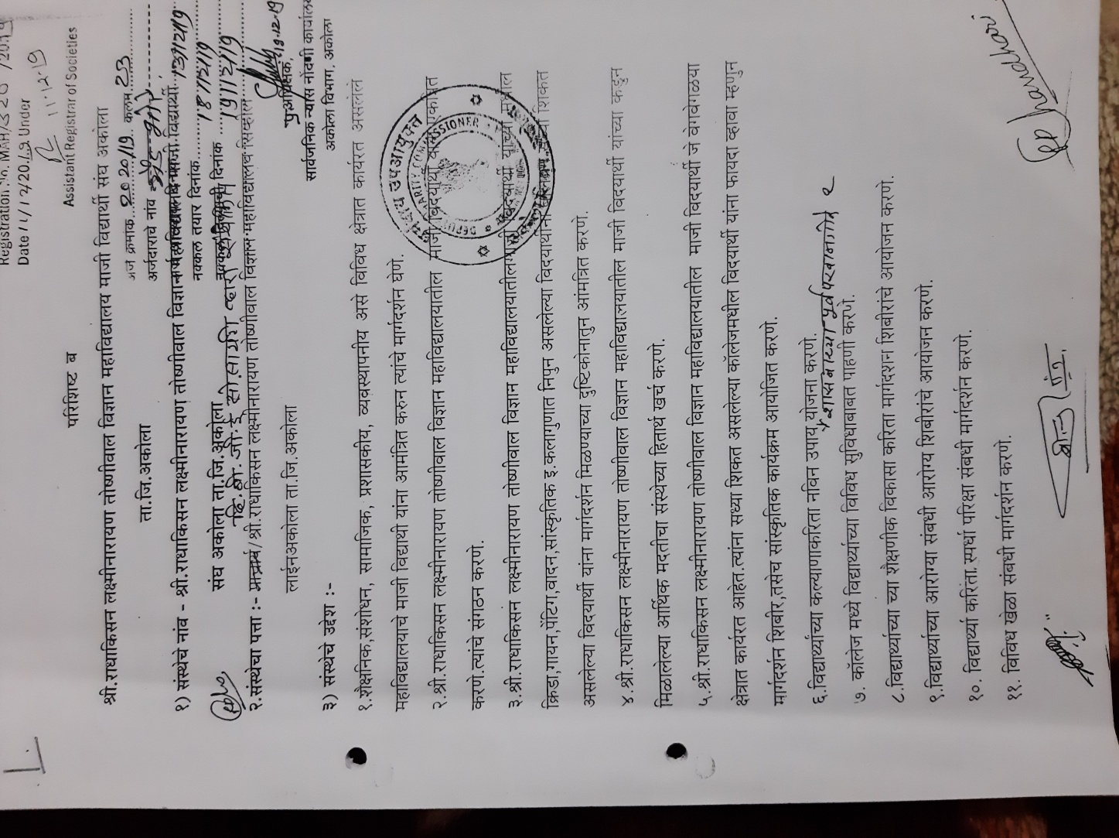

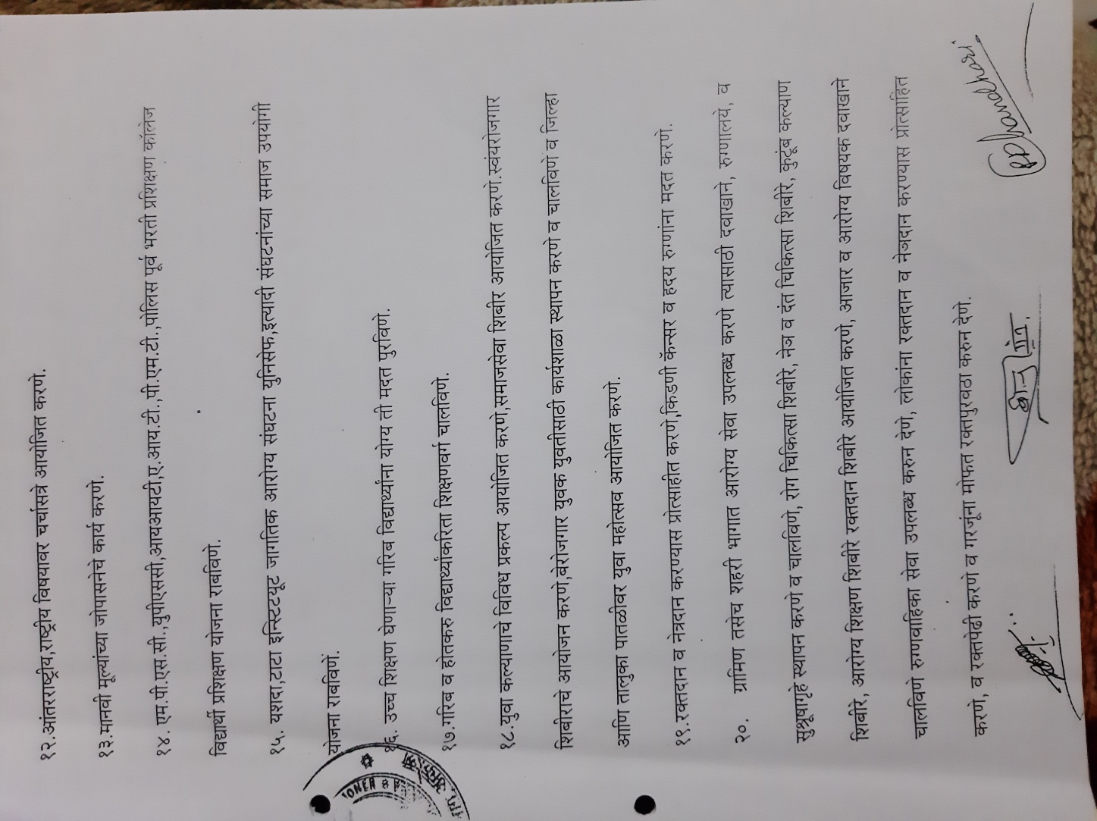

Account Details

Name :- Shri R.L.T.College of Science
AlumniAssociation,Akola
Account no. : – 3858820618
IFSC Code :- CBIN0283820
Bank :- Central Bank of India RLT Branch , Akola
Account Statement

- Balancing Amount on Dated 24 /12/2021 - Rs. 1,0390/-

Alumni meeting in the year 2021-22:-

Sr.No. | Date of meetings
1 | Online meeting 20 june 2021
2 | Online meeting 10 september2021
3 | 12 December2021
4 | 24 December 2021
5 | 20 june 2022

2 )Alumni of our college celebrate world farmers Day :-

On the occasion of Birth anniversary of the prime minister of India late. Charanshingh Chaudhari is celebrating as the farmers day of the world . our alumni association , Dept of
Botany and Environmental cell celebrated the farmer day today felicitation of one hardworking farmer Shri Waman Rathod and their wife from wanoja in presence of our principal Dr.V.D.Nanoty, respected shri Amar Gaud sir , Dr.P.T.Agrawal madam , Badgujar Madam R.D.Chaudhari sir, sarap sir, Dr.Heda madam , Dr.joshi madam , Dr.khadse sir , shri Madavi sir and all non teaching and the students of M.Sc

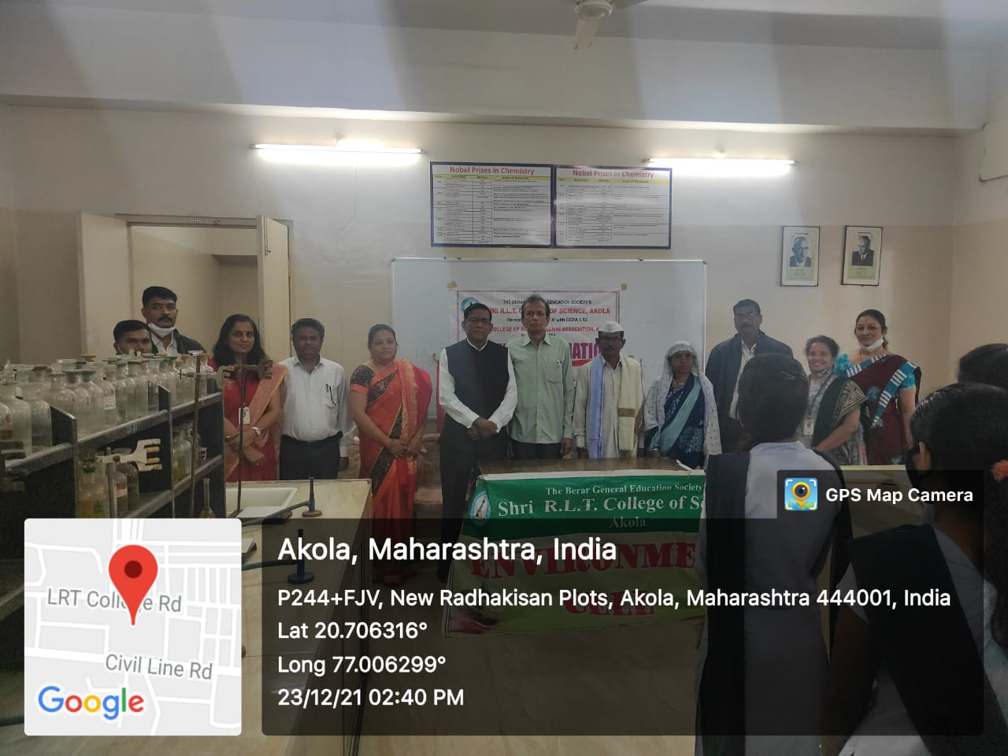

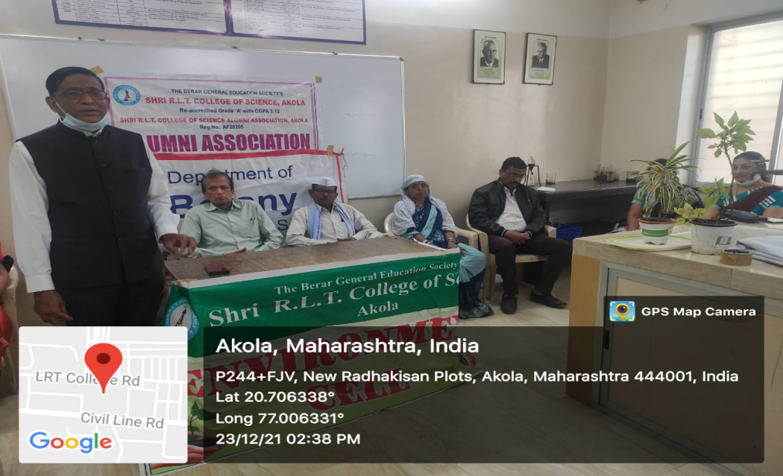

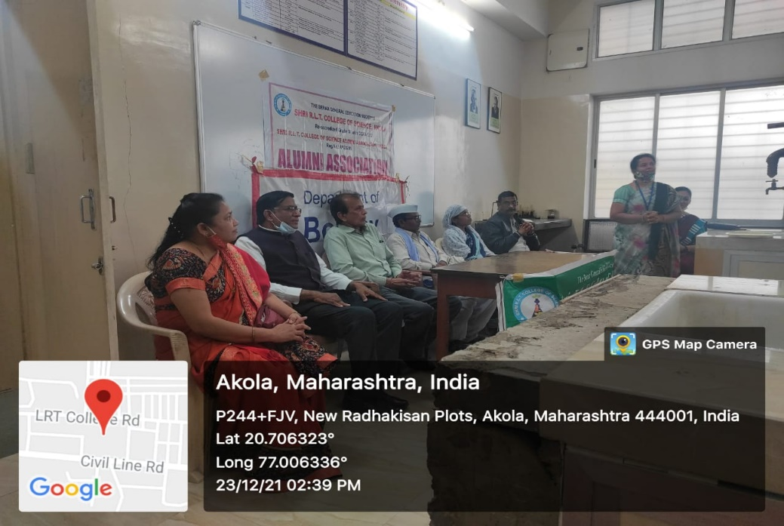
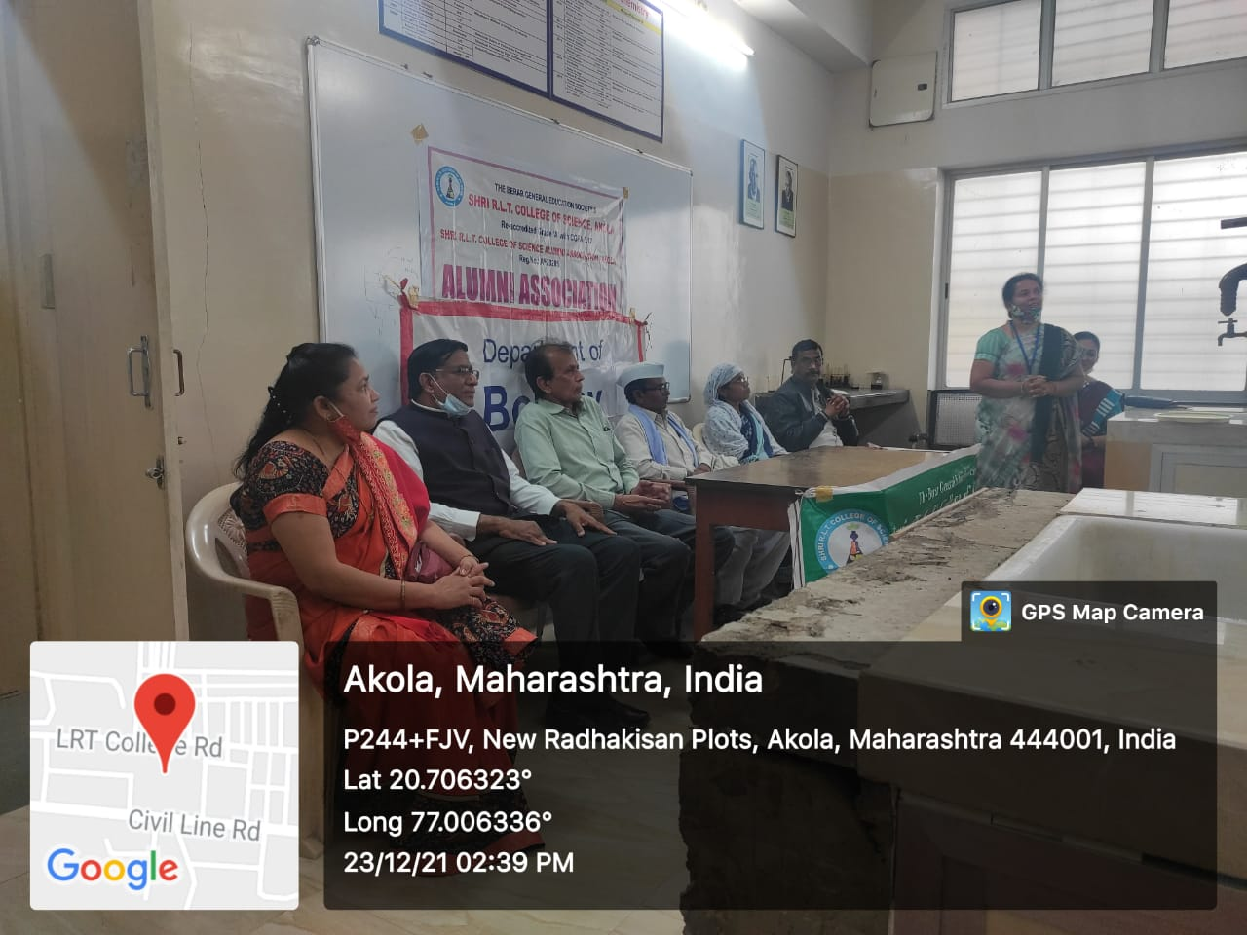

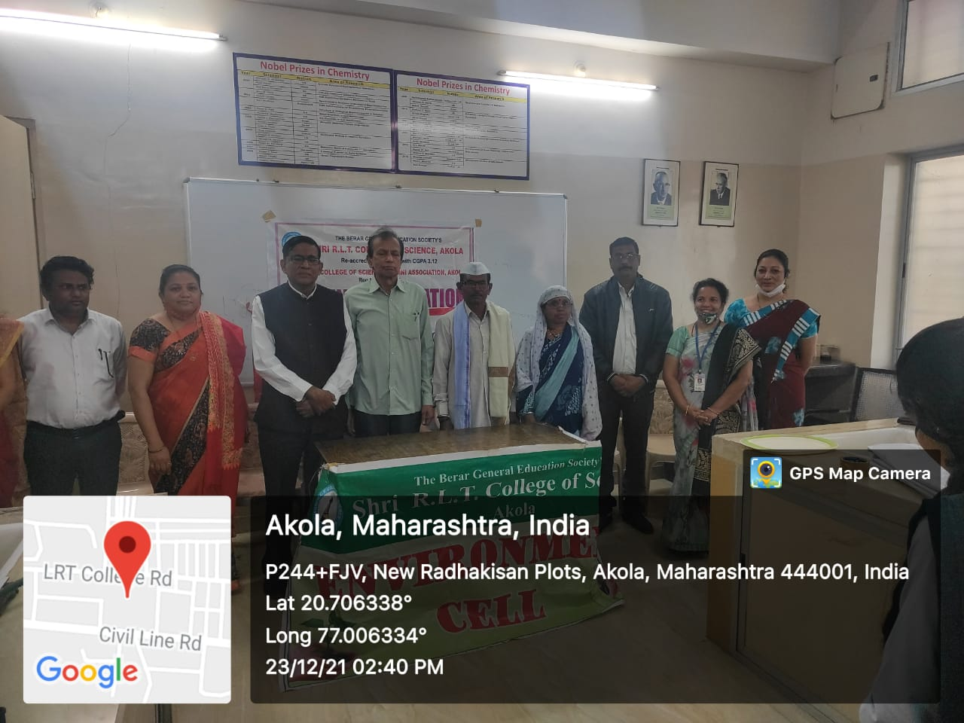

Blood donation camp and alumni day 24 Dec 2021 :-
For The inauguration of Late Principal M.G.Joshi Memorial day Programme on 24th Dec. 2021` Our College alumna Dr.Gulhane sir ,HOD, education department ,sgbau Amravati university,Amravati , felicitated and inaguarated the programme in presence of .Hon.Adv .M. G.Mohata. ,President The B.G.E.Society, Akola and Shri Pavanaji Maheshwari, Secretary, The BGE society,Akola Shri.Vijaykumar ToshnivalSr.vice president ,Shri Abhijitaji Paranjape Jt. secretary andDr.Ravindra Jain,Jr.vice president of the BGE society, Akola gives the message to our students and Felicited the meritorious students.

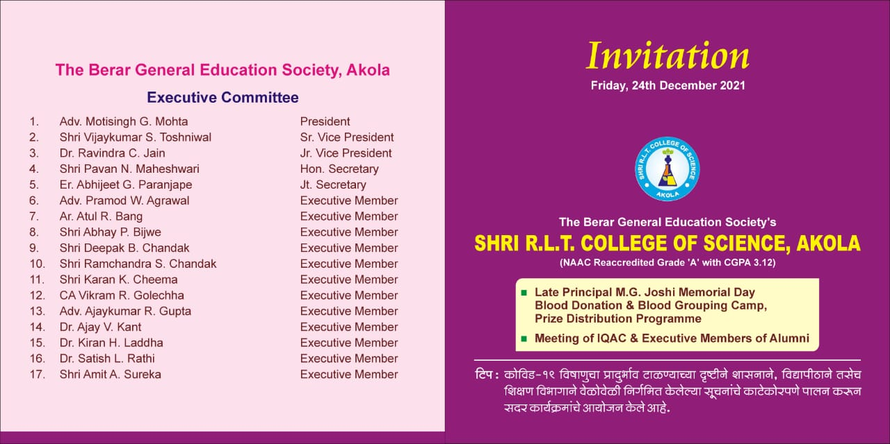
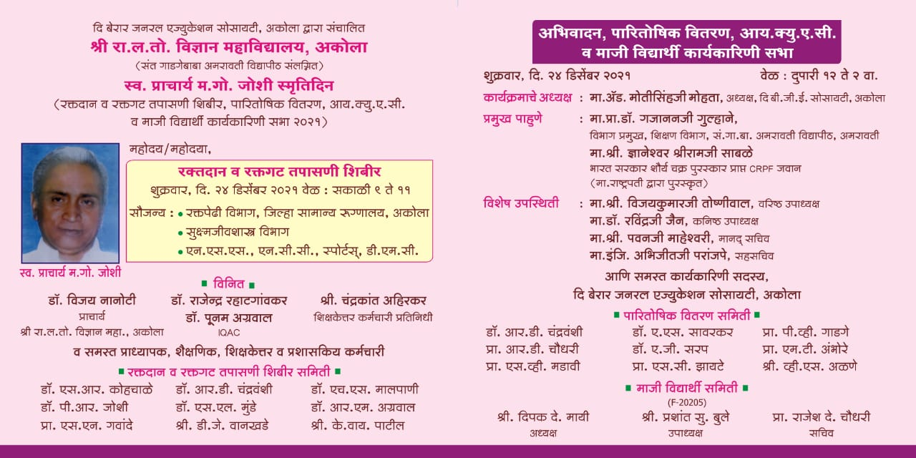

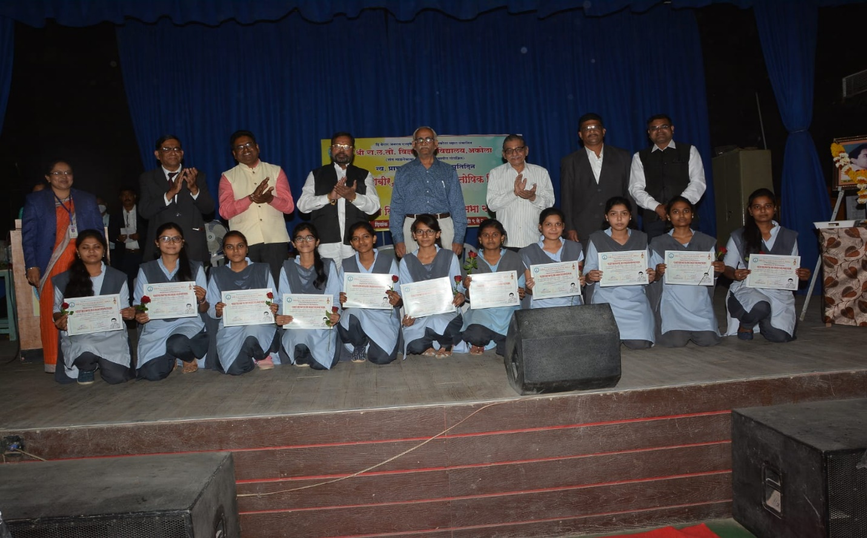
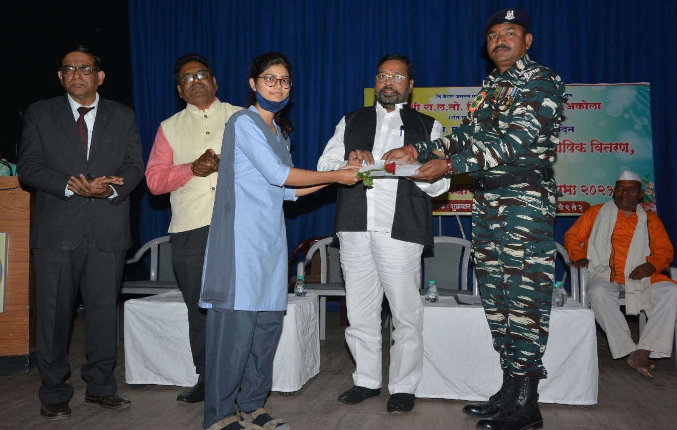
Felicitation of merit students
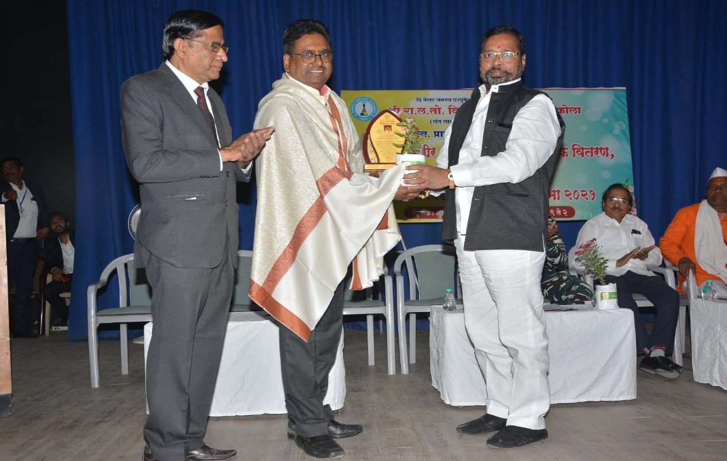
Our resp. President The B.G.E.Society ,Akola felicitated Dr.Gajanan Gulhane (Alumnus)
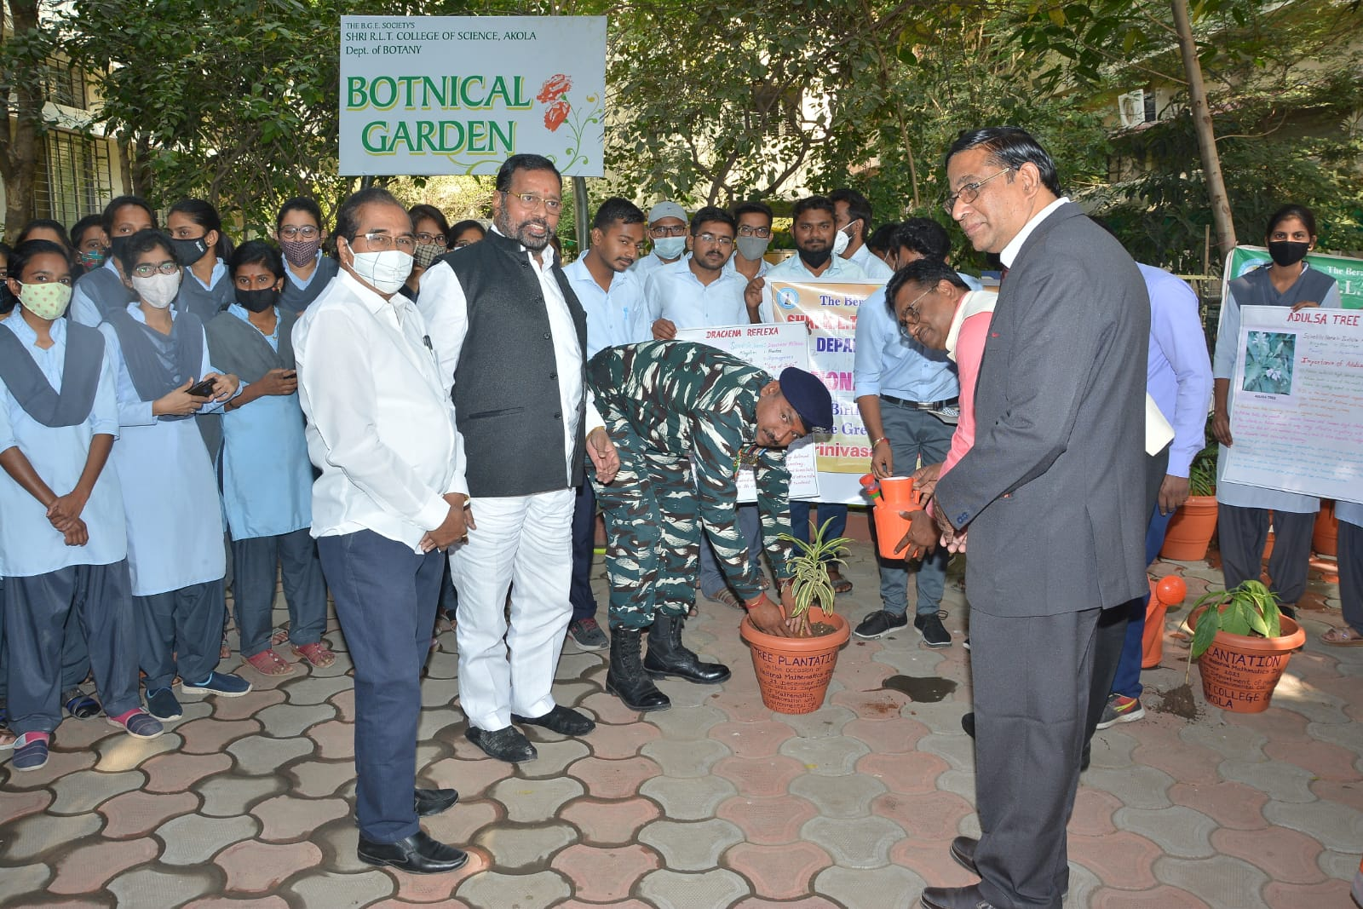
Tree plantationby the hands of hon. Dnyneshwarsarji Sable CRPF and Honoured by govt. of India as Shourya Puraskar

Blood donation by our Alumni

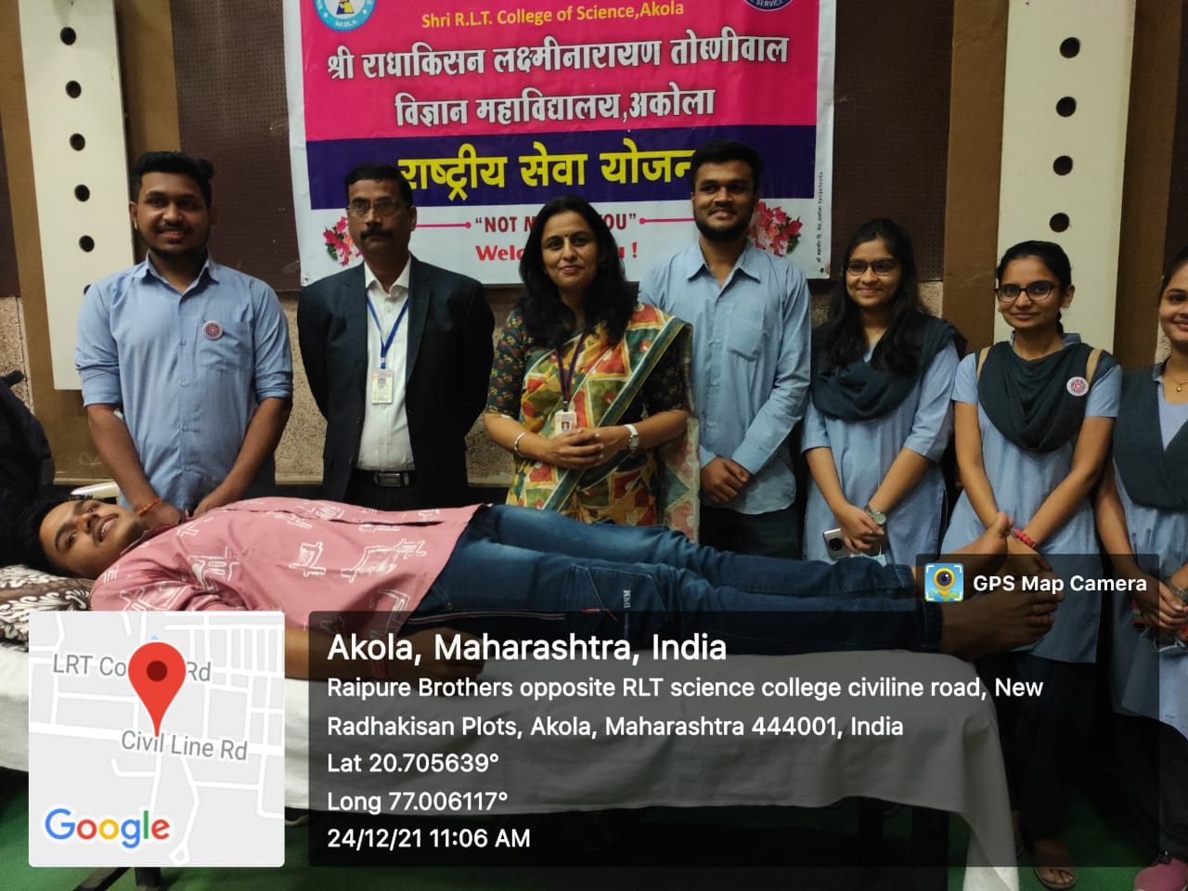
Our Alumni Participated in the blood donation camp every year
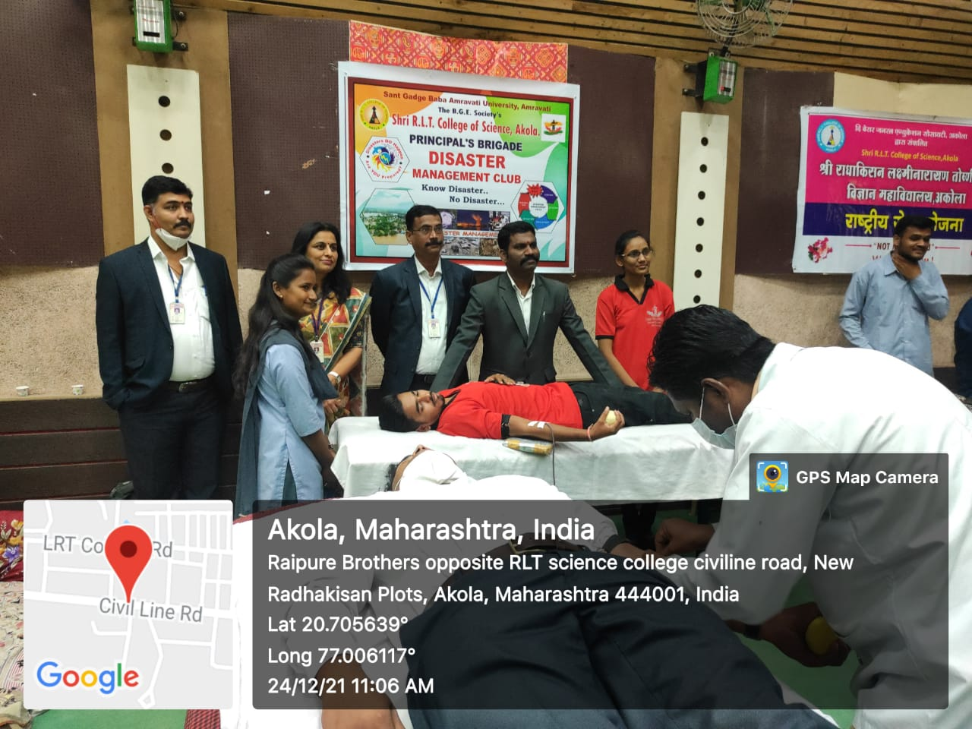

Alumni Social Activity :-
- Distribution of books to needy students of our college in presence of alumni association .

Distribution of mask by our alumni association.:-
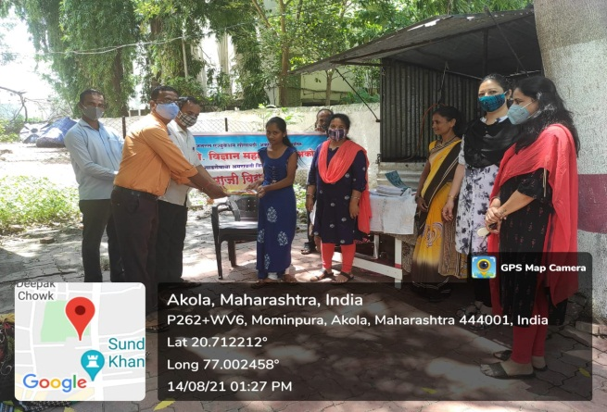
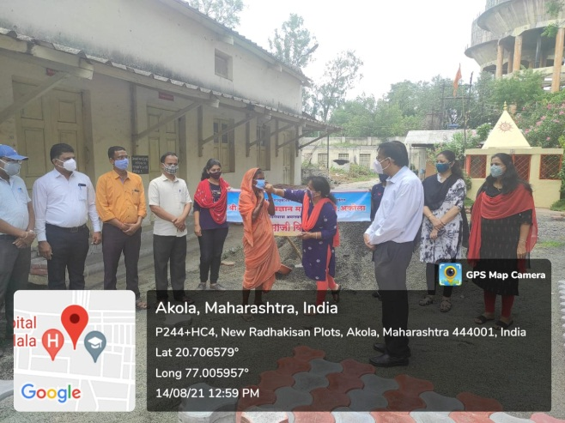
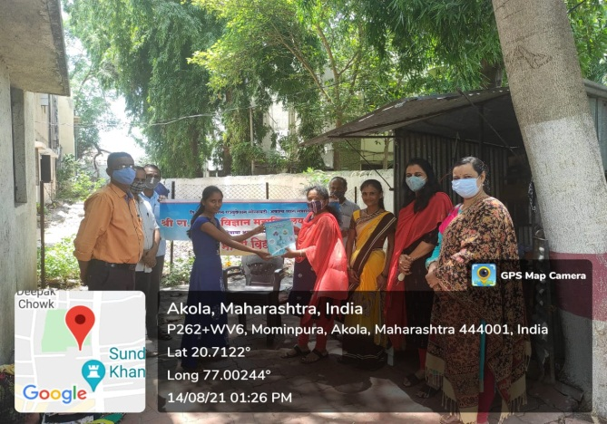
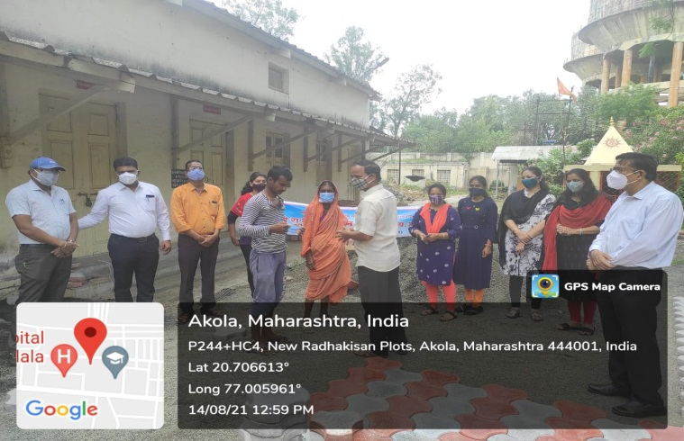
Distribution of sanitizer by our alumni association
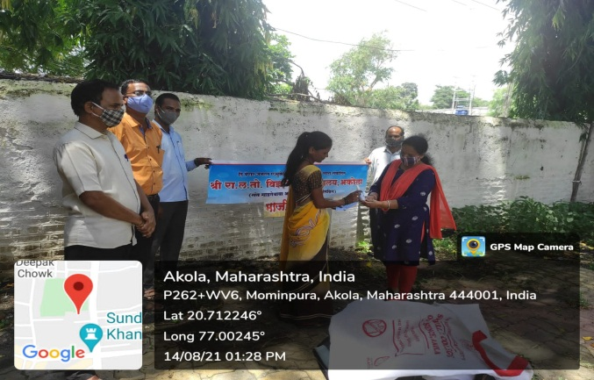
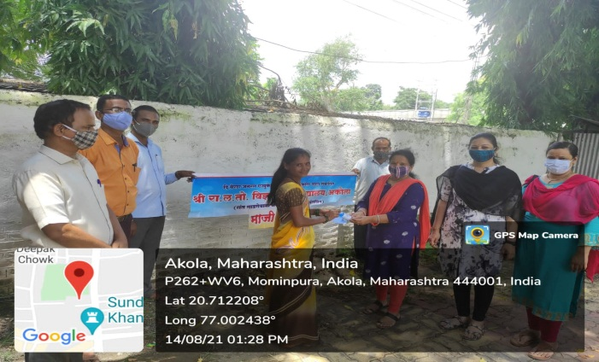

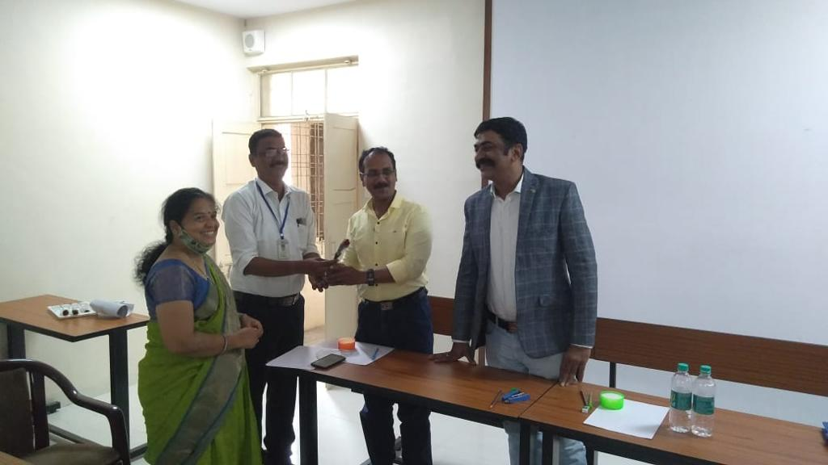

Felicitation of the 3 students of Electronics departments got job in Mr. Harshal Gokhe - SBI ,Mr.Gaurav Kharche - Cognizant, Mr.Akshay Bhatkar - MIDC Amravati felicitated by the hands our respected Principal Dr. V.D.Nanoty Sir
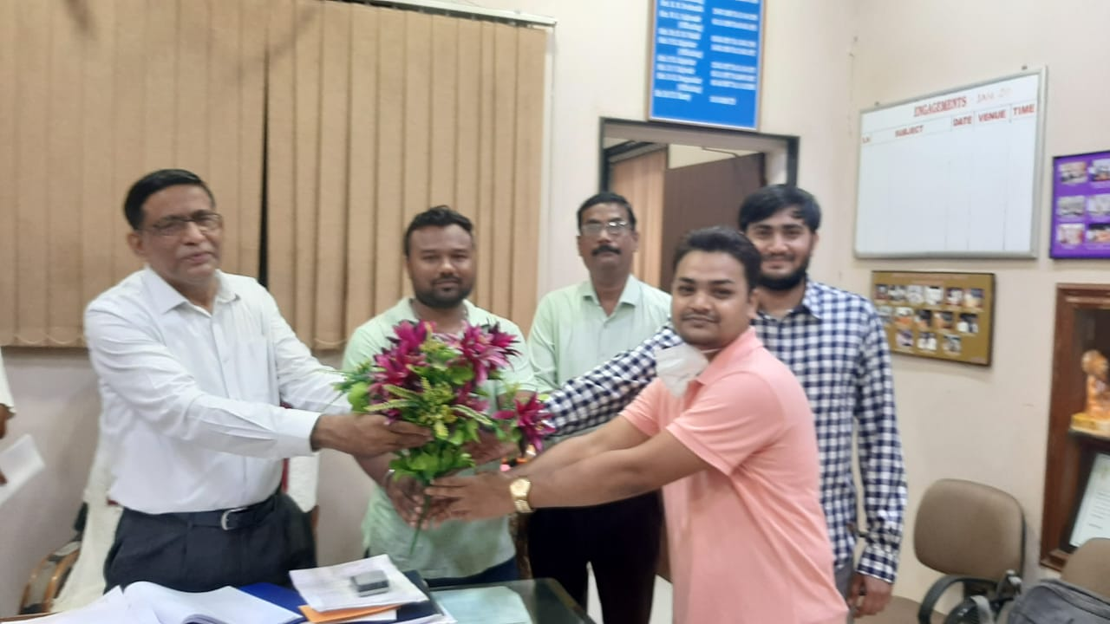

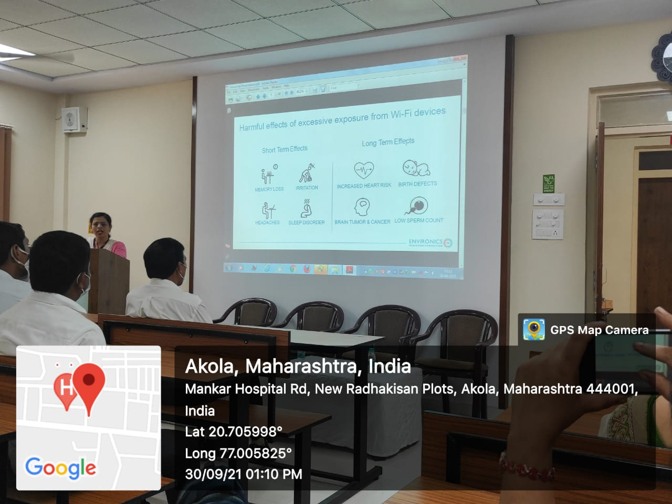
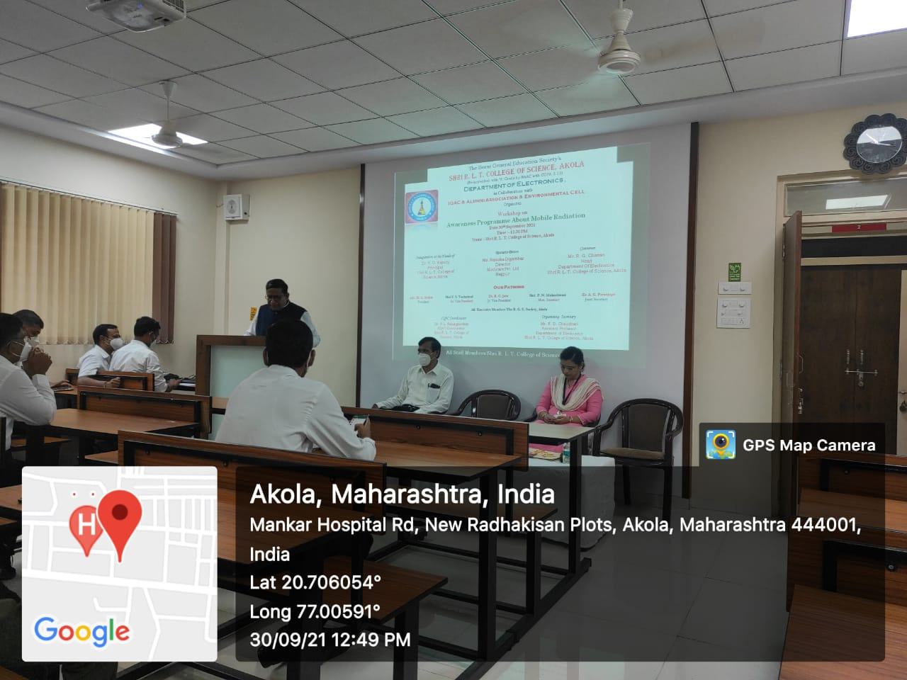
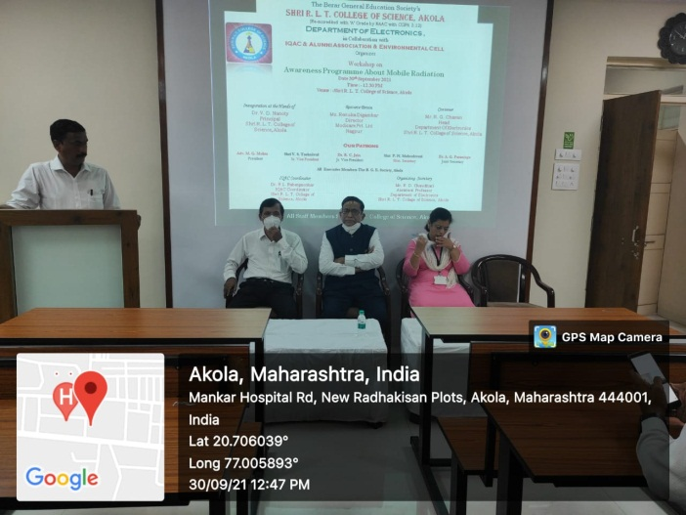
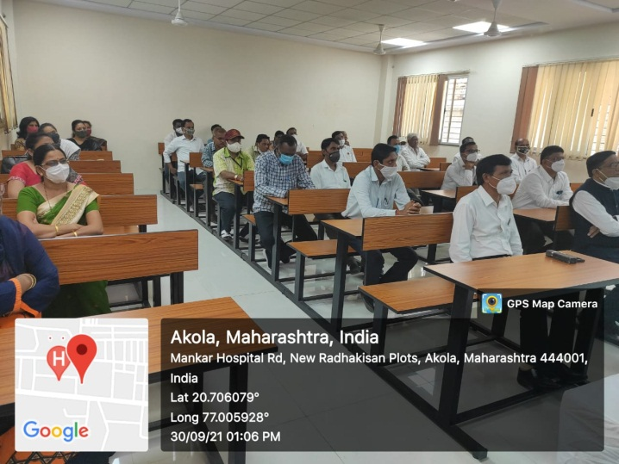

Report Of
Seminar on “Job Opportunities in Industry” Organized by the Crystal Club of Department of Chemistry
In Collaboration with
Career Counselling Cell of Shri R.L.T. College of Science, Akola &
Microns Cell of Department of Microbiology Dated On
Monday, 27th December 2021 Speaker: Shri Prasad Pangarkar (Alumni of our college)
(Assistant Vice-President Reliance Industry Mumbai)

Crystal Club of Department of Chemistry organized Seminar on Job opportunities in Industry for the Post graduation department of Chemistry and microbiology students. Mr. Prasad Pangarkar delivered the lecture on this topic.
A chemical engineer by profession, Mr. Prasad Pangarkar is an alumnus of RLT Akola. MrPangarkar graduated from LIT Nagpur. He completed his post-graduation from UDCT Mumbai and joined the industry. He has nearly two decades of industrial experience which spans in the domains of operations, technology, research, engineering & projects, process automation & business management.
He started his career at Reliance Industries Ltd at the Patalganga Manufacturing Division and has handledvariousprojectsindifferentcapacities.Afteraninitialstintinoperations,hemovedtothe research & technology function. Among the various assignments handled by him, notable were the studies towards packed bed & CSTR reactor modelling, recovery of value added chemicals from residue, and effluent degradation studies of polycarboxylic acid. He later worked in the engineering&projectsdomainandwaspartoferection&commissioningofthenoneofthelargest capacity purified terphthalic acid (PTA) plant. After completing his course from IIM-Bangalore he briefly worked in the capacity as executive assistant to the Technology & R&D head. Later he was associated with the management projects viz the business transformation atReliance
He has represented at various seminars and conferences and has also contributed for a chapter on reactor design in the book ‘Design of Multiphase Reactors’ by Wiley Publications. He is the

recipientofthe‘OutstandingYoungChemicalEngineer’awardwhichwasbestowedbytheIndian Institute of Chemical Engineers. He has also received the National award i.e. the ‘NOCIL award forexcellenceindesignordevelopmentofprocess,plant&equipment’duringtheannualchemical engineering congress – CHEMCON-2011. He has a patent in his name on thesame.
His interests lie in the field of new product development, scale-up and process automation. He is presently working at the Reliance Technology Centre of Excellence as group lead (AssistantVice President) for process design, scale up and process automationprojects.
Dr.V.D.NanotysirwasthePresidentofthisProgramme.DR.PoonamAgrawal,HeadDepartment oftheChemistrywastheorganizingsecretaryofthefunctions.Theprogrammewasgracedbythe presenceofDr.P.P.Deohate,AssociateProfessor,DepartmentofChemistry,Dr.HarishMalpani, HOD department of Microbiology and Dr. Aashish Sarap, Assistant Professor Department of chemistry. The Programme was conducted by Dr. Kavita Heda.
The Programme begins with the floral welcome of the guest.

