Environment Cell Report-2021-22
Celebration of “Krushi Din”1st July 2022
On 1stJuly 2021 “Krushi Divas was celebrated in all over Maharashtra by Tree plantation. Owing to this .'krushi Din' was celebrated by Dept. of Botany & Environmental cell by Tree plantation activity at the hands of Our Principal Dr.V.D. Nanoty Sir., Dr. Chandravanshi Sir,Dr. Nagrale Sir,Mrs. V.N. Badgujar Madam, Co-ordinator of Environment Cell, Dr. A.A Sangole Madam Dr.Munde Sir, All teaching & Non teaching Staff of Botany Dept. Were present.
On this occasion. Dr. Nanoty Sir Focused on the importance of Plantation and significance of the day. Dr. Sarap Sir also took efforts for this Plantation Activity. The event was ended by proposing vote of thanks by Prof.S.V Madavi Sir.

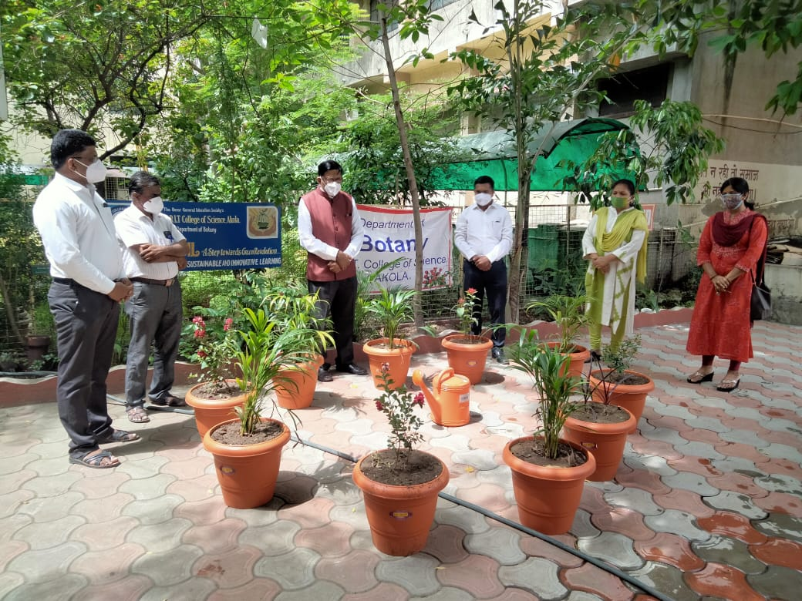

Environment Cell Co - ordinator
Prof. Vaishali N.Badgujar

Tree plantation ( 4Th OCT 2021)
On the occasion of “Drug Designing & Drug discovery” Workshop held on 4th Oct. 2021,”Tree plantation” was done at the hands of Hon. Vice-Chancellor of SGBAU, Dr. Dilip Malkhede Sir in college campus.
In this activity President of B.G.E. Society, Ad. Motisinghji Mohota Sir, Vice president, Shri. P. N. Maheshwari Sir, Principal Dr. V.D. Nanoty Sir, Principal Dr S. G Chapke Sir, Principal Dr . Egoavkar Sir grace the occassion. Environment Cell Co Ordinator Prof. Mrs. V. N. Badgujar, , Dr. A.A. sawarkar DR P.M.Khadse,Dr A.A. Sangole Dr.R.P. Joshi ,Mrs. Gawande ,Shri S. V. Madavi & All the members of Environment cell were present on this occasion.

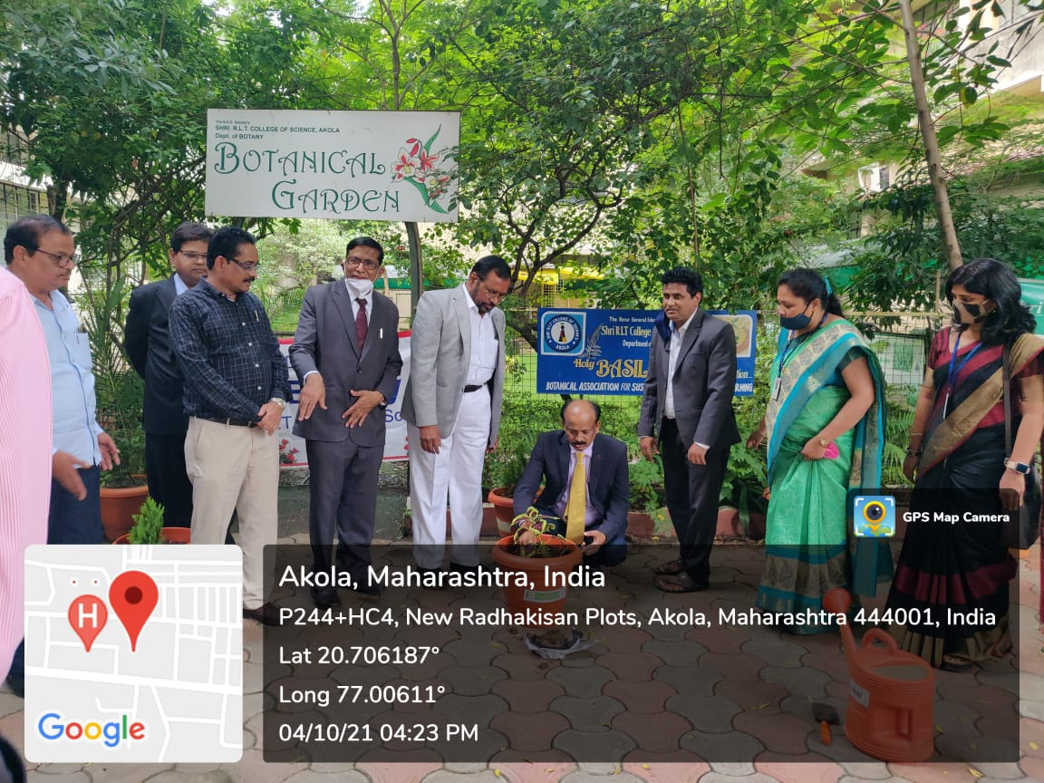
Environment Cell Co – ordinator
Prof. Vaishali N.Badgujar

Celebration of Farmers Day of India
Dt:(23/02/21)
On the occasion of Birth anniversary, of the Prime Minister of India Late.Charanshingh Chaudhary 23.02.2021 , This day is celebrated as the Farmer’s day of India. Owing to this , Our Alumni association, Dept. of Chemistry, Dept. of Botany and Environment cell celebrated the Farmer’s day. On this occasion felicitation of one hardworking farmer was done in presence of our Principal Dr.V.D.Nanoty, Resp. Shri Amar Goud Sir, Dr. P.T.Agrawal Madam , Mrs. Badgujar Madam , Shri. R.D.Chaudhari Sir, Dr.Sarap Sir, Dr. Sangole Madam Dr.Heda Madam, Dr. .Joshi Madam, Dr.khadse Sir , Shri Madavi Sir and All Non teaching Staff was present. All the students of M.Sc Chemistry and Environment cell celebrated the Farmer day.

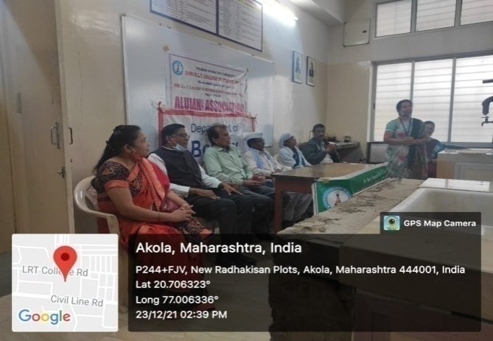
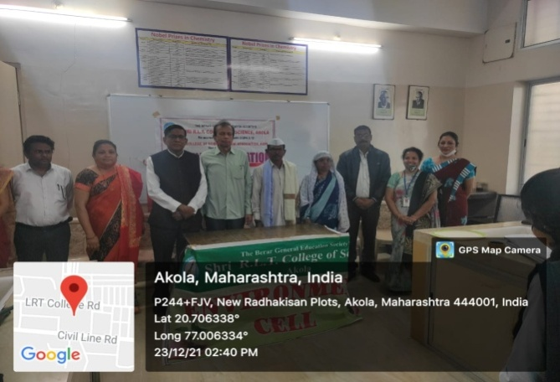

Environment Cell Co – ordinator
Prof. Vaishali N.Badgujar

World Environment Day
5th June 2022

NSS unit of Shri RLT College of Science, Akola under the guidance of Res. Principal
Dr. V. D. Nanoty celebrated World Environment Day on 5/6/2022 and the theme for the year is One “Only One Earth”. The volunteers with Program officer Dr. Rashmi Joshi cleaned the Botanical garden in campus and gardening was done by adding new soil and organic
Fertilizer to the plants. The new vegetable gardening is also started from today in the garden in campus. At the time respected Principal had given information about, How the vegetables can be cultivated and how the basic need of it in the kitchen of girls hostel and in canteen can be fulfilled. They told the volunteers that we can conserve the Mother Earth by doing such small activities. He evoked the students keep going such activities and conserve Earth and Environment Pollution free.

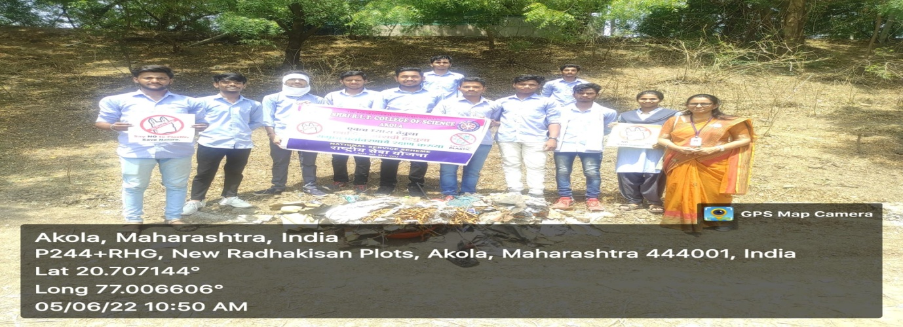
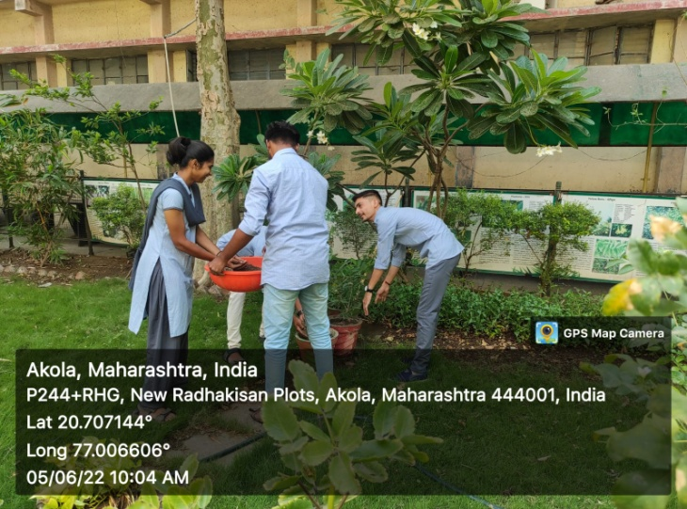

Co- Ordinator Environment Cell
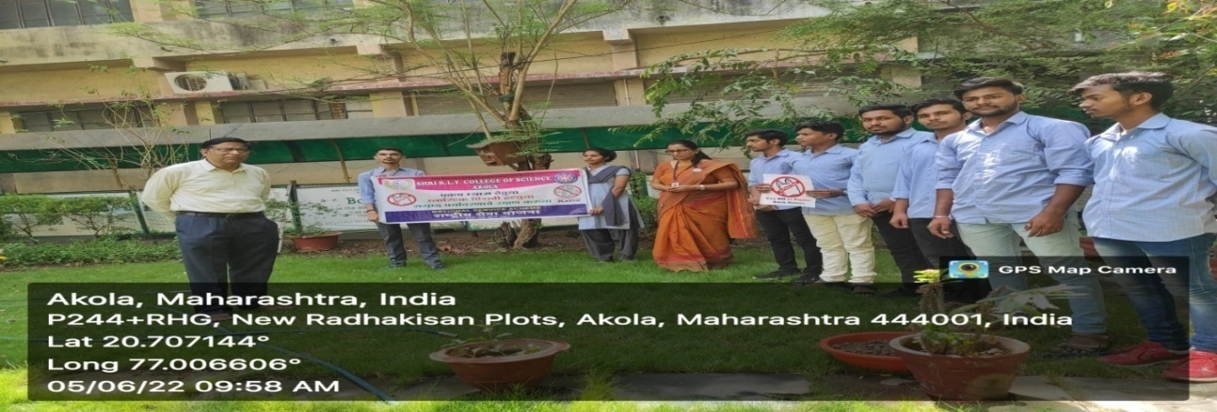
Prof. Mrs. V. N. Badgujar

Awareness Program to save Electricity, Paper & Energy
26-08-2021 Issue Addressed:Environment consciousness
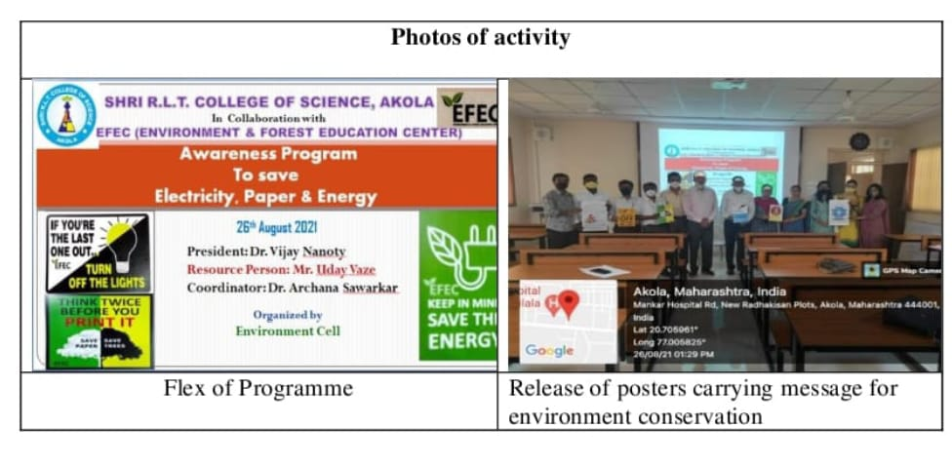
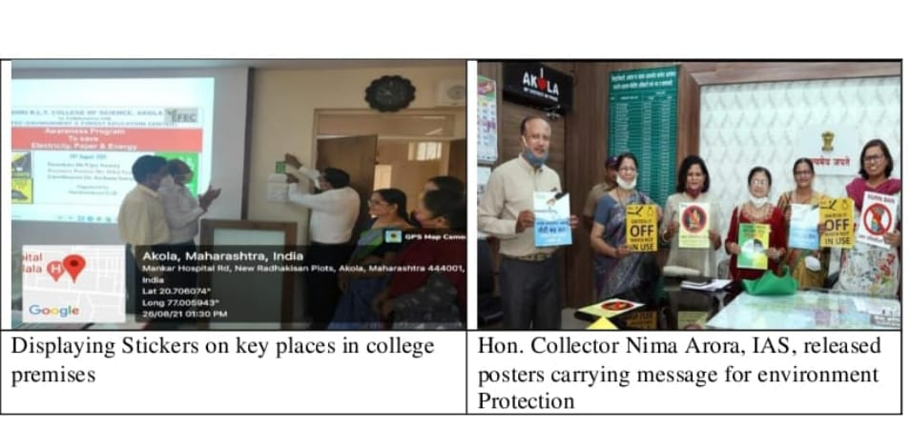
Shri R.L.T. College of Science, Akola and EFEC (Environment and Forest Education Center) jointly organized an awareness program to save electricity, paper and energy on 26th August 2021. Mr. Uday Vaze of EFEC explained that excessive pollution and exploitation of resources is causing immense environmental damage. Hence, EFEC came up with an idea to display posters and stickers that carry the message of protecting the environment at large. Dr. Archana Sawarkar, Coordinator of programme told how to avoid misuse of resources and save environment from pollution. Posters carrying message for environment conservation were released. Stickers displaying the message of protecting environment, saving electricity, papers and energy were posted on key places in college premises. In Presidential address Principal Dr. V. D. Nanoty sir stated that nature is beautiful and needs to be preserved. He appreciated the green initiative of EFEC and environment cell of the college. All members of Environment cell and Criterion VII participated in the event. Members of Environment cell also joined Public awareness program, in which Hon. Collector Nima Arora expressed importance on Public awareness programs and expects that thecitizens will try hard to save environment from pollution and misuse of resources.

Dr. Archana Sawarkar Dr. R.L. Rahatgaonkar Dr. V. D. Nanoty
Activity Co-ordinator IQAC Co-ordinator Principal

Environment Cell Co - ordinator
Prof. Vaishali N.Badgujar
Online Workshop on

E-Waste Management:
Reduce, Repair, Refurbish, Recycle & Reuse

Department of Computer Science, Electronicsand Physics in collaboration with Parent Teacher Association (PTA) organized online Workshop on “E-Waste Management: Reduce, Repair, Refurbish, Recycle & Reuse” on dated 11-08-2021 at 11:00am. Resource persons of this workshop were Dr. Y. S. Tamgadge, (HOD, Physics; Mahatma Fule Mahavidyalaya, Warud) and Mr. R. G. Chavan (HOD, Electronics; Shri R.L.T. College, Akola). It was conducted on online platform through Google Meet and also provided YouTube link: https://youtu.be/vQhiVK6EaZ4
This workshop was organized for making awareness in students and their parents about E-Waste and its Managements. Topic was very ellaboratively explained in English and local language Marathi by both resource persons. Mr. Sanjay Ingle, Authorized e-waste dismantler gave best wishes to this innovative workshop.Mr. Shailesh JaiswalAsst. Professor, Department of Physics gave idea about future Electronic waste collection program of College.
The Principal Dr. V. D. Nanoty, Chairperson and Inaugurator of the program addressed participants. Workshop was conducted by Dr. Archana S. Sawarkar, Associate Professor in Zoology and convener of workshop. Mr. Ram B. Ghayalkar, Asst. Professor, Department of Computer Science, Coordinator of the Workshop proposed Vote of Thanks.More than 300 students and parents get benefited by this workshop.
Recorded YouTube Link:
https://youtu.be/vQhiVK6EaZ4

Registration Link:
https://forms.gle/2TFkhxijtFJiRpvc8

Feedback form link:
https://forms.gle/tmvhmJyY94XrvZ6c8

Some Pictures while session:

 | 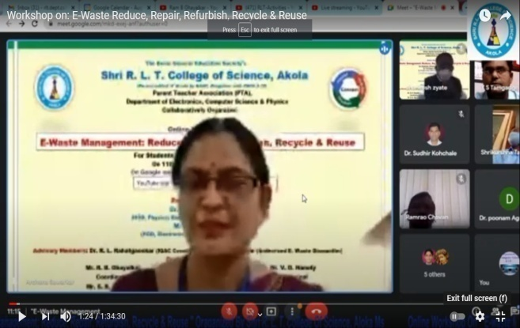
Inaugural speech by  Principal Dr. V. D. Nanoty sir | Conduction of Programme by  Dr. Archana S. Sawarkar
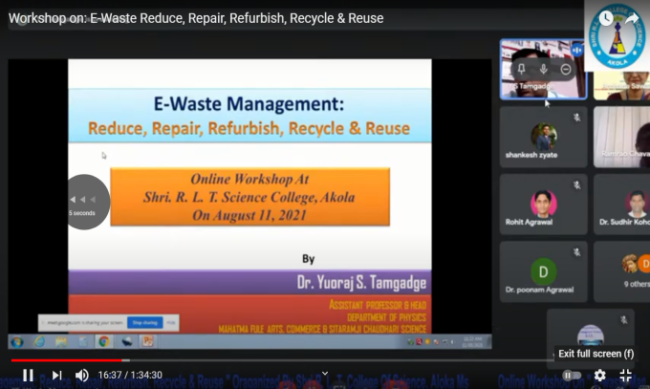 | 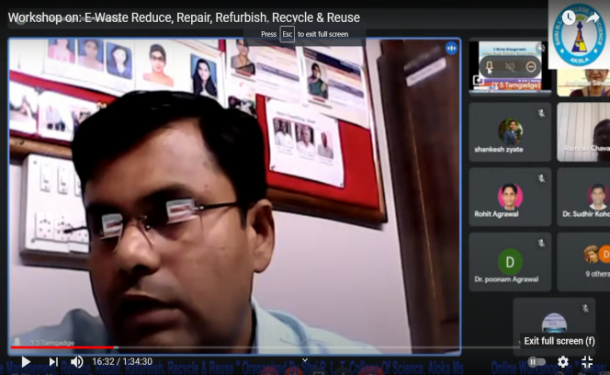
Guidance by Dr. Y. S. Tamgadge on topic
“E-Waste Management: Reduce, Repair, Refurbish, Recycle & Reuse”
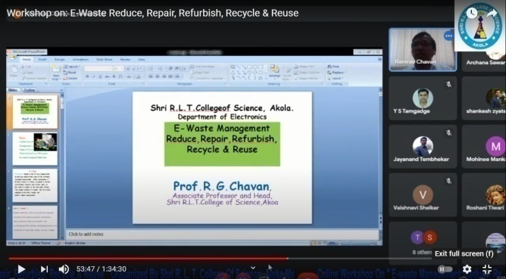 | 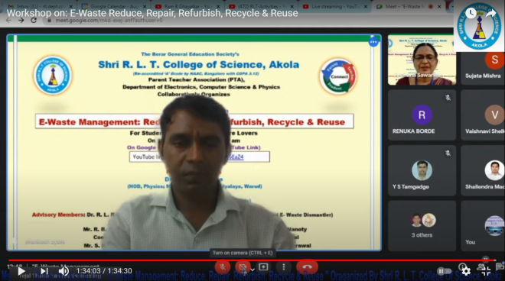
Guidance by Mr. R. G. Chavan  on topic “E-Waste Management” | Vote of Thanks by  Mr. Ram B. Ghayalkar

Dr. Archana S. Sawarkar Mr. Ram B. Ghayalkar Dr. V.D. Nanoty
ConvenerCoordinator Principal

Environment Cell Co - ordinator
Prof. Vaishali N.Badgujar

Bicycle Day for Eco Friendly Environment
( 1/1/2022)
Environment cell in collaboration with NCC,NSS, Observed Bicycle day on 01.01.2022 On this occasionProf. R.G.Chavan, HOD Dept of Electronicsguided students.
SimilarlyCo-ordinator of Environment cell Mrs. V.N.Badgujar guided students about conversation of Mother Earth and steps taken for Ecofriendly Environment.
On this event Dr.Rahatgaoakar,(IQAC Co-ordinator),Dr.A.A.Sawarkar, Dr.P.M.Khadse, Dr.A.A.Sangole, Dr.K.M.Heda, Dr.Rohit Agrawal, Dr.Rashmi Joshi (NSS officer),Prof.S.V. Madavi were present.
All the students of NSS,NCC &Environment cell were present on this occasion.
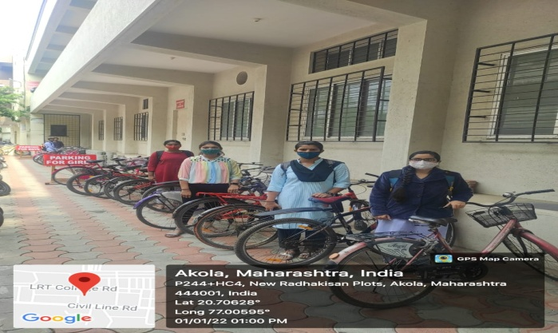
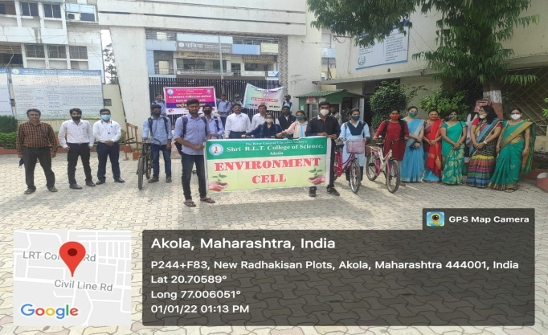
No Vehicle day was celebrated by use of Bicycle to reduce pollution.

Environment CellCo - ordinator
Prof. Vaishali N.Badgujar

75th Independence Day( Azadika Mahotsav)

On the occasion of 75th Independence Day Department of Botany and Environment Cell of the College Organised “Tree plantation” programme. Speciality of this programme was higher quantity of oxygen produced Plants i.e. air pollution and sound pollution reducer plants were planted in the campus in presence of Resp. Principal Dr. V. D. Nanoty Sir and Resp. Dr. U.K. Bhalekar Sir.
Plants like Asparagus, Areca palm, Snake plant, Spider plant, Money plant , Aloe vera, plant, Umbrella plants were planted. All the members of Environmental cell & Botany Department were present in this event.

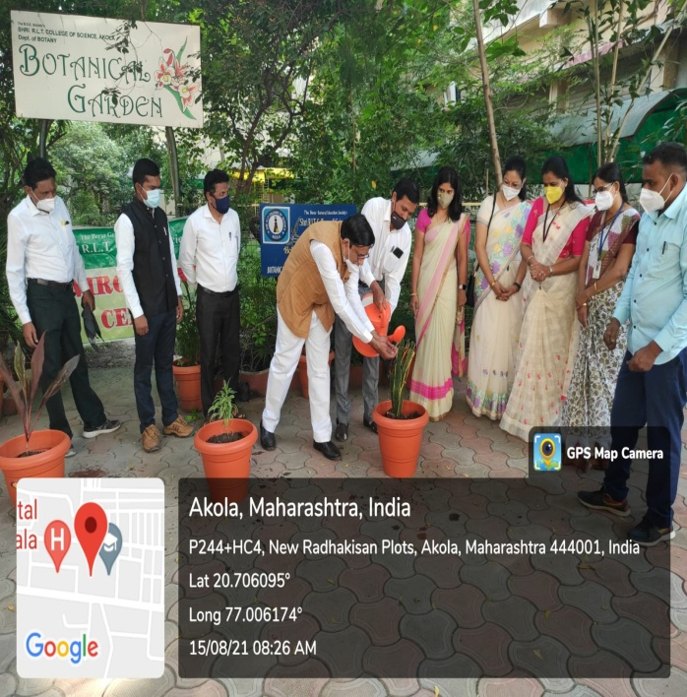
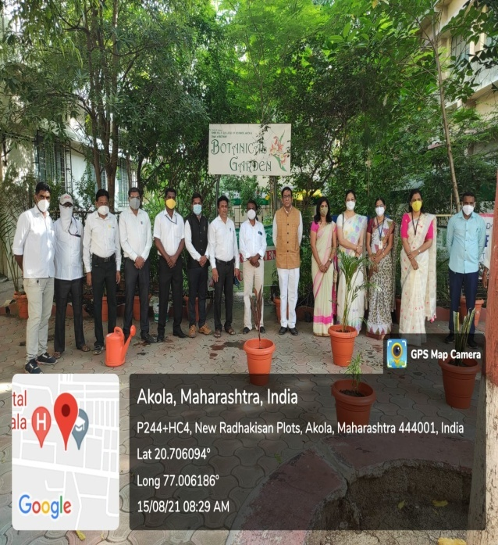

Environment CellCo - ordinator
Prof. Vaishali N.Badgujar

Shri Radhakisan Laxminarayan Toshniwal
Collge of Science, Akola.
Environment Cell
Report -2021-22

- Celebration of “ Krushi Din”1st July 2022
- Tree plantation- 4Th OCT 2021
- Celebration of Farmers Day of India- 23rdFeb2021
- World Environment Day 5th June 2022
- Awareness Program to save Electricity, Paper & Energy
- 26-08-2021 Issue Addressed: Environment consciousness
- Online Workshop on
E-Waste Management:
Reduce, Repair, Refurbish, Recycle & Reuse
- Bicycle Day for Eco Friendly Environment 1st Jan.2022)
- 75th Independence Day – Azadika Mahotsav( 15thAugust 2021)

