BOTANY DEPARTMENT REPORT
2021-2022
Department of Botany always shown its potential by participating & conducting various curricular and co-curricular activities during the academic session.
Departmental activity and student’s achievement
On 1 July 2021 “Krushi Divas” was celebrated by tree plantation activity in gracious presence of Dr.V.D.Nanoty Sir & other staff members.
Plantation on Independence Day
On 75th Independence Day (Azadika Amrit Mahotsav), Dept. of Botany &Environment cell of the college organized Tree plantation of Medicinal plants in the campus in presence of Principal Dr.V.D.Nanoty Sir. All the members of Botany, Environment cell & Non-Teaching staff were present on this event.
On 31.01.2022 Botany Research lab Recognition committee has visited & got the Recognition of Research lab. On this Occasion Dr. U.S.Patil Sir (B.O.S. Chairman, Botany) Dr.Malode Prof. & Head GVISH Amravati, Dr.K.C.More Dept. of Botany, SGBAU Amravati were present.
National Science Day Celebration:-
On the occasion of National Science day 28th Feb 2022 Dept. of Botany organized intercollegiate quiz competition on the Occasion of National Science day, Dr.A.A.Sangole & Shri S.V. Madavi organized of the programme.

Sanctioning of Post. Graduation:-
Department of Botany has got sanctioning for Post Graduation in Botany.
Student’s achivement:-
Our Student Mr Bhushan Viishnu Gondchawar (B. Sc.III year)B5 Batch has secured 4th rank in National Virtual seminar competition held at Shri Shivaji College of arts.comm. & Science, Akola. On the Occassion of World Fungus Day.

The achievement of Staff members are listed below.
1.Mrs.V.N.Badgujar She has worked as Convenor of Intercollegiate Exhibition cum Competition on “pulses for Sustainable Nutrition” on 16.03.2022. She has presented research paper in One Day Multidisciplinary International Conference On 17 May 2022 organized by Late Shankarrao Gutte Gramin Arts & Science College Dharmpuri &published paper in International Journal of Advance and Applied research (IJAAR), ISSN-2347-7075 She has also presented paper in National conference on basics and Advances in Biological sciences organized by Dada Ramchand Bakru Sindhu Mahavidyalaya Nagpur.She has also worked as Jury member in Elocution Competition on Gender equality for & Sustainable Tomorrow on 08 March 2022 Organized by Crystal club, Department of Chemistry Shri R.L.T. College of Science, Akola.

2. Dr.P.M.Khadse
- Dr. P.M. Khadse has Organized Tree plantation activity on the occasion of Independence Day by Dept. of Botany and Environmental cell
- Dr. P.M. Khadse has working as supervisor on MPSC Examination.
- Dr. P.M. Khadse has worked as Co– Convener Organized Intercollegiate Exhibition cum Competition on “Pulses for Sustainable Nutrition” and Guest lecture on Fungal systematic and applied aspects. On date 16/03/2022.
- He has presented & published research paper in International journal of scientific research and Technology ISSN:2395-602Xand Aayushi International interdisciplinary Research Journal with ISSSN:2349-638X.
- He has worked as co-officer on the summer 2022 Examination of S.G.B Amaravati University. Amaravati at Smt. Narsamma Arts, Commerce & Science College, Amaravati
Dr. A.A. Sangole
- She has published One paper in International Journal and Two paper presented in International Conference.
- worked in editorial board of Info Science Magazine.
- Worked as jury member of Virtual seminar competition on the occasion of “World Fungus Day. Organized by Shri Shivaji Science College Akola in collaboration with Shri Shivaji Science College, Amravati & Mycological Society of India.
- Worked as a Coordinator of Intercollegiate Quiz Competition On the Occasion of National Science Day.
- Worked as a Coordinator of “Intercollegiate Exhibition cum competition on Pulses for sustainable nutrition”.
4- Mr. Shailendra V. Madavi
- He has participated in training programmed on mainstreaming of DRR in education sector event Organized by Yashwantrao Chavan Academy of Development Administration (YASHADA) Pune. At Prabodhini Amravati at 11/10/2021 to13/10/2021.
- He has worked as Organizer of Inter Collegiate Quiz Competition on the occasion of National Science Day (Online) Organized by Department of Botany Shri R. L. T. College of Science, Akola28/02/2022.
- He was Guest Speaker in Workshop on Disaster Management
Organized by Department of Lifelong Learning and Extension, SGB Amravati University, Amravati. 02/03/2022 to 05/03/2022
- He has Worked as Organizing Secretary of Inter collegiate Exhibition cum Competition on “Pulses for Sustainable Nutrition” Organized by Department of Botany Shri R. L. T. College of Science, Akola16/03/2022
- He has Delivered a Lecture on Disaster Management in NNS Camp Organized by NSS Unit Shri R. L. T. College of Science, Akola23/03/2022
- He has Worked as Resource Person in One Day Workshop on Disaster Management Organized by Shri Shivaji Arts, Commerce and Science College, Akot, Dist. Akola 30/03/2022
- He has Participated and Presented Poster in Two days National Conference on Basic and Advances in Biological Sciences Organized by Dada Ramchand Bakhru Sindhu Mahavidyalaya, Nagpur 08/04/2022 to 09/04/2022
- He has delivered a Lecture on Disaster Management in NSS Camp Organized by Shri Dnyaneshwar Maskuji Burungule Science and Arts College, Shegaon 03/04/2022
- He has Delivered a Lecture on Disaster Management Organized by Navoday Vidhyalaya, Washim 04/04/2022
- He has Participated in Water Rescue training program by State Disaster Response Force (SDRF) Organized by District Disaster Management Authority, District Collector Office, Akola 10/05/2022
Besides this, Our faculty member working as CHB Mr. Charansingh Mounas has qualify CSIR-UGC NET Exam on 24.03.2022 similarly Miss Pratiksha D. Salunke has qualify GATE-22 Examination.

(Holy -basil Activity)
Inter Collegiate Quiz Competition Report 28th February 2022

The Berar General Education Society's Shri R.L.T. College of Science, Akola, Department of Botany organized Inter Collegiate Quiz Competition on 28th February 2022 on the occasion of National Science Day. Total 151 participants from various colleges of Akola District and SGB Amravati University participated in this competition. This competition was organized for UG and PG students. Student was provided with 25 questions and they had to solve all of them. Minimum passing criteria was 40% and those students who have got passing percentage were provided with E-certificates. This entire program was organized under the guidance of Principal Dr. V. D. Nanoty and under observation of Mrs. V. N. Badgujar, HOD Botany. Dr. A. A. Sangole and Mr. S. V. Madavi worked as organizers of this program and Dr. P. M. Khadse and Mr. C. J. Maunas worked as member of organizing committee. All teaching and non-teaching staff and students of Botany department helped for the success of this programme.

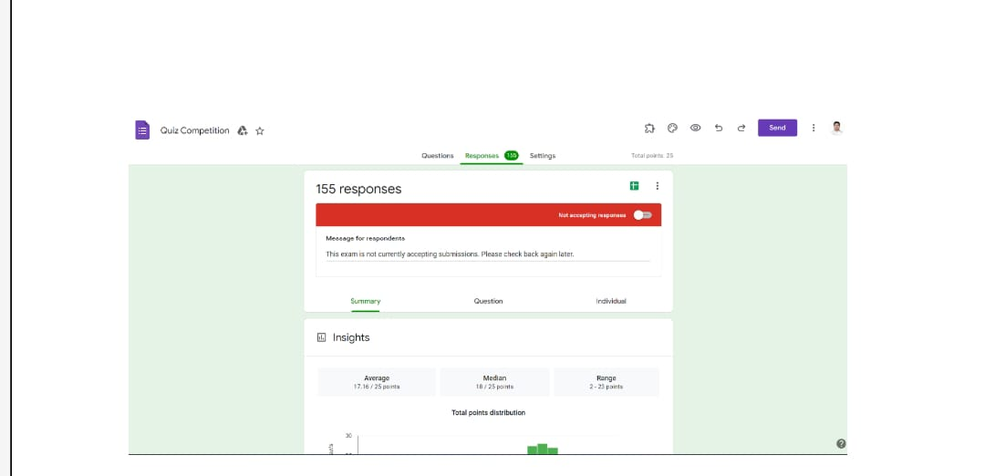
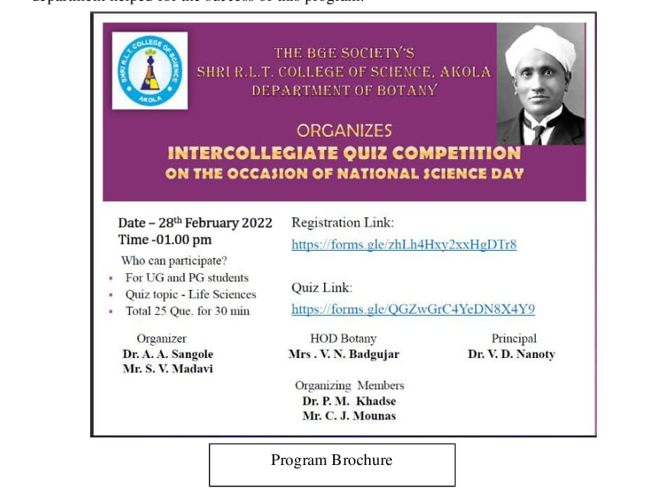

Organizer Organizer HOD Botany Principal
Mr. S. V. Madavi Dr. A. A. Sangole Mrs. V. N. Badgujar Dr. V.D. Nanoty

Botany P.G. Activity Report
(Botanical Society Activity)

* Guest Lecture by Dr S. L. Hate Sir:
ON 14thDepartment of Botany, Zoology &Competitive Examination Cell in collaboration has conducted a Guest Lecture on “Carrier opportunities in Biological Sciences” for the students in Botany Dept. on 14th March 2022. The main objective of this lecture is to developed scientific temperament about the scope in Biological Sciences. In these Dr. S.L.Hate, Sindhu Mahavidyalaya , Nagpur has guided the students about the preparation of NET,SET, GATE, examination. Prof. Dr. Deepak Koche, Shivaji College was Chief Guest of the Programme. Prof.V.N Badgujar, Dr. S. M. Nagrale, Dr. P. M. Khadse, Dr. A. A. Sangole, Dr. A.S. Sawarkar, Prof. S. V. Madavi were present. . In these about 53 students have been benefited from these lectures. The committee members and students took pains to make the function grand success.
* Formation of Botanical Society
PG Department of Botany in collaboration with IQAC organized Inauguration of Botanical society 2021-22. On 16/03/22.On this occasion PG Department organises two another activities that is guest lecture (Offline) on the Topic- “Fungal systematic and applied aspects” and second activity was “Intercollegiate Exhibition cum competition on Pulses for sustainable nutrition”.
During inauguration of Botanical society ceremony, dignitaries on the dias Honourable Principal Dr.V.D. Nanoty as chairman of the programme Honourable Dr. Dilip Hande as a chief guest of the programme . Head Deptt. of Botany Mrs. V.N. Badgujar (Convener), Incharge of PG (Botany) Dr. P. M. Khadse ( Co- convener ), Dr. A. A. Sangole (Co-Ordinator) , Mr. S.V. Madavi (Organizing Secretary) and all HOD’s of various department of college were present.
During welcome ceremony the Chief guest of programme Hon. Dilip Hande Sir was felicited by offering shall and sapling by the hands of Hon. Principal Dr. V.D. Nanoty Sir, welcome of principal Dr. V.D. Nanoty Sir by offering sapling was done by the hands of HOD Botany Mrs. V.N. Badgujar, All the HOD’s& staff members of Botany were welcome by offering sapling and flowers.Dr. P. M. Khadse and A.A. Sangole were felicited by offering shawl and sapling by the hands of Honourable guest on Dias for recognition as Ph.D supervisor by SGBAU Amravati.Dr. P.M. Khadse announces the name of members in Botanical society during the inauguration of Botanical society 2021-22.Conduction of programme was done by Miss. Priya Khobare and Miss. Vaishnavi Gaikwad. & Vote of thanks was proposed by Mr. Bilal Khan. During second activity Dr. Dilip Hande delivered his lecture on the topic “Fungal Systematic and Applied Aspects.” Dr. Hande sir elaborate fungi from its basic aspect to applied aspect like morphology, variety of fungi uses in various fields, their infection from lower plants to higher plants including humans, their nutrition values as food.
The third activity was Intercollegiate” Exhibition Cum Completion on Pulses for Sustainable Nutrition.” All the students of Msc. were participated in the exhibition cum competition , various types of species and categories of pulses were display by students in the exhibition explain their importance and nutritional values in the diet. Today’s chief guest Dr. Dilip Hande sir worked as examiner and the prizes were given to the winners.

SHRI R. L. T. COLLEGE OF SCIENCE, AKOLA
P.G. Dept. Botany 2021-22
Name of the Activity | - Inauguration of Botanical society 2021-22  - Guest lecture (Offline) on the Topic- “Fungal systematic and applied aspects”  - “Intercollegiate Exhibition cum competition on Pulses for sustainable nutrition”.
Date | Venue | Department/ Committee | Organizing commiittee
16/03/22 | Botany laboratory  & Digital Room | Botany | Mrs. V.N. Badgujar Convenor & Head  Dr. P. M. Khadse Co-Convenor & PG In-charge  Dr. A. A. Sangole Coordinator, Mr. S. V. Madavi Organizing Secretory
Time | 2-5.00 pm | Number of Participants | Nature Indoor/Outdoor
 |  | 40 | Indoor
Support/ Assistance | -

BRIEF INFORMATION ABOUT THE ACTIVITY (CRITERION NO. ……..)
TOPIC/ SUBJECT OF THE ACTIVITY | - “Intercollegiate Exhibition cum competition on Pulses for sustainable nutrition”.
OBJECTIVES | PG Department of Botany in collaboration with IQAC organized inauguration of Botanical Society 2021-22. On dated 16/03/22 on this occasion PG Dep.t organises two another activities that is guest lecture (Offline) on the Topic- “Fungal systematic and applied aspects” and second activity was “Intercollegiate Exhibition cum competition on Pulses for sustainable nutrition”.
METHODOLOGY | During inauguration of Botanical society ceremony, dignitaries on the dias Hon. Principal Dr.V.D. Nanoty as Chairman of the Programme Hon Dr. Dilip Hande as a chief guest of the programme . Convenor & Head dept. of Botany Mrs. V.N. Badgujar, Dr. P. M. Khadse Co-Convenor & PG In-charge , Dr. A. A. Sangole Co-ordinator & Mr. S. V. Madavi Organizing Secretory and all HOD’s of various Dept. of college were present.  During welcome ceremony the chief guest of programme Hon. Dilip Hande felicited by hands of offering shall and sapling by the hands of Hon.. Principal Dr. V.D. Nanoty Sir, welcome of principal Dr. V.D. Nanoty Sir by offering sapling by the hands of HOD Botany Mrs. V.N. Badgujar, all the HOD’s were ..welcome by offering sapling and flowers.  Dr. P. M. Khadse and Dr.A.A. Sangole were felicited by offering shawl and sapling by the hands of Hon. guest on Dias for recogntion as Ph.D supervisor by SGBAU Amravati. Dr. P.M. Khadse announces the name of members in Botanical society during the inauguration of Botanical Society 2021-22.  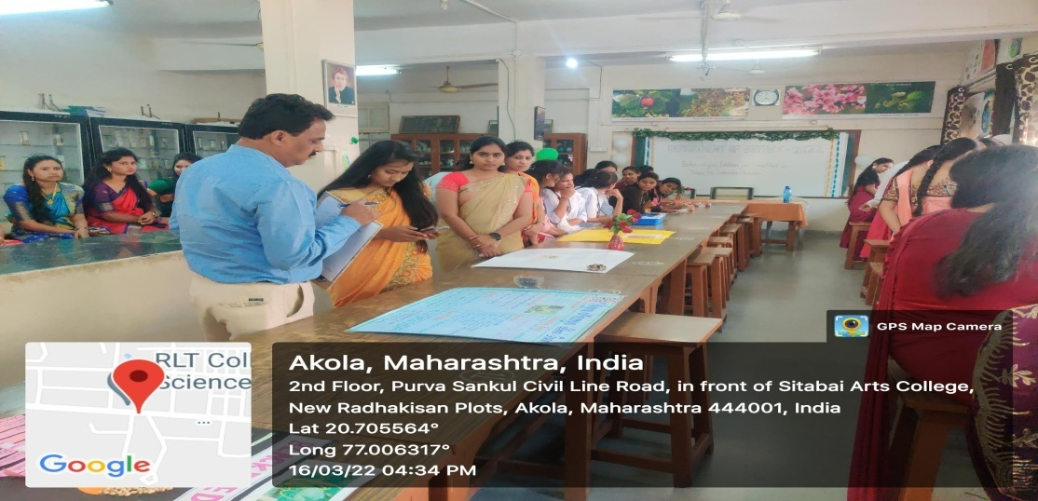  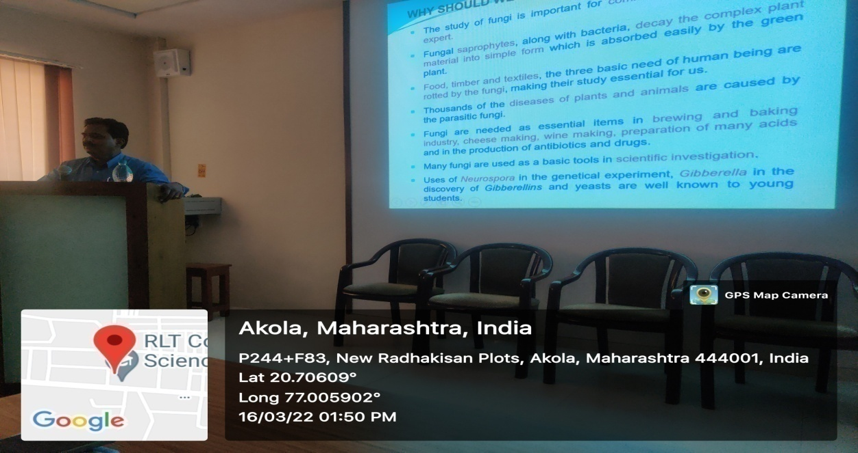  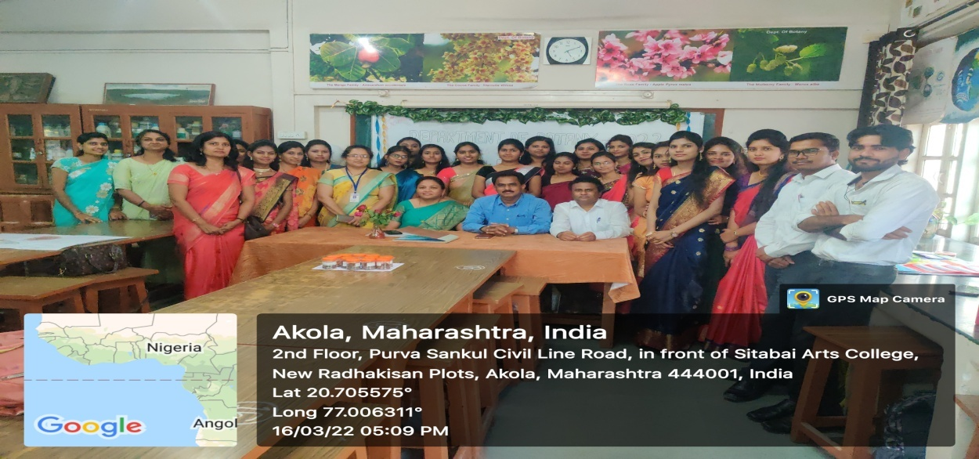
OUTCOMES | At the end of programme vote of thanks proposed by Mr. Bilal Khan and conduction of programme by Miss. Priya Khobare and Miss. Vaishnavi Gaikwad.  During second activity Dr. Dilip Hande delivered his lecture on the topic “ Fungal Systematic and Applied Aspects.” Dr. Hande sir elaborate fungi from its basic aspect to applied aspect as like Morphologically their various types , different types uses in various fields, their infection from lower plants to higher plants including humans, their nutrition values as consumed as food .  The third activity was Intercollegiate” Exhibition Cum Completion On Pulses For Sustainable Nutrition .” All the students of M.Sc.I were participated in the exhibition cum competition , various types of species and categories of pulses were display by students in the exhibition explain their importance and nutritional values in the diet. Today’s chief guest Dr. Dilip Hande sir worked as examiner and selected as best three winners from the competition and with two consolation prizes.  We are very much thankful to Organising Committee members Committee Members Mr. C. J Mounas Ms. D. G. Raipure Ms. P. D. Salunke And all staff members and students of P.G. Department of Botany, Shri. R. L. T. College of Science, Akola. I am also thankful to other teaching and non teaching staff for their Co-operation for the successful organization of this event  The winners are as follows.  I ^{St} – Prize:-  - Miss. Ruchita G. Bawaskar - Shri RLT College of Science, Akola  2nd - Prize :-  - Miss. Priya C. Khobare - Shri RLT College of Science, Akola  3rd – Prize:-  - Miss. Komal D. Shrivastao Shri Shivaji Colllege of Science, Akola  Consolation Prizes:-  - Mr. Bilal A. Khan - Shri RLT College of Science, Akola  - Miss. Renuka Thorat - Shri Shivaji Colllege of Science, Akola

- Celebration of ‘World Earth Day’’
Dept. of Life Science in collaboration with IQAC of Shri R.L.T. College of Science, Akola celebrated “world Earth day” on22nd April 2022 in Dept. of Microbiology. Poster presentation and Elocution competitions were held for PG students. All the teaching staff of the Biochemistry, Botany, Microbiology & Zoology were present for the event.
Department of Life Sciences (Biochemistry, Botany, Microbiology & Zoology) in collaboration with IQAC of Shri.R.L.T College of Science, Akola celebrated "World Earth Day" on 22nd April, 2022, in the Dept. of Microbiology. The event was chaired by Dr.V.D. Nanoty (Principal, Shri.R.L.T College of Science, Akola), Dr. R.L. Rahatgaonkar (IQAC Co-ordinator), Dr.S.M.Nagrale (Head, Dept. of Zoology), Mrs.V.N.Badgujar (Head,Dept.ofBotany), Dr.H.S.Malpani(Head, Dept.of Microbiology & Biochemistry), and Dr. A.S. Sawarkar (Dept. of Zoology) shared their views concerns about Earth conservation during the event.
The PG students talked about the problems that we are creating for our Benefit on Earth and the solutions that we can opt for its Conservation. Poster presentation and Elocution competitions were held for PG students. Dr. Kohchale, Prof. Madavi,. Dr A.A. Sangole, Dr.R.P.Joshi, Ms. S.N. Gawande and all the teaching staff of the Departments of Biochemistry, Botany, Microbiology, & Zoology were present at the event.

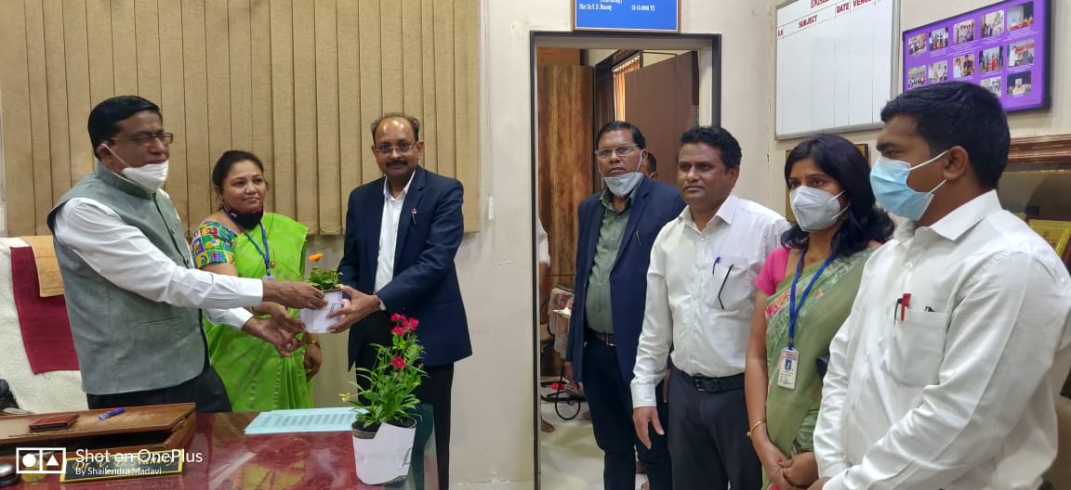
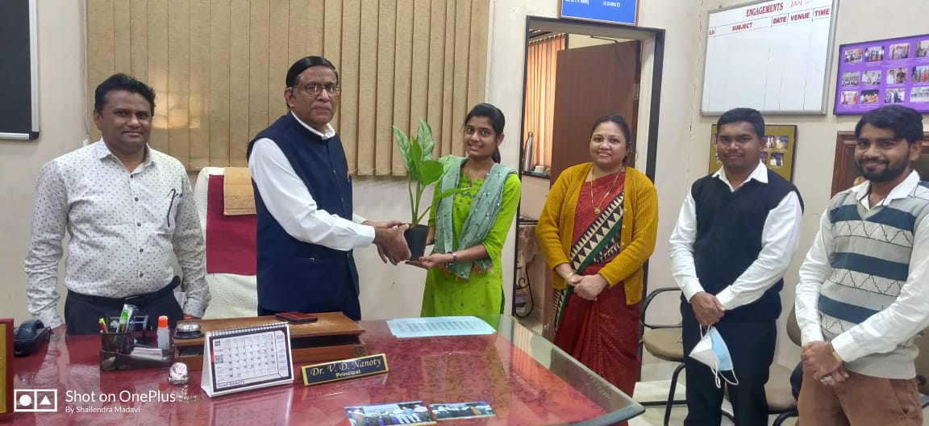
Visit of BOS Chairmanof Botany Dr. U S. Patil Sir, Dr.Malode Sir &Dr More Sir For Research Lab recognition of Botany.

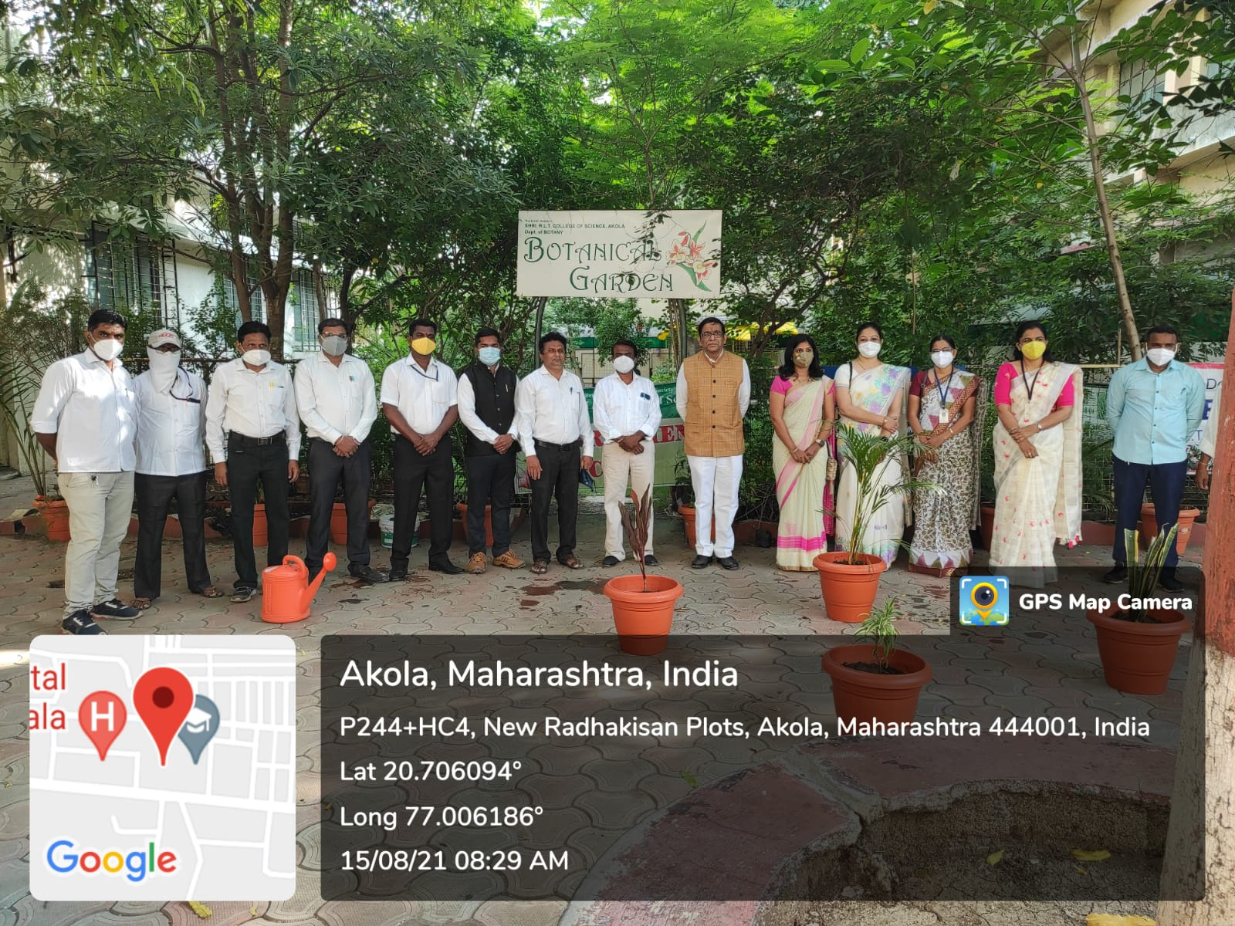
Felicitation of CHB Teacher Ku.Pratiksha madam by Principal Dr. V. D. Nanoty sir.

Tree plantation Activity on 75th Independence Day
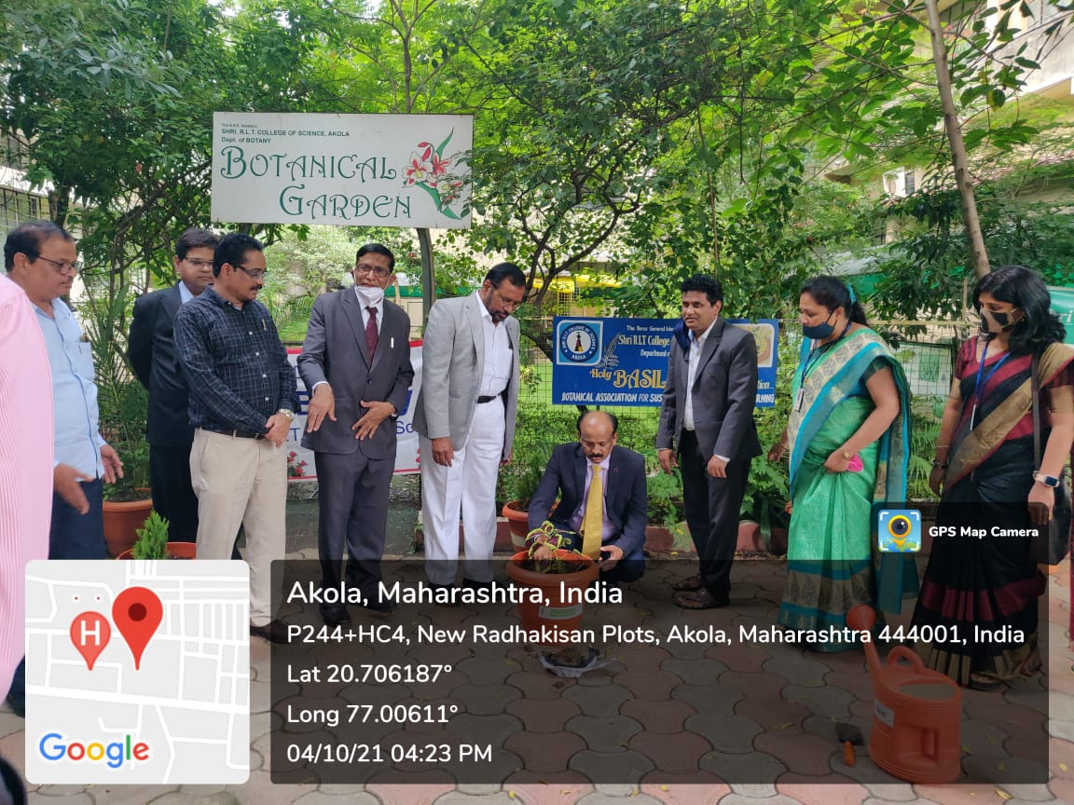

Tree Plantation at the hands of Hon. Vice Chancellor SGBAU, Amravati Dr. Dilip Malkhede Sir.

Mr.Bhushan V. Gondchawar secured 4th Rank in National seminar.

Mr.Bhushan V. Gondchawar secured 4th Rank in National seminar.

Go Green.................
HOD
Mrs. V. N. Badgujar
Department Of Botany

