Shri R. L. T. College of Science, Akola

ALUMNI Committee REPORT
2018-19

Committee members

Prof. R. D. Chaudhari Chairman
Prof. R. G. Chavan Alumni Sr. Member
Dr. P. T. Agrawal Member
Prof. R. B. Ghayalkar Member

Contents
Sr. No. | Activities
1 | One Day Workshop on Self Employment : Manufacturing of Fragrance Stick dated 12 Aug 2018.
2 | Inauguration of Digital Classroom 4 Sept 2018
3 | Alumna of Our Hon. Dr. Ranjit Patil Minister of Home Affairs arranged Mega Job fair 4 october2018 and Job Fair on 05 Jan 2019 for our college students
4 | Guest lecturer on Stress management 21-10-2018
5 | Blood donation camp and alumni day 24 Dec2018
6 | Guest lecturer by department of microbiology on 26 Dec2019
7 | Workshop 24 January 2019  Bio informatics department conducts one day workshop
8 | University Level Seminar of Mathematics PG Department on 12 March 2019
9 | Anshu Jagmohan

Chairman Principal

Alumni
Report 2018-19
- One Day Workshop on Self Employment : Manufacturing of Fragrance Stick dated 12 Aug 2018

CRYSTAL Club Department of Chemistry organizes one day workshop on manufacturing of fragrance stick to make the students self employed and to develop a practical skill among the students. Mr. Abhijit Chalse Alumni of our department give the demonstration on How to make the fragrance stick and which chemicals were used to make various types of fragrance. Apart from this the second part of workshop includes the environmental friendly fragrance preparation by using the temple waste known as ‘Nirmalya’. This is the best part of workshop . Student themselves prepared the stick by suing the Nirmalya & sold this sticks to the Teaching and Non – Teaching staff members of the college and money collected from this activity was donated for Kerla Flood.
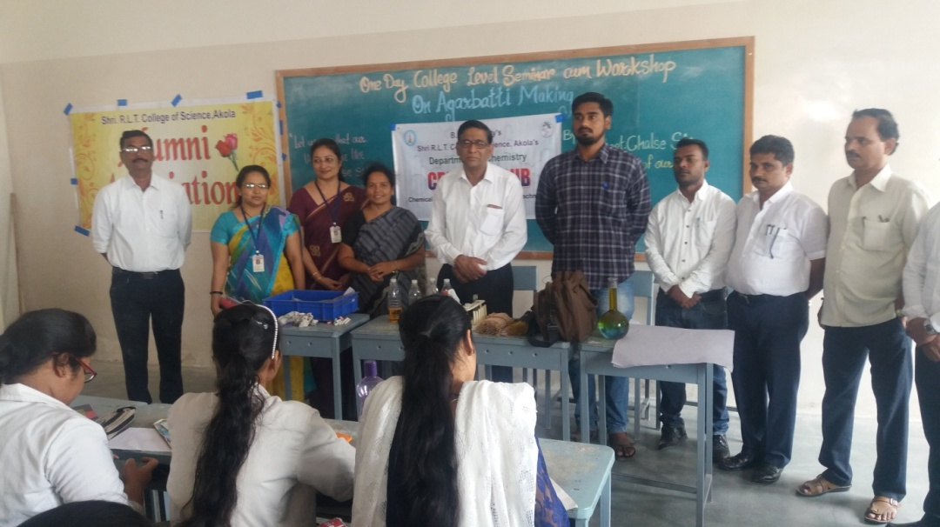

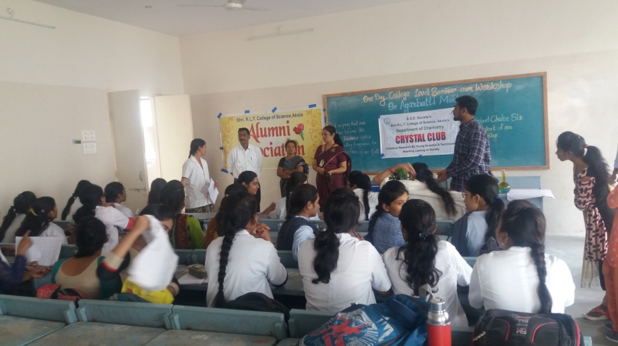

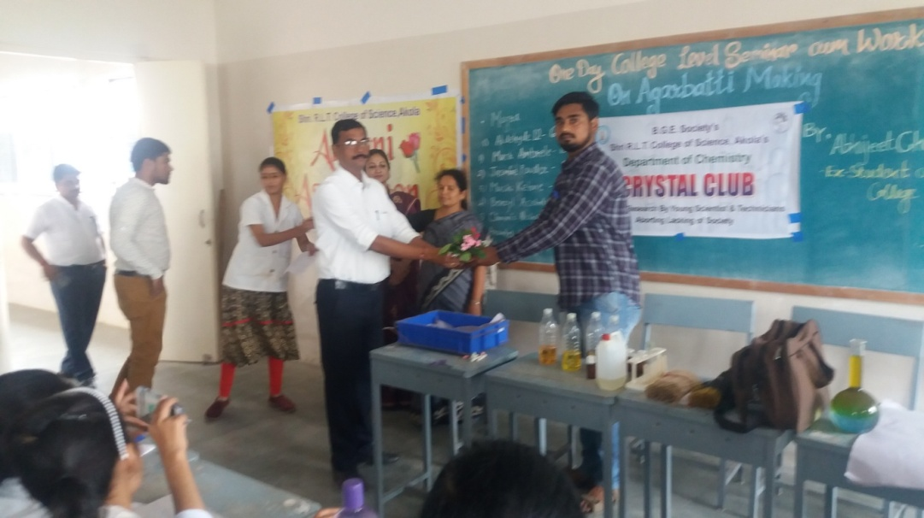

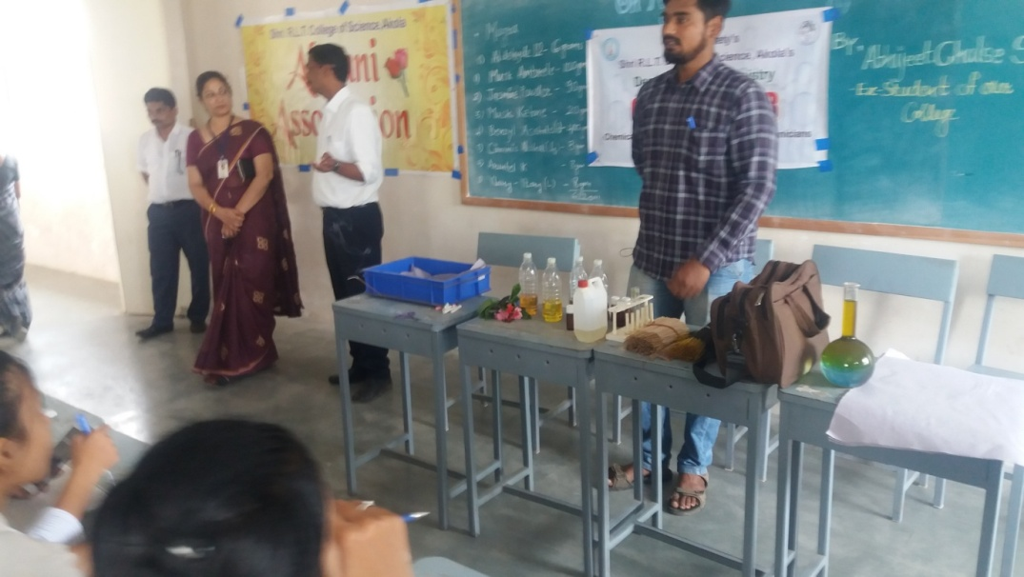

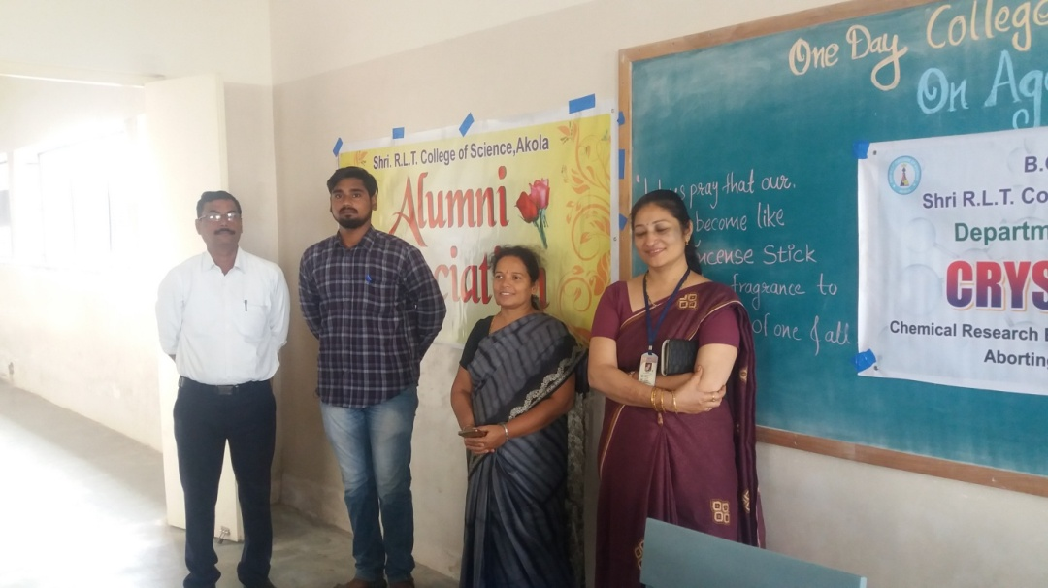

- Inauguration of Digital Classroom
AlUMNA of Our Hon.Dr.Ranjit Patil Minister of Home Affairs inaugurated our 3 Digital Classroom (4 Sept 2018)
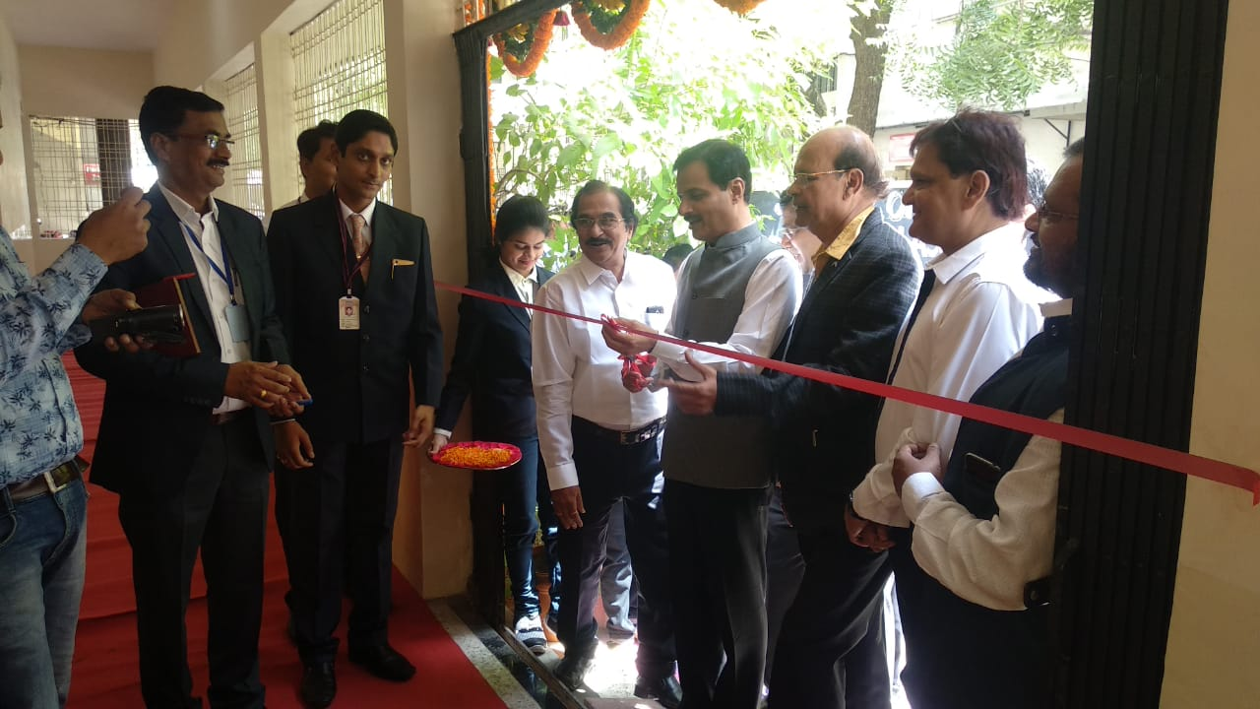
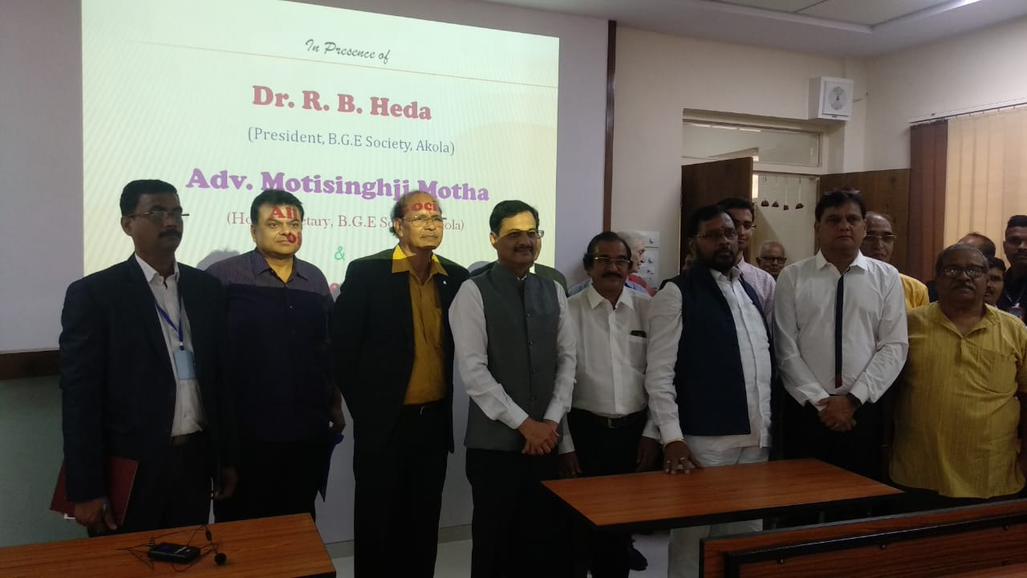
- . Alumna of Our Hon. Dr. Ranjit Patil , Minister of Home Affairs arranged Mega Job fair 4 October 2018 and Job Fair on 05 Jan 2019 for our college students

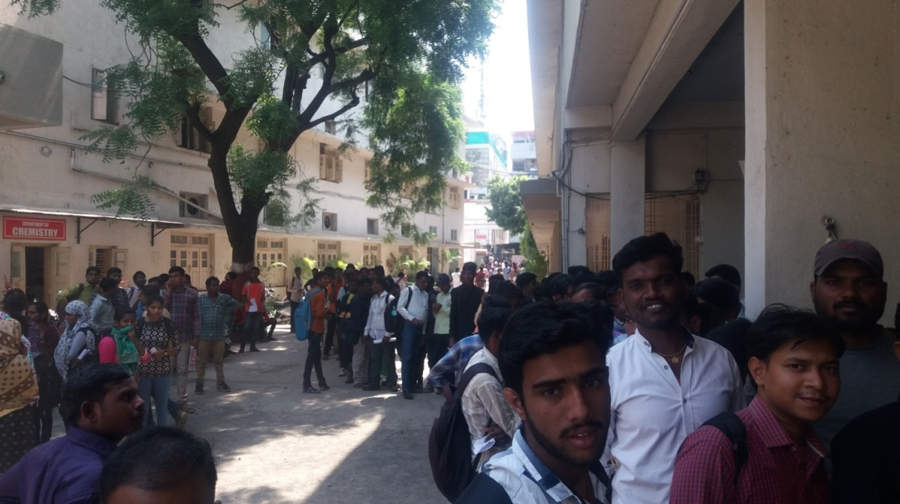

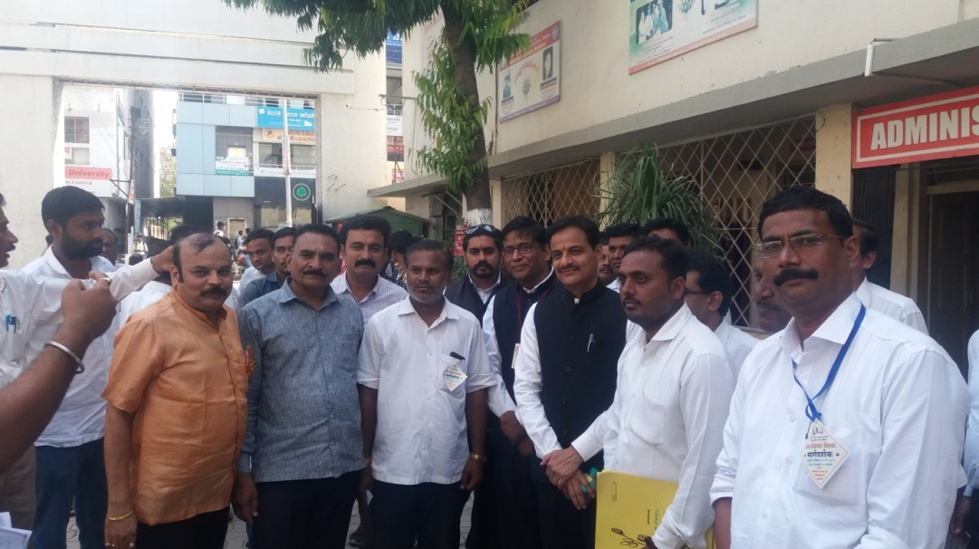
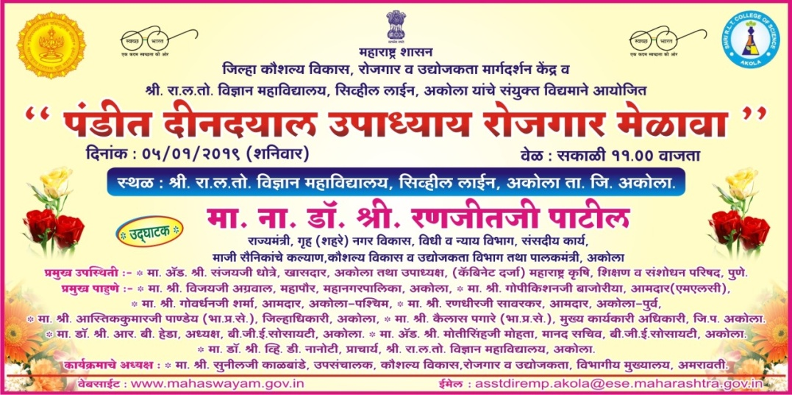
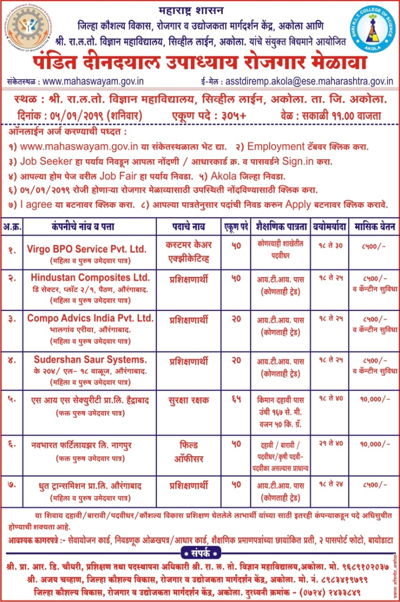
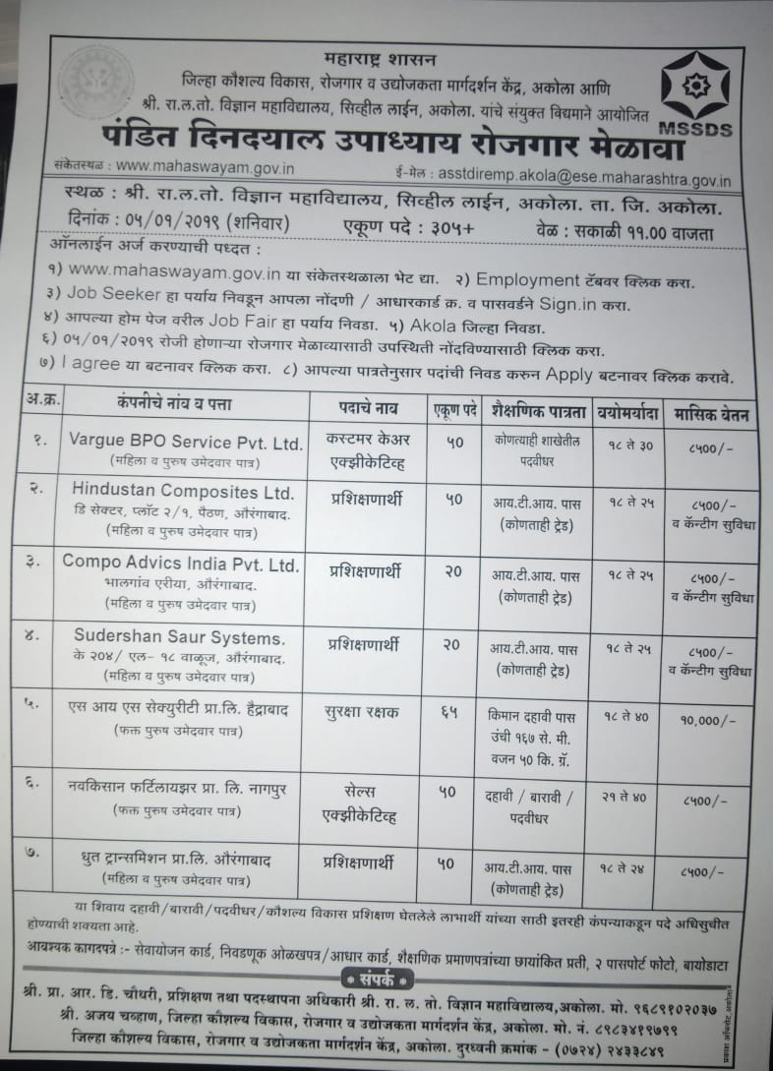

- On behalf of memory Our college alumna late Nikunj Kothari’s father Dr.Kothari arranged the lecture on young and stress management by Dr.Sudhir Bhave M.D.Psychatric from Nagpur has given the valuble speech on stress management.

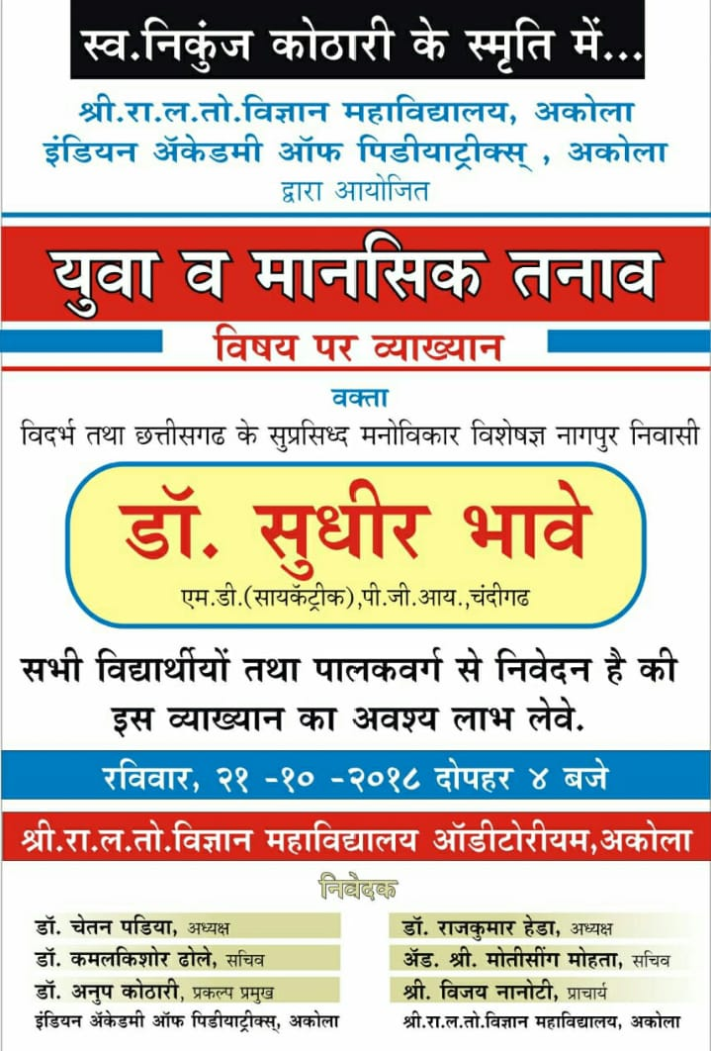

- Blood donation camp and alumni day 24 Dec 2018
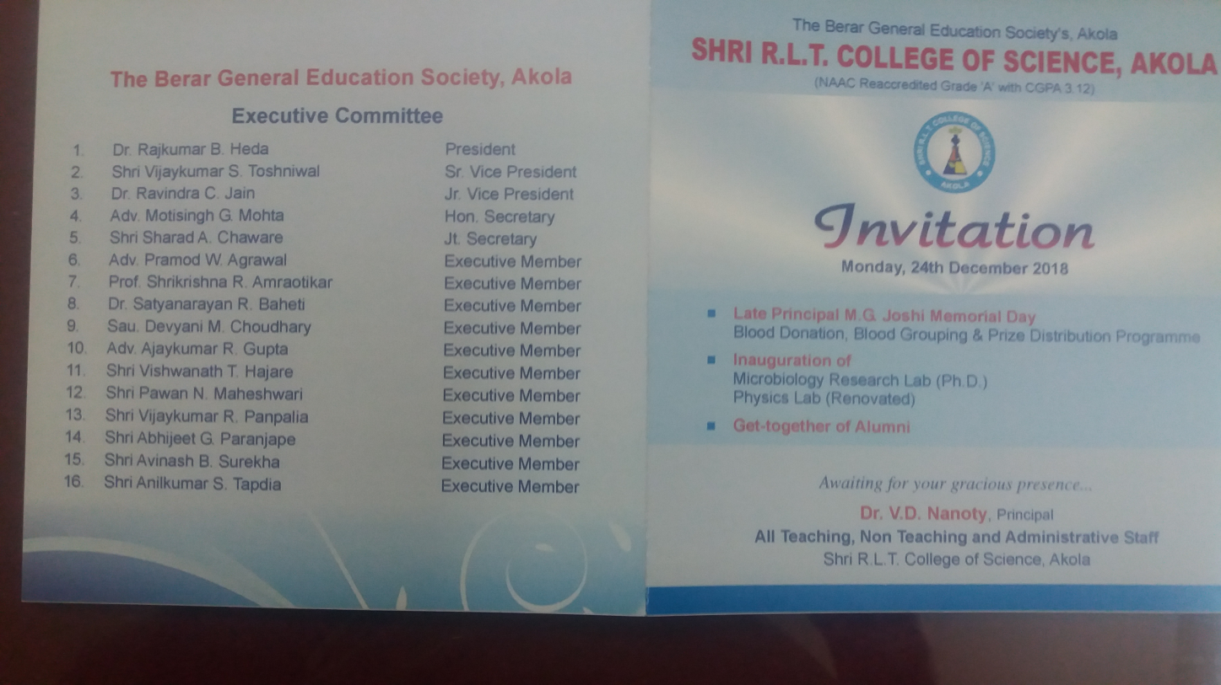
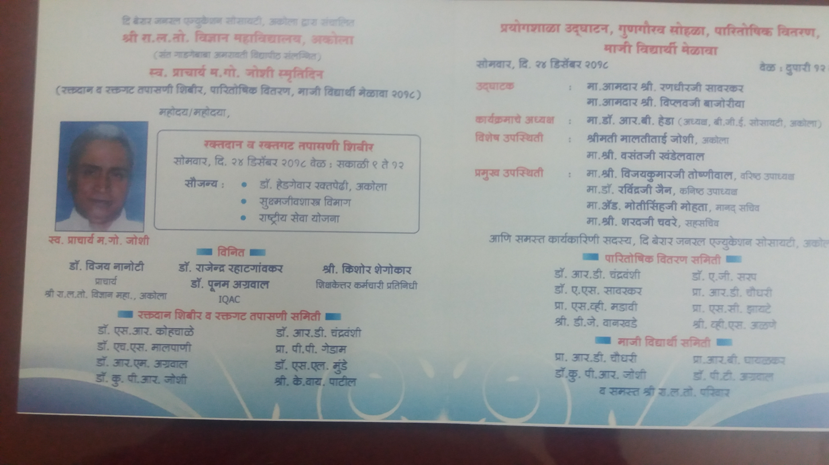

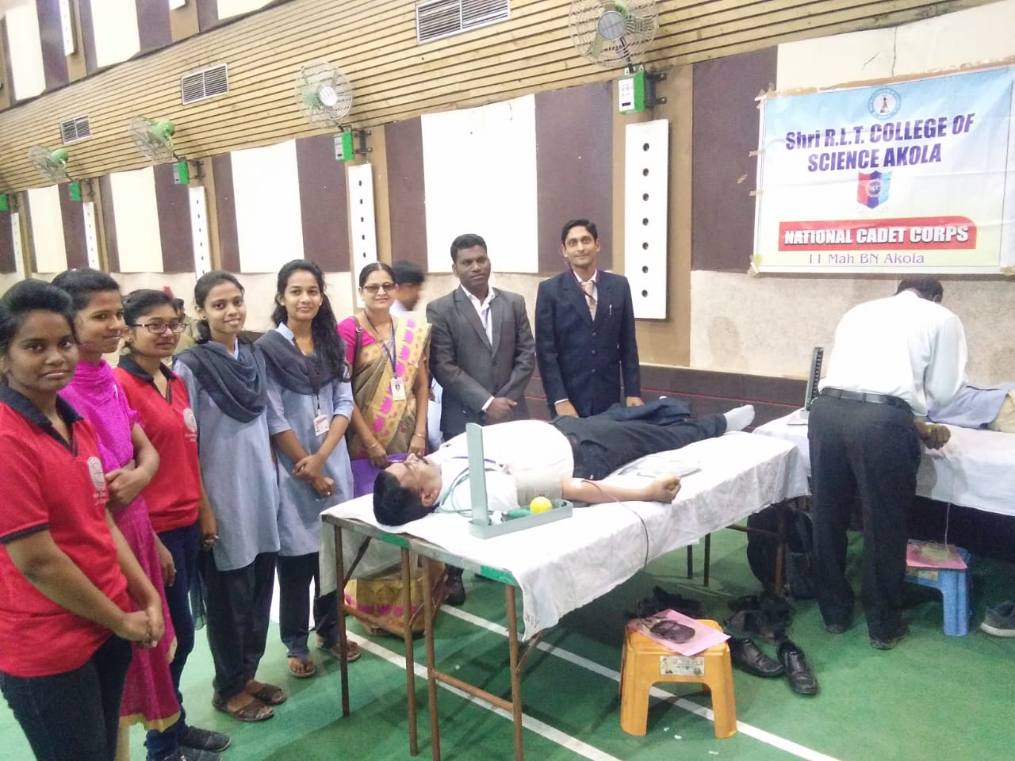
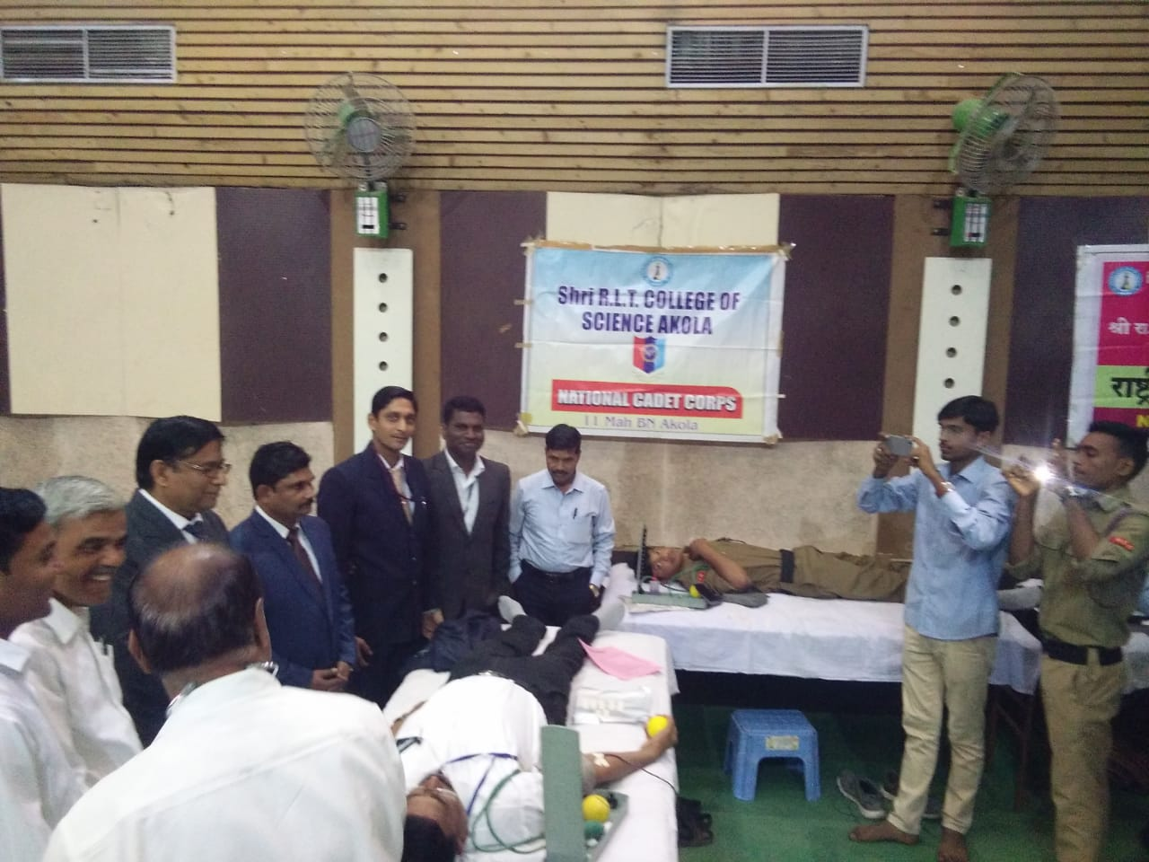
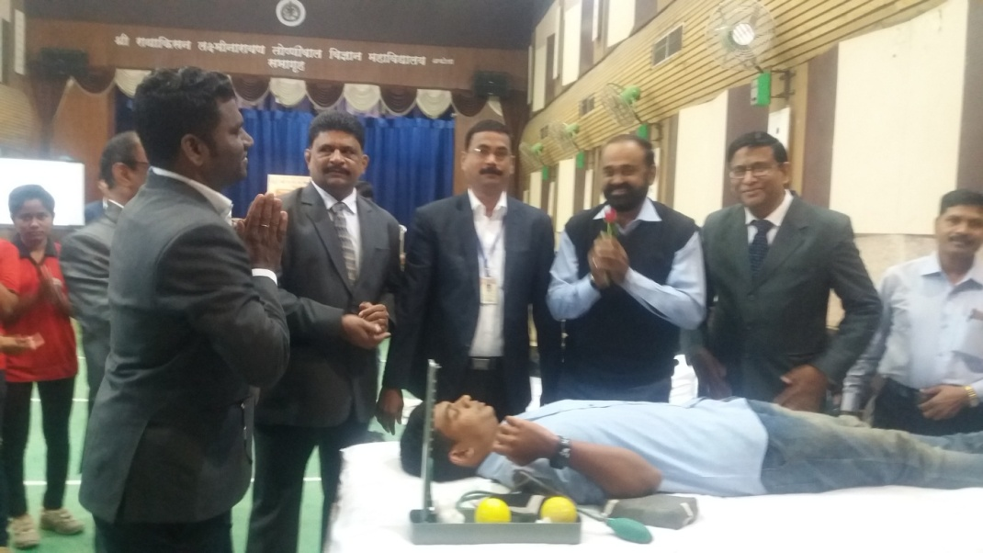

For The inaguaration of Late Principal M.G.Joshi Memorial day Programme on 24 th December 2018 . Our College alumna Hon.Shri Viplav Bajoriya.MLC Maharashtra and Hon. Shri Randhir Sawarkar ,MLA, Maharastra inaguarated that programme and give the message to our students.

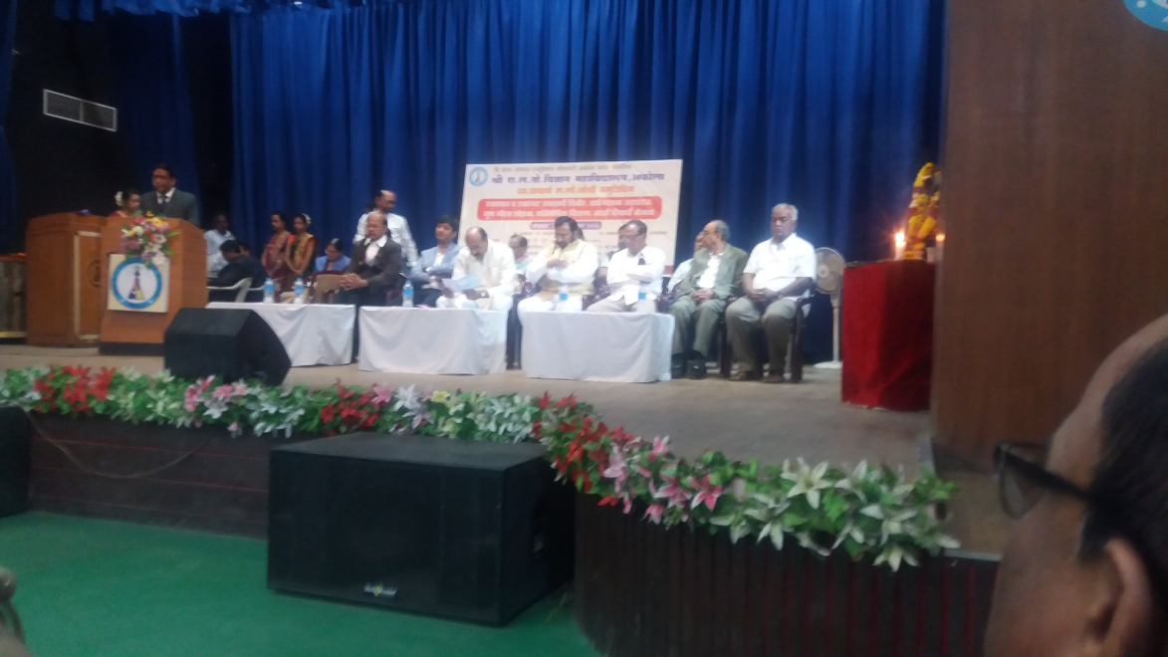
‘

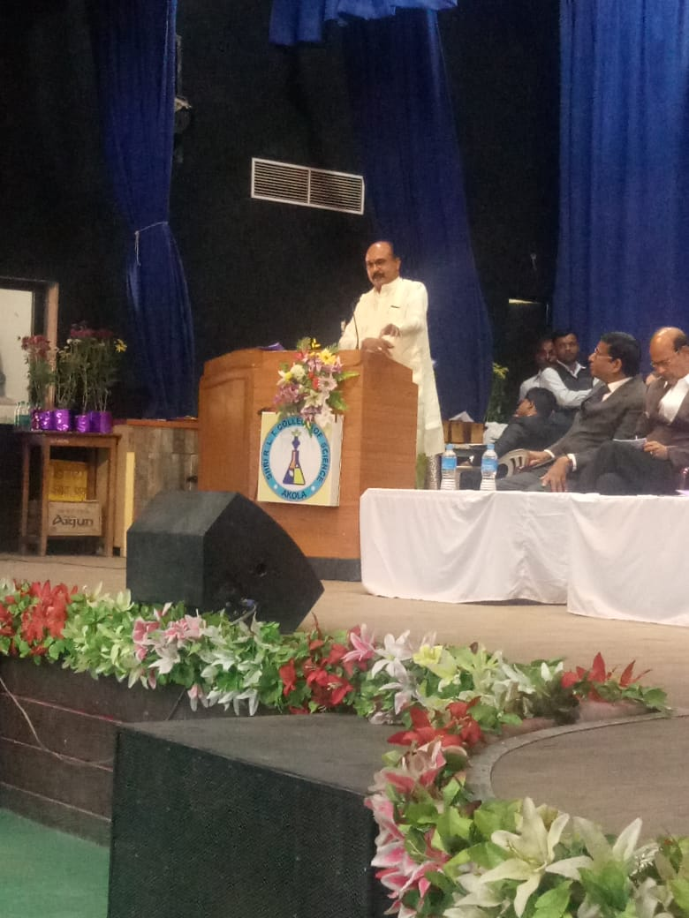
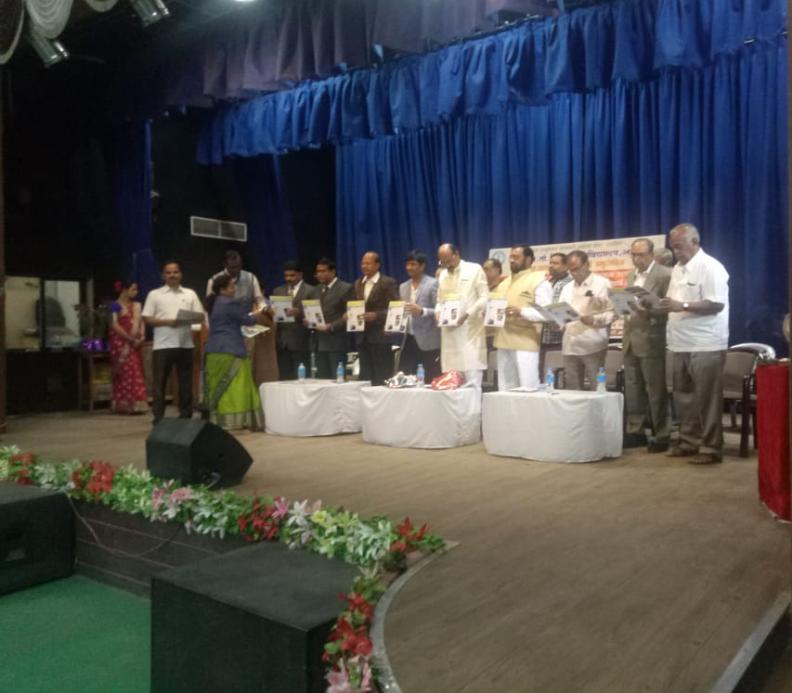

- Guest lecturer by department of microbiology on 26 Dec 2019
Our College Alumna Dr Jagdish K.Zade ,Deputy Director (Rotavirus Vaccine)
SERUM INSTITUE OF INDIA PVT.LTD ,PUNE has given the lecture on rotavirus vaccine to our M.Sc. Microbiology students

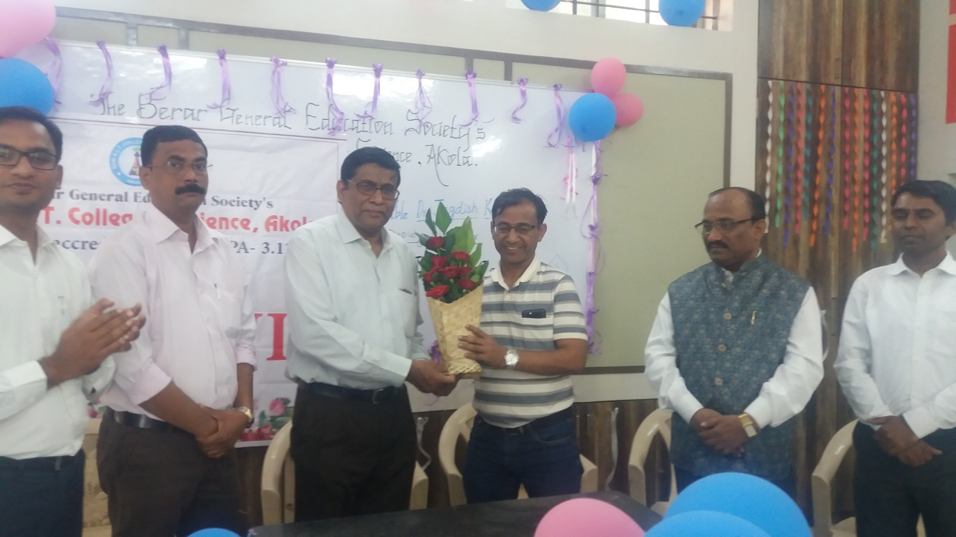

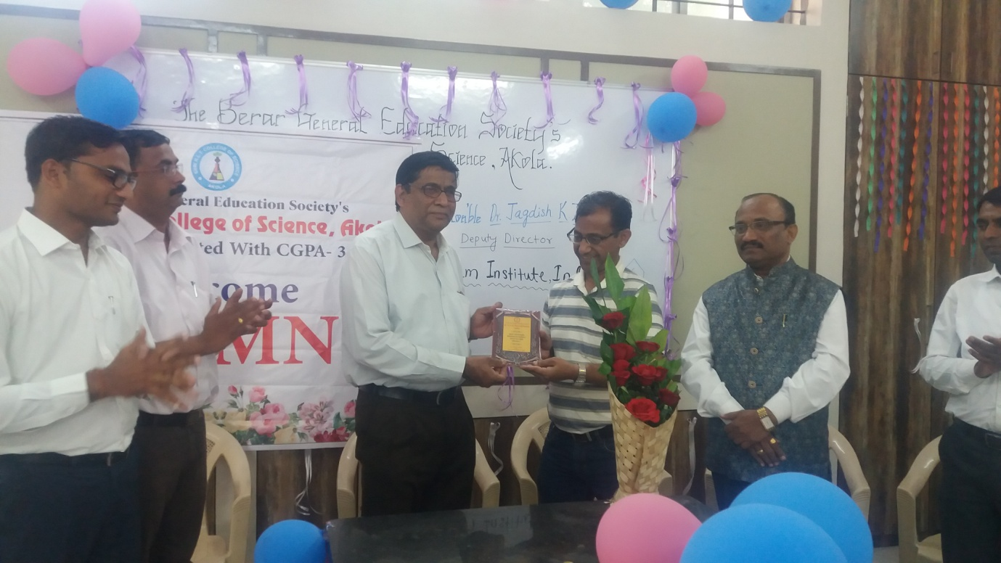

- Workshop 24 January 2019

Bio informatics department conducts one day workshop on bioinformatics-genomics and proteomics for bioinformatics students at digital classroom on 24jan2019. Our college alumna ku . Bhagyashree Gadodiya . bioinfo. Drug designer working at banglore.

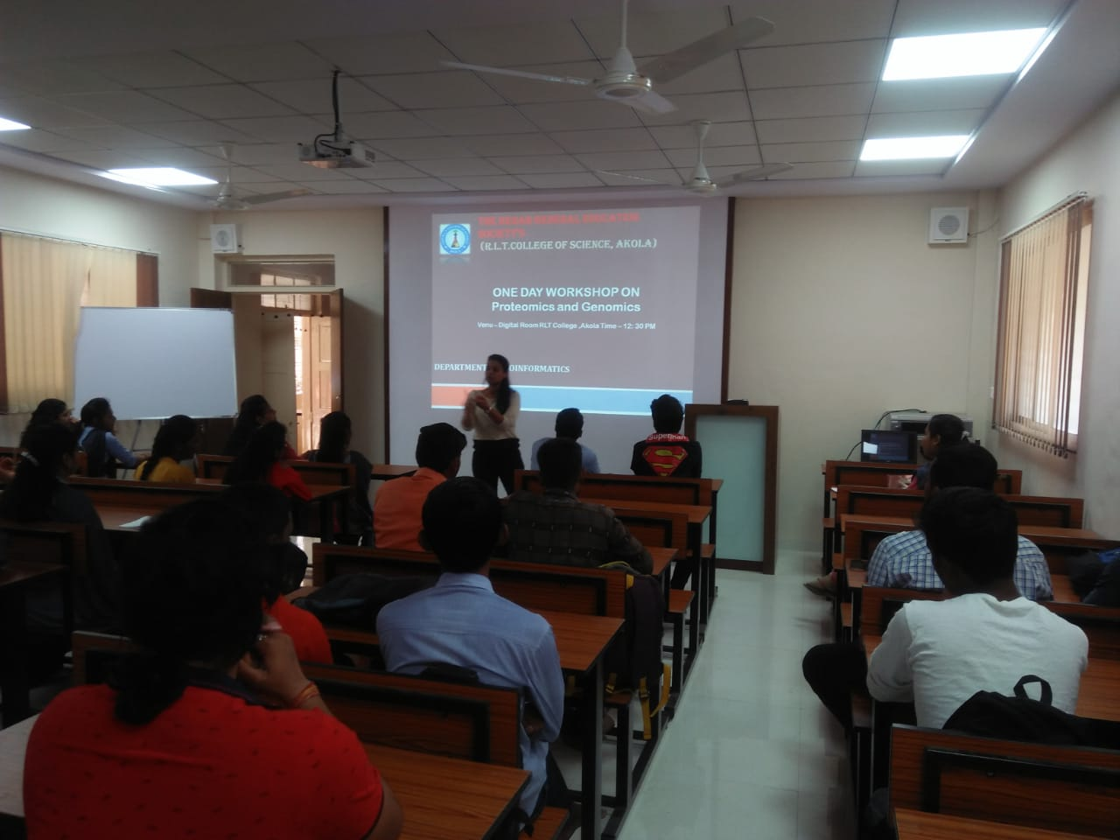

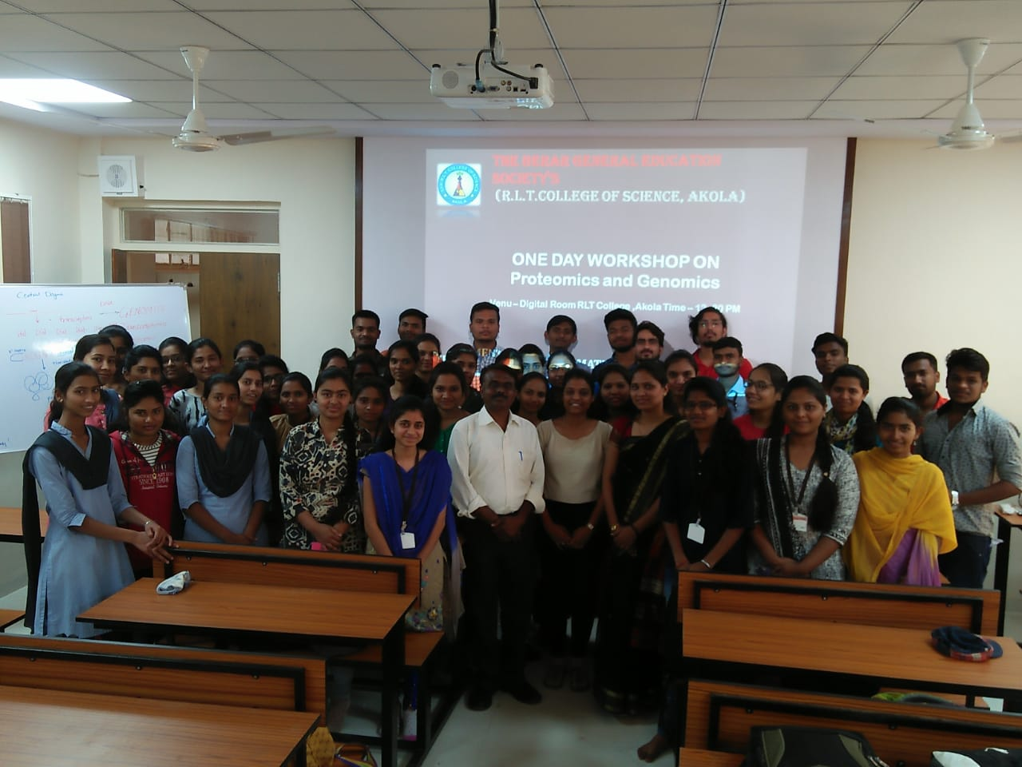
- University Level Seminar of Mathematics PG Department on 12march 2019 :-Dept of Mathematics arranged the University level Seminar for PG Department of mathematics . Our College Alumna Dr.S.D.Katore Prof.and Head ,Dept of Mathematics SGBAU ,Amravati has given their valuable contribution for upliftment of our students.
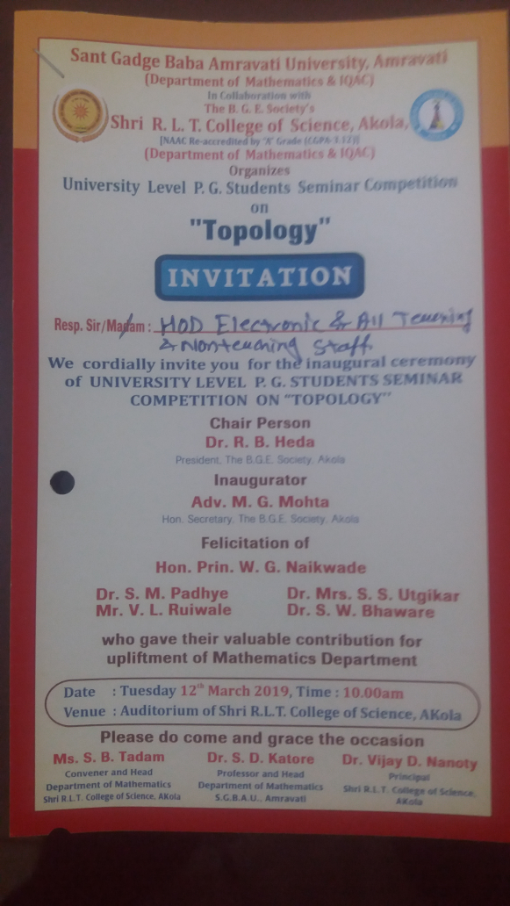

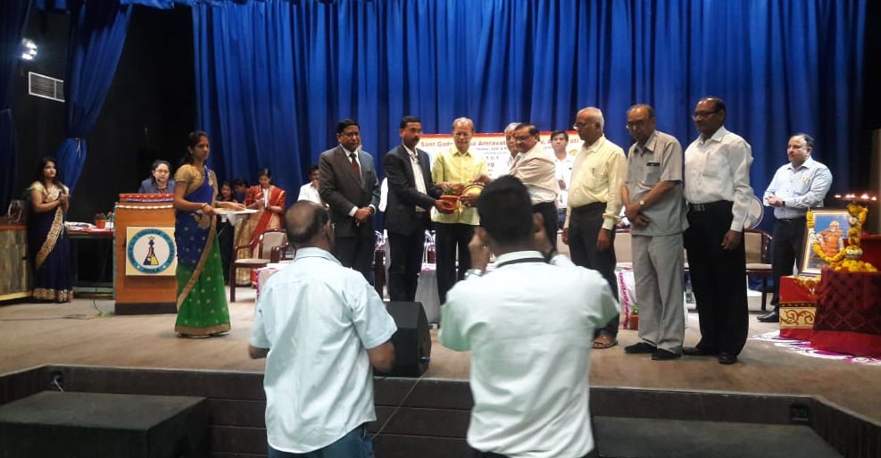
- Our College Alumna Capt.Anshu Jagmohan Sinha visited our and motivate the students of NCC His posting at Assam 4GR
