Report
On
Four Days Workshop
Soft Skill Development
5th - 8th January-2022
Organized By
Shri R.L.T.College of Science, Akola
Sponsored by
Student Development Cell, Sant Gadge Baba Amravati University, Amravati.
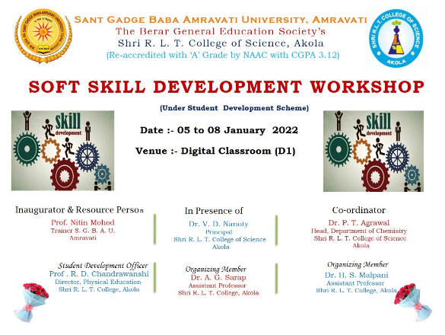

Shri R.L.T.College of Science is always ahead for organizing various programmes for the beneficiaries of student. It is the main Moto of our institution to bring out all over development of the students and this is the reason why RLTions are ahead not only academically but also in all field of the society which may be Medical, Engineering Scientists or even Politics.
In view of the overall development of students and as per the today need of soft skill development among the students, Shri R.L.T.College of Science in collaboration with student development. Sant Gadge Baba Amravati University, Amravati organized four days workshop for the B.Sc. Final year students on soft skill development.
The programme schedule form 5th to 8th January- 2022.

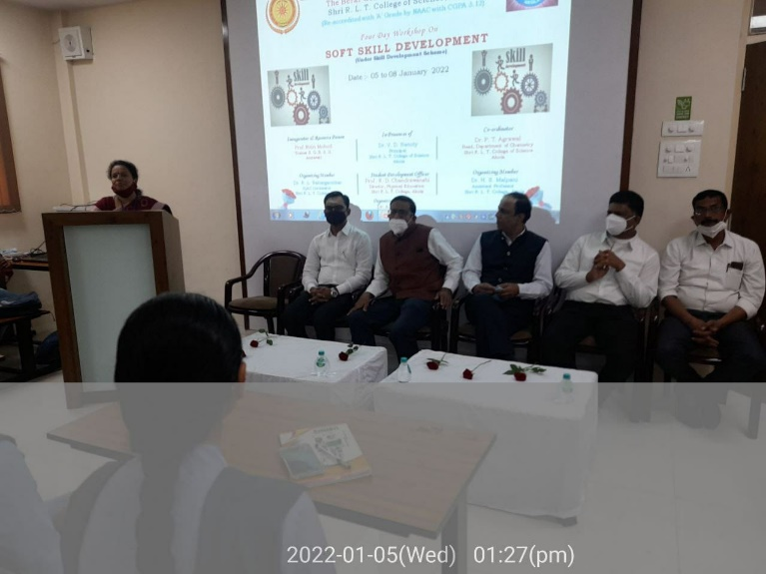
The programme begins on 5th October with registration of student from 11.00 a.m. to 12.00 noon then there was inauguration of the workshop. Dr.V.D. Nanoty, Principal of our College was the Inaugurator of workshop and Dr. Nitin Mohod sir, Associate Professor Shri Shivaji College, Akola was the Resource person for the first day.

Dr. Rajesh Chandrawanshi, Physcial Director and student development officer in his introductory speech motivated and inspire the students for such workshop.

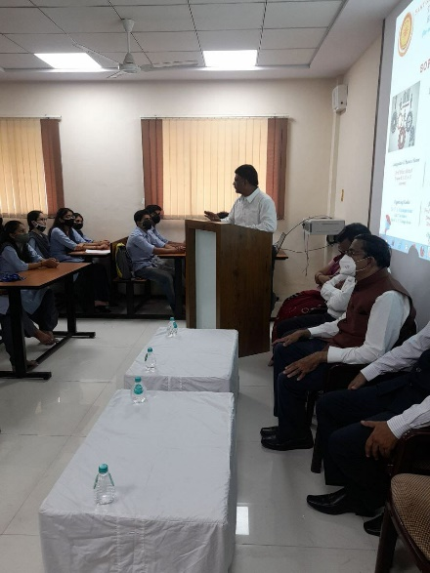

Dr. Poonam T. Agrawal Coordinator of workshop in her speech thanks to Vice Chancellor, Amravati University and Dr. Satange sir, Student development Cell, S.G.B. Amravati University, Amravati for giving opportunity to our college for this organization.

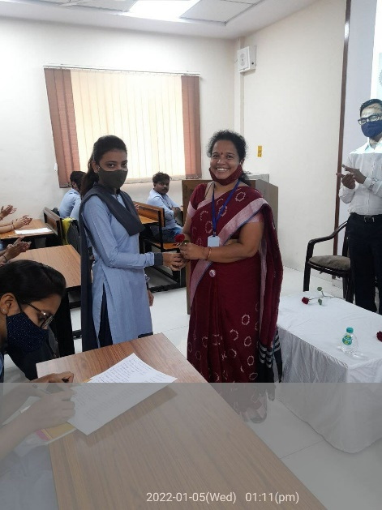

Dr. V.D. Nanoty Sir guided the students about the need of workshop and giving some examples on time management.

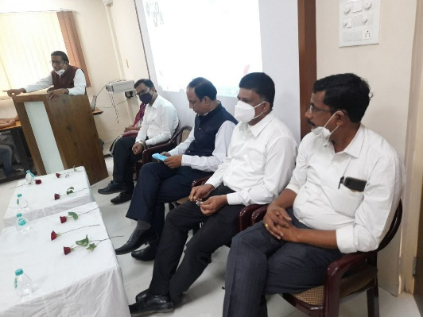

In First Session Dr. Nitin Mohod sir delivered his speech on Motivation Group discussion and personality deveopment.

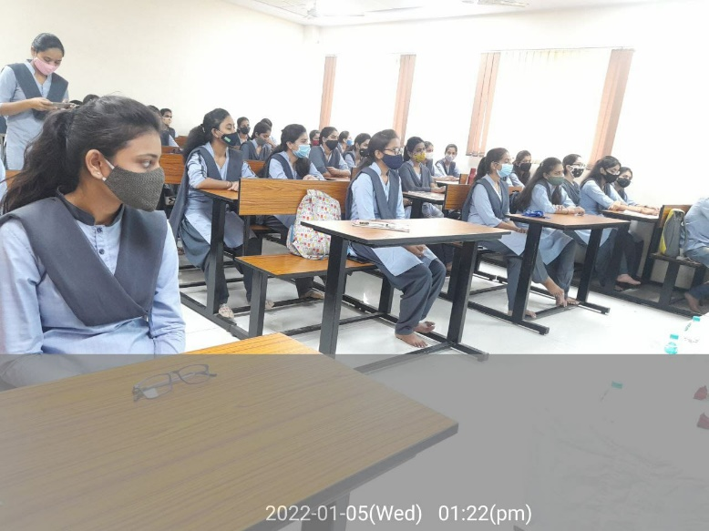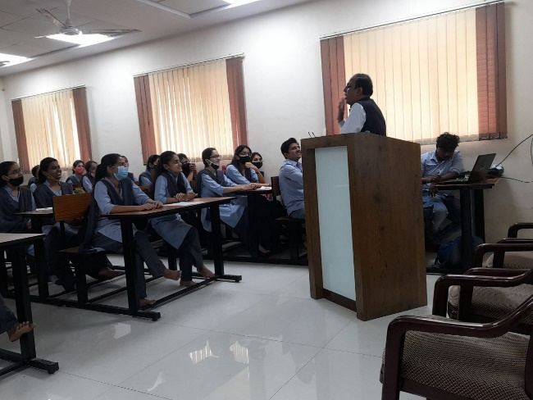

First day session ends with the vote of thanks by Dr. Harish Malpani.

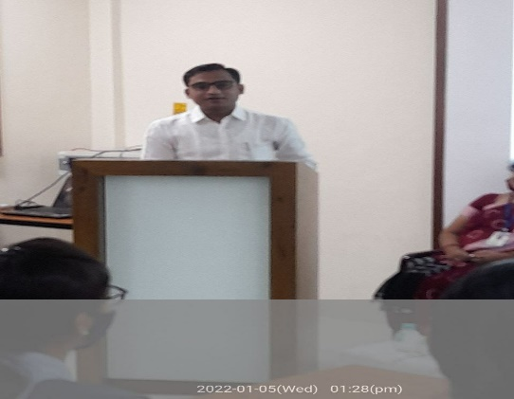

Second day there was a lecture of Dr. Swati Damodare, Associate Professor L.R.T. College Akola on-Non-verbal communication and Motivation. Prof. Ram Chavahan, Head Dept. of Electronics was the chief guest for this activity. Dr. Rajesh Chandrawanshi, Physical Director of our college as well as Student Development Officer of our College Cell proposed the vote of thanks.

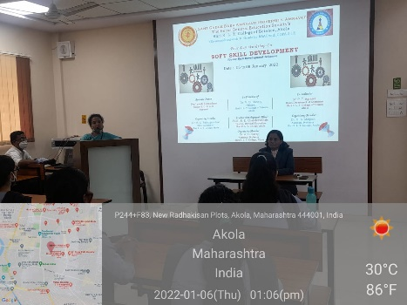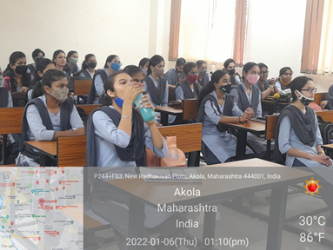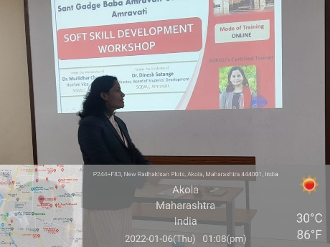

Third day there was a two sessions of Dr. Chapke sir, Asst. Professor L.R.T. College Akola on-Resume writing. Dr. Harish Malpani, Asst. Professor Dept, of Microbiology proposed the vote of thanks.

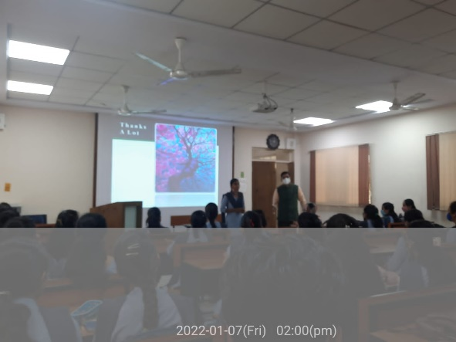
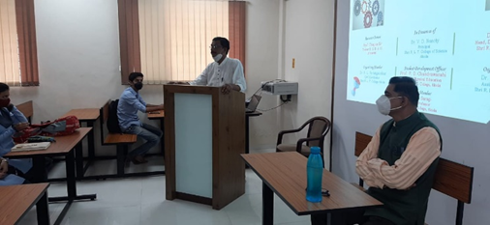

On fourth day there was first session of DR. R.D. Choudhary, Shri R.L.T. College of Science, Akola and second session of Dr. Rohit Agrawal, Shri R.L.T. College of Science, Akola.

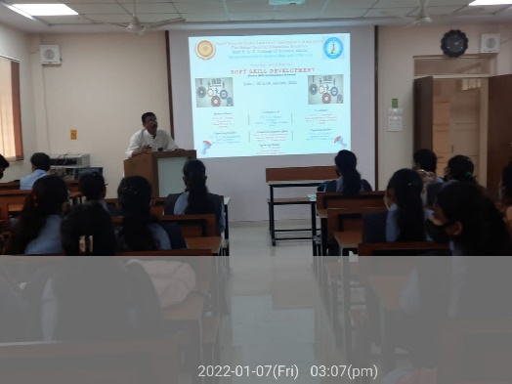
The workshop ends with the valedictory function, Dr. V.D. Nanoty sir was the chairperson and DR. Aashish Sarp Conducted the Programme. DR. R.D. Chandrawanshi, DR. R.D. Choudhary, Dr, Harish Malpani and all the teaching and non-teaching staff members of the college worked hard for the success of the workshop. Total 57 students registered for the workshop.

DR. Poonam T. Agrawal
Coordinator, Soft skill development workshop
Shri R.L.T. College of Science, Akola

List of the Students

Sr. No. | Name of students | Mobile No.
1 | Miss Achal Devendra More | 9356785134
2 | Miss Renuka Chandrashekhar Gole | 9766466445
3 | Miss Vaishnvi Sitaram Jadhao | 7721041453
4 | Miss Soniya P. Jangid | 8956591051
5 | Miss Radhika Rajote | 7218008312
6 | Miss Achal Arun More | 9119450930
7 | Miss Roshani Santosh Tiwari | 7822968182
8 | Miss Sunidhi Navinkumar Chitlange | 9112254758
9 | Miss Aditi Sandanand Raut | 7721831757
10 | Miss Vaishnavi Dashrath Waghmare | 8669805063
11 | Miss Sakshi Dilip Nakhale | 8686343492
12 | Miss Anjali Suresh Ambalkar | 7745060194
13 | Miss Vaishnavi Pradip Kolhe | 9370929369
14 | Miss Rutuja Ravindra Jamodkar | 9503620494
15 | Miss Vaishanvi Sanjay Tekade | 9325247175
16 | Miss Shrutika Gajanan Deshpande | 7822807946
17 | Miss Apoorva Harshad Damodar | 8308162061
18 | Miss Vaishnavi Ramesh Datir | 7058067541
19 | Miss Achal Anil Tayade | 8483065423
20 | Miss Vaishnavi Rameshwar Tayade | 9325700574
21 | Miss Nikita Suresh Tayade | 9322436653
22 | Miss Nikita M. Tayade | 9145134787
23 | Miss Prachi Kisan Chavhan | 9890263484
24 | Miss Vaishnavi Ravindra Damdhar | 7020522318
25 | Miss Poonam Ajaysingh Bais | 7999698441/8605665613
26 | Miss Divya Babanrao Virulkar | 7058806384
27 | Miss Prajakta Subhash Dhurde | 7709767599
28 | Miss Vaihnavi Shrikrushna Shelkar | 8080826431
29 | Miss Vaidehi Sudhir Kulkarni | 9307824402
30 | Miss Aishwrya Girish Pathak | 7743555624
31 | Miss Nidhi Ajay Dixit | 7758845408
32 | Miss Renuka Haribhau Borde | 9527502623
33 | Miss Siddhi Snjay Chaudhari | 8956345103
34 | Miss Gayatri Anil Tayade | 7972685772
35 | Miss Mayuri Ranjit Deshmukh | 98600887706
36 | Miss Sanskruti Vinodrao Ganoje | 9075192706
37 | Miss Sakshi Sanjay Girhe | 7666212802
38 | Miss Vaishnavi Ganesh Girhe | 9657360746
39 | Miss Arpita Subhash Pophale | 8669702195
40 | Miss Sakshi Santosh Katole | 7517473547
41 | Mr Aniket Asjok Kharde | 9665636193
42 | Mr Dipesh Gopal Giri | 9546453234
43 | Miss Ankita Digambar Sonone | 9307435647
44 | Miss Aparna Ganesh Rakhonde | 9772305816
45 | Miss Diksha Pramod Londe | 7218267061
46 | Miss Radhika Gopal Malokar | 7448249232
47 | Miss Pratiksha Dnyaneshwar Chiliwant | 9172900367
48 | Miss Sakshi Ananta Tale | 9579037551
49 | Miss Nikita Rajesh Hage | 8767994208
50 | Miss Vaishnavi Shrikrishna Kadu | 9011908736
51 | Miss Kshiteeja Santosh Nakat | 8459360995
52 | Miss Gauri Sanjay Wakode | 9420523633/7840916337
53 | Mr Agohit Suresh Ambuskar | 9766519749
54 | Mr Siddharth Sahebraw Ingle | 9146533649
55 | Mr Prashant P. Kale | 8518708604
56 | Mr Yash S. Tayale | 9175180699
57 | Mr Mandar Sunil Kalley | 9373185962

