Report
On
Hazardous Management and Fire Extinguisher Demonstration Workshop
One Day Level workshop on Hazardous Management and Fire Extinguisher Demonstration workshop was organized by Department of Chemistry and Disaster Management Club of Shri.L.T.College of Science, Akola on 16th September 2021. The objective of this workshop is to bring awareness among the Teaching, non-teaching staff and the post-graduation students about the hazardous management. The workshop also aims to give demonstration and training to the teaching, non-teaching staff members as well as M.Sc. Chemistry students about the use of fire extinguisher. How this fire extinguisher work, what are the different types of Hazardous in laboratory and how can you mange all this hazardous. I
The workshop started with the inauguration function Dr.Murlidhar Waderkar Hon’ble Joint Director of Amravati University who is also a man of Chemistry was the inaugurator of this workshop. Dr. V.D. Nanoty, Principal Shri R.L.T.College of Science, Akola was the President of this function. Respected Dr. Rameshwar Bhise, Principal, Shri Shivaji College Akola, Prof.Dr. K.N.Puri, Head department of chemistry Shri Shivaji college of science, Akola and Dr. S.V.Kolhe, Associate Professor, Department of Chemistry Shri Shivaji College Akot, graced the Programmed. The Programme started with the falicitation of guests.

Dr. Pravin Kawle, Assistant Professor department of Chemistry conduct the inauguration programme. Dr. Poonam Agrawal, Associate Professor and Head department of Chemistry, Shri R.L.T. College of Science, and Organizing secretary of the workshop gave the introductory speech.
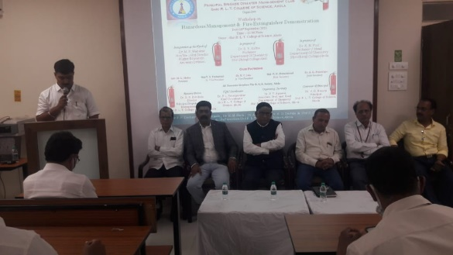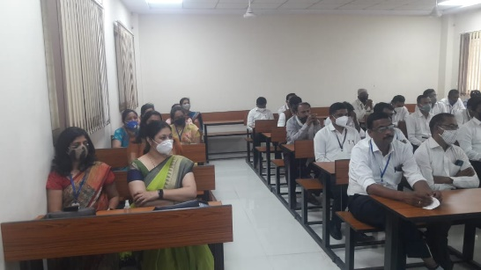
Hon’ble DR. Murlidhar Wadekar in his inaugurator speech appreciated the department of chemistry for organization of such type of demonstration workshop. He also felt sorry to say that many organization have all the safety equipment’s but the staff members are unable to handle it. Due to lack of knowledge of handling and managing this hazardous situation many accidents may occur so it is good initiatives taken by Shri R.L.T.College of Science, Akola.

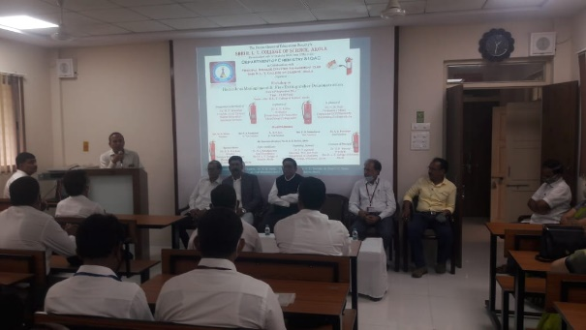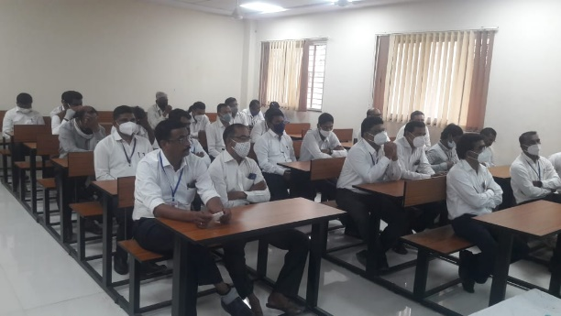
Principal Dr. V.D. Nanoty, in his presidential speech motivated the students towards to take such training and be aware of such types of incidents. Dr. Aashish Saraf Proposed the vote of thanks. Total 117 students and teaching and non-teaching staff members get benefited by this workshop.

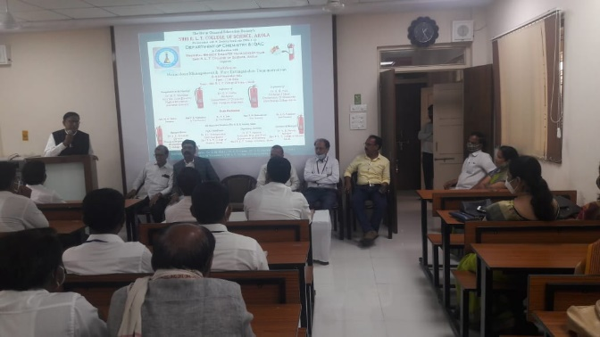
During the first technical session Dr. Poonam Agrawal, Organizing secretary and head department of Chemistry deliver the lecture on various hazardous in the laboratory and safty measure about how to handle such types of hazardous. She explain in detail about the various hazardous management.

In the second technical session Dr. Sudhir Kochale, Assistant Professor and director of Disaster management club of shri R.L.T.College of Science gave the information about various types of fire Extinguisher and also gave the demonstration and training to the non-teaching staff and students of the fire extinguisher. All the staff members and students get benefited by this workshop.

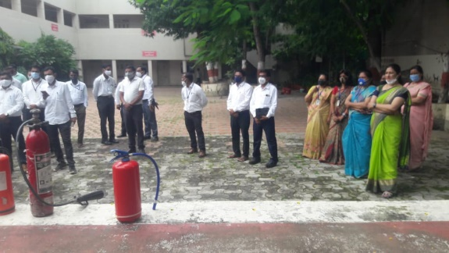

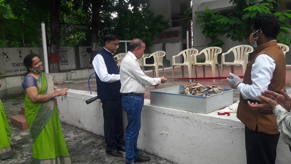
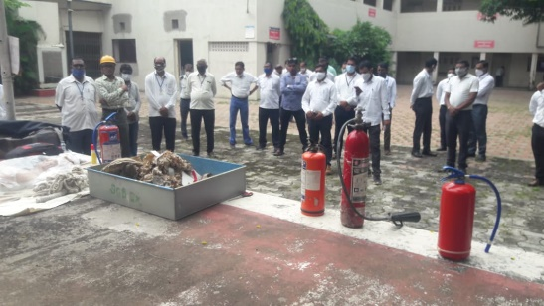
Dr. P.R. Kawle Dr. Aashish Sarp, Dr. Kavita Heda, Dr.V.D. Deotale, Dr. R.L. Rahatgaonkar, Prof. R.D.Choudhary, Dr. Sudhir Kochale, Dr. Harish Malpani took the efforts for the successful organization of this events.
Organizing Secretary Principal
Dr.Poonam T. Agrawal, DR. V.D.Nanoty
Associate Professor& Head
Deparrment of Chemistry
Shri R.L.T.College of Science, Akola

