Report
On
Process of Drug Designing and Drug Discovery
One Day National Level workshop on The Process of Drug Designing and Drug Discovery was organized by Shri.L.T.College of Science, Akola on 4th October 2021. The objective of this workshop is to educate next-generation scientists about rational drug design, discovery & development of drugs. This workshop is an educational forum that endeavours to provide a comprehensive overview of the drug discovery process against a back drop of the technology and research revolution and includes a horizontal overview of the disciplines involved in the drug discovery process and a vertical delve in to the critical elements of each discipline.
The design and production of drugs is a field in which chemistry has had a favourable impact on life expectancy and quality over the past century. As such, this field provides a rare opportunity to introduce several concepts in chemistry and biochemistry to a large audience.
It is widely known that the design and development of a new drug generally costs more than 1 billion dollars in total and takes at least 10 years, while, despite all these efforts, only a very limited number of drug discovery projects will lead to the actual release of a new drug. Several technologies have been developed to rationalize the process by reducing duration, cost, and attrition rate, one of which is computer-aided drug design (CADD). CADD uses computing resources, algorithms, and 3D-visualization to help generate rational ideas about how to create or modify molecules, and to make decisions in the execution of the drug design process.
The workshop started with the inauguration function Prof. Ram Chavhan sir, Head department of Electronics, Shri R.L.T.College of Science, Akola and CDC member of our college was the inaugurator for this function. Dr. V.D. Nanoty, Principal Shri R.L.T.College of Science, Akola was the President of this function.DR .Lokeshkumar Gandhi, Associate Professor, SGSPS Pharmacy College Akola and Prof. S.L.Khan, Assistant Professor NBS Institute of Pharmacy Ausa, Latur, graced the Programmed.
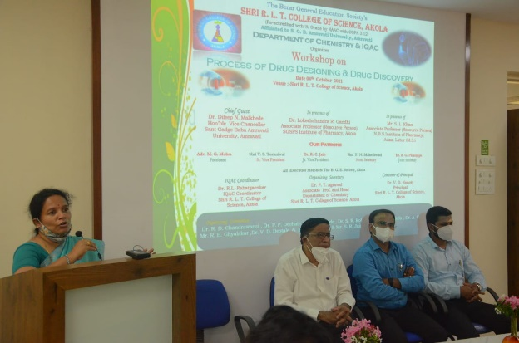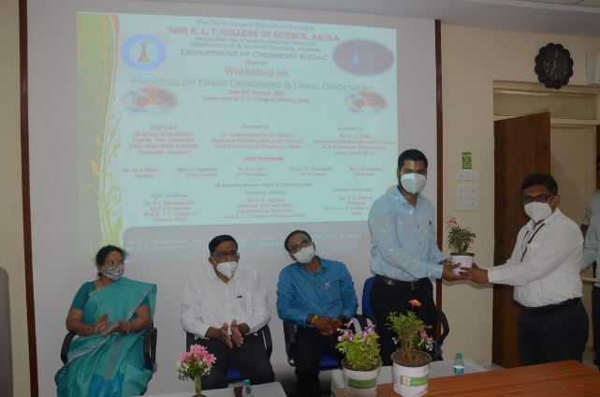
DR.Pravin Kawle,Assistant Professor department of Chemistry conduct the inauguration programme. Dr. Poonam Agrawal, Associate Professor and Head department of Chemistry, Shri R.L.T.College of Science, and Organizing secretary of the workshop gave the introductory speech. Prof. R.G.Chavhan sir in his inaugural speech explain the need of more research in the field of Drug designing.

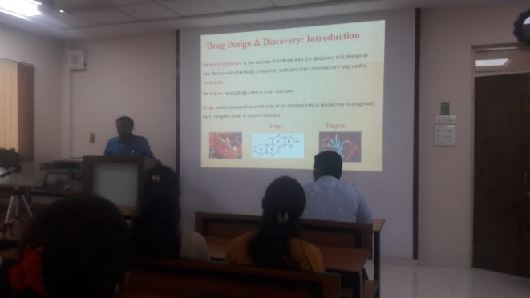
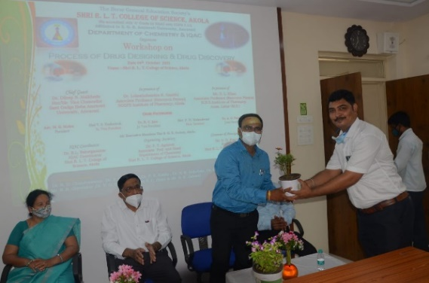

Principal Dr. V.D. Nanoty, in his presidential speech motivated the students towards to move towards this new era of drug designing. Dr. Aashish Saraf Proposed the vote of thanks. Total 100 students get benefited by this workshop.
First technical session was conducted by Dr. Pravin Kawle sir, Dr. Lokeshkumar Gupta was the resource Person for first session. In his lectures sir make the students aware about different terms used in drug discovery and technique used for the manufacturing of drugs.. The session ends by the vote of thanks by DR. Vinod Deotale.
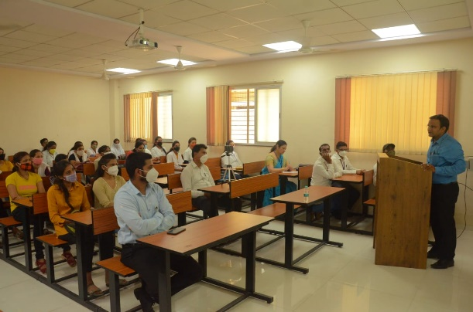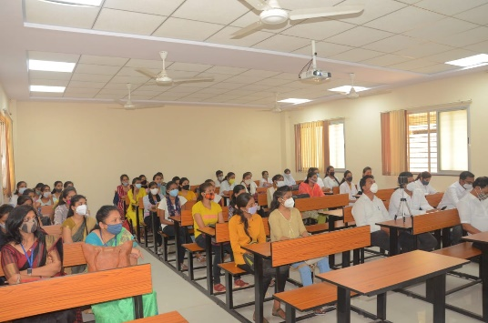
In the second technical session Prof.S.L.Khan demonstrated the process of drug designing with the help of software. The students also tried at their own the drug designing by using the software. Realy it was a very nice hand in experienced for the students. Dr. Vinod Deotale conducted this technical session two.
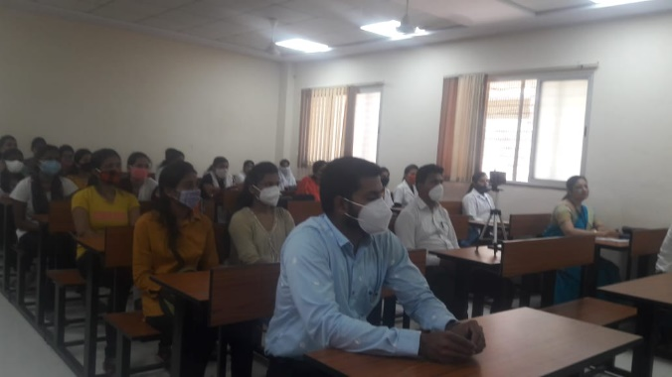
The valedictory function was graced by the presence of hon’ble DR. Dileep Malkhede sir The Vice Chancellor of the sant Gadge Baba Amravati University, Amravati. Sir was the chief Guest for this occasion. Hon’ble Adv. Motisinghji Mohta, the President of the B.G.E. Society, was at the presidential seat of this valedictory function. Respected DR. Shriprabhu Chapke, Principal, Smt. L.R.T. Commerce College , Akola, Respected Dr.Devendra Vyas, Principal smt. R.D.G. Women College , Akola, Dr. Gajanan Egaonkar, Principal Nathmal Goenka Law College Akola, were the guest of Honour for this occasion. The valedictory function begins with lightning of lamp followed by the welcome of the guests.
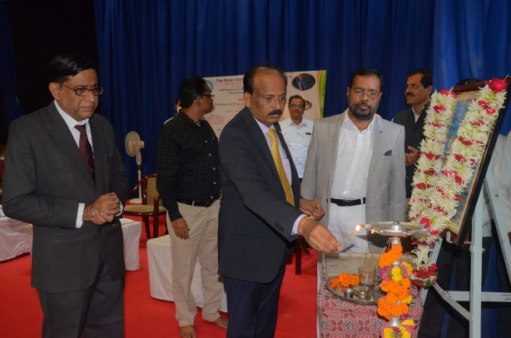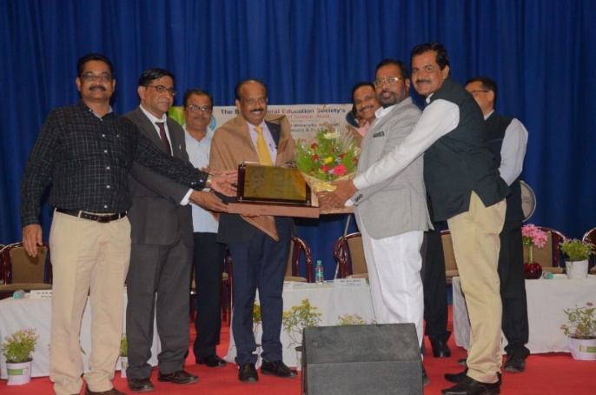

Principal DR. V.D. Naoty sir gave welcome cum introductory speech and also gave the details of the registration and beneficiaries of the workshop.
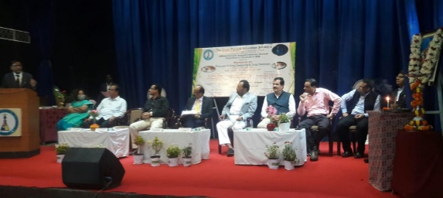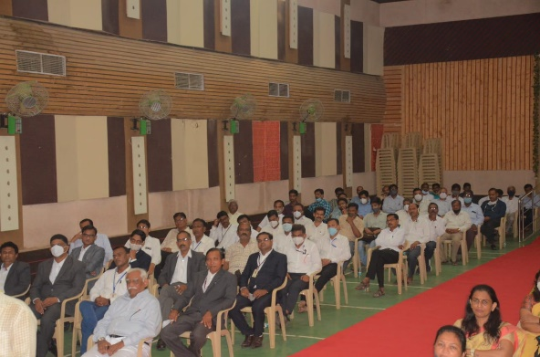

Hon’ble Vice Chancellor Dr. Dileep Malkhede appreciated the efforts taken by the department of chemistry for organizing such workshop at district level. He focused on the importance of such type of programme, He also mentioned that there is a need in redrafting of syllabus where there should be incorporation of such skill based programme.

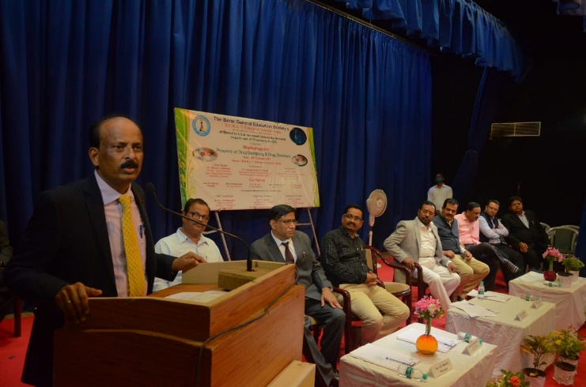
Hon’ble adv.Motinsinghji Mohta sir in his presidential speech highlighted that college is always ahead in organization of such skill based and job oriented programme. He gave assurance to the Hon’ble Vice chancellor that in future also The B.G..E. Society always take initiation in such organization. He also appreciated the department of chemistry for such nice organization always taking such programme like perfume making soap making, agarbatti making which provides job opportunity to the students.

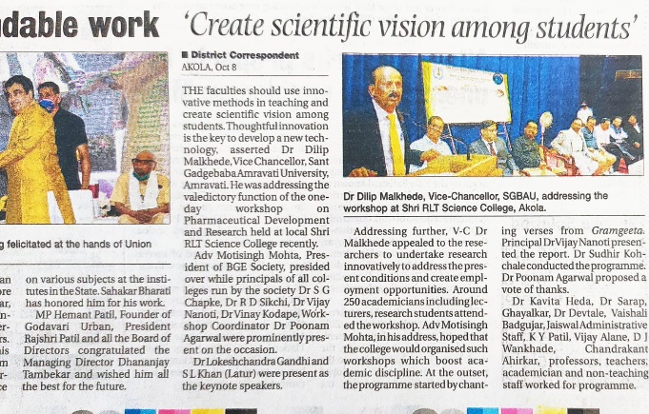

The programme was conducted by DR. Sudhir Kochale , Assistant Professor department of Zoology, Shri R.L.T.College of Science Akola and DR. Poonam Agrawal, organizing secretary Proposed the vote of thanks.
DR. R.D. Chandrawanshi, Dr.P.P.Deohate, Dr. Kavita Heda, DR. R.L.Rahatgaonkar, Prof. R.D.Choudhary , Dr. Harish Malpani , Shri R.B.Ghayakar, Shri S.R.Jaiswal took the efforts for the successful organization of this events.
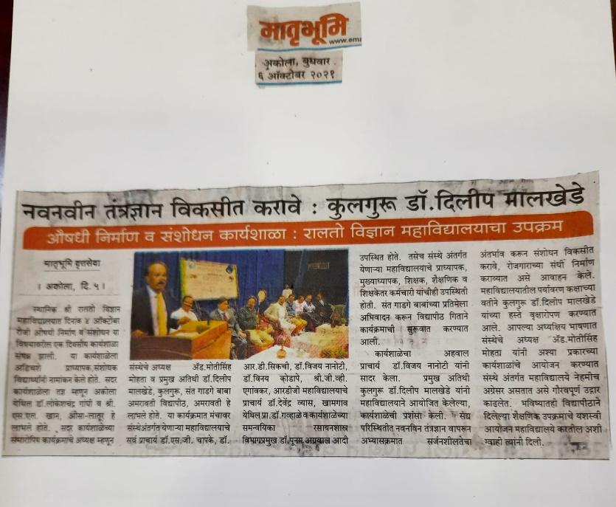

Invitation Card

Certificate

Online Programme Link
https://youtu.be/lOxCavYERKo

Organizing Secretary Principal
Dr.Poonam T. Agrawal, DR. V.D.Nanoty
Associate Professor& Head
Deparrment of Chemistry
Shri R.L.T.College of Science, Akola

