Shri R. L. T. College of Science, Akola

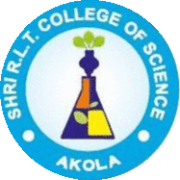

ALUMNI COMMITTEE REPORT
SESSION- 2019-2020

Prof. R. D. Chaudhari Chairman
Prof. R. G. Chavan Alumni Sr. Member
Dr. P. T. Agrawal Member
Prof. R. B. Ghayalkar Member

Contents
Sr. No. | Activities
1 | Permanent Registration Number
2 | Registered Alumni Committee
3 | Objective of the Alumni Association
4 | Account details, statement, Donor
5 | Guest Lecture by Alumni
6 | Blood Donation on 24th Dec. 2019.
7 | Felicitation of Alumni
8 | Blood sampling and Testing.
9 | Our alumna as a chief Guest in National conference
10 | Meeting of Alumna Association
11 | Visit of our Alumni at college in the year 2019-2020

Chairman Principal

Permanent Registration No. F-20205

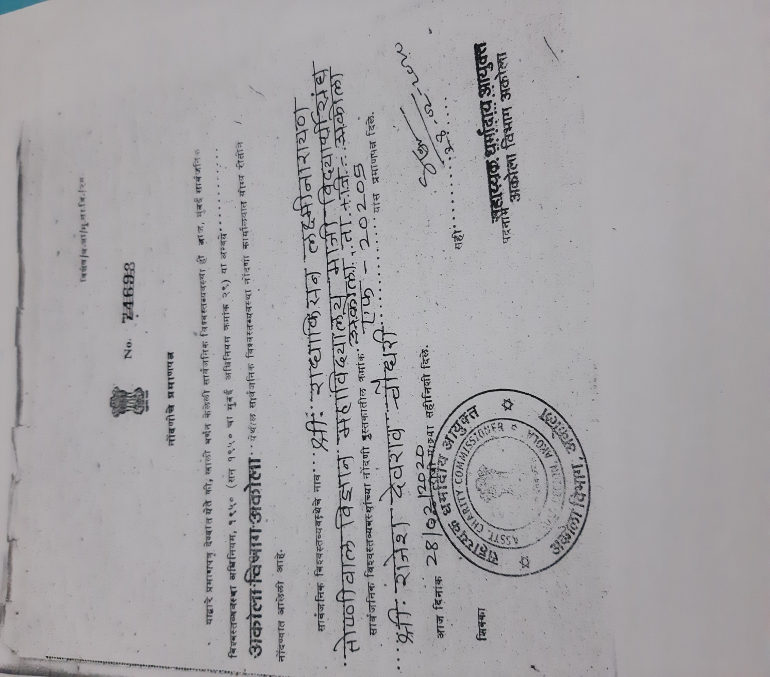

Registered Alumni Committee Members
Reg. No. F - 20205

- Shri Deepak Mayee – President

2) Shri Prashant Bule – Vice –President

- Shri R.D. Chaudhari – Secretary

- Dr. V.D.Nanoty – Member /Principal

- Shri R.G.Chavan – Member

- Dr. R.L. Rahatgaokar – Member

- Dr. Poonam T. Agrawal – Member

- Shri Sunil T. Patil – Member

- Shri Sunil M . Jadhao – Member
\
- Dr. Jayshree V. Bhale – Member

- Dr. Ashivini S.Morwal – Member

Objective of the Registered Alumni

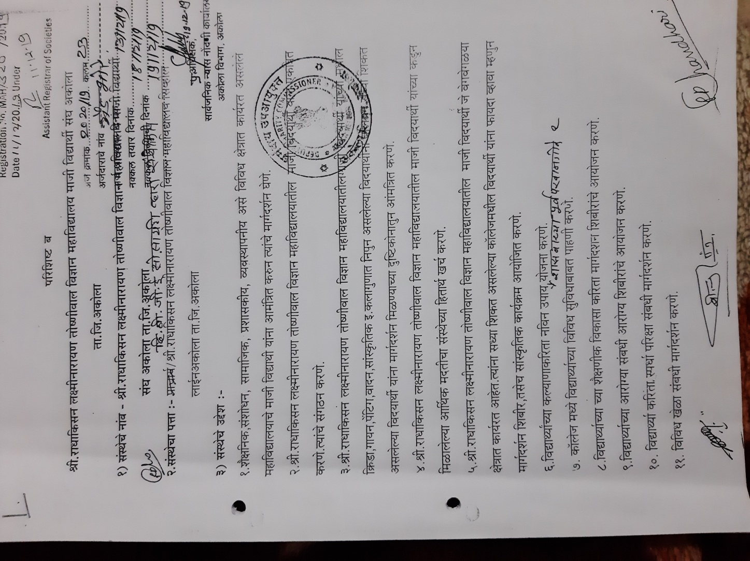

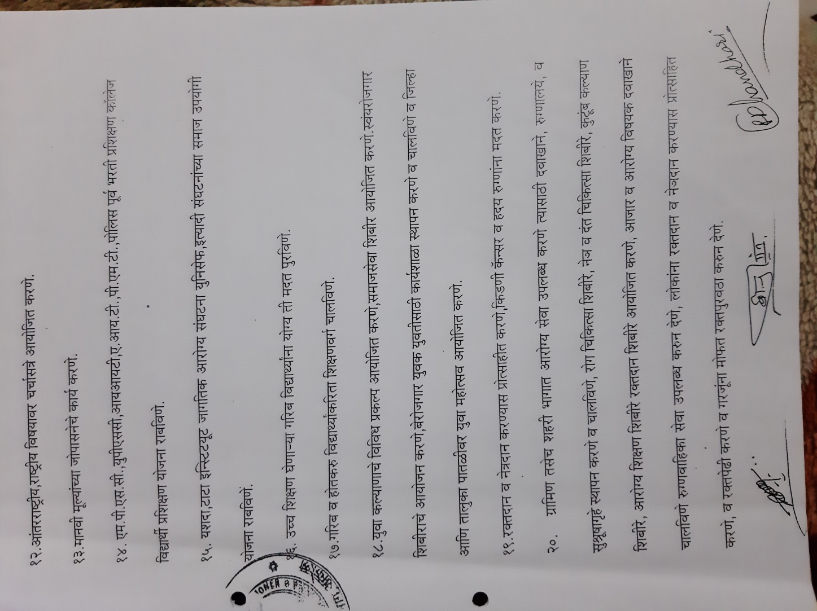

Account Details

Name :- Shri R.L.T.College of Science
Alumni Association, Akola
Account no. : – 3858820618
IFSC Code :- CBIN0283820
Bank :- Central Bank of India RLT Branch , Akola
Account Statement

- Opening Balance - Rs. 7000/-
- Balancing Amount on Dated 24 /12/2020 - Rs. 10000/-

Details of the Alumni Donor for Association

Sr.No. | Name of the Donor | Amount
1. | Shri Deepak Mayee | 1000
2. | Shri Sunil Patil | 1000
3. | Dr.Jayshree Bhale | 500
4 | Dr. Ashivini S.Morwal | 500
Total Amount |  | 3000/-

Guest Lecture
Shri R.L.T. College of Science , Akola
Department of Mathematics
Guest Lecture Report

On the occasion of Golden Jubilee celebration of shri.R.L.T. College of science the department of mathematics in collaboration with the Alumina Association And IQAC organized a guest lecture by Mr.V.L.Ruiwale Ex Asso Professor of Shri R.L.T college of science, Akola on 12 Oct 2019 in Room no 19. The members of the organizing committee were Dr.R.L.Rahataonkar (NAAC Co-ordinator), Dr.S.B.Tadam (H.O.D),Dr.S.L.Munde,Mr Y.O.Heda.On the topic “Mathematical patterns of share market fluctuations” All the students of first and second year M.Sc (Maths) attended the lecture.
The president of the program was principal Dr.V.D.Nanoty sir, the program was also graced by the presence of Mr.M.R.Ubale(librarian)&Mr.R.M.Agrawal(Asst Prof), Mr. Manish Sachdev & Mr. Nilesh Deoke financial Advisory since 15 years. The introductory speech was given by Dr. S.B.Tadam (H.O.D) where she advised the students on the importance of application of mathematics and its uses she also emphasised on the uses of mathematics and its vast applications in the field of share market, whereas the presidential speech was delivered by the principal Dr.V.D.Nanoty sir, in his speech he glorified the 50 years that the college is about to complete this year, how the college has served to build the lives of many students and how they are working in various fields. He also motivated students to gain knowledge to build a strong future
After a short introduction about the speaker given By Miss Asma Fatima, Mr.V.L.Ruiwale, he began his lecture , giving a brief insight on share market he moved on with the mathematical aspects in calculating the trends in the share market, he explained in brief about various topics that effect the rise and fall of the company , He explained various terms like EPS i.e. earning per share and DEMA i.e. day exponential moving average and how to find the feasible time to buy and sell a stock using these guidelines, the lecture was quite productive for all the listeners who wanted to have knowledge on how to invest their money and how to grow it.
He said that investment should start from a young age. In addition, during the lecture, the students learn how to calculate the risk factor in the markets. He advised the students to learn relevant theory before entering the market and how not to play the blind game. During his lecture, Mr. Ruiwale displayed the quotations of several renowned scientists such as Einstein, to bring out the importance of gaining practical knowhow along with theoretical knowledge. He drew many graphs to explain the students the actual fluctuations and how to interpret these graphs and lines; he was keen on giving the information about the terms that are used by the analysts in share markets and trading sector. The lecture was not only informative but also aspired students, teachers and all the listeners to gain an insight on financial planning.
The conduction of the program was done by Miss Asma Fatima Ab Jabbar and Miss Karuna Sharma proposed the vote of thanks.

Date: Dr.S.B.Tadam
H.O.D. , Dept. Of Mathematics
A Photo Report on Guest Lecture
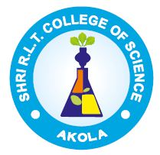
On the topic
Mathematical Pattern of Share Market Fluctuations
On 12th Oct. 2019
(on the Occasion of Golden Jubilee Year Celebration)
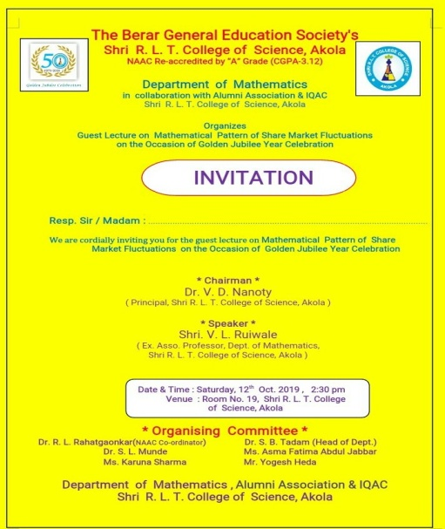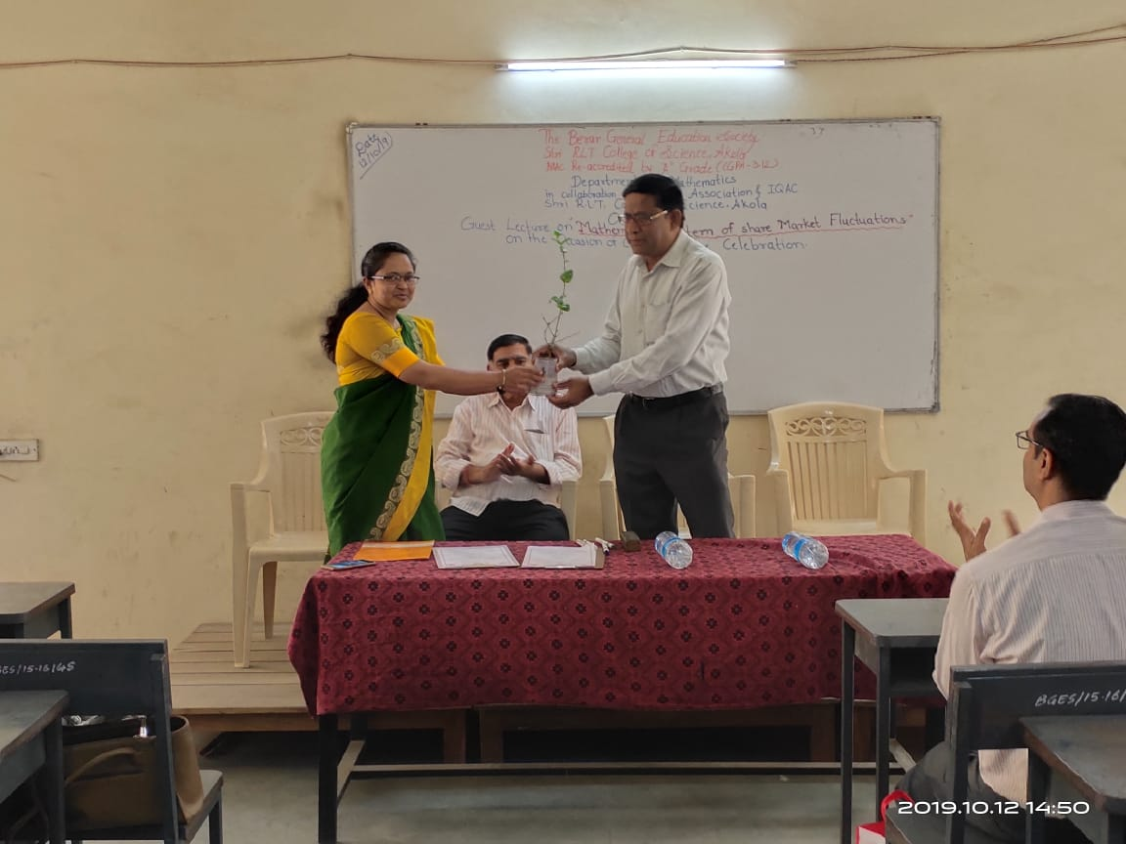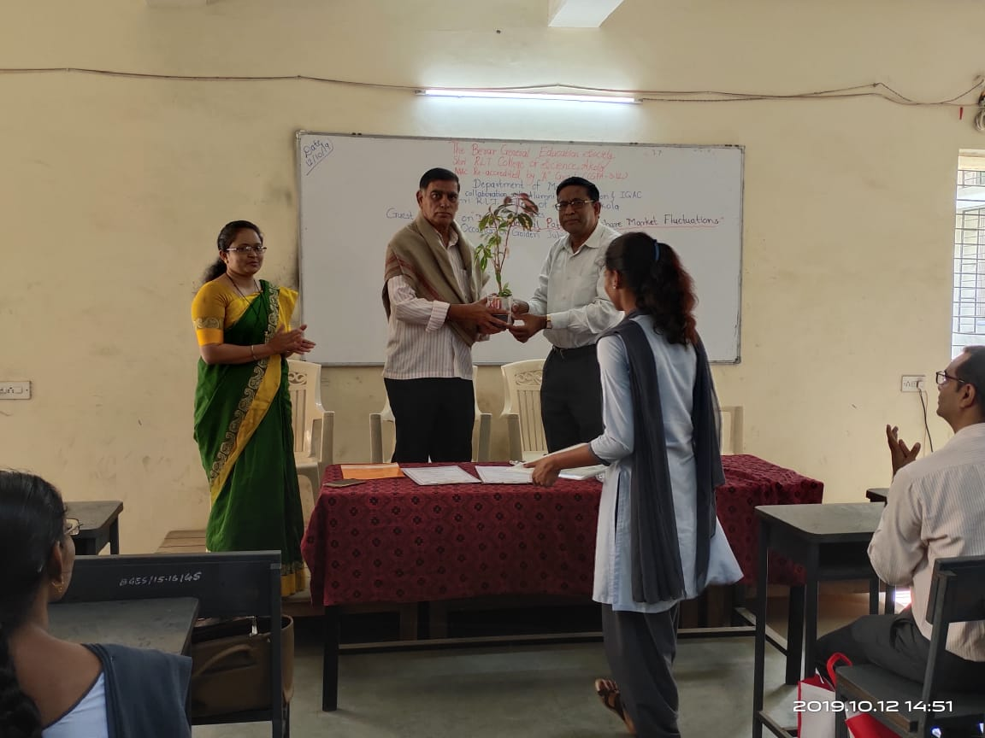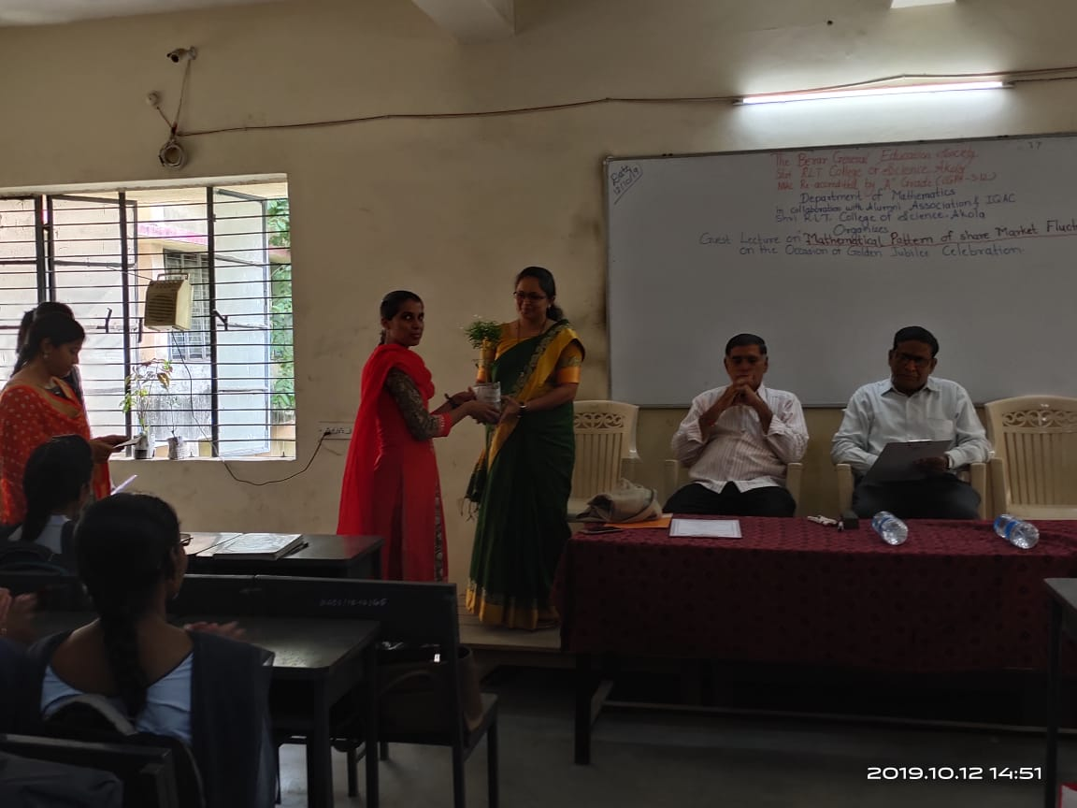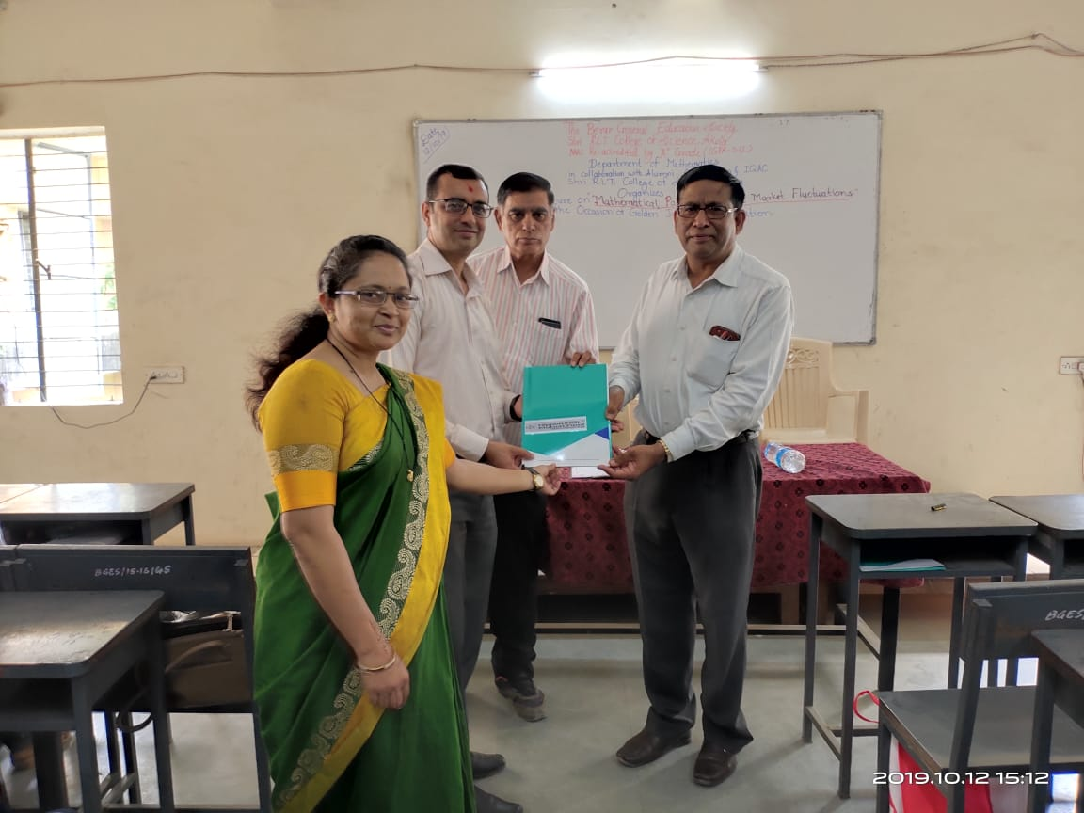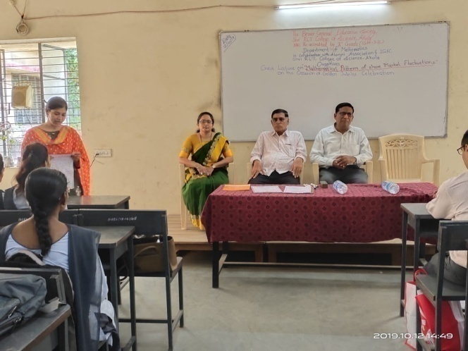
Ms. Asma Fatima conducting the program
Welcome of H.O.D. Dr. S.B.Tadam
Welcome of Chairman Principal Dr. V.D.Nanoty
Felicitation of Speaker Mr. V.L.Ruiwale

A Photo Report on Guest Lecture
On the topic
Mathematical Pattern of Share Market Fluctuations
On 12th Oct. 2019
(on the Occasion of Golden Jubilee Year Celebration)
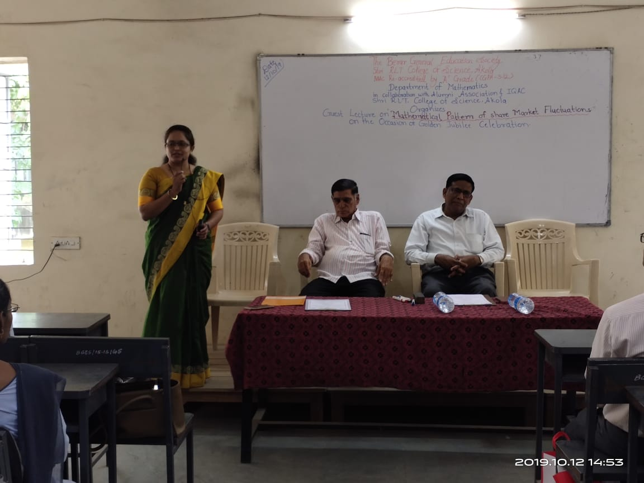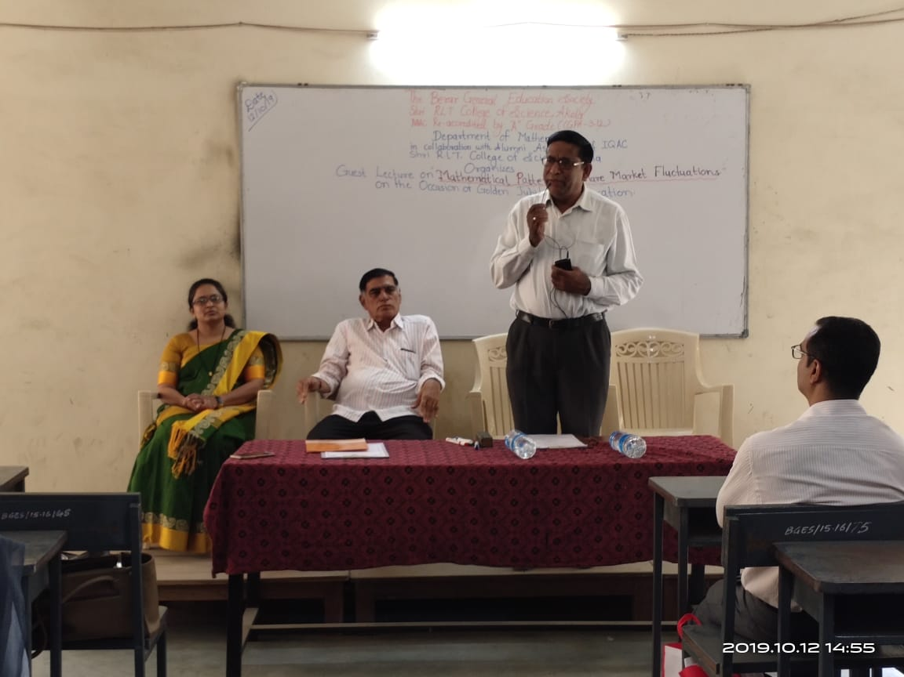
Introductory speech given by Dr.S.B.Tadam
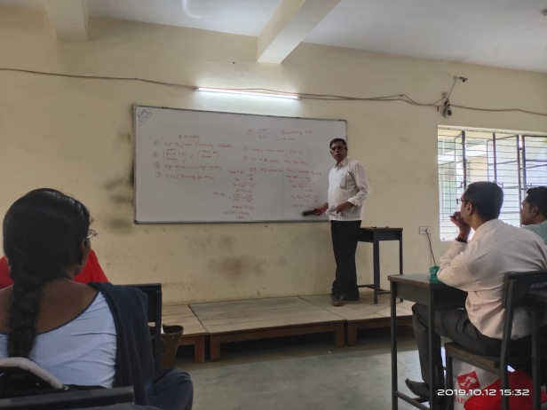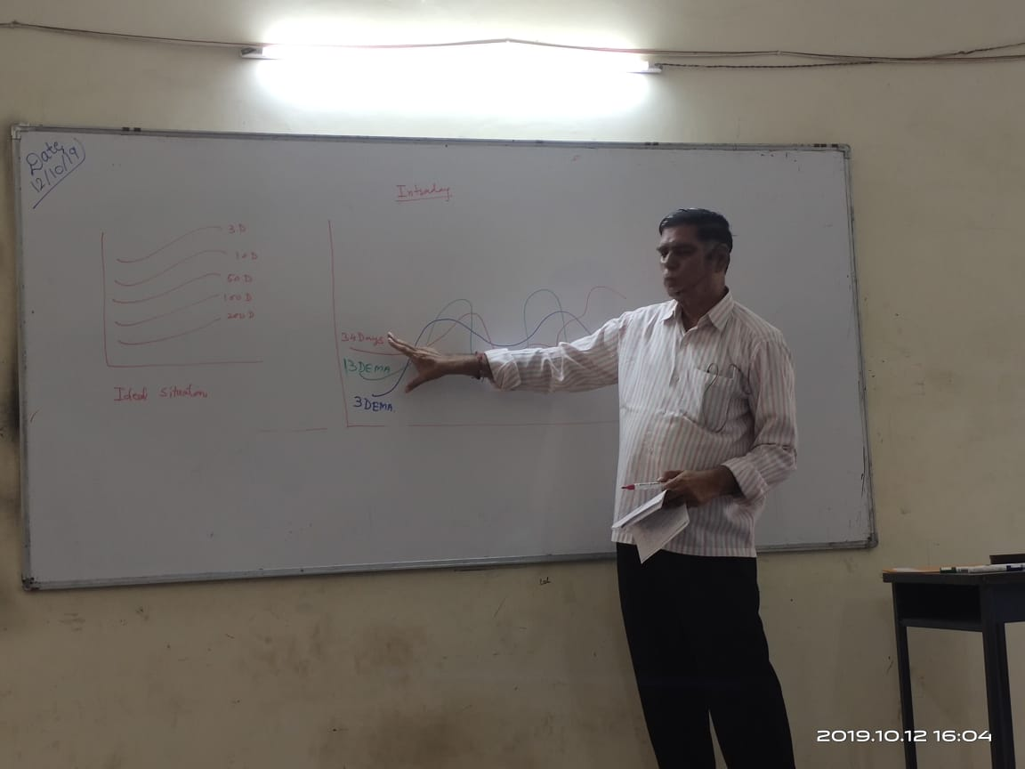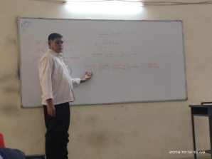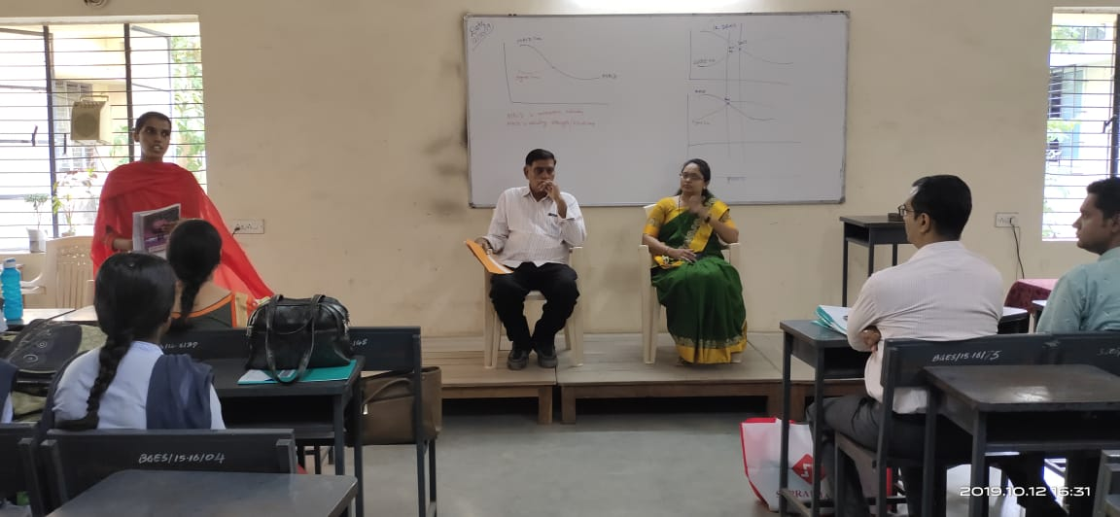

A Photo Report on Guest Lecture
On the topic
Mathematical Pattern of Share Market Fluctuations
On 12th Oct. 2019
(on the Occasion of Golden Jubilee Year Celebration)

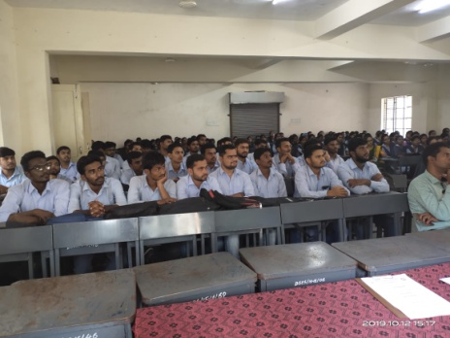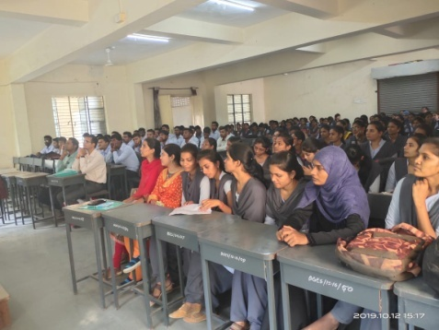

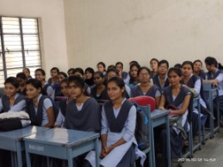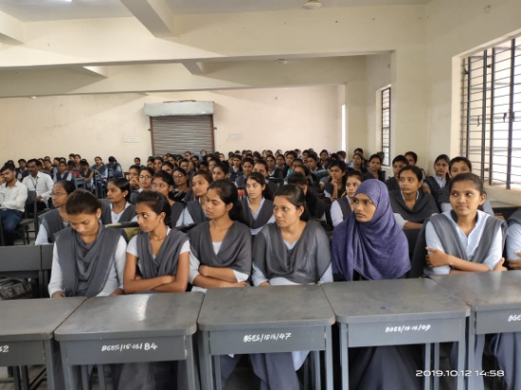

Blood donation camp and alumni day 24 Dec 2019 :-
For The inauguration of Late Principal M. G.Joshi Memorial day Programme on 24th Dec. 2019 Our College alumna Hon.Shri Bhausaheb Naikwade, Hon. Dr. R.B.Heda ,President The B.G.E.Society, Akola and Shri Gopikisan Bajoriya ,MLC Akola inaugurated that programme in Presence of Shri. Vijaykumar Toshnival, Dr.Ravindra Jain, Adv. Motisinghaji Mohata ,And Shri sharadaji Chaware give the message to our students and Felicited the meritorious students

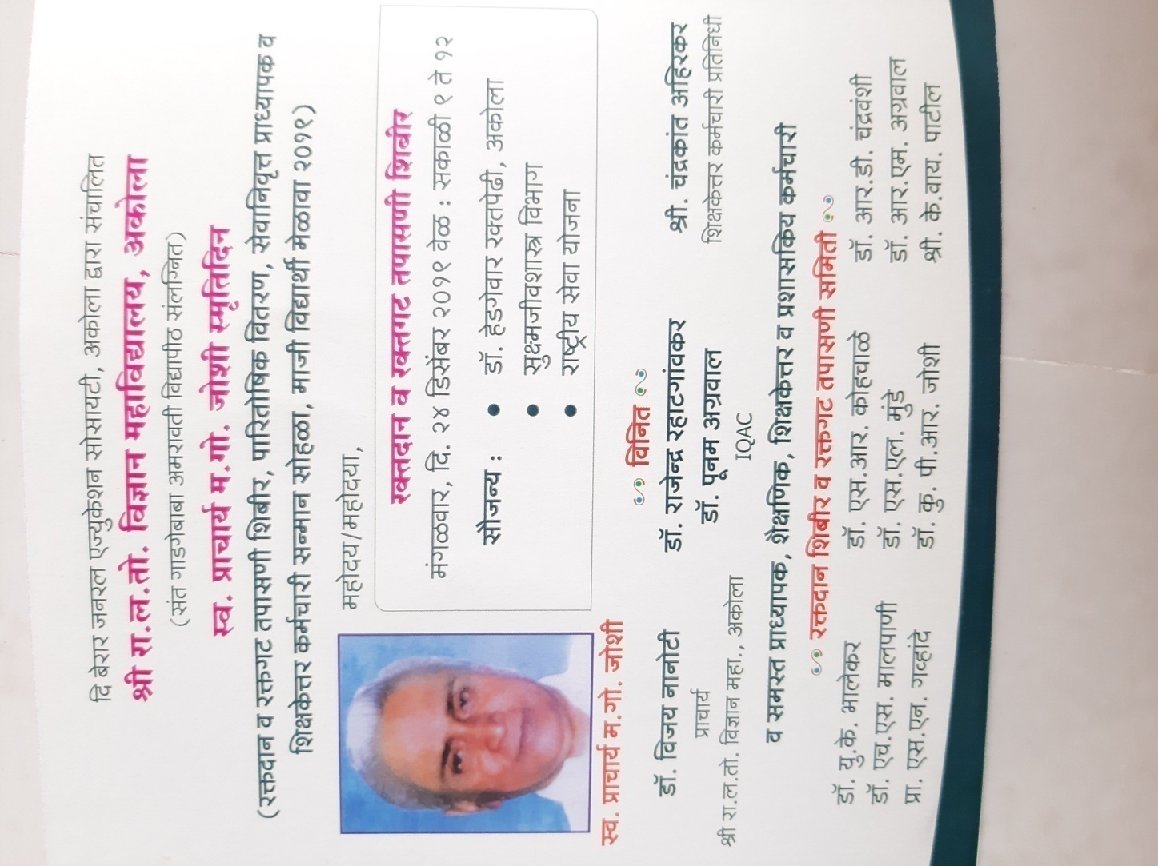

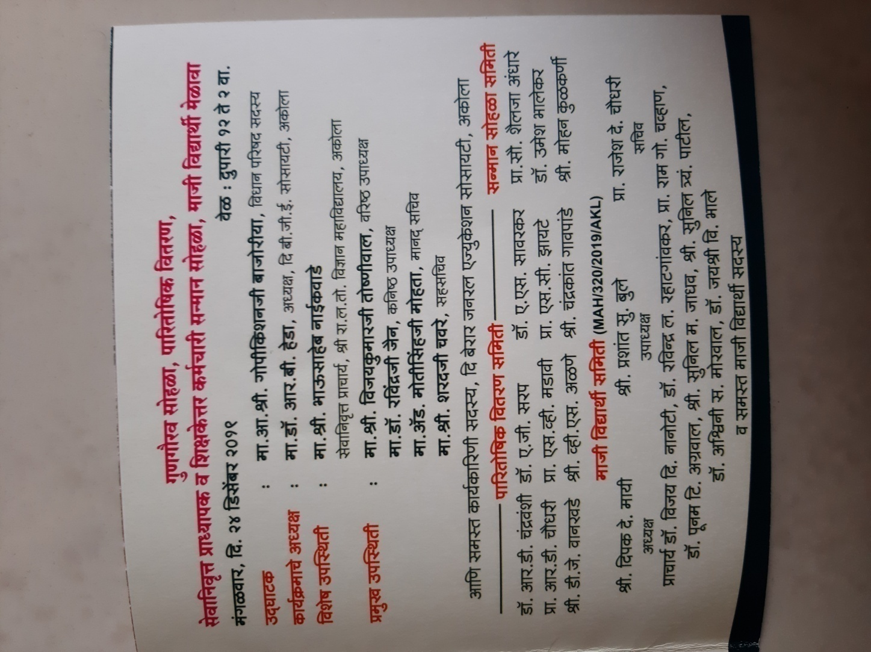

In Presence of the President of the Shri R. L. T. College Alumni Association Shri Deepak Mayeee the blood donation Camp was held on 24th Dec. 2019.

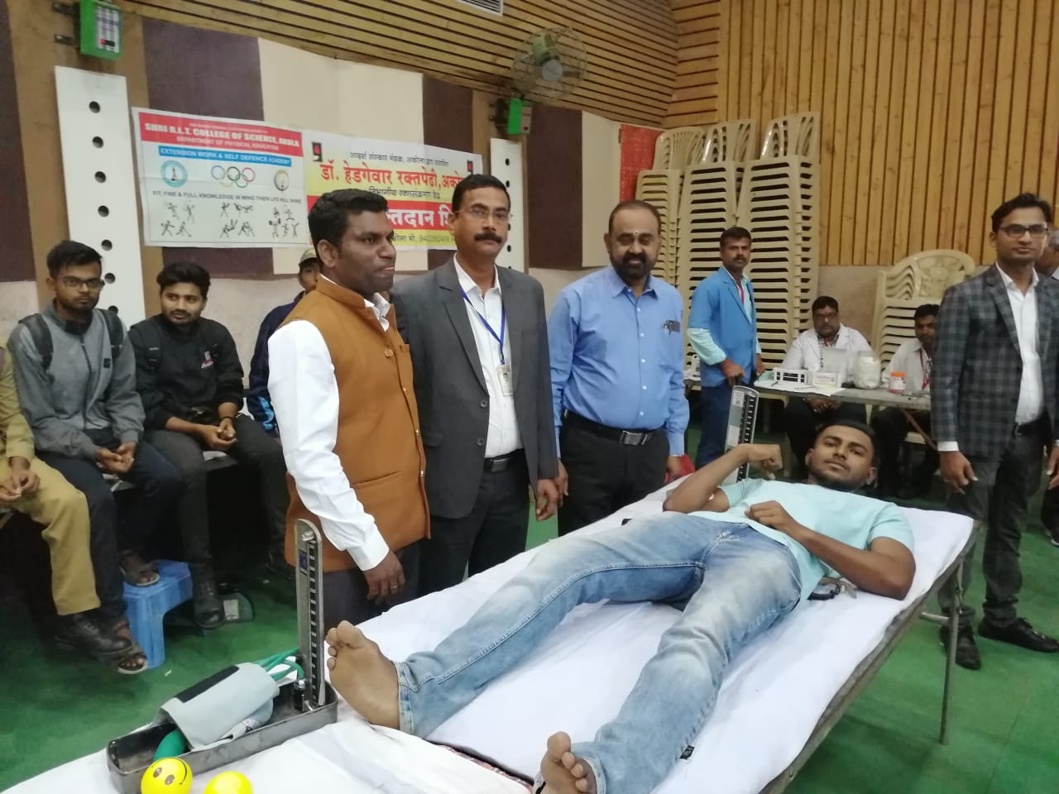

Felicitation of the Alumni on 24th Dec. 2019 with hands of our President of the BGE. Society, Akola Dr. R. B. Heda Sir:-
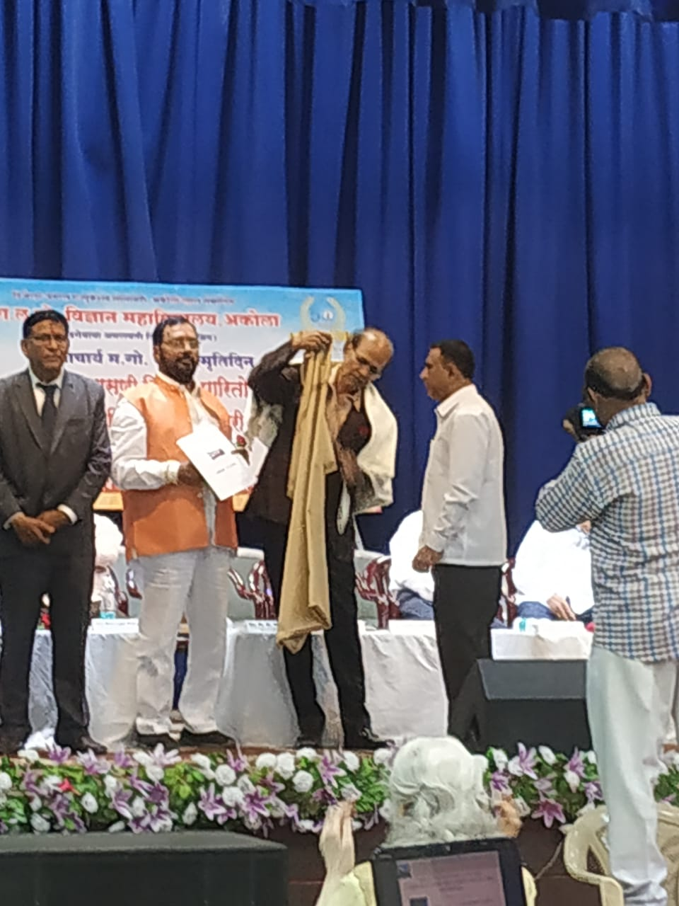

Felicitated Alumni Gathered together with on photograph:-
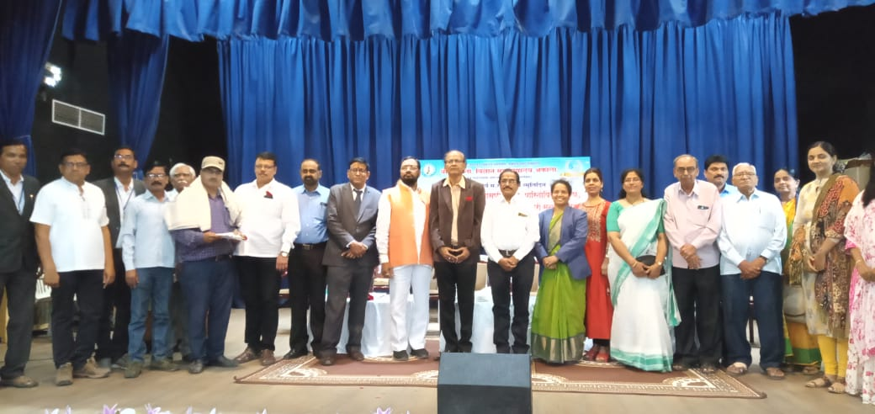
Departmental visit of our Prestigious Alumni in Electronics Department
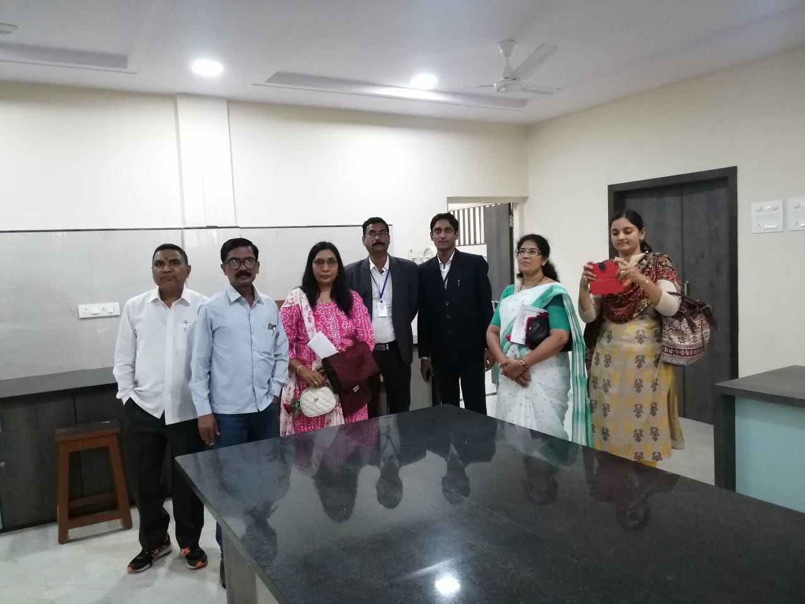

Blood Sampling and testing by microbiology department on the occasion of Alumna day to college premises on 24th Dec. 2019
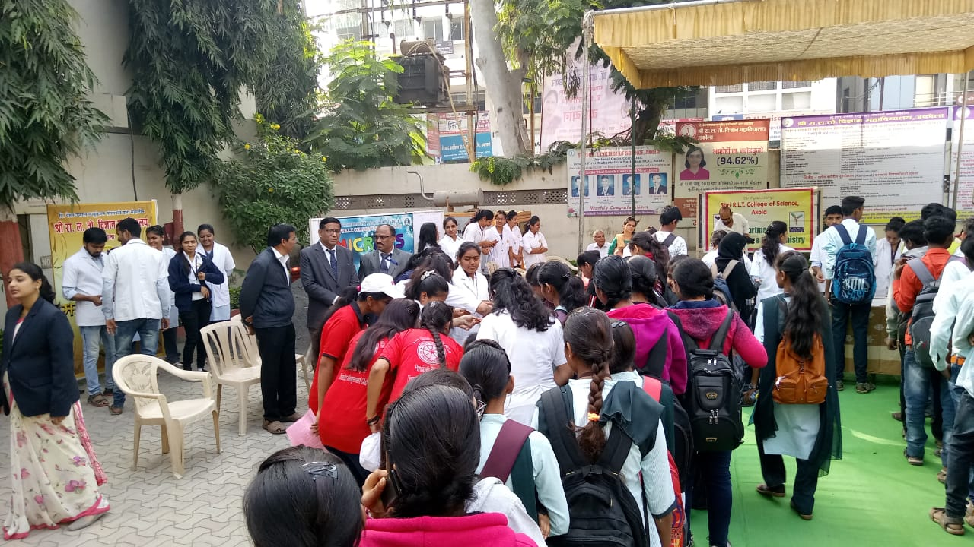

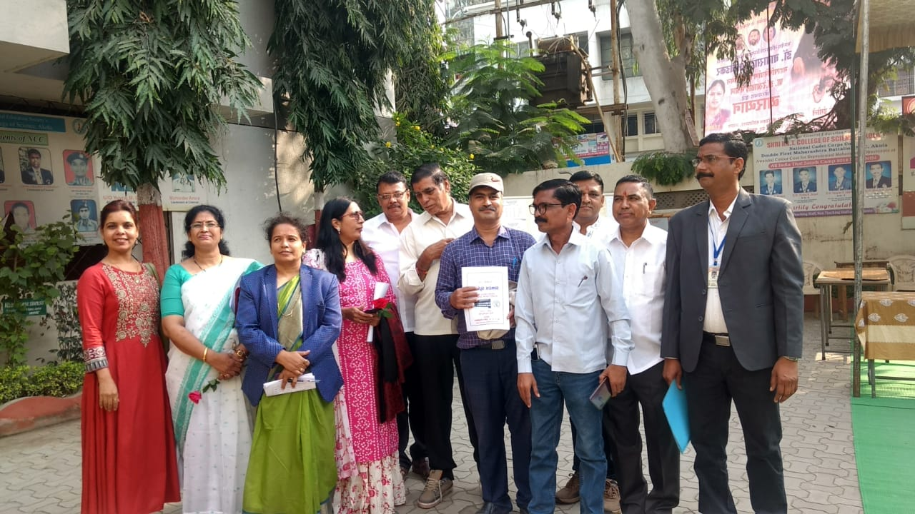

Our Eminent Alumna As a chief guest on National Conference arranged on 24th January 2020 at our college :-
Our college National Conference on 24th January 2020. We invited our Alumna Dr. Satish Sharma, Professor and Head , Department of Electronics and Computer Science, R.T.M. Nagpur university, Nagpur.
He Was a Guest of Honour on the occasion of National Conference on 24 Jan 2020 Sir had completed his graduation from our college in 1985.
Sir also visited various departments and opens their old memories in the college.
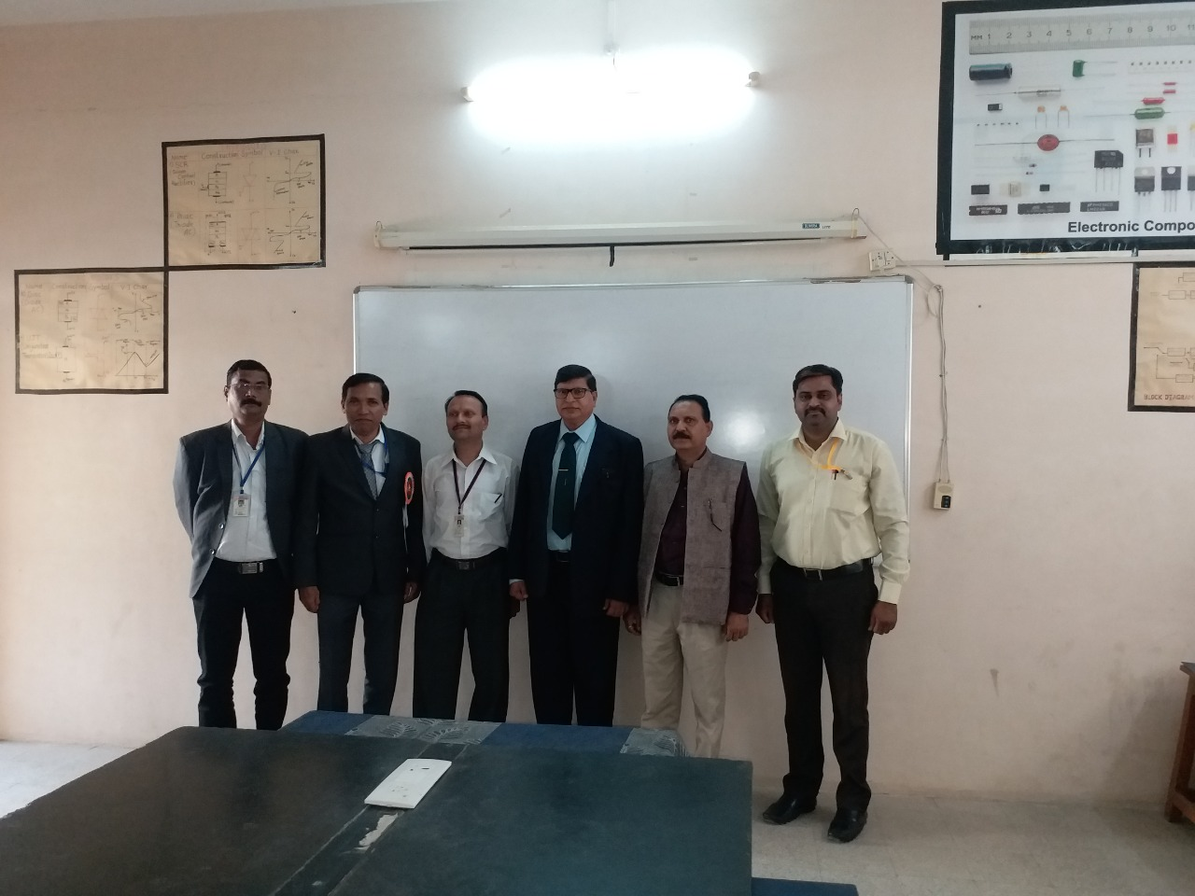
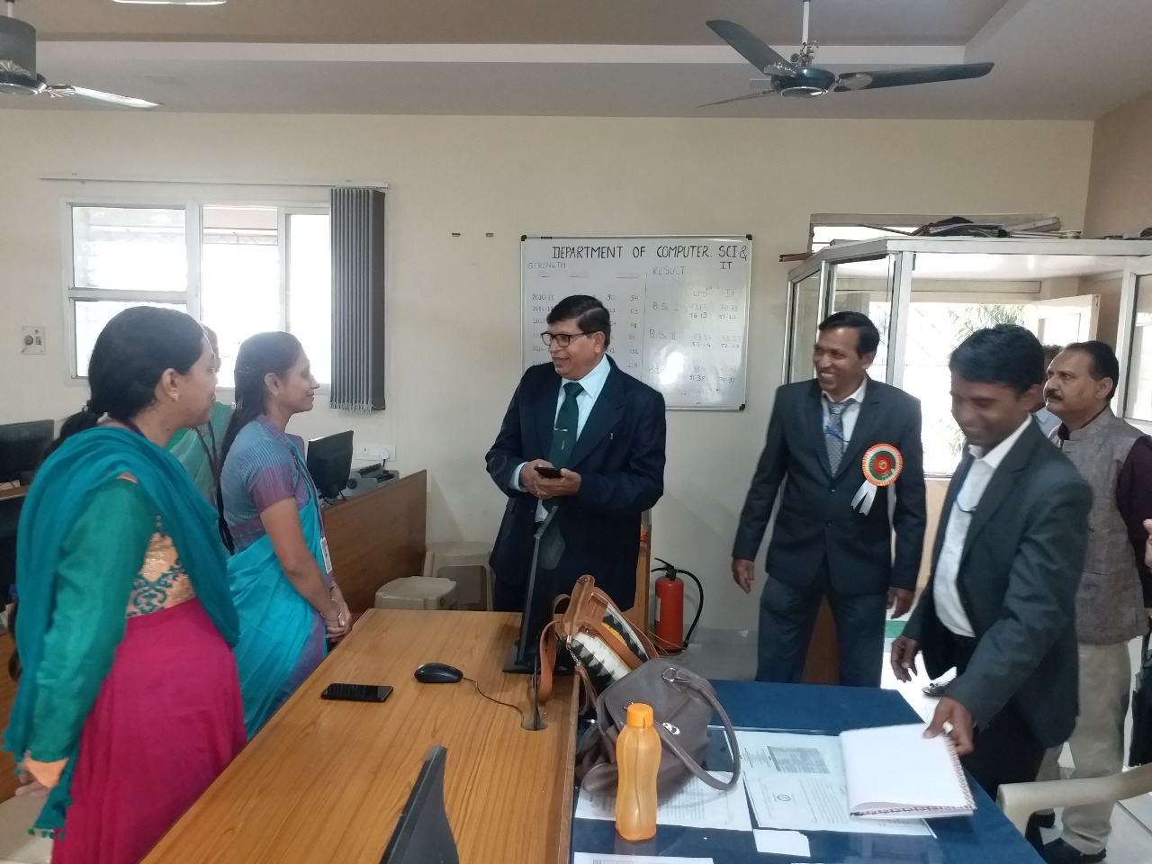

The following dates have taken Alumni meeting for various purposes:-

- The meeting was held on 20th Dec. 2020
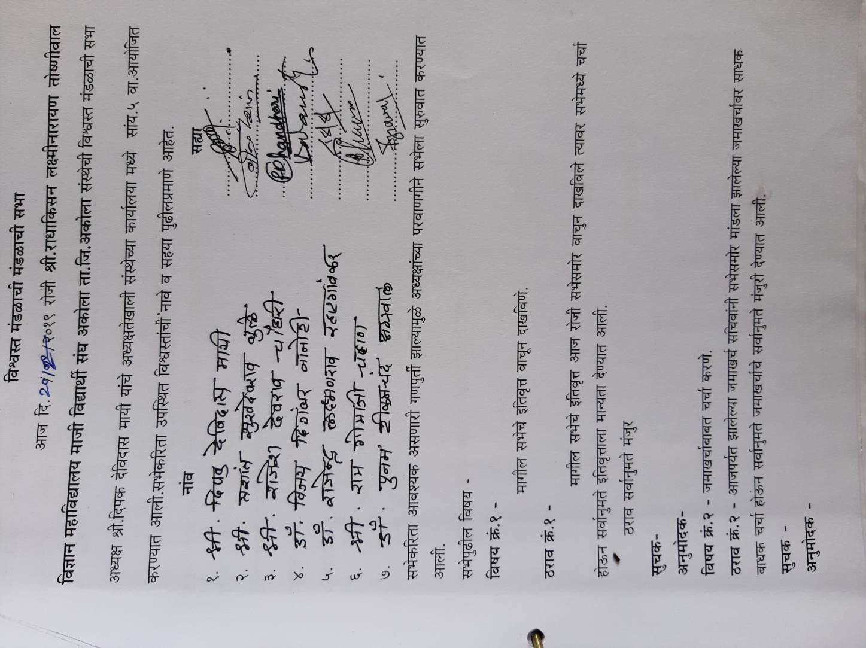

The meeting was held on 24 Dec2019 on the occasion of Alumni Day

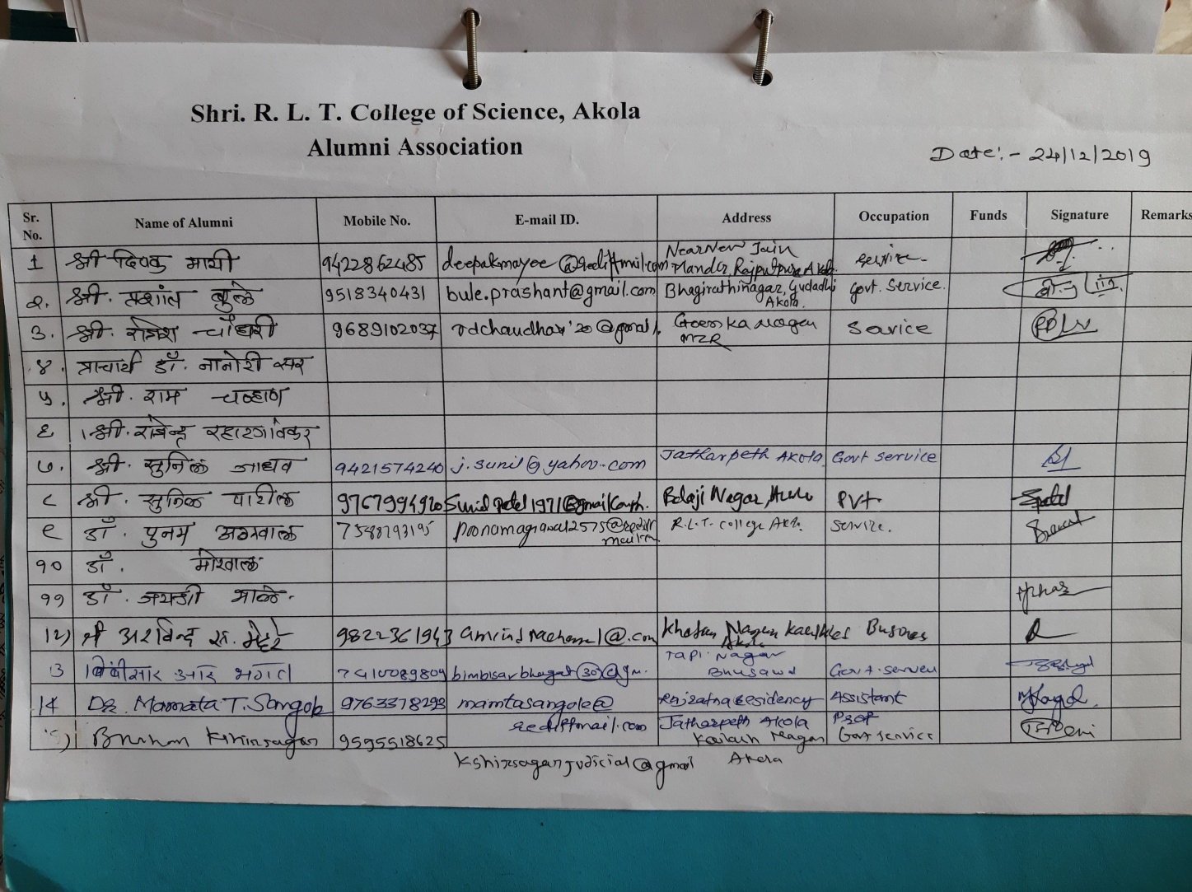

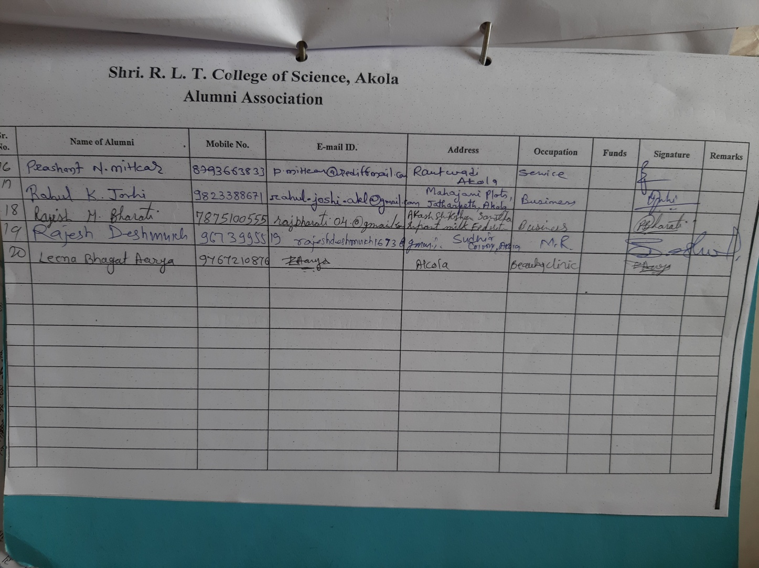

The meeting was held on 10 March 2020 About opening of the Account of Alumni Association.

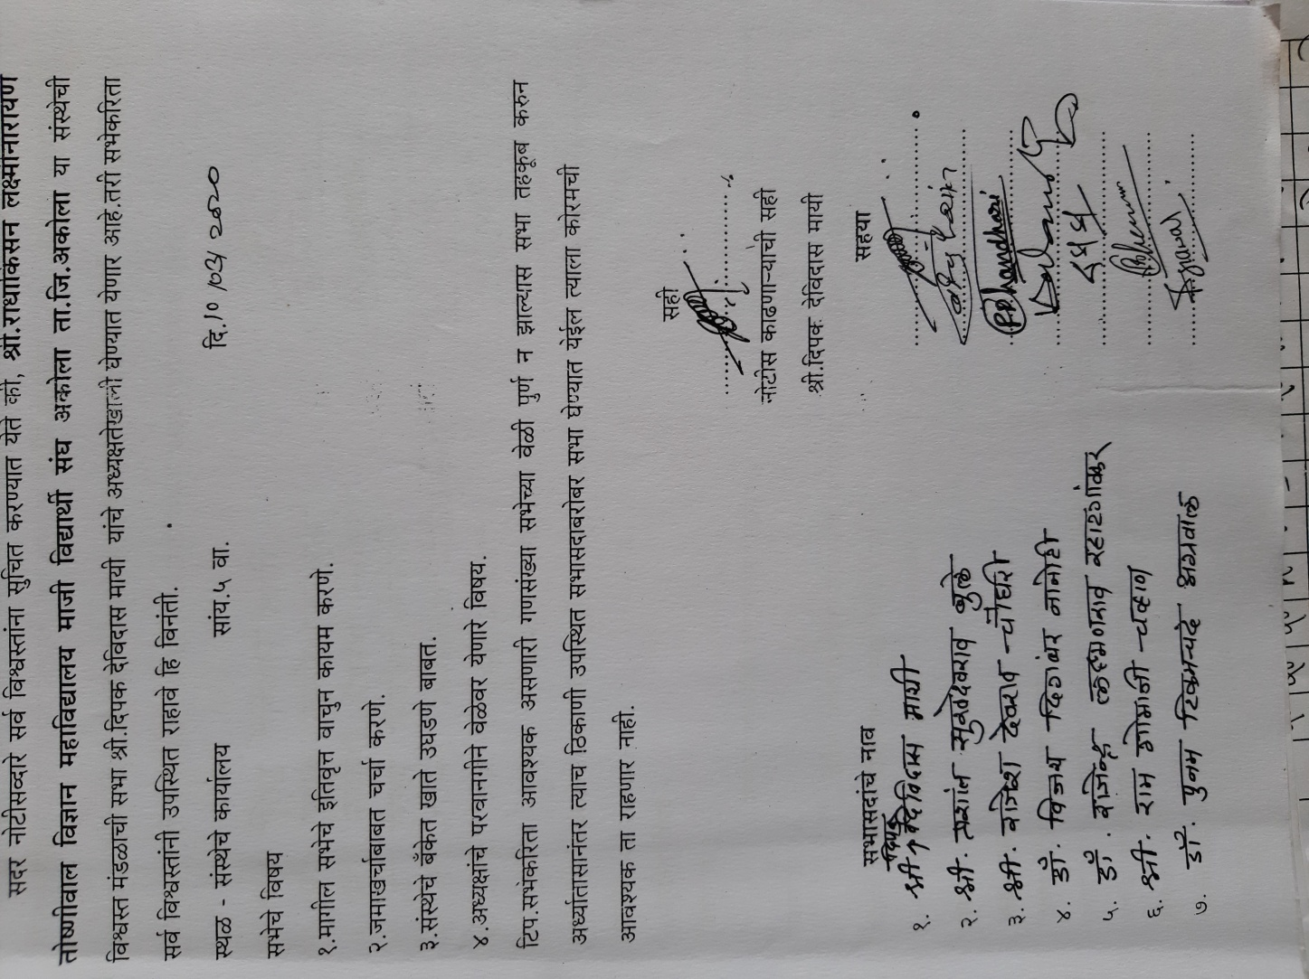

The meetig was held on 13th Dec. 2019 About Registration of the Alumna Association.:-
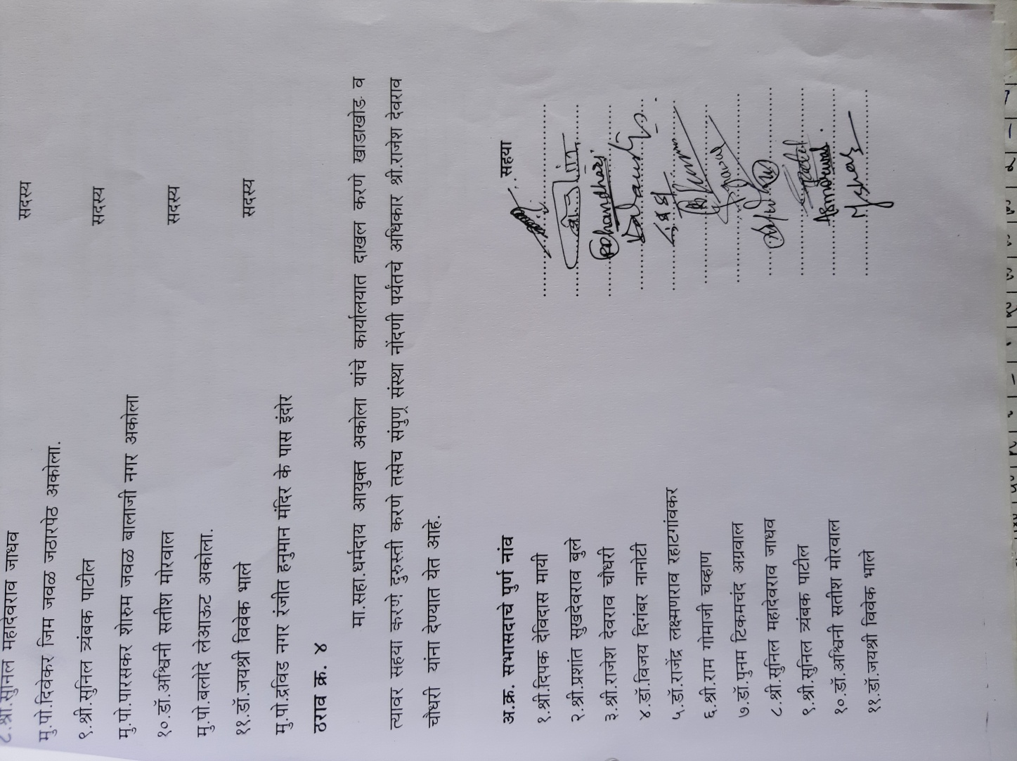

The Following Emminent RLT Alumni Visited The College during the year 2019-2020 :-
Sr.No. | Name of the Alumni | Designation/post
1 | Dr.Pradeep Agrawal | Opthomologist,Akola
2 | Dr. Amol Chitnis | Radiologist, Nagpur
3 | Dr. Nikhil panse | Plastic surgeon,Pune
4 | Dr.Prakash Metange | Ortho,m Akola
5 | Dr.Vrinda Bhattad | Dental ,Akola
6 | Dr.deepali Mohokar | Opthomo, paratwada
7 | Prof V.L.Ruiwale | Retired Proffessor
8 | Shri Chandrashekar m. payal | Retired SBI
9 | Mrs Manjusha Boralkar | Dept Dir., Mah. State.
10 | DR. Satish Sharma | Professor
11 | Prof P.R. Bhagat | Professor and Head at Wellhor
12 | Dr. D.M. Sanghai | Professor
13 | Dr. Pethe | Professor

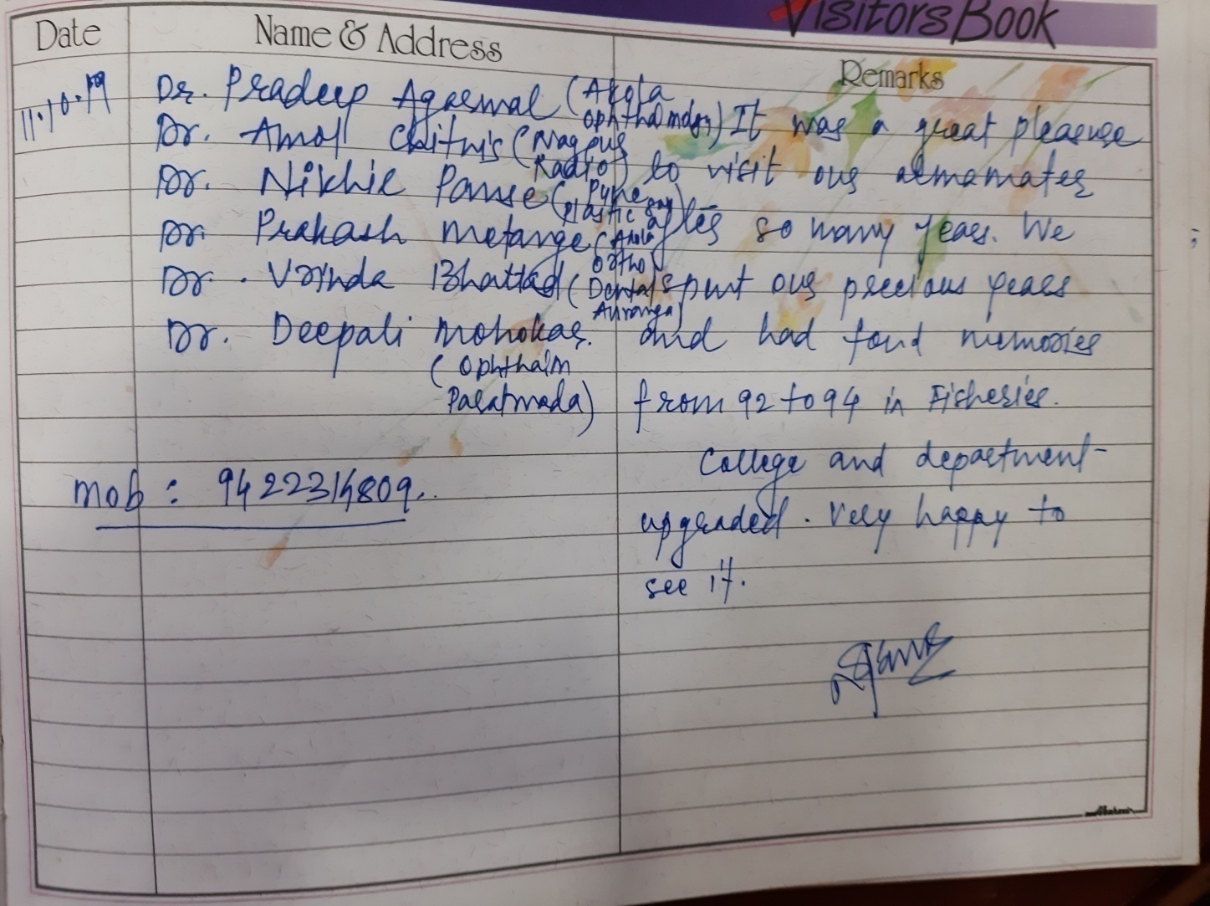
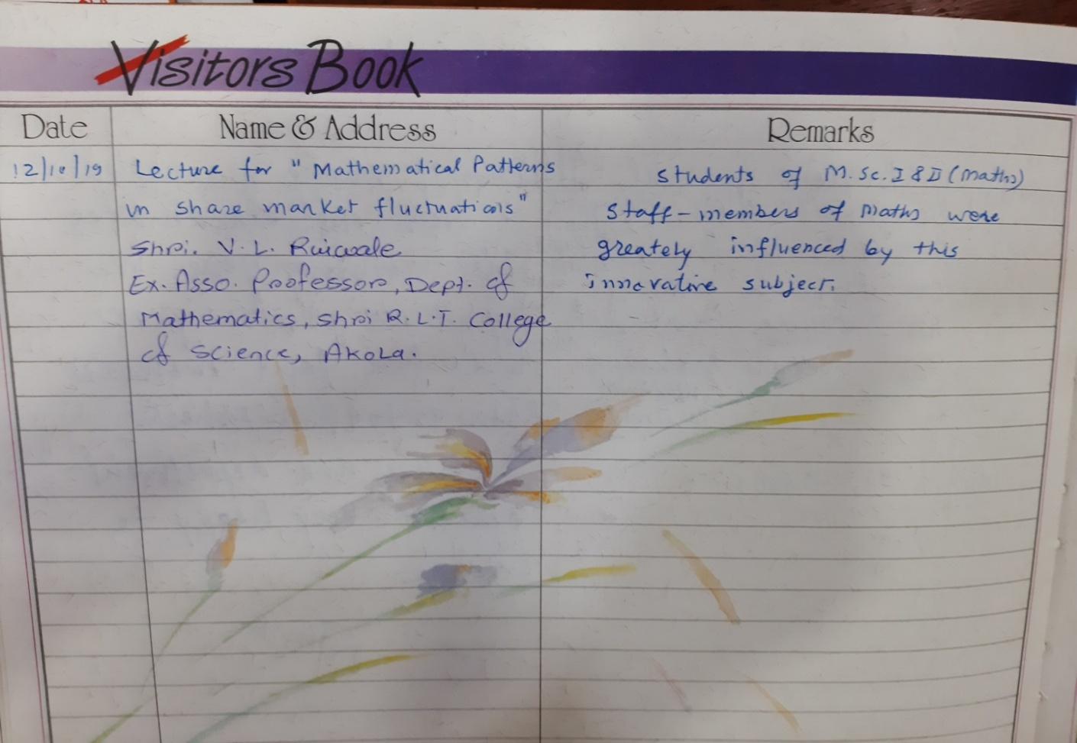

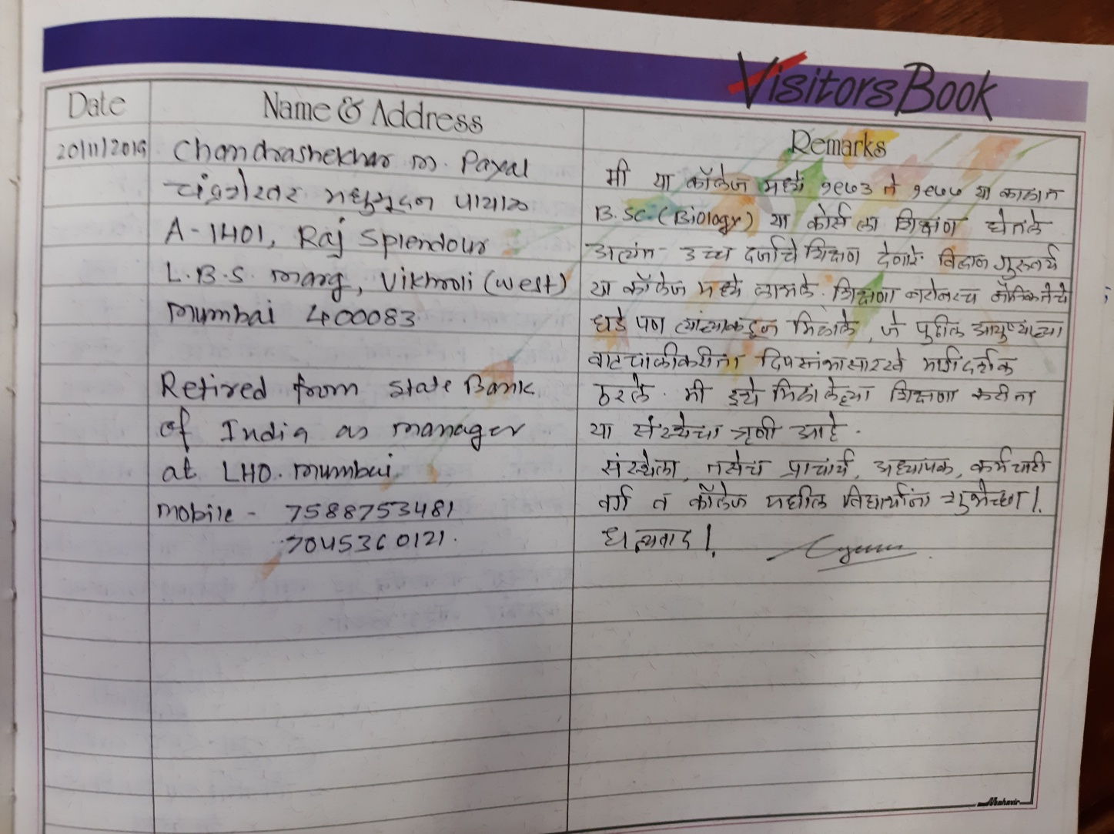
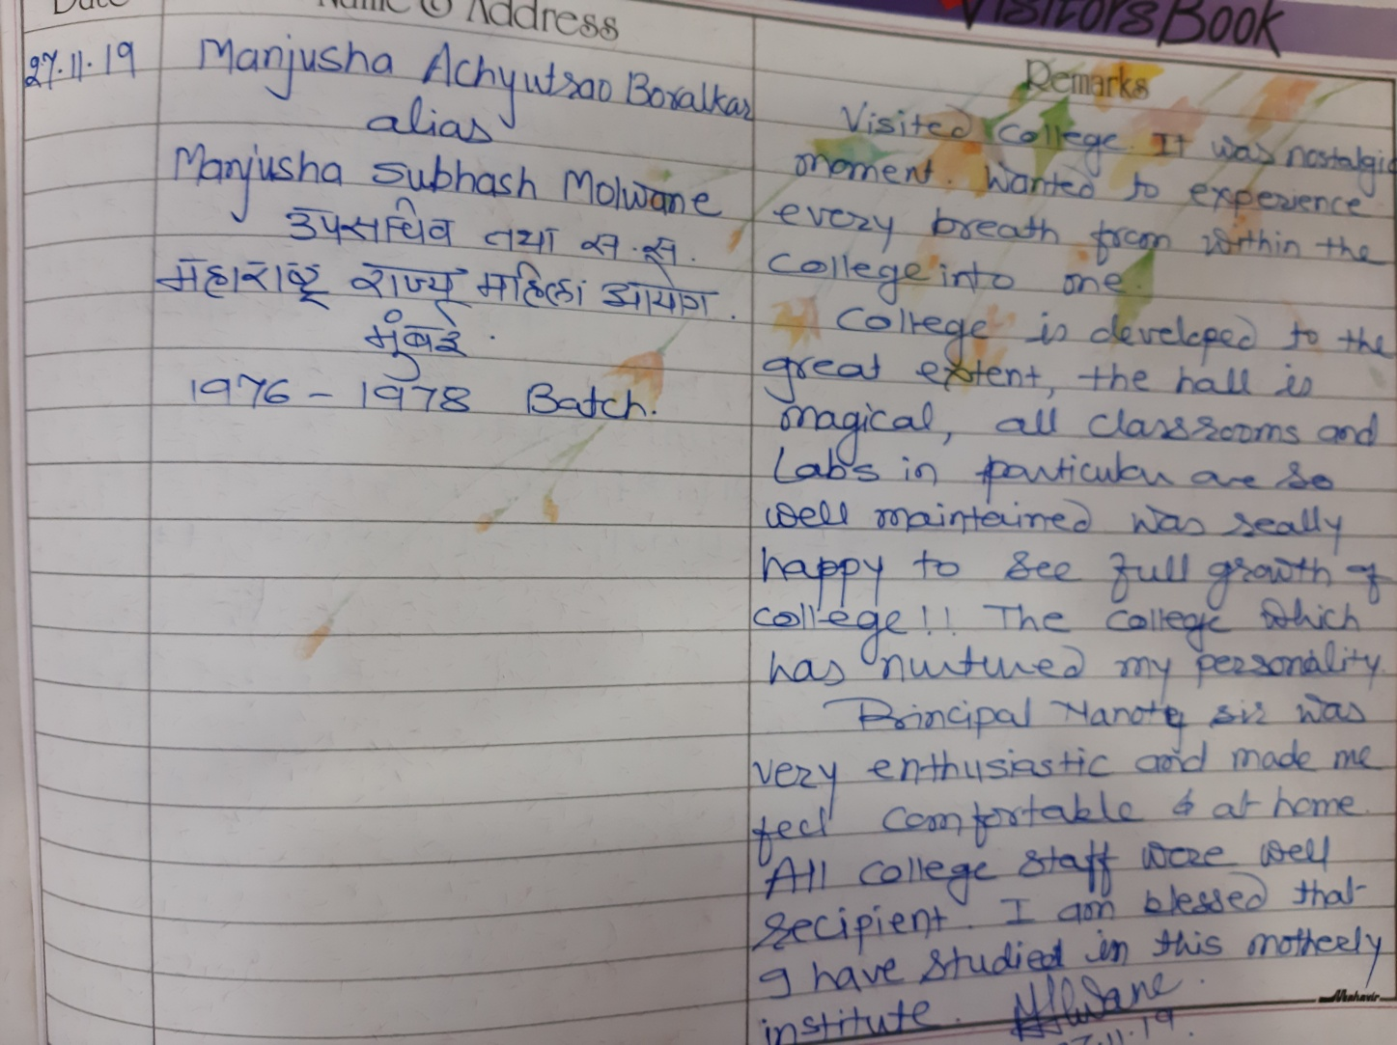

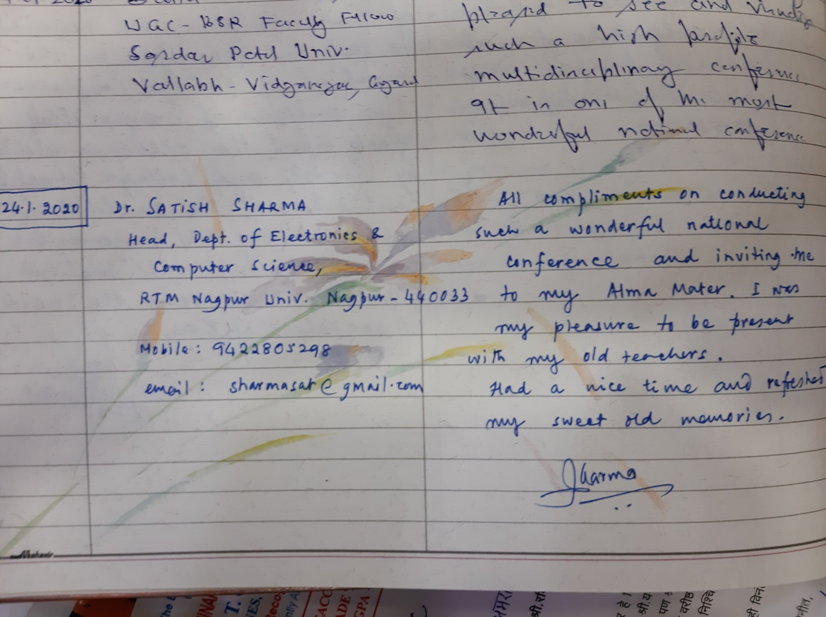
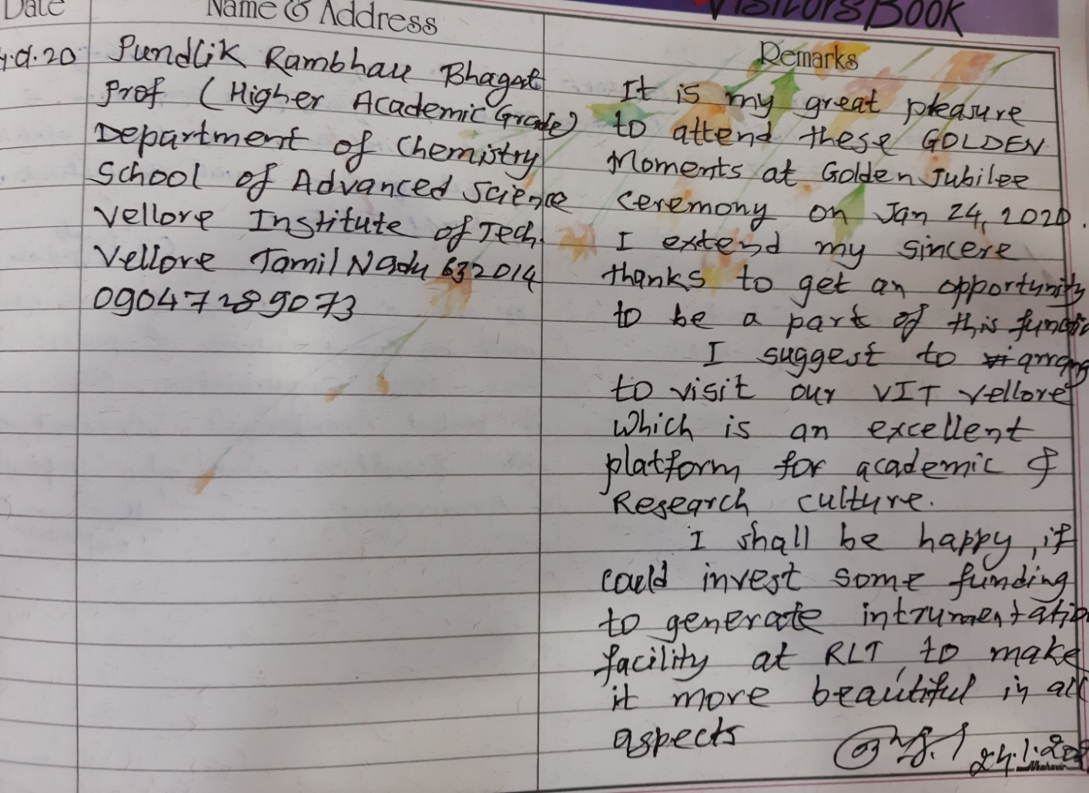

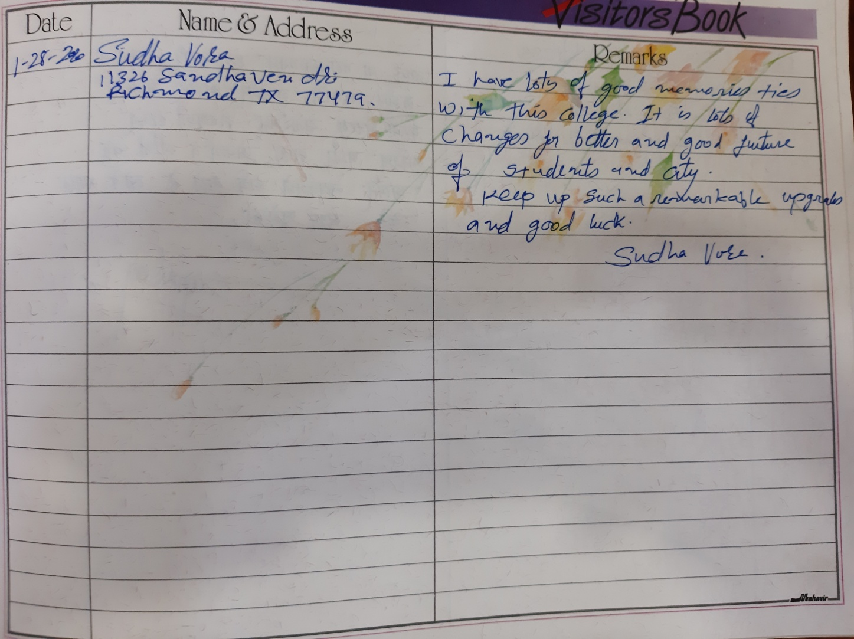
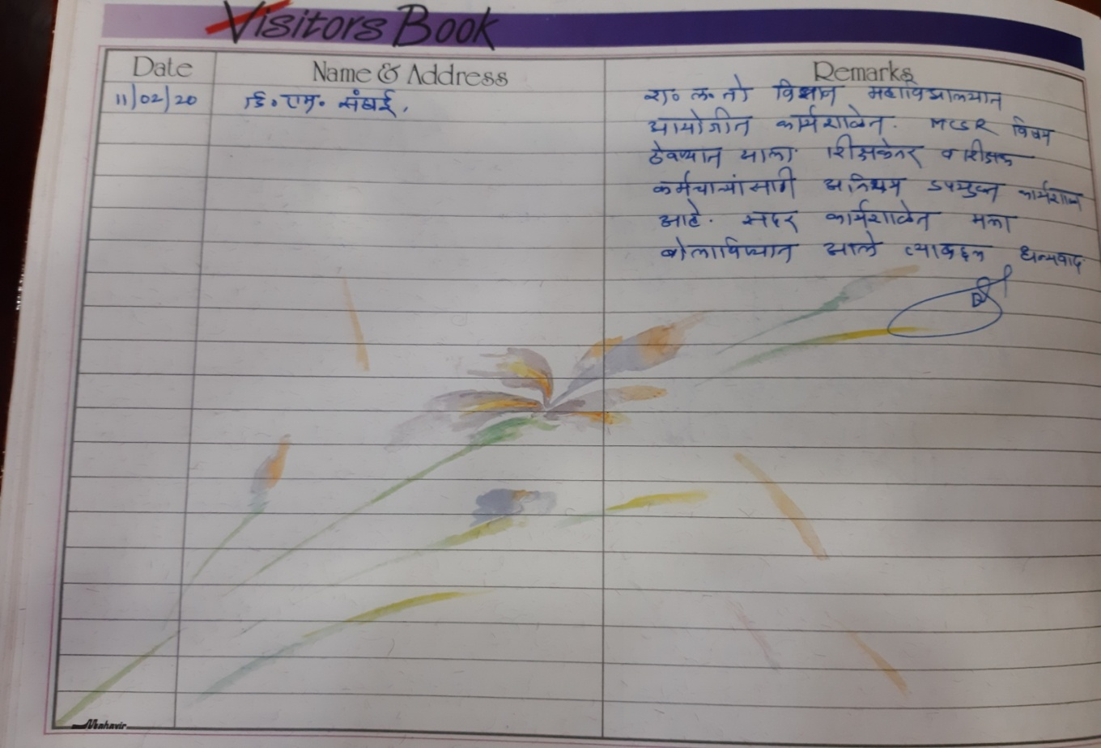

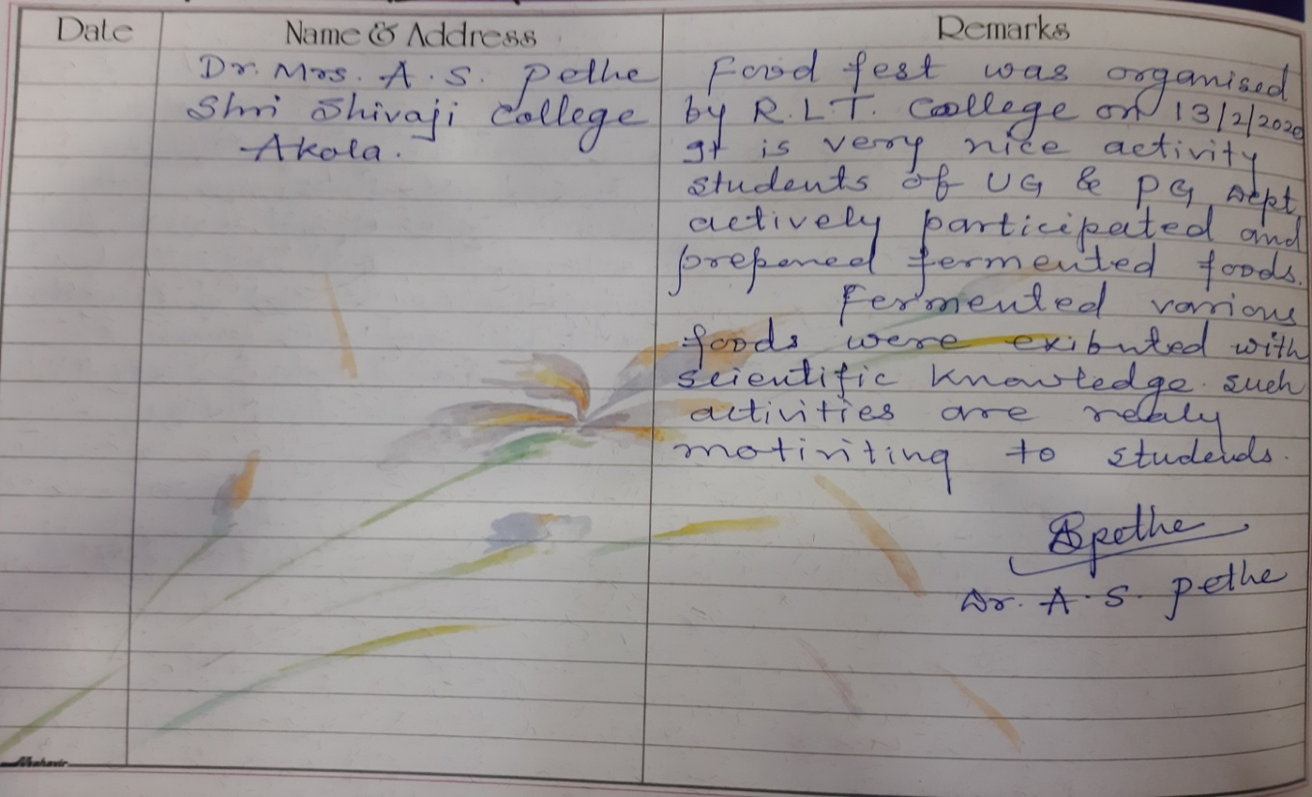

Prof. R.D. Chaudhari
Asst. Prof. in Electronics
Department of Electronics

