SHRI R. L. T. COLLEGE OF SCIENCE, AKOLA
REPORT FOR IQAC 2019-20
(On the Occasion of Golden Jubilee Year of Shri R. L. T. College of Science, Akola)

IQAC ACTIVITY No.: 3
Name of the Activity | District Level Teacher Research Festival Avishkar  (On the Occasion of Golden Jubilee Year of Shri R. L. T. College of Science, Akola)
Date | Faculty | Department/ Committee | Coordinator Name
10-01-2020 | ------- | Shri R.L.T.College of Science, Akola | Dr. Poonam T. Agrawal
Time | Venue | Number of Participants | Nature Indoor/Outdoor  /Online/Offline
------- | Shri R.L. T. College of Science, Akola | 125 Students | Offline
Link
Support/ Assistance | S. G. B. Amravati University, Amravati &Shri R.L.T. College of Science, Akola

Principal

Shri R.L.T.College of Science, Akola

BRIEF INFORMATION ABOUT THE ACTIVITY
TOPIC/ SUBJECT OF THE ACTIVITY | District Level Teacher Research Festival Avishkar
OBJECTIVES | - To Provide the Small scale business to the students.  - To motivate the Students for Research Activity.  - To Develop and Nourish the Research culture among the teachers and students.  - To Provide the Platform for the innovative concept of the students.  - To develop thinking and creativity among the students.
METHODOLOGY | The event was organized at shri R.L.T.College of Science, Akola on 10th January 2020. Avishkar is an intercollegiate research festival which provide platform for research talent of the students at the university level. It also aims to inculcate research culture and original thinking as essential in the age of openness and globalization for knowledge based society.  Total 62 posters and models from five subjects were registered for the event from above subjects from different colleges from Akola District. Each posters and models were presented by two or three students. Total 125 students had directly participated in the event and 150 more students visited posters and models from various colleges.  Hon. D.T.Ingole, Director Incubation and Innovation & linkage centre, SGB Amravati University, Amravati inaugurated the festival. Hon. R. B. Heda, President The B.G.E. Society, Akola presided over th function. Hon. Adv. MotisinghMohta was the Chief Guest for the function. Introductory remarks were express by Dr. Poonam Agrawal, District coordinator of Akola District. Welcome speech was delivered by Dr, V.D. Nanoty, Principal, Shri R.L.T. College of Science, Akola, Dr. SudhirKochale conducted the Programme and Vote of thanks were proposed by DR. A.G. Sarap.  Hon. V.D. Nanoty, Principal Shri R.L.T. College of Science, Akola was the president for Valedictory function. Dr. S.B. Tada. Conducted the valedictory and Dr. Kavita Heda proposed vote of thanks.  Finally 20 entries of Researches from Amravati district were selected for University level Avishkar-2019.  The overwhelming responses to this science fest, boosts our moral and encourage us to organize, the similar event in future also. The response of the students to this festival indicates that the youth are having the many innovative and creative ideas and by this festival to exhibit their innovations and ideas.
OUTCOMES | - Total125 students of Sant Gadge Baba Amravati University, Amravati get benefitted by this Research Festival.  - As a Result of this workshop a huge response is received for the Research Activity from our college.  - 11 Students from our college get selected at University level Competition.  - Two Students Awarded with color coat and represented the University at Interuniversity competition.

Photo Gallery

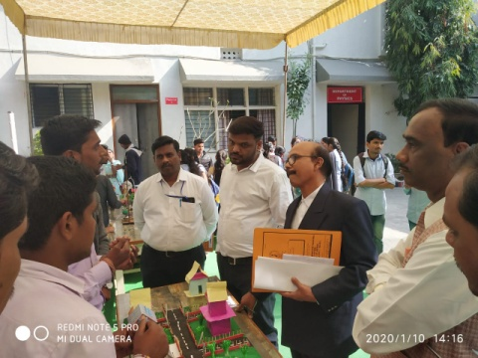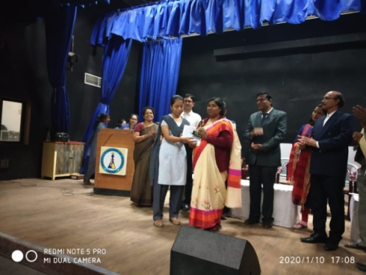

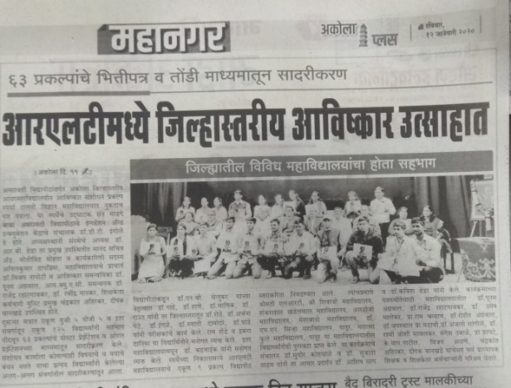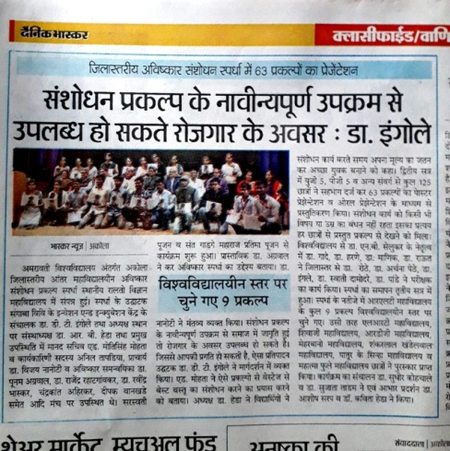

Coordinator
Dr. Poonam T. Agrawal
Assistant Professor & Head,
Department of Chemistry,
Shri R.L.T. College of Science, Akola

