SHRI R. L. T. COLLEGE OF SCIENCE, AKOLA
REPORT FOR IQAC 2019-20
(On the Occasion of Golden Jubilee Year of Shri R. L. T. College of Science, Akola)

IQAC ACTIVITY No.: 1
Name of the Activity | Soft Skill Development Workshop  (On the Occasion of Golden Jubilee Year of Shri R. L. T. College of Science, Akola)
Date | Faculty | Department/ Committee | Coordinator Name
3-10-2019  To  6-10-2019 | Dr. Poonam T. Agrawal-Coordinator  Shri.R.D. Chaudhary-Member  Dr. A.G. Sarap-Co-coordinator  Dr. H.S. Malpani-Member | Department of Chemistry  & Career Counselling Cell  Placement Cell &  IQAC  Shri R.L.T.College of Science, Akola | Dr. Poonam T. Agrawal
Time | Venue | Number of Participants | Nature Indoor/Outdoor  /Online/Offline
------- | --- | 50 | Offline
Link | https://forms.gle/n4AFdUa2b9cfsiSC8
Support/ Assistance | Shri R.L.T. College of Science, Akola

Principal

Shri R.L.T.College of Science, Akola

BRIEF INFORMATION ABOUT THE ACTIVITY (CRITERION NO. ……..)
TOPIC/ SUBJECT OF THE ACTIVITY | Soft Skill Development Workshop
OBJECTIVES | - To guide students in making appropriate and responsible decisions.  - All round Development of students.  - Make them ready for competitive Examinations.  - To create a desire to fulfill individual goals, and to educate students about aims and goals.  - To develop the Personality of the students.
METHODOLOGY | The programme begins on 3rd October with registration of student from 9.00 a.m. to 10.00 a.m. then there was inauguration of the workshop. Dr.V.D.Nanoty, Principal of our College was the Inaugurator of workshop and Dr. Sonal Kame madam, Asst. Professor R.D.G.College, Akola was the Resource person for the first day. Dr. Poonam Agrawal, Coordinator of workshop in her inauguration speech thanks to Vice Chancellor, Amravati University and Dr. Satange sir, Student development Cell, S.G.B. Amravati University, Amravati for giving opportunity to our college for this organization. . Dr. V.D. Nanoty Sir guided the students about the need of workshop and giving some examples on time management. Dr. Sonal Kame madam delivered her speech on Motivation Character Ethics & Moral. Total 50 students registered for the workshop. First day session ends with the vote of thanks by Dr. Aashish Sarap.  Second day there was a lecture of Dr. Chapke sir, Asst. Professor L.R.T. College Akola on-Resume writing. Dr. U.K.Bhalekar, Head Dept. of Microbiology was the chief guest for today’s activity. Dr. Rajesh Chandrawanshi, Physical Director of our college as well as Student Development Officer of our College Cell motivated the students in our Speech. Dr. R.D. Chandrawanshi proposed the vote of thanks.  Third day there was a two sessions of Dr. Nitin Mohod Sir, Associate Professor, Shri Shivaji College of Science, Akola . Sir has delivered a talk on Personality development. Dr. Harish Malpani, Asst. Professor Dept, of Microbiology proposed the vote of thanks.  On fourth day there was first session of DR. R.D. Choudhary, Shri R.L.T. College of Science, Akola and second session of Dr. Rohit Agrawal, Shri R.L.T. College of Science, Akola.  The workshop ends with the valedictory function, Dr. V.D. Nanoty sir was the chairperson and DR. Poonam Agrawal Conducted the Programme. DR. R.D. Chandrawanshi, DR. R.D. Choudhary, Dr. Aasshish Sarap, Dr,Harish Malpani and all the teaching and non-teaching staff members of the college worked hard for the success of the workshop.
OUTCOMES | - Total50 students get benefitted by this workshop.  - At the end of this workshop students should be able to….  - Observe the change is his personality.  - Develop effective communication skills (spoken and written).  - Develop effective presentation skills.  - Develop effective reading skills.  - Conduct effective business correspondence and prepare business reports which produce results.  - Self-confidence is developed among the students.

Photo Gallery

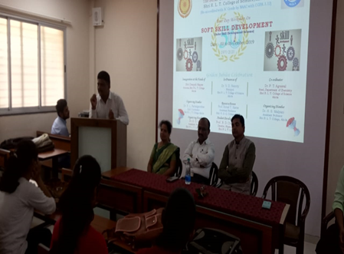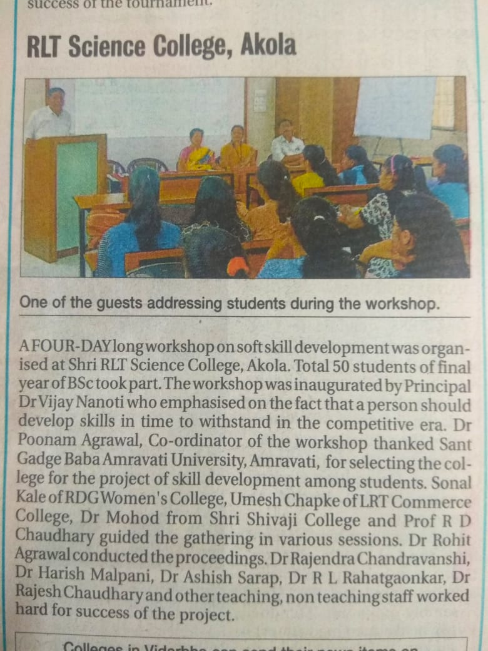

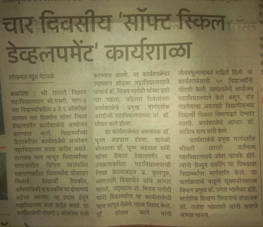

Coordinator
Dr. Poonam T. Agrawal
Assistant Professor & Head,
Department of Chemistry,
Shri R.L.T. College of Science, Akola

