SHRI R. L. T. COLLEGE OF SCIENCE, AKOLA
REPORT FOR IQAC 2019-20
(On the Occasion of Golden Jubilee Year of Shri R. L. T. College of Science, Akola)

IQAC ACTIVITY No.: 1
Name of the Activity | District Level Teacher coordinators Workshop for Avishkar  (On the Occasion of Golden Jubilee Year of Shri R. L. T. College of Science, Akola)
Date | Faculty | Department/ Committee | Coordinator Name
19-09-2019 | ------- | Shri R.L.T.College of Science, Akola | Dr. Poonam T. Agrawal
Time | Venue | Number of Participants | Nature Indoor/Outdoor  /Online/Offline
------- | Shri R.L. T. College of Science, Akola | 13 Teachers  200 Students | Offline
Link
Support/ Assistance | S. G. B. Amravati University, Amravati &Shri R.L.T. College of Science, Akola

Principal

Shri R.L.T. College of Science. Akola

BRIEF INFORMATION ABOUT THE ACTIVITY (CRITERION NO. ……..)
TOPIC/ SUBJECT OF THE ACTIVITY | District Level Teacher coordinators Workshop for Avishkar
OBJECTIVES | - To motivate the Students for Research Activity,  - To Develop and Nourish the Research culture among the teachers and students.  - To Provide the Platform for the innovative concept of the students.  - To develop thinking and creativity among the students.
METHODOLOGY | Sant Gadge Baba Amravati University, Amravati every year organizes the Research Festival Avishkar for the students of U.G., P.G., Post P.G. and teacher perusing Mphil. Ph.D.To Promote the research culture among the students there is organization of Avishkar Festival. For this there is organization of 14th Intercollegiate Research Convention, Teacher Coordinators Workshop on 19th Sept. 2019 at Shri R.L.T. College of Science, Akola. Total 13 teacher coordinators and more than 200 students were registered for the event.  Hon’ble Adv. M. G. Mohta, honorary Secretary, The Berar General Education Society, Akola President over the function. Hon’ble Dr. D.Y.Chacharkar, Associate Professor Dept. of Commerce and Management inaugurated the festival. Dr. V.D. Nanoty Principal Shri R.L.T. College of Science, Akola delivered the welcome speech. Introduction remarks were expressed by Dr. Poonam Agrawal, District coordinator of Akola District. Dr. SudhirKochale conducted the Inauguration function. Hon’ble Dr. D.Y. Chacharkar, Hon’ble Dr. R.D.Sarode, Hon’ble Dr. P.A. Gawande and Hon’ble Dr. Z. H. Khan sir was the resource persons for the workshop.  All the detail information about the research projects , how to select the Project and what are the different evaluation process of Avishkar competition were explain by the resource persons in four technical session. Vote of Thanks was proposed by Dr. Aashish Sarap.  Hon’ble Dr. D. T. Ingole, Director Innovation and Incubation linkages centre , S.G. B. Amravati University, Amravati was the chief Guest for the valedictory function of workshop. Dr. Harish Malpani presents the report of whole events and Dr. Kavita Heda proposed a vote of thanks of Valedictory function. Dr. R.L.Rahatgaonkar, DR. R.D. Choudhary and all teaching and non-teaching staff members worked for the success of the programme.
OUTCOMES | - Total13 students and 200 students get benefitted by this workshop.  - As a Result of this workshop a huge response is received for the Research Festival Avishkar.  - 11 Students from our college get selected at University level Competition.  - Two Students Awarded with color coat and represented the University at Interuniversity competition.

Photo Gallery

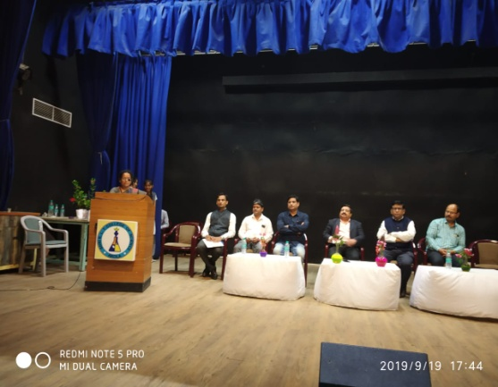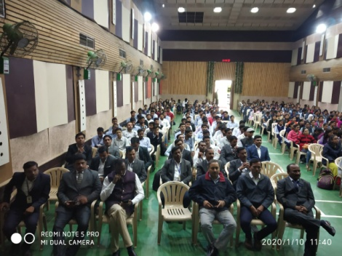

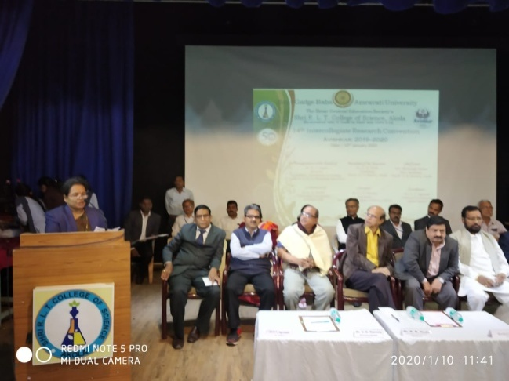
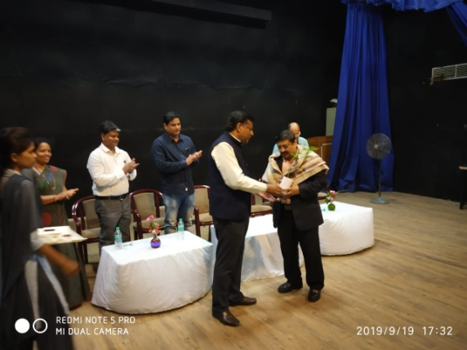

Coordinator
Dr. Poonam T. Agrawal
Assistant Professor & Head,
Department of Chemistry,
Shri R.L.T. College of Science, Akola

