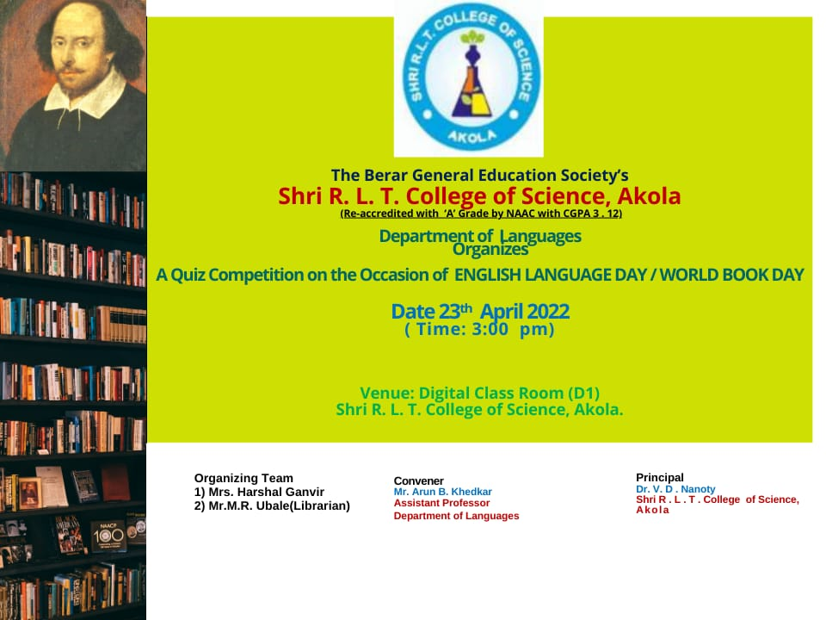

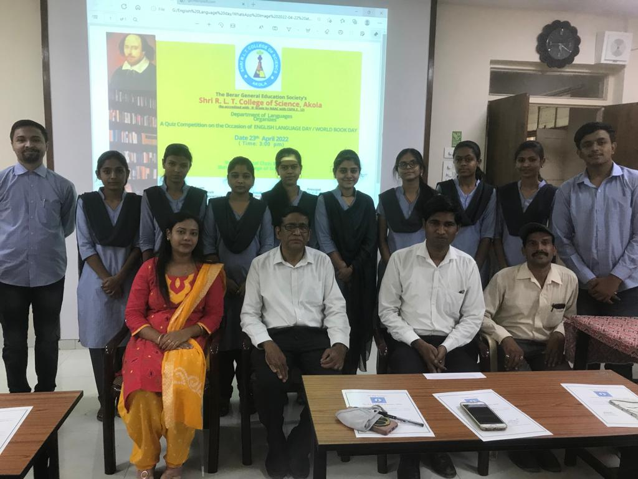

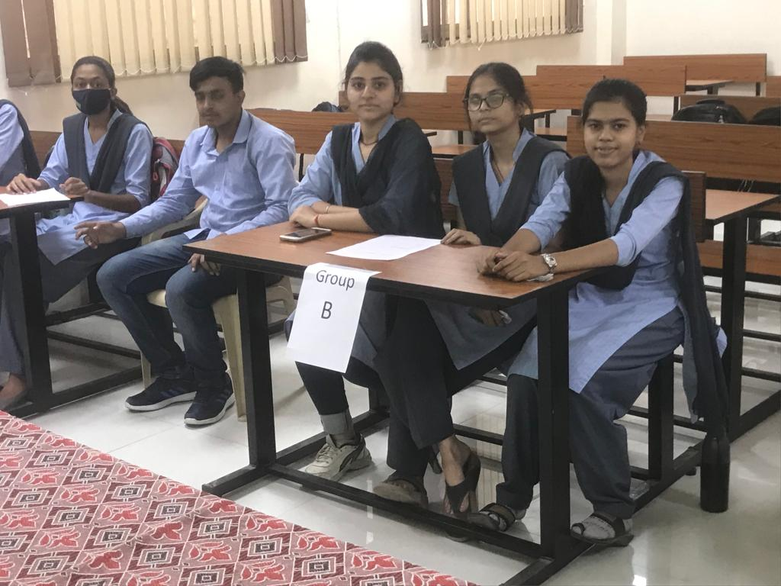

English language Day celebrated

World book day along / English Language Day was celebrated on 23.04.2022 at Shri R.L.T. College of Science college, Akola.The Language department organised a quiz competition on this occasion. This quiz was designed to create awareness and interest of students towards English Language and reading books.
Participants were given certificate by college principal Dr. V.D. Nanoty. Mrs. HarshalP.Ganvir& Mr. Arun B. Khedkar conveyed the whole event successfully.principal Dr. Nanoty sir felicitated students and appreciated their enthusiastic participation in competition .He also urged student to learn to speak proper English language for that students should cultivate the habit of reading good books .the programme was concluded with a vote of thanks by Mr. A.B Khedkar

Score Card of the event

Group | Round I | Round II | Round III | Round IV | Round V | Round VI | Total
A | 20 | 10 | 10 | 10 | 10 | 0 | 60
B | 20 | 10 | 10 | 10 | 10 | 10 | 70
C | 10 | 10 | 5 | 10 | 10 | 10 | 55

Result: Group B was the winner of Quiz.
Group B consists of the following members:
1) Deeksha Mishra
2)Shruti Ghore
3)Mrunal Lahute
Mr Arun B Khedkar
Convenor
…………………………………..END………………………………………….

