National Youth Day Celebration
Guest lecture on
‘Social values and the Responsibility of youth towards Society
and the Nation’

Date: 12-01-2022
Issue Addressed: Social values and the Responsibility of youth
Code of conduct Monitoring committee in collaboration with the department of Languages and IQAC organized online guest lecture on the occasion of National Youth Day, 12th January 2022. The topic of the lecture was ‘Social values and the Responsibility of youth towards the Society and the Nation’. A key note speaker was Dr. Amar Singh; Professor and Head Department of English, Government College, Chand Chhindwara, Madhya Pradesh. Program was conducted on online platform through Google Meet and YouTube live streaming. Around 275 students registered their names and many more students as well as parents watched on YouTube.
The programme began at 12.00 noon by paying salutation and offering garlands with the hands of Principal Dr. Vijay D. Nanoty to portraits of Swami Vivekananda and Rajmata Jijau on their birth anniversary. Dr. Archana Sawarkar, Coordinator of programme, gave welcome and introductory speech. A key note speaker, Dr. Amar Singh guided the participants. He said that youth should have a clear vision to succeed in life and they should make success by developing constructive habits and work hard and never to give up. Dr. Singh urged students to adhere to values or value system established by our great Indian culture. He further gave allusions to many great people, stated the need for creativity in youths. He also urged parents to give limited facilities and more sacraments (Sanskar) to their wards. Students should have values and ethics so that they can return something to the society. In his presidential speech, Principal Dr. V. D. Nanoty told that, Swami Vivekananda grew up as the symbol of youth power. He reminded the popularized slogan of Swamiji ‘Arise! Awake! And stop not till the goal is reached.’ He also appealed the students and all stakeholders to follow the Code of Conduct given by college. Programme was anchored by Mr. Arun B. Khedkar and Mr. Shankesh Zyate proposed vote of thanks.
Dr. Archana Sawarkar worked as coordinator while Mr. Arun B. Khedkar worked as organizing Secretary. Organizing committee members Dr. Rashmi P. Joshi (Sawalkar), Mr. Shankesh Zyate and Mr. Shailesh Jaiswal worked for the success of the program.
Google meet link— http://meet.google.com/orz-zfpy-qdp
Youtube link= https://youtu.be/B61oUx8Nz00

Photos of activity
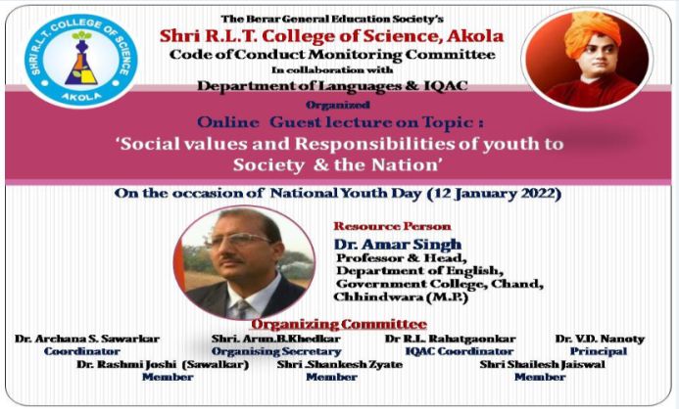 | 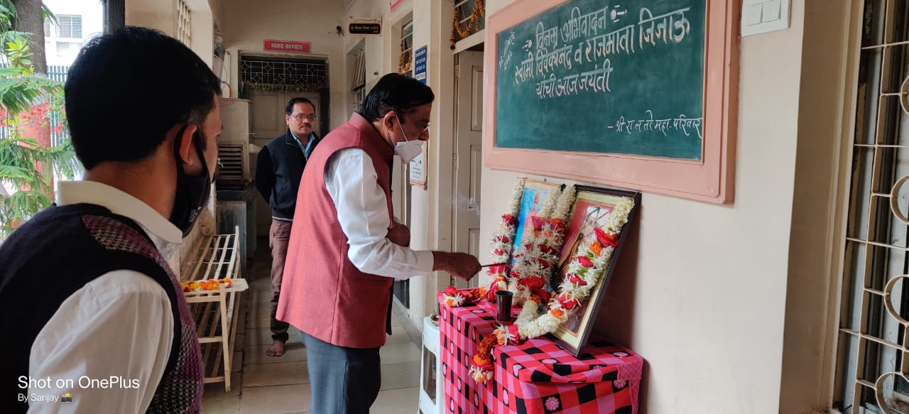
Flex of Programme | Salutation to Swami Vivekananda and Rajmata Jijau
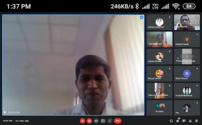 | 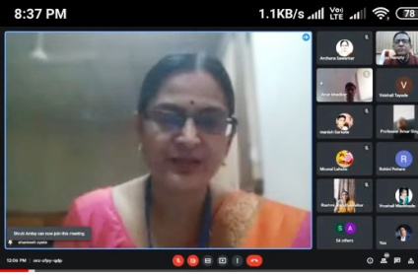
Anchoring by Mr. Arun B. Khedkar | Introductory speech by Dr. Archana Sawarkar
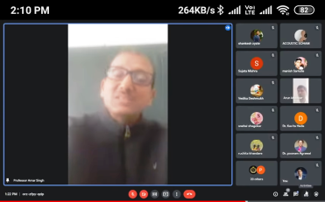 | 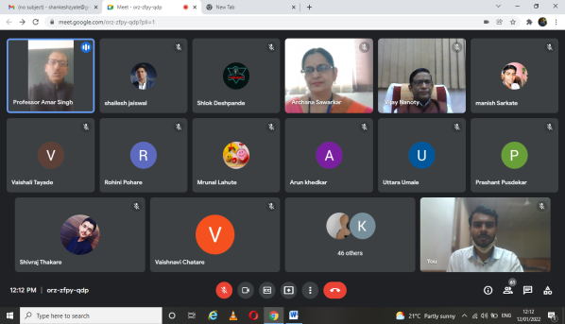
Guidance by Dr. Amar Singh
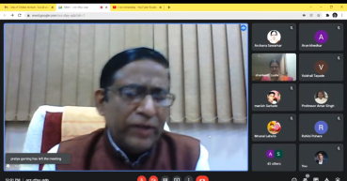 | 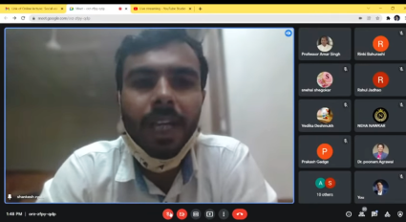
Presidential speech by Principal Dr. V. D. Nanoty | Vote of thanks by Mr. Shankesh Zyate

Dr. A.S. Sawarkar Shri. A. B. Khedkar
Coordinator Organising Secretary
Dr. R.L. Rahatgaonkar Dr. V.D. Nanoty
IQAC coordinator Principal

