Annual Report( session 2021-22) : Department of Languages
The academic session 2021-22 has been an eventful year right from the beginning till closure as the admission process extended a little longer than usual it also affected the academic schedules. At the very beginning Introduction to the Department was given for students In Deeksharambh : Student Induction Program 2021-22 which was organized for newly admitted students.All teachers of the Department introduced themselves to the students.
On 25th May 2022 ,Creative writing Competition 2021-22 was organized for students which received a good response Despite it was exam preparation period . This year the theme of the competition was New Education Policy 2020. Students and staff members wrote articles on the topic selected articles will be published in the College annual magazine Pratibimb issue 2021-22 students submitted drawings ,poems and shorts stories for the competition.the winners of this competitions will be felicitated with a certificate and a book in the next session .
The Code of conduct Monitering committee in collaboration with the department of Languages and IQAC organized online guest lecture on the occasion of National Youth Day 12th January 2022.which received a tremendous response from students in the earlier registration process around 275 students registered their names for the lecture and attended the lecture online. .The lecture was delivered by a key note speaker Dr Amar Singh Professor and Head Department of English, Government College Chand Chhindwara, Madhya Pradesh.Iin which he urged students to adhere to values or value system established by our great Indian culture.He further gave allusions to many great people stated the need for creativity in youths and said youth should have a clear vision to succeed in life and the youths should make success their habit and work hard and never to give up and also urged parents to give sacraments ( Sanskar) to their children more and less facilities .students should have values and ethics so that they can return something to the society they are a part of . The programme began sharply at 12.00 p.m. by paying honour to Swamiji on his birth anniversary .The honorable principal Dr Vijay D. Nanoty presided over the program who also gave introductory remarks as well as welcomed the resource–person .Dr Archana sawarkar worked as coordinator while Mr. Arun B khedkar worked as organizing Secretary whereas Dr.Rashmi Joshi ,Mr. Shankesh Zyate and Mr Shailesh Jaiswal worked for the success of the programe as organizing team member .
Youtube link= https://youtu.be/B61oUx8Nz00
Google meet link-Digital platform, Google meet link— http://meet.google.com/orz-zfpy-qdp
World English Language Day
The World book day along / English Language Day was celebrated on 23.04.2022 at Shri R.L.T. College of Science college, Akola.The Language department organised a quiz competition on this occasion which was held at digital classroom no 1 at 3;00 p.m. .Initially students were given a qualifying test and from that 12 best students were selected to be divided into 4 groups namely A,B,C and D . This quiz was designed to create awareness and interest of students towards English Language and reading books.Group B performed very well and so declared as winner Group B consists of the following members:1) Deeksha Mishra 2)Shruti Gore 3)Mrunal Lahute all these students were from Bsc part one.
Participants were given certificates by the principal Dr. V.D. Nanoty. Mrs. Harshal P.Ganvir & Mr. Arun B. Khedkar conveyed the whole event successfully.principal Dr. Nanoty sir felicitated students and appreciated their enthusiastic participation in competition .He also urged student to learn to speak proper English language for that students should cultivate the habit of reading good books .the programme was concluded with a vote of thanks by Mr. A.B Khedkar .Thus program was conducted very smoothly and successfully.

Marathi Rajbhasha Din Celebration 28th Feb.2022
Marathi Rajbhasha Din was also celebrated with great zeal on 28th February 2022 as it was Sunday on 27th .This is the day on which every year Marathi language is honoured.On this day is the birth Anniversary of great Marathi poet Kusumagraj .As Marathi is a mother tounge of most of the local students This programme was initiated by Marathi Teachers Dr S E Rekhe and Mrs Dange madam who encouraged students to come on the stage and present their best speeches ,poetry,stories,best lyrics of Marathi language.About 15 students came on the stage and performed outstandingly .
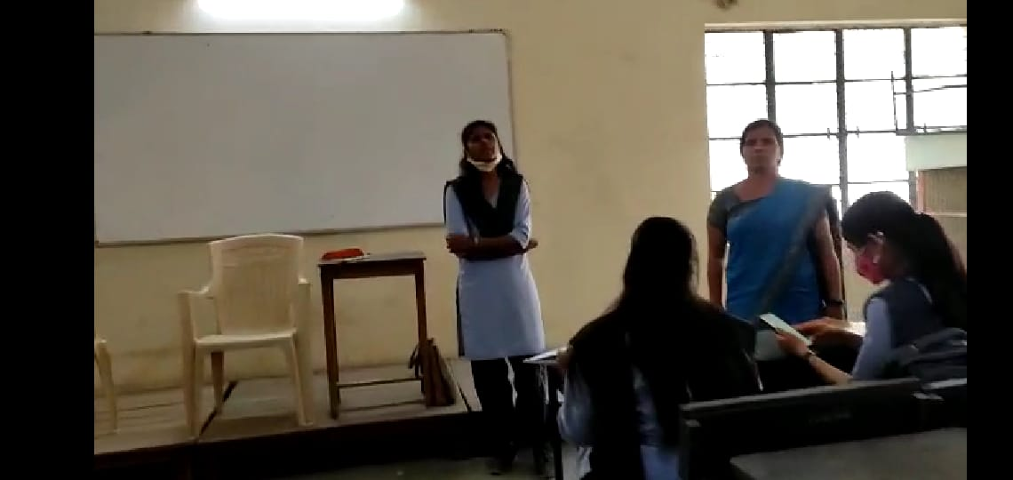
Ku Vaishnavi Aglawe won consolation prize at a state level Research Article Competition organized by Dr.Shyamprasad Mukherjee Arts College ,Shendurjanaghat.Dist Amravati

Mr Arun B Khedkar
Assistant Professor in English
Department of Languages

