The Number of students attend that examination are 135. In The Above test the following three students win the Prizes .
Prize No. | Name of the students | Marks obt. Out of 50
1 | Kruti Prakash Koradia | 42
2 | KARISHMA RAMESHLAL PANJWANI | 43
3 | Shraddha shivmangal dongre | 43

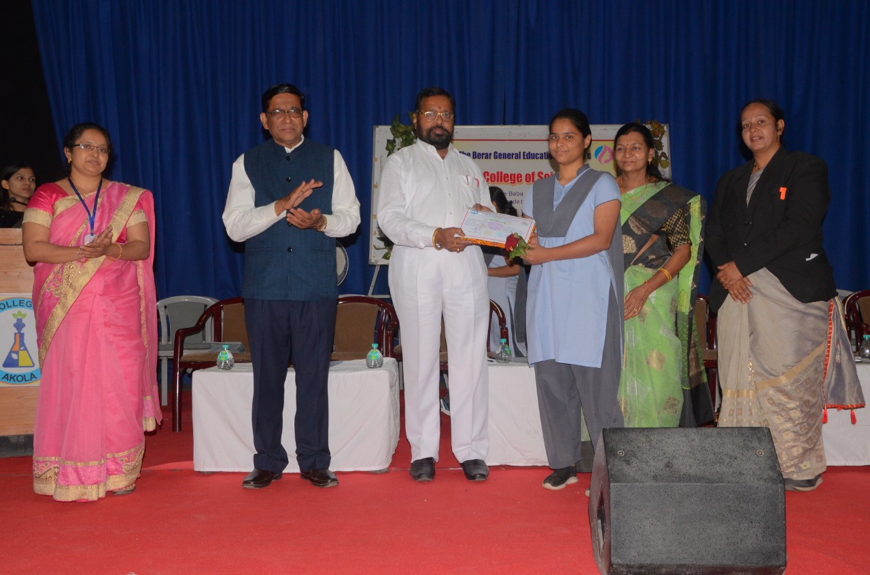
The Winners of this examination felicitated by the Hon. Adv. Motisnghaji Mohta, President , The B.G.E. Society, Akola in presence of our Principal Dr. V.D.Nanoty and staff members of our college.

Sr.No. | Name Of The Student | Total score
1 | Shruti | 10.00 / 50
2 | Vaishnavi Sharad Bache | 11.00 / 50
3 | Om Gajanan Dose | 12.00 / 50
4 | Raj | 13.00 / 50
5 | Mahendra Ratan Pande | 13.00 / 50
6 | Aditya Ramesh Talokar | 13.00 / 50
7 | Samiksha Rajesh Amode | 18.00 / 50
8 | Pooja sanjay raut | 19.00 / 50
9 | Gauri Khadse | 19.00 / 50
10 | Roshan zalke | 19.00 / 50
11 | Divya Vishnu Mule | 20.00 / 50
12 | Pooja Nitin Nandekar | 20.00 / 50
13 | Tejal Tejrao Patil | 21.00 / 50
14 | Divyani Sanjay khandare | 22.00 / 50
15 | Vaishnavi Ravindra Thorat | 22.00 / 50
16 | Dipali gajanan dandale | 22.00 / 50
17 | Ahhaha ajajajan | 24.00 / 50
18 | SAKSHI ARUN GADLINGE | 26.00 / 50
19 | JUVAIRIYA SADIYA NASIR KHAN | 26.00 / 50
20 | Krishna Rajesh Kulkarni | 26.00 / 50
21 | Rasika Dilip Banole | 27.00 / 50
22 | ku.pradnya Mohan Bhatkule | 27.00 / 50
23 | Shraddha chandravachan kharat | 27.00 / 50
24 | Nisha sunil bodade | 28.00 / 50
25 | Ram pandurang kalmegh | 28.00 / 50
26 | srushti Amol Wahurwagh | 28.00 / 50
27 | Shubhangi kailas yadgire | 28.00 / 50
28 | Vishakha Ramesh Lokhande | 29.00 / 50
29 | Dnyaneshwari santosh awale | 29.00 / 50
30 | Shri R.L.T college of science, Akola | 29.00 / 50
31 | Himanshu Manoj Bobade | 30.00 / 50
32 | Rekha Ratiram Bajiya | 30.00 / 50
33 | Prajakta prabhudas kale | 30.00 / 50
34 | Mayuri Rajesh Dhanbhar | 30.00 / 50
35 | Aishwarya Chapke | 30.00 / 50
36 | Rutuja Narayan Thombre | 30.00 / 50
37 | PRASHAD SANTOSHRAO EKADE | 31.00 / 50
38 | Prajakta Gajanan Lavhale | 31.00 / 50
39 | Yogita Patil | 31.00 / 50
40 | Shivam Chandrakant Lakhe | 31.00 / 50
41 | Vaishnavi sanjay jagdhan | 32.00 / 50
42 | Sakshi Pravin Tuljapure | 32.00 / 50
43 | Swaranjali Dinkar katre | 32.00 / 50
44 | Vaishnavi pandurang raut | 32.00 / 50
45 | Devyani Jadhav | 32.00 / 50
46 | Radhika Gopal Malokar | 32.00 / 50
47 | SHITAL SUNIL GAIKWAD | 34.00 / 50
48 | Suraj khillare | 34.00 / 50
49 | Anjali Tejrao Tayade | 34.00 / 50
50 | Utkarsh Sanjay Suley | 34.00 / 50
51 | Aishwarya Ashok Tayade | 34.00 / 50
52 | Vaishnavi Sanjay Tekade | 34.00 / 50
53 | Dhanashri vidhate | 34.00 / 50
54 | Sakshi Mukund Deo | 35.00 / 50
55 | Kumud Vijay Matre | 35.00 / 50
56 | Sakshi Dnyaneshwar Shinde | 35.00 / 50
57 | Nausheen Parveen Qaiyyum khan | 35.00 / 50
58 | Shabana Parveen Syed Zaheer | 35.00 / 50
59 | Vaishnavi Digambar kale | 35.00 / 50
60 | Vaishnavi Santosh khandare | 35.00 / 50
61 | Nikita Rajesh Hage | 35.00 / 50
62 | anjali ramdas kale | 35.00 / 50
63 | Swaranjali Sunil Gawande | 35.00 / 50
64 | Achal Arun More | 36.00 / 50
65 | Laxmi Satyanarayan mhasaye | 36.00 / 50
66 | Vaishnavi Rajesh Dandale | 36.00 / 50
67 | Poonam Ramesh Waghmare | 36.00 / 50
68 | Rupali Mahendra Thakare | 36.00 / 50
69 | Adiba khatoon Ayyub khan | 36.00 / 50
70 | Aafreen Parveen sayyed zaheer | 36.00 / 50
71 | Rashmi Sanjay Bulani | 36.00 / 50
72 | Ankita rajan Ingle | 36.00 / 50
73 | Arati Rajesh Kawalekar | 36.00 / 50
74 | Ashwini Prakash Gawande | 36.00 / 50
75 | Prajakta sudhakar Nimbokar | 36.00 / 50
76 | Vaishnavi Shrikrishna Kadu | 36.00 / 50
77 | Vaishnavi Pandhari Chavhan | 36.00 / 50
78 | Achal ganesh pohare | 36.00 / 50
79 | Preeti Vijay Navkar | 37.00 / 50
80 | ANKIT ULHAS INGLE | 37.00 / 50
81 | Vaishnavi Rajesh Rudrakar | 37.00 / 50
82 | Rutuja Santosh Dandale | 37.00 / 50
83 | Divya Vasudeorao Mate | 37.00 / 50
84 | Samruddhi Vijay Shete | 37.00 / 50
85 | Rakhi Mahadev Narwade | 37.00 / 50
86 | Shreya sanjay sonone | 37.00 / 50
87 | Sakshi sanjay valesha | 37.00 / 50
88 | ASMITA PRADIP KHANDARE | 37.00 / 50
89 | Divya Narayan Thakare | 38.00 / 50
90 | Shubhangi Ramesh Thakare | 38.00 / 50
91 | Uzma mehwash Ayyub khan | 38.00 / 50
92 | SAURABH PRAKASH WANKHADE | 38.00 / 50
93 | Nisha Ashok Kalaskar | 38.00 / 50
94 | Aishwarya Girish Pathak | 38.00 / 50
95 | Sakshi Ajay Surana | 38.00 / 50
96 | Samiksha Bharat Ingle | 38.00 / 50
97 | Akanksha Gajanan Ingle | 38.00 / 50
98 | Shruti Ashish Amley | 39.00 / 50
99 | Aparna Ganesh Rakhonde | 39.00 / 50
100 | Gayatri sarangdhar ingle | 39.00 / 50
101 | Gaurav vijaysingh parmar | 39.00 / 50
102 | Kalyani Ramesh Pakdhane | 39.00 / 50
103 | Nikita Pramod Vanjari | 39.00 / 50
104 | Arpita Jadhao | 39.00 / 50
105 | Priyanka Vijay Nidhane | 39.00 / 50
106 | Vaishnavi Basantrao Thorat | 39.00 / 50
107 | Vaishnavi Prakash Dange | 39.00 / 50
108 | Krishna jagannath shukla | 39.00 / 50
109 | Aditi Sadanand Raut | 39.00 / 50
110 | Sonali.Ramesh .Godwe | 40.00 / 50
111 | Anuradha Vivek Dharamkar | 40.00 / 50
112 | Prerana Gajanan Pawar | 40.00 / 50
113 | Gauri Ramesh Yenkar | 40.00 / 50
114 | Pooja Prakash lngle | 40.00 / 50
115 | Gopal Narayan Jaitade | 40.00 / 50
116 | Mrunal Gopal Partike | 40.00 / 50
117 | Samiksha Sunil Lingayat | 40.00 / 50
118 | Shritej Rajesh Gawande | 40.00 / 50
119 | Revati kishor gawande | 41.00 / 50
120 | Vaishnavi deshmukh | 41.00 / 50
121 | Vaishnavi Ravindra Damdhar | 41.00 / 50
122 | Ki. Divya Ramdas Gawai | 41.00 / 50
123 | Gayatri Anil Tayade | 41.00 / 50
124 | Rutuja Ravindra Jamodkar | 41.00 / 50
125 | Kruti Prakash Koradia | 42.00 / 50
126 | Madhumita Y Sugandhi | 42.00 / 50
127 | Sanandan Sunil Deshmukh | 42.00 / 50
128 | Tanaya Bharati Apurva | 42.00 / 50
129 | Anuj Sharma | 42.00 / 50
130 | Vaishnavi Rahul Shegaonkar | 42.00 / 50
131 | Shivam manikarao kalambe | 42.00 / 50
132 | Pooja Gajanan Pawar | 42.00 / 50
133 | Vaishnavi Dayaram Nesanatakar | 42.00 / 50
134 | KARISHMA RAMESHLAL PANJWANI | 43.00 / 50
135 | Shraddha shivmangal dongre | 43.00 / 50

