Report of Online Workshop on
E-Waste Management: Reduce, Repair, Refurbish, Recycle & Reuse
Date: 11-08-2021
Issue Addressed: Environment consciousness
Department of Computer Science, Electronics and Physics in collaboration with Parent Teacher Association (PTA) organized online Workshop on “E-Waste Management: Reduce, Repair, Refurbish, Recycle & Reuse” on dated 11-08-2021 at 11:00am. Resource persons of this workshop were Dr. Y. S. Tamgadge, (HOD, Physics; Mahatma Fule Mahavidyalaya, Warud) and Mr. R. G. Chavan (HOD, Electronics; Shri R.L.T. College, Akola). It was conducted on online platform through Google Meet and also provided YouTube link: https://youtu.be/vQhiVK6EaZ4
This workshop was organized for making awareness in students and their parents about E-Waste and its Managements. Topic was very ellaboratively explained in English and local language Marathi by both resource persons. Mr. Sanjay Ingle, Authorized e-waste dismantler gave best wishes to this innovative workshop. Mr. Shailesh Jaiswal Asst. Professor, Department of Physics gave idea about future Electronic waste collection program of College.
The Principal Dr. V. D. Nanoty, Chairperson and inaugurator of the program addressed participants. Workshop was conducted by Dr. Archana S. Sawarkar, Associate Professor in Zoology and convener of workshop. Mr. Ram B. Ghayalkar, Asst. Professor, Department of Computer Science, Coordinator of the Workshop proposed Vote of Thanks. More than 300 students and parents get benefited by this workshop.
Recorded YouTube Link:
https://youtu.be/vQhiVK6EaZ4

Registration Link:
https://forms.gle/2TFkhxijtFJiRpvc8

Feedback form link:
https://forms.gle/tmvhmJyY94XrvZ6c8

Some Pictures while session:
 | 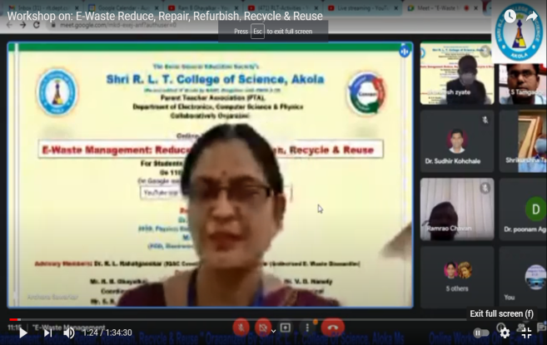
Inaugural speech by  Principal Dr. V. D. Nanoty sir | Conduction of Programme by  Dr. Archana S. Sawarkar
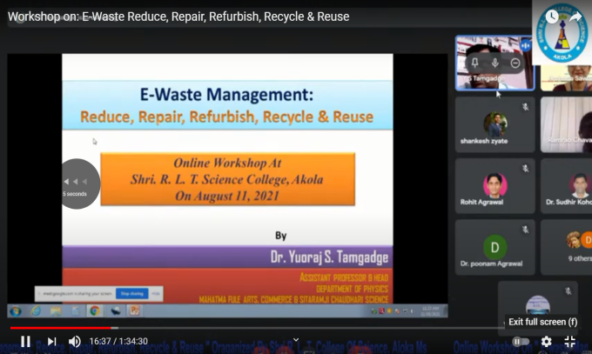 | 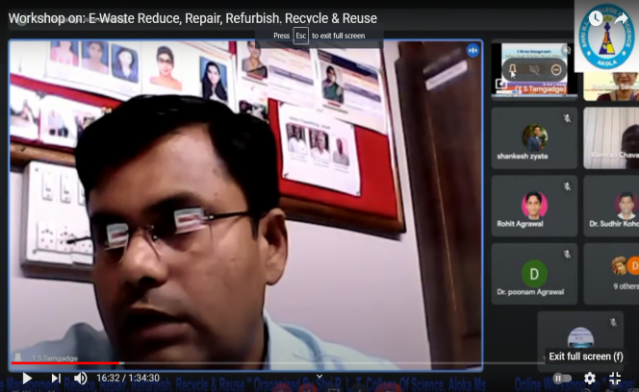
Guidance by Dr. Y. S. Tamgadge on topic
“E-Waste Management: Reduce, Repair, Refurbish, Recycle & Reuse”
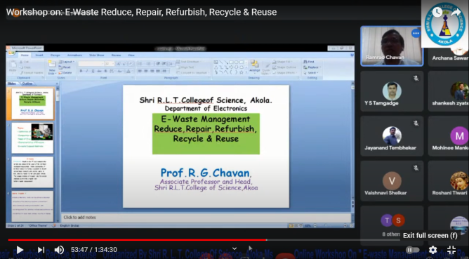 | 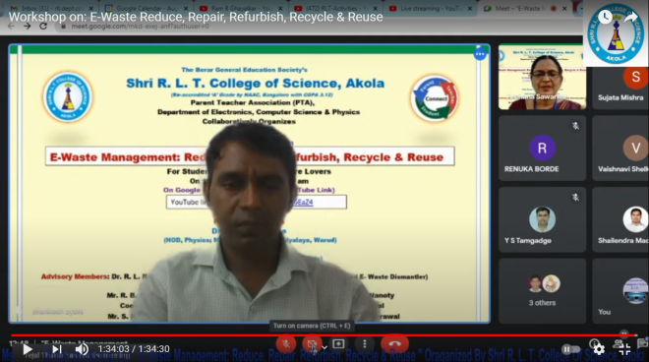
Guidance by Mr. R. G. Chavan  on topic “E-Waste Management” | Vote of Thanks by  Mr. Ram B. Ghayalkar

Dr. Archana S. Sawarkar Mr. Ram B. Ghayalkar
Convener Coordinator

Dr. R.L. Rahatgaonkar Dr. V. D. Nanoty
IQAC Coordinator Principal

