Awareness Program to save Electricity, Paper & Energy
Shri R.L.T College of Science, Akola and EFEC (Environment and Forest Education Center) jointly organized an awareness program to save electricity, paper and energy on 26th August 2021.
Mr. Uday Vaze of EFEC explained that excessive pollution and exploitation of resources is causing immense environmental damage. Hence, EFEC came up with an idea to display posters and stickers that carry the message of protecting the environment at large. Dr. Archana Sawarkar, Coordinator of programme told how to avoid misuse of resources and save environment from pollution. Posters carrying message for environment conservation were released. Stickers displaying the message of protecting environment, saving electricity, papers and energy were posted on key places in college premises. In Presidential address Principal Dr. V. D. Nanoty sir stated that nature is beautiful and needs to be preserved. He appreciated the green initiative of EFEC and environment cell of the college. All members of Environment cell and Criterion VII participated in the event. Members of Environment cell also joined Public awareness program, in which Hon. Collector Nima Arora expressed importance on Public awareness programs and expects that the citizens will try hard to save environment from pollution and misuse of resources.
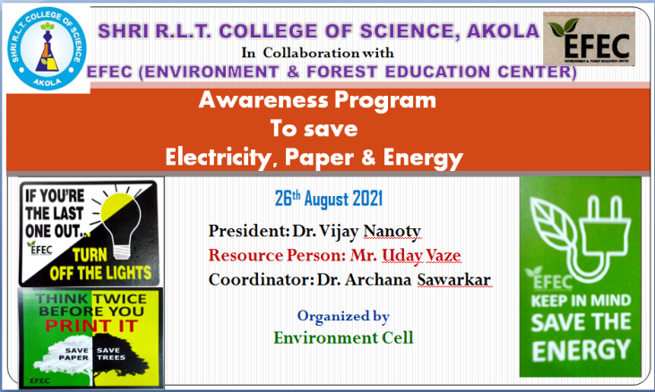 | 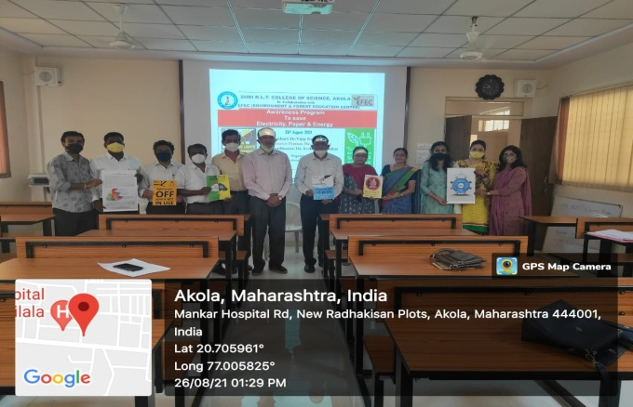
Flex of Programme | Release of posters carrying message for environment conservation
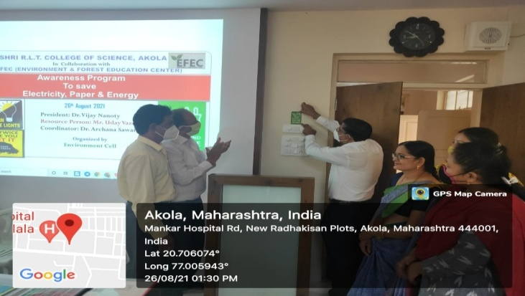 | 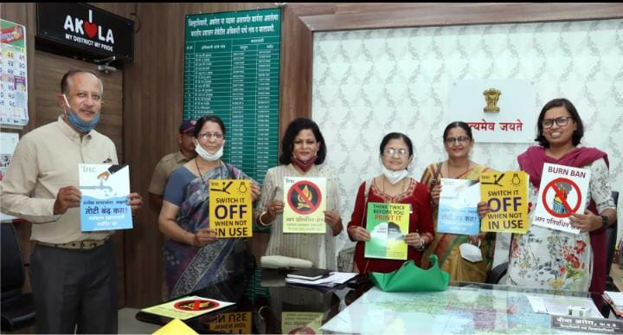
Displaying Stickers on key places in college premises | Hon. Collector Nima Arora, IAS, released posters carrying message for environment Protection

Dr. Archana Sawarkar
Activity Coordinator

