Shri R. L. T. College of Science, Akola

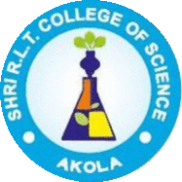

ALUMNI COMMITTEE REPORT
SESSION- 2020-2021

Prof. R. D. Chaudhari Chairman
Prof. R. G. Chavan Alumni Sr. Member
Dr. P. T. Agrawal Member
Prof. R. B. Ghayalkar Member

Contents
Sr. No. | Activities
1 | Permanent Registration Number
2 | Registered Alumni Committee
3 | Objective of the Alumni Association
4 | Account details, statement, Donor
5 | Guest Lecture by Alumni
6 | Blood Donation on 24th Dec. 2020.
7 | Felicitation of Alumni
8 | Alumni activity Distribution of mask, sanitizer and books
9 | National workshop on “IPR and Patent filing”
10 | Meeting of Alumna Association

Chairman Principal

Permanent Registration No. F-20205

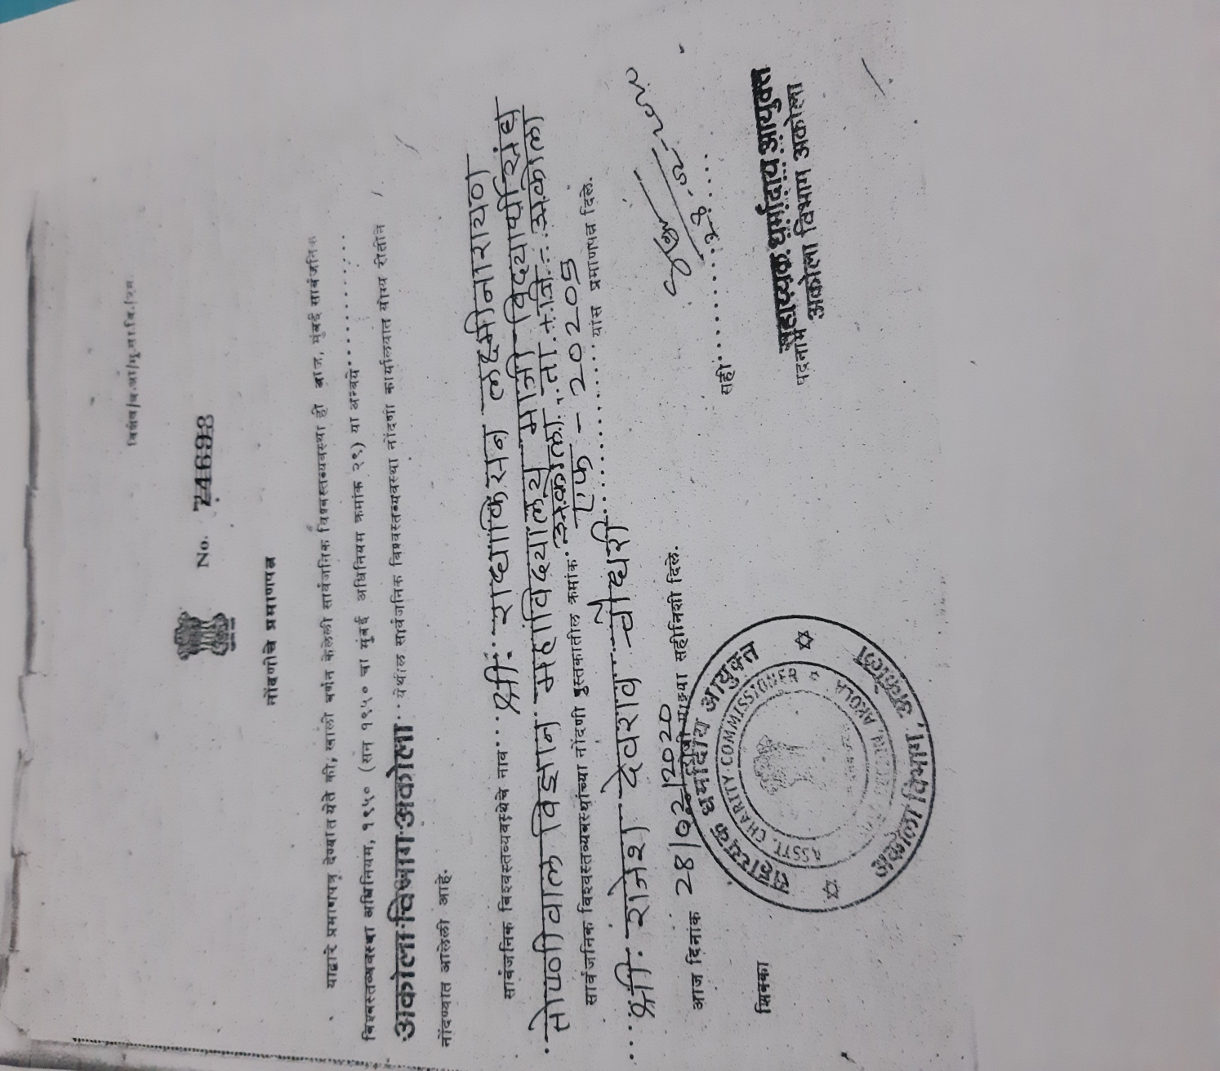

Registered Alumni Committee Members
Reg. No. F - 20205

- Shri Deepak Mayee – President

2) Shri Prashant Bule – Vice –President

- Shri R.D. Chaudhari – Secretary

- Dr. V.D.Nanoty – Member /Principal

- Shri R.G.Chavan – Member

- Dr. R.L. Rahatgaokar – Member

- Dr. Poonam T. Agrawal – Member

- Shri Sunil T. Patil – Member

- Shri Sunil M . Jadhao – Member
\
- Dr. Jayshree V. Bhale – Member

- Dr. Ashivini S.Morwal – Member

Objective of the Registered Alumni

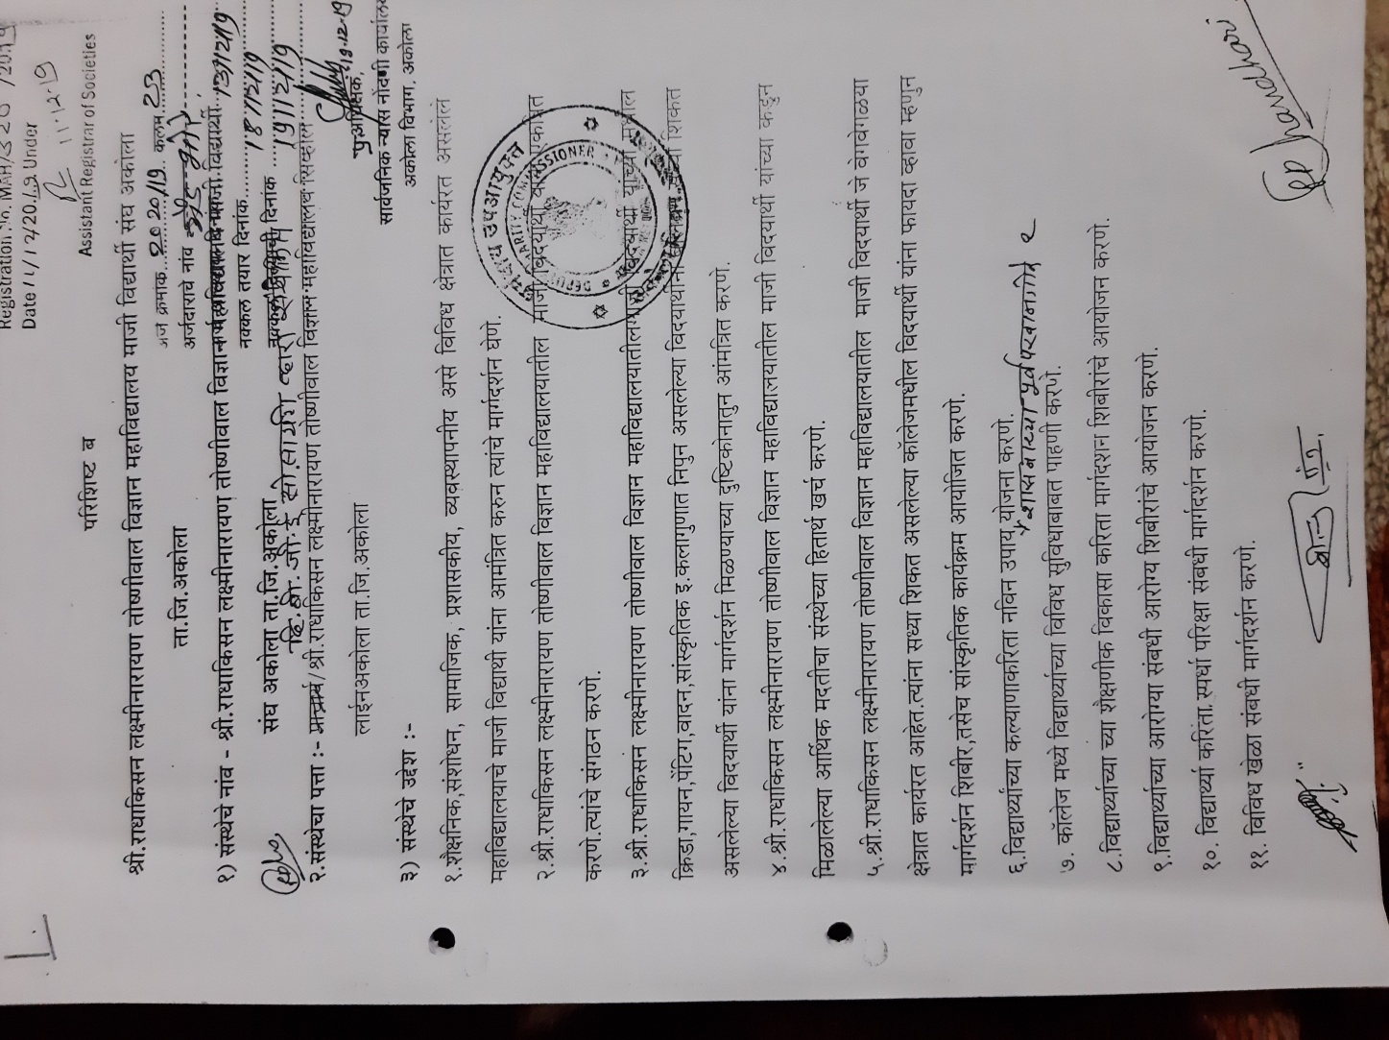

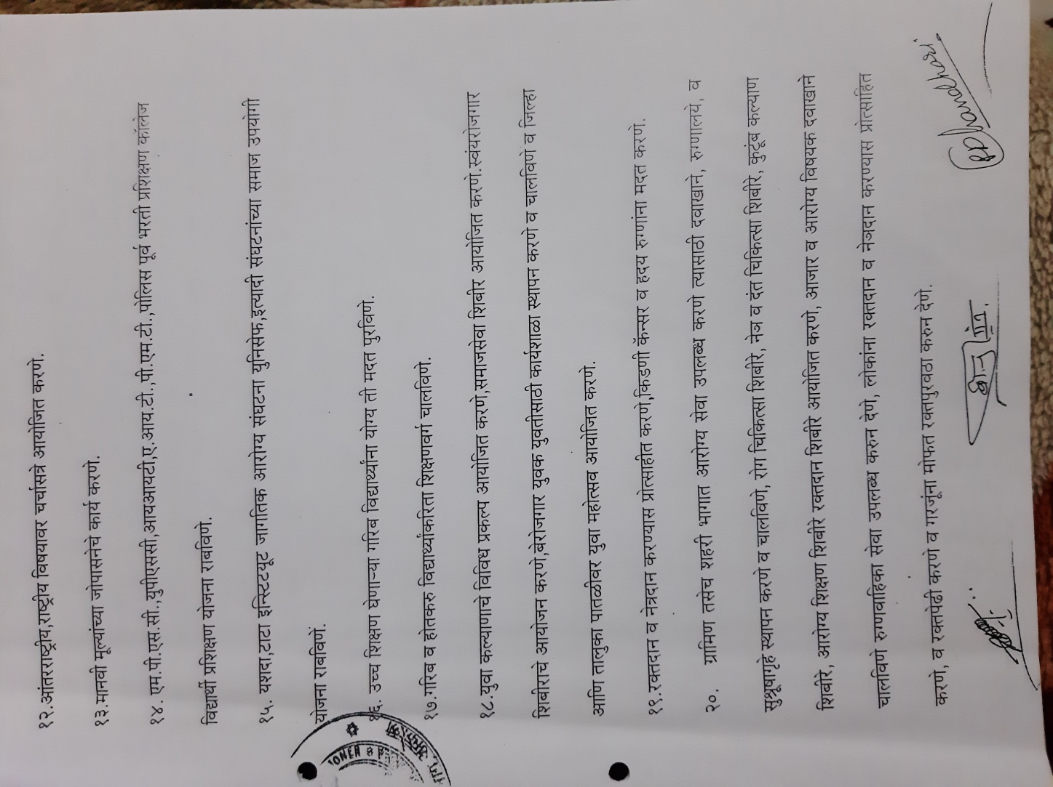

Account Details

Name :- Shri R.L.T.College of Science
Alumni Association, Akola
Account no. : – 3858820618
IFSC Code :- CBIN0283820
Bank :- Central Bank of India RLT Branch , Akola
Account Statement

- Balancing Amount on Dated 27 /08/2021 - Rs. 70184/-

Alumni meeting in the year 2020-21:-

Sr.No. | Date of meetings
1 | Online meeting 20 june 2020
2 | Online meeting 10 september2020
3 | 12 December2020
4 | 24 December 2020
5 | 20 june 2021

Blood donation camp and alumni day 24 Dec 2020 :-
For The inauguration of Late Principal M. G. Joshi Memorial day Programme on 24th Dec. 2020 Our College alumna Sau. Andhare Madam ,Lecture Dept of Mathematics ,Shri. R.L.T.College of Science, Akola felicitated and inaguarated the programme in presence of .Hon.Adv .M. G. Mohata. ,President The B.G.E.Society, Akola and Shri Pavanaji Maheshwari, Secretary, The BGE society,Akola Shri. Vijaykumar Toshnival Sr.vice president ,Shri Abhijitaji Paranjape Jt. secretary and Dr.Ravindra Jain, Jr.vice president of the BGE society, Akola gives the message to our students and Felicited the meritorious students.

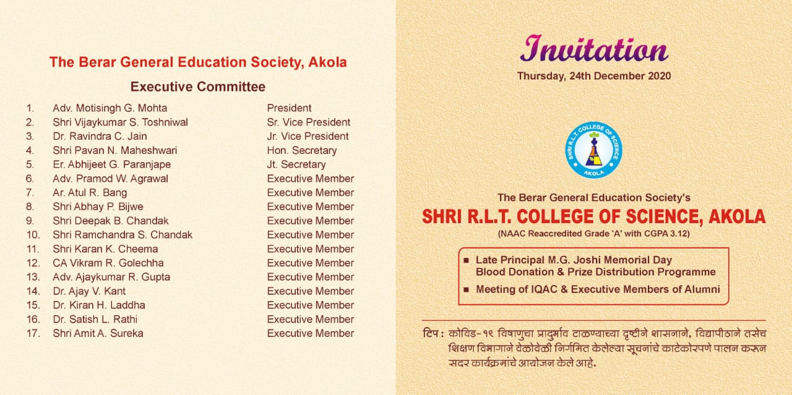
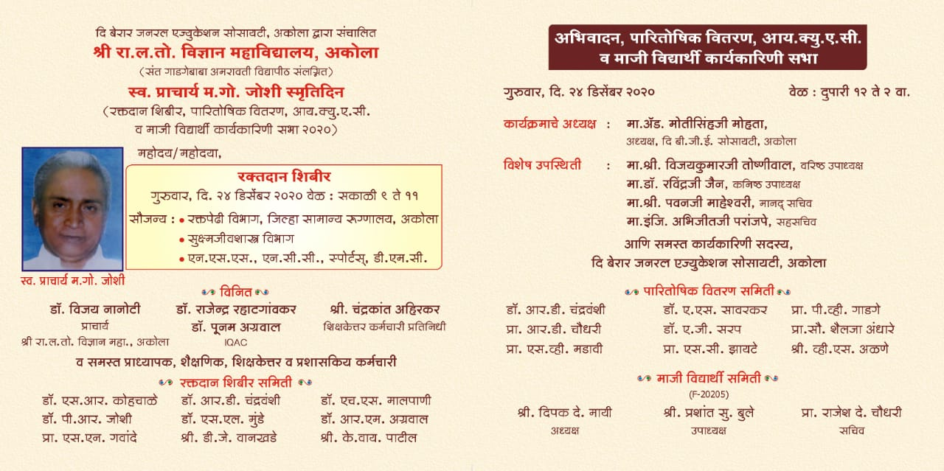
Blood donation by our Alumni
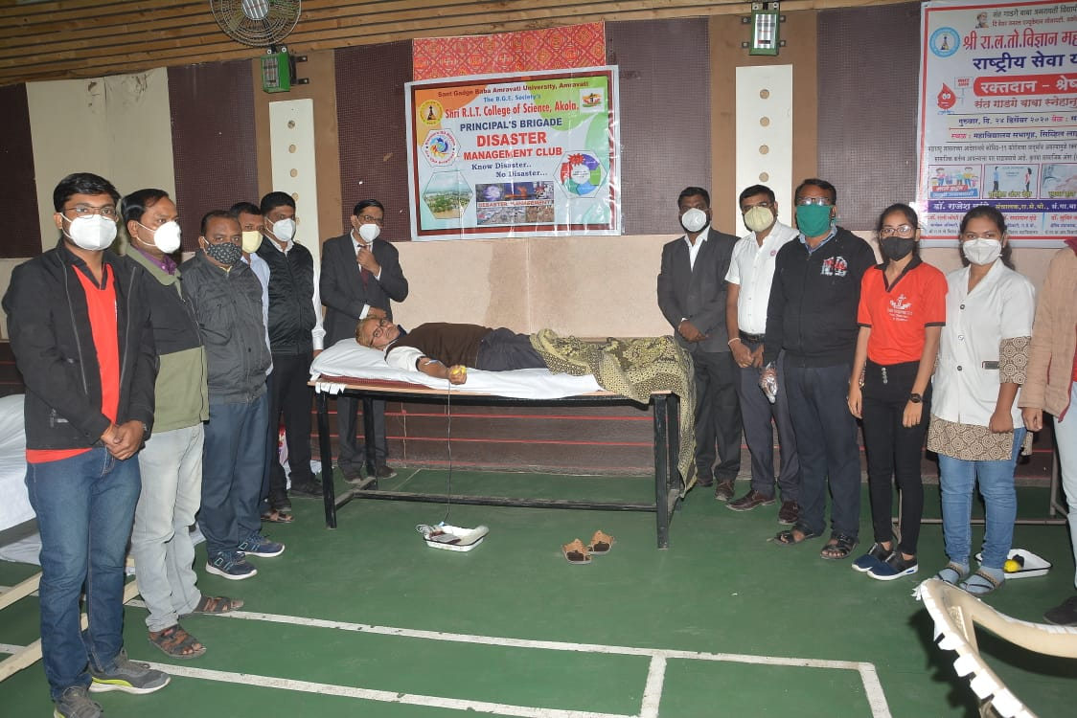
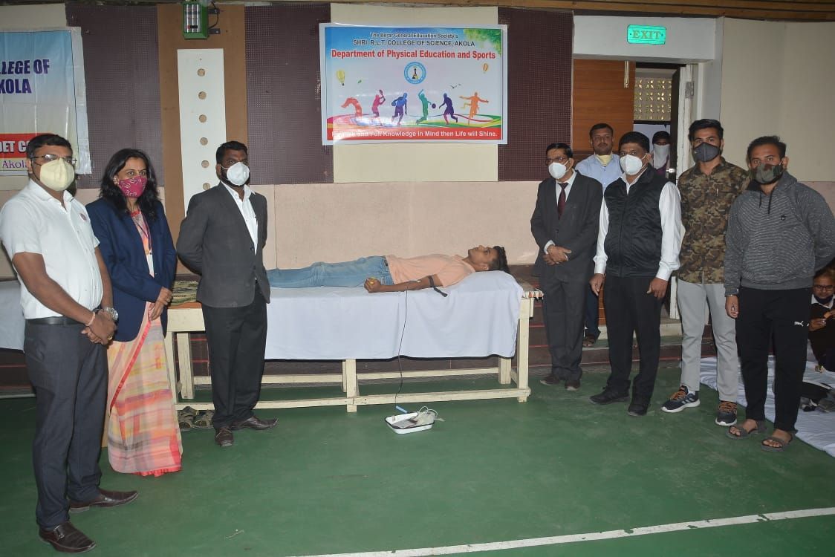
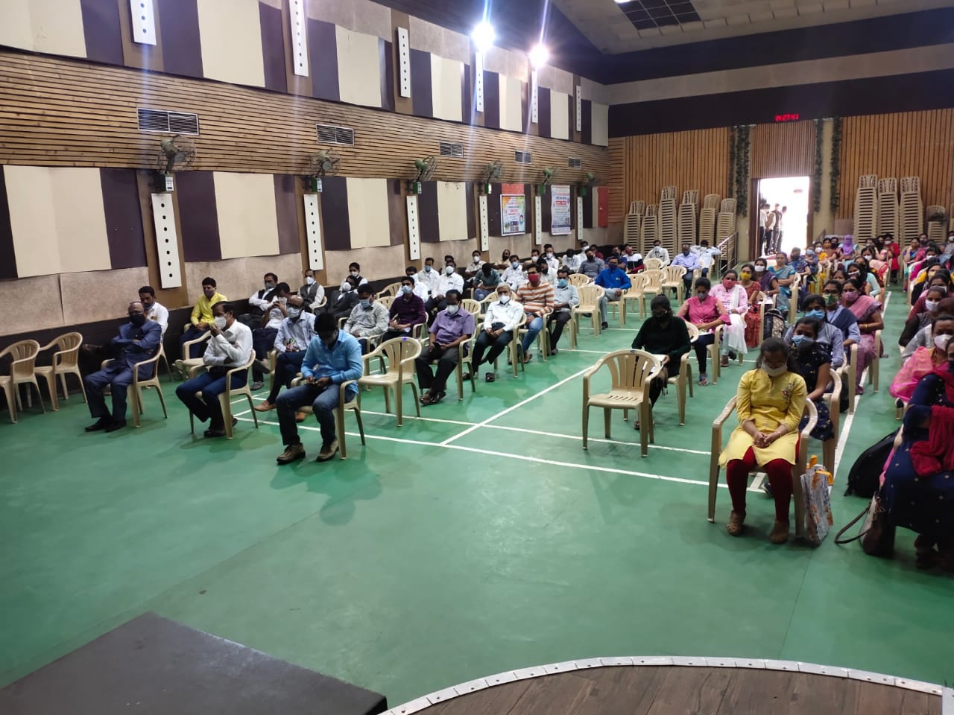

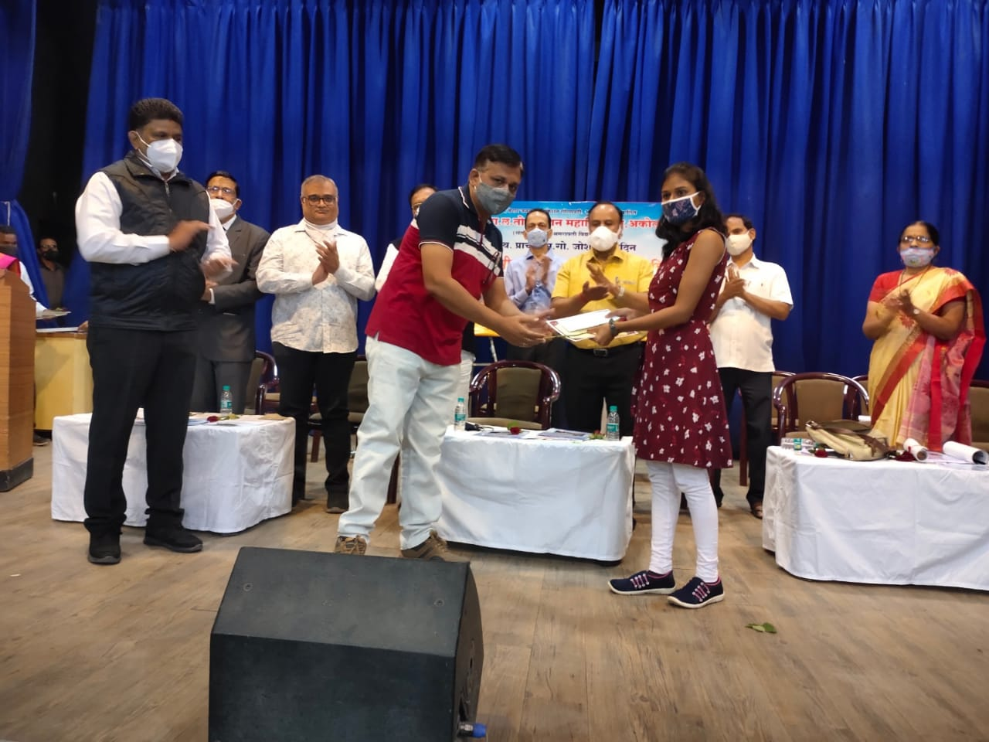
Alumni Gathered Together :- The Eminent Alumni present for the alumni meet on 24/12/2020

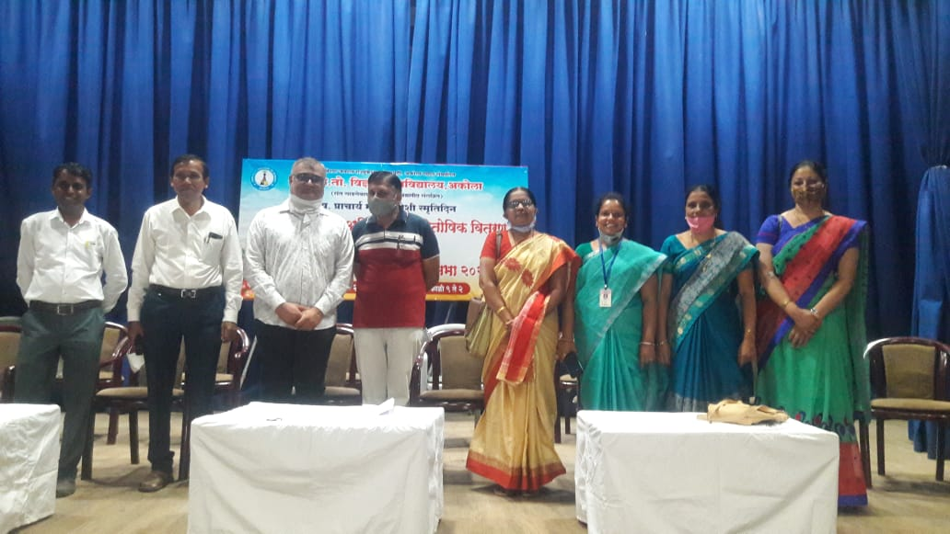

Corona warriors felicitation :- Seven students of microbiology department are the pride alumni for us . they have got the job in GMC for covid19 testing labarotary as technician. these are Ku.Medha Bharate,Ku.Vaishnavi Gandhi,Ku.Sneha Jadhao, Ku.Sanjana Narwade,Ku.Shital Ghuge,Ku.Supriya Ghangate,Ku.Shruti Joshi felicitated on this day.
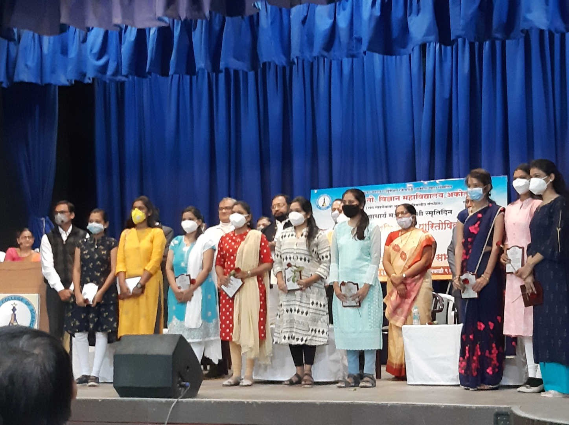

Feliciation of Alumni :- Our Alumna Sau. Andhare madam , Lecturer in department of mathematics of our college felicitated by the hands of our President Adv. Motisinghaji Mohata sir,President,Shri Pawanji Maheshwari sir Secretary Shri Abhijitaji Paranjape sir Jt. Secretary ,The BGE society,Akola and our Principle Dr. V.D.Nanoty
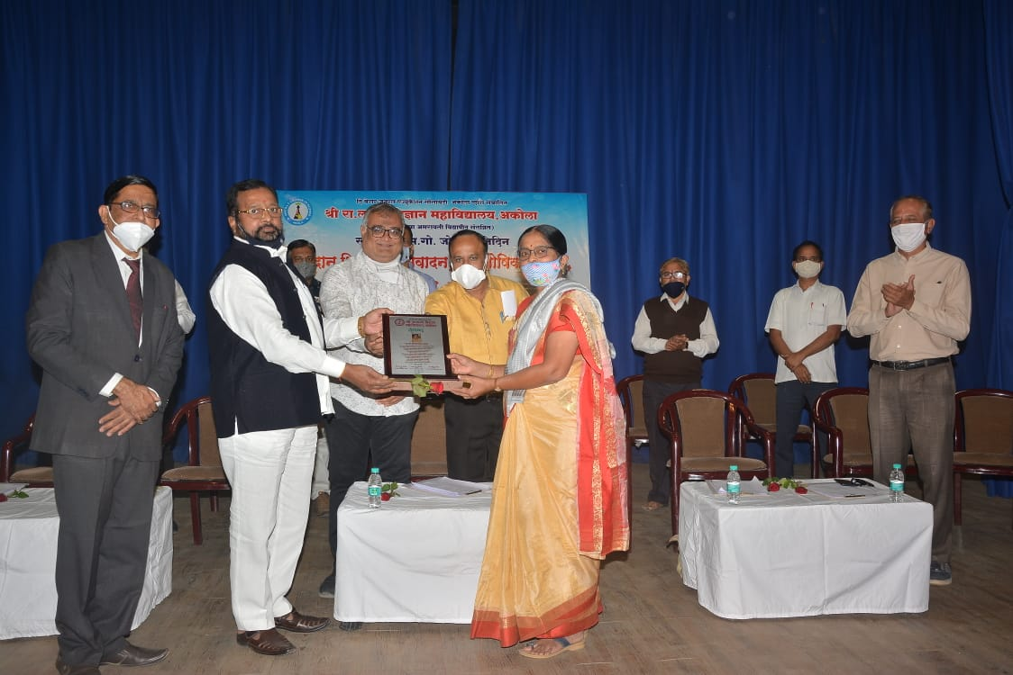
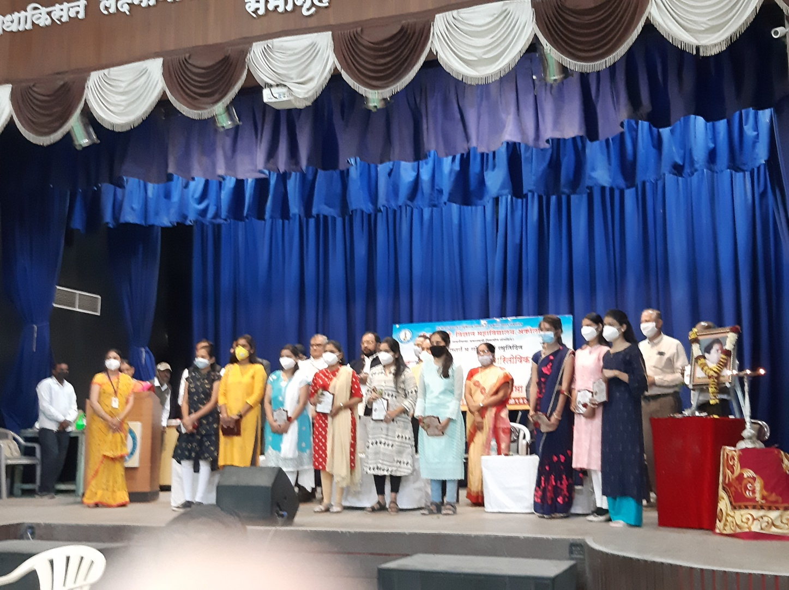

Alumni Social Activity :-
- Distribution of books to needy students of our college in presence of alumni association .

Distribution of mask by our alumni association.:-
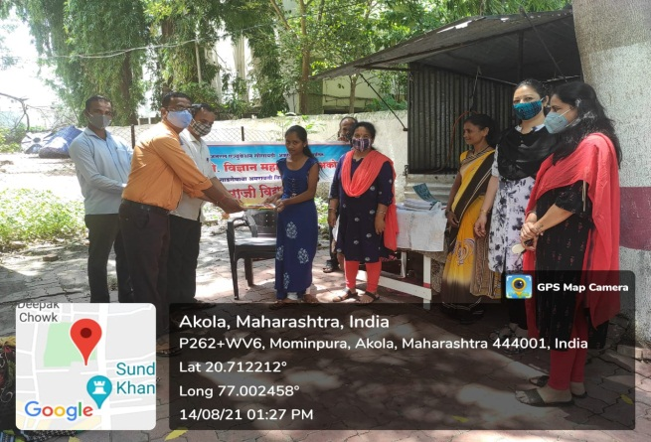
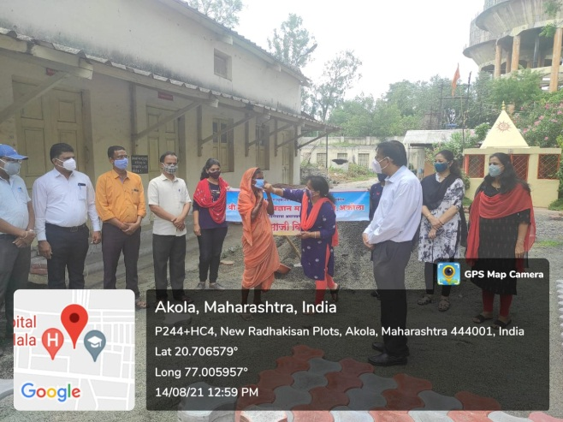
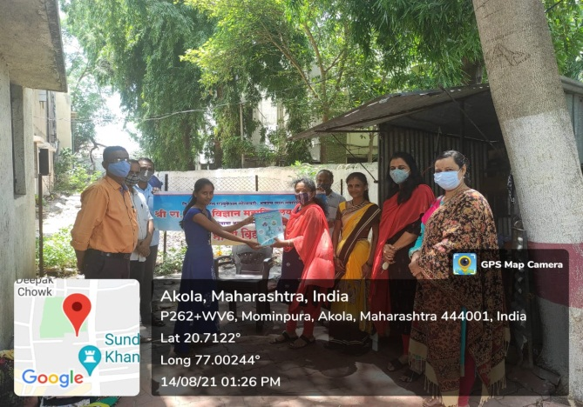
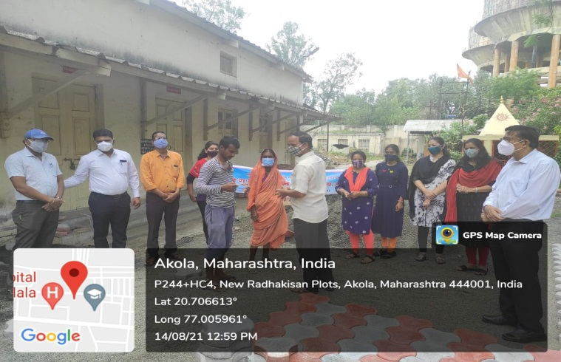
Distribution of sanitizer by our alumni association
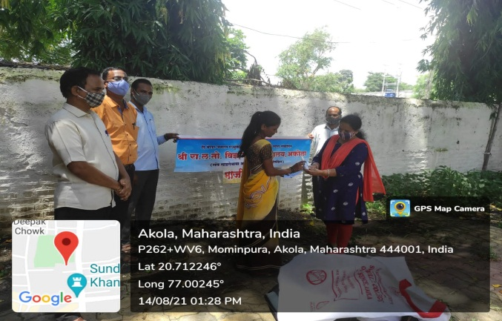
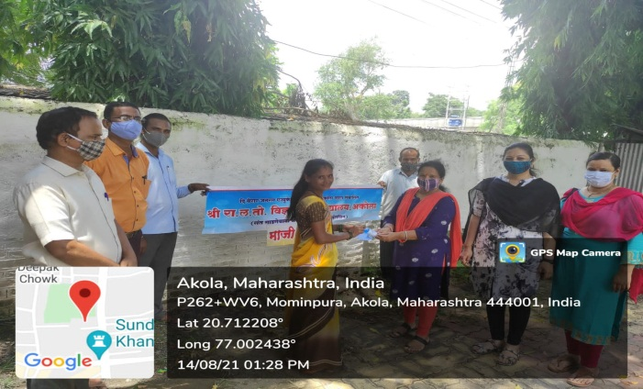

National online workshop on “Intellectual Property Rights and Patent filing “-
Online National workshop on IPR and Patent filing organised successfully with huge response of 230 participants across the India. Our alumnus Dr.Aniket Gade ,Assist Professor, Dept. of Biotechnology S.G.B.Amravati university, Amravati has delivered excellent talk on “ IPR and patent filing “on 31 august2021 online link . He has given the brief idea about IPR and patent filing. I congratulate IQAC, Department of Microbiology and Alumni Association. Good efforts taken by Dr. Harish Malpani, Dr.Rahatgoankar, Dr. Agrawal, Dr. Nagrale, Dr. Sarap, Shri Ghyalkar ,Shri Choudhary, Ms. Gawande. Special efforts taken by Dr. Kohchale and Shri Jaiswal.

Participants can join the youtube link as given Due to default limit of 100 participants , join on youtube live...
https://youtu.be/lgBDzZMjlJY

