#### **Theories of Origin and Evolution of Angiosperms**

#### Bennettitalean Theory:

The bennettitaleans, which first appeared in the Triassic and became extinct towards the end of the Cretaceous, were originally mistaken for cycads because of their cycad-like growth form. However, the reproductive structures of these plants and presence of syndetocheilic stomata, place them soundly in the anthophyte clade.

**Two major groups of bennettitaleans have been recognized :**

**[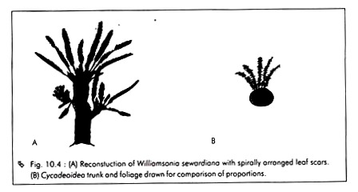](https://cdn.biologydiscussion.com/wp-content/uploads/2016/05/clip_image002-30.jpg)**

1. **Cycadeoidea:**

They are with stout trunks and bisporangiate reproductive structures, and relatives of Williamsonia.

2. **Williamsoniella:**

They have slender, branching trunks and either bisporangiate or mono-sporangiate strobili. Both groups produced entire simple leaves or pinnate foliage and had woody stems that were heavily armored with persistent leaf bases, much like modern cycads. The groups only differ in the details of stomatal morphology.

The Bennettitalean theory was first proposed by Saporta and Marion (1885), followed by Arber and Parkin according to which, Bennettitales have been proposed as possible ancestors of angiosperms, on the basis of the resemblance in structure between the strobili of the Mesozoic genus Cycadeoidea and the flower of Magnolia.

**Both these structures are:**

i. Bisexual, and

ii. Contain an elongated axis having protective bracts, microsporophyll’s and megasporophylls, arranged successively from below upwards.

**However, in spite of these superficial resemblances, further studies have shown several differences, which are as follows:**

1.In Magnolia, the microsporophyll’s (stamens) are free and are spirally arranged on the axis, whereas in Bennettitales they are whorled and mostly connate.

**[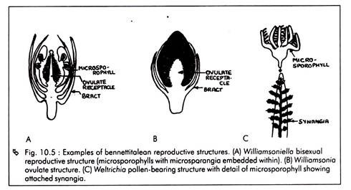](https://cdn.biologydiscussion.com/wp-content/uploads/2016/05/clip_image004-27.jpg)**

2. In Bennettitales, the megasporophylls are greatly reduced, simplified stalk-like structures, each bearing a solitary terminal erect ovule. Between megasporophylls, there are sterile scales (inter-seminal scales), which are protective in function. No such structures are present in the flowers of Magnolia.

**[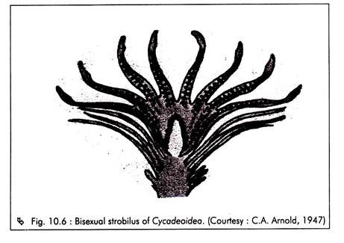](https://cdn.biologydiscussion.com/wp-content/uploads/2016/05/clip_image006-24.jpg)**

**[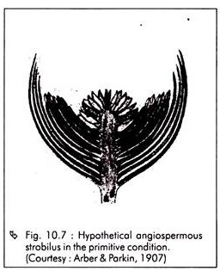](https://cdn.biologydiscussion.com/wp-content/uploads/2016/05/clip_image008-23.jpg)**

**[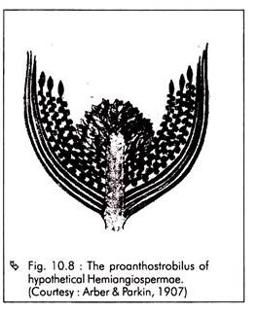](https://cdn.biologydiscussion.com/wp-content/uploads/2016/05/clip_image008-24.jpg)**

3. The micropylar tube formed in the ovules of Bennettitales are absent in the angiosperms and the pollen grains are shed on the stigma of the carpel (megasporophyll).

4. The seeds of Magnolia and other primitive angiosperms are with copious endosperm and small embryo while those of Bennettitales are non-endospermic with a large embryo.

5.In the bennettitalean stem there is a large pith, a thin vascular cylinder and a thick cortex, while the angiosperm stem has a small pith, a thick vascular cylinder and a thin cortex.

These differences indicate that Bennettitales cannot be considered as the ancestors of angiosperms. The similarities with angiosperms, most probably, might have resulted due to a common ancestry and parallel evolution. Arber and Parkin have postulated that the two groups did have a common origin from seed ferns and they might have diverged very early.

#### Pteridosperm Theory:

Pteridosperms (seed ferns) have been considered as ancestors of angiosperms by a large number of phylogenists such as Andrew, Arnold, Cronquist , Long and Thomas.

**This theory is based on the following characters, which are enough to bring seed ferns (Pteridosperms) closest to angiosperms:**

i. Presence of features such as reticulate venation, monopodial branching and cambium.

ii. Origin of sepals from leaves and petals from sepals and stamens, and therefore, there is possibility of the evolution of a flower in angiosperms from cones or cone­ like structures of gymnosperms.

iii. The mega and microsporophyll’s are often borne on the same plant but they are not arranged in definite strobili.

iv. Similarities of seed structure and existence of one or several ovules subtended by a cupule. The angiosperm carpel is regarded as derived from a dorsoventral bivalved pteridosperm cupule by Long.

v. Similarity in the morphological nature of the mega sporangium or nucellus, as established by Hofmeister.

vi. Development of triploid endosperm and extreme reduction of female gametophyte.

vii. Some primitive angiosperms lack vessels in the secondary wood, a feature also found in seed ferns.

viii. The reproductive branch in Glossopteris (a pteridosperm) is somewhat comparable with that of the present-day angiosperm Dichapetalum.

Glossopterid leaves were abundantly and ubiquitously present in Pennsylvanian to Triassic rocks of Australia, Africa, South America, Antarctica, and the Indian peninsula, which lead geologists to the conclusion that these continents had once formed a continuous land-mass – the Gondwanaland.

The glossopteris are reconstructed (Fig. 10.12) as shrubs or large trees and the diversity of their reproductive structures suggests that they constituted a species-rich group, with a great number of species (over 200 described). Glossopteris leaves are tongue-shaped, commonly with an entire (smooth) margin. They have a distinct mid-rib and reticulate venation adjacent to the mid-rib.

**[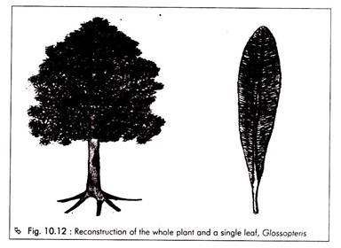](https://cdn.biologydiscussion.com/wp-content/uploads/2016/05/clip_image016-16.jpg)**

Leaves are borne in spirals or whorls, probably on short shoots. Basically, both pollen and ovulate structures (Fig. 10.13) are borne separately on the adaxial side of a more or less modified Glossopteris leaf. In the case of ovulate fructifications, ovules are arranged on a dorsiventral structure that has been variously called capitulum, megasporophyll or cupule.

On the basis of this and other evidences, Melville has proposed a new theory regarding the origin of angiospermic flower known as the “**Gonophyll theory**“.

Advocates of the Glossopteris-ohgin theory propose the glossopteris vegetative leaf to be homologous with the angiosperms carpel, and the megasporophyll with the outer integument of an angiosperm seed, based on some peculiar specimens with abaxially borne seeds.

**[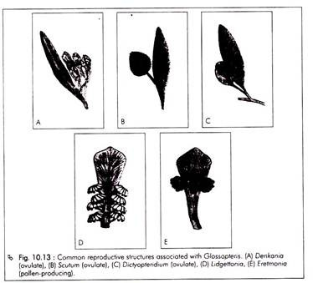](https://cdn.biologydiscussion.com/wp-content/uploads/2016/05/clip_image018-16.jpg)**

**However, there are two serious objections to the theory of Pteridospermi ancestry of angiosperms, which include:**

a. The absence of scalariform xylem elements in Pteridosperms, which occur in angiosperms.

b. No satisfactory explanation for cupule as an equivalent of capillary wall in case of multi-ovulate cupules.

In spite of these objections, the similarities found between the pteridosperms and angiosperms suggest that angiosperms have some very close connection with pteridosperms. Due to the absence of any direct evidence, there is a growing tendency among phylogenists to accept the pteridospermic ancestry of angiosperms, at least tentatively.