Dear students On the behalf of Department of Zoology I , Dr.R.L.Rahatgaonkar well come you all. Dear students , in this Academic Session 2020-21 we are going to discuss about the paper entitled “**LIFE AND DIVERSITY OF CHORDATA AND CONCEPT OF EVOLUTION”** the main title of your paper . By considering this main title the paper is subdivided in to 6 units and as per the instructions of HOD of zoology department the units which I am going to discuss with you are as follows:

UNIT: III: **Class Aves:**

**Type study:** Pigeon-*Columba livia* Habits and habitat, External characters, Respiratory system, urinogenital system. Flight adaptations, Migration in birds.

**Class Mammalia:**

Primitive mammals: salient features of Prototheria and Metatheria, Morphology of mammalian endocrine glands.Aquatic mammals.

**AND**

UNIT : VI:

Adaptive radiations in mammals.

Evolution of Man- brief accounts of Parapithecus, Dryopithecus, Ramapithicus, Australopithecus, Homocreatus Neanderthal man, Cro-Magnon man and modern man.

Evolution of heart, aortic arches, and urinogenital systems of vertebrates

Animal Adaptation: Desert aquatic and terrestrial.

Today we start with the UNIT III .

**Class Aves**

**In this article we will discuss about the type study : Pigeon(***Columba livia)* **and the content are as follows-**

1. Introduction
2. Distribution of Pigeon.
3. Habits and Habitat of Pigeon.
4. External Characters of Pigeon.
5. Respiratory system of Pigeon.
6. Urinogenital system in Pigeon.
7. Flight Adaptation in Birds
8. Migration in Birds

1. **Introduction:**

The pigeons are the typical representative of flying birds and are known both as wild and domesticated forms. They exhibit most of the peculiar characters of birds and are available in large numbers.

They are scientifically known as Columba livia domestica and belong to the Order Columbiformes. The other pigeons are wood pigeons (Columba palumbus), stock dove (Columba oenas), parrot pigeons (Treron abyssinica), crowned pigeons (Coura sp.) and tooth billed pigeon (Didunculus strigirostris)

**Systematic Position:**

According to J. Z. Young, 1981 the systematic position of pigeon is:-

Phylum : Chordata

Subphylum: Vertebrata

Superclass :Cnathostomata

Class: Aves

Subclass: Neornithes

Super order: Neognathae

Order: Columbiformes

Family: Columbidae

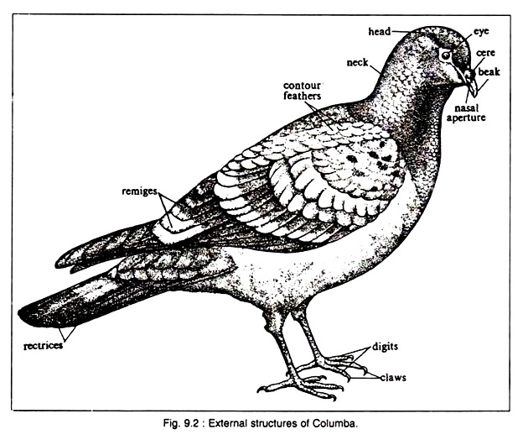

There are Some common names given to pigeon in the regional areas and that are in Bengali it is known as Payra, Gola payra, in Hind it is Kabutar; Tamil—Malai pura, Mada pura; Where as in Marathi it is known as Parva.

**2. Distribution of Pigeons:**

The pigeons are seen almost throughout the world, specially in tropical and temperate zones. Near about 10 species of pigeons are found in India. They are:

(i) Blue rock pigeon( Columba livia) commonly called kabutar or parva in Marathi is found though out India except the Himalayan range beside this it is also found in Pakistan, Bangladesh, Shri Lanka in Asia and in Europe and North America.

(ii) Orange breasted Green Pigeon, Treron bicincta (throughout India, mainly in wet, evergreen and moist deciduous forests),

(iii) Pintailed Green Pigeon, Treron apicauda (Lower Himalayas),

(iv) Wedge tailed Green Pigeon, Treron sphenura (Himalayan foot hills),

(v) Grey fronted Green Pigeon, Treron pompadora (South Western India),

(vi) Green Imperial Pigeon, Ducula aenea (N. E. India, eastern parts of Bihar and U. P., Orissa, A. P., Western Ghats, Andaman and Nicobar Islands),

(vii) Maroon backed Imperial Pigeon, Ducula badia (Tamil Nadu, Kerala, Karnataka and East Himalayan Duars),

(viii) Purple wood Pigeon, Columba punicea (West Bengal, Orissa, M.P., Bihar and N. E. India),

(ix) Nilgiri Wood Pigeon, Columba elphinstonii (Kerala to Bombay)

X) Common Green Pigeon, Treron phoenicoptera (throughout India),

**3. Habits and Habitat of Pigeons:**

Both the wild and domesticated forms of pigeons exhibit social behaviour. They fly in flocks and roost together. Usually these birds start the day with a chorus of humming notes. In the mor­ning and afternoon, entire flock flies to search food and water.

Pigeons drink water by draw­ing long draughts. Such drinking is unusual in other birds, which usually sip water. It returns to its perching place during the hottest part of the day and retires at night.

**Habitat:**

In wild state, the blue rock pigeon lives in rocky hills and cliffs but they also seen to nest in railway stations, forts, old unused buildings, grain warehouses, temples and in their favourite haunts.

**Food: The food of the** *Columba livia is generally grains or seed*

(gra­minivorous), and some are frugivorous. The Blue rock pigeons mostly feed on cereals, pulses and groundnuts.

**External Structures: The external characters of** *Columba livia includes:-*

*1) Size:* The size of the bird varies from 20-25 cm. The appearance varies in different varieties but all of them have a compact and more or less spin­dle-shaped body. The body is dis­tinctly divisible into three regions — head, neck and trunk. Most part of the body is cov­ered by feathers, which are integumentary derivatives.

**2)Head:**

The head is small, round and anteriorly pointed and it contains the following structure-

**(i) Mouth:**

It is a wide gap at the anterior end of head and bounded by upper and lower beaks. Both the beaks are covered by a sheath, called horny sheath or rhamphotheca. The beaks are pointed, hard and suitable for its grain-eating habit.

**(ii) Cere:**

Near the base of the upper beak a pair of swollen, feather covered areas, called cere is present. Just anterior to the cere, a pair of external nares is present as minute slits.

**(iii) Eyes:**

On each lateral side of the head, a prominent eye is placed. Each eye is pro­vided with an upper, a lower and a mov­able transparent third eyelid or nictitating membrane, which runs across the eye­ball.

**(iv) External ear:**

These small paired aper­tures are present one on each lateral side of the head and slightly posterior to the eye. Each aperture remains covered by a special group of feathers called auricular feathers. Each aperture leads into a canal, called the external auditory meatus.

**3)Neck:**

The neck is long and flexible. It holds the head over the trunk and its flexible nature is responsible for the universal movement of head.

**4)Trunk:**

The trunk is compact, stout and immov­able. All the heavier organs are placed on the central part of the trunk and immediately beneath the wings.

**The trunk region contains the following structures:**

**(i) Forelimbs:**

Paired forelimbs are con­nected with the anterior region of the trunk and are greatly modified as wings. At the time of rest, the wings lie on the lateral side of the trunk as a folded ‘Z’. Each wing has three divisions — upper arm, fore arm and hand. Folds of skin extend between upper arm and trunk and also between upper arm and fore arm.

The former fold is called post- patagium and the latter is known as pre-patagium. Both the patagia are great­ly reduced. The portion of hand is tight­ly packed by a fold of skin and each has three clawless insignificant digits.

**(ii) Hind limbs:**

Paired hind limbs work as legs and are modified to carry the entire weight of the body during perching and walking on land. It is connected with the trunk near its postero-lateral side. The thigh portion of the hind limb runs parallel to the body and during rest remains under the cover of the wings.

Each hind limb is provided with four toes of which the first one is called hallux which is directed backwards and the remaining three are pointed anteriorly. The upper part of the hind limb is feath­ered but the lower part is covered by scales.

All the toes are provided with sharp and pointed claws. At the time of flight, the hind limbs are kept withdrawn and are released like the wheels of an aero plane immediately before landing.

**(iii) Tail:**

Posterior most conical end of the trunk is known as uropygium. On the ventral side of the uropygium lies a trans­verse slit, called vent or cloacal aperture, which serves as the outlet of cloaca. On the mid-dorsal region of the uropygium, there is a gland, called uropygial or preen or oil gland.

This gland produces an oily secretion, which is drawn by the beaks and is sprayed all over the body to ‘dress’ the feathers. The uropygium has special series of feathers, called rectrices. These feathers in the uropygium consti­tute the tail of pigeon. The tail is used as steering and brake during flight and works as balancing organ during walking or perching or flying.

**5)Skin:**

The skin of pigeon is dry, thin and loose in texture. Skin glands are rare. The uropygial gland is the only integumentary gland. All over the skin numerous free nerve endings remain scattered. Near the base of the upper beak these nerve endings form specialised organ for touch in the cere.

It is represented by a patch of naked swollen skin. In spite of its thin appearance, the skin has great ability to pro­duce keratin, which is used largely in the for­mation of various integumentary derivatives.

**Skeletal Structures:**

Pigeon possesses well-formed exoskeletal and endo-skeletal structures.

**Exoskeleton:**

Following integumentary structures are seen in birds which perform different functions.

**(i) Beaks:**

These are horny exoskeletal derivatives which cover the upper and lower jaws. It is used during ingestion, preening of feathers and fighting.

**(ii) Claws:**

These are pointed, sharp and horny exoskeletal organs which are present at the extremities of the toes. The claws are typically reptilian in construction and help during perching and walking.

**(iii) Scales:**

These reptile-like exoskeletal structures are present on the exposed parts of the hind limbs. These scales orig­inate from the epidermal part of the skin and remain arranged in tile-like fashion.

**(iv) Feathers:**

These exoskeletal structures are the unique features of birds and are not seen in any other animal. These distinc­tive epidermal structures furnish a flexi­ble, light-weight and resistant body cove­ring of pigeon and are supposed to be modified reptilian scales. They cover the most parts of the body and form the wings and tail.

**Kinds of feathers:**

Pough, Heiser and McFarland (1996) divided the feathers of pigeon into five types.

a. Contour feathers (Pennae) including body covering feathers and the flight feathers (remiges and rectrices),

b. Down feathers,

c. Filo-plumes or hair feathers

d. Semi-plumes and

e. Bristles.

a. Contour feathers form the majority of the covering feathers and give the bird its external shape. They provide airfoils for the flight. Contour feathers differ from the other body feathers such as down feathers and semi plumes; in that they bear two vanes along a shaft that have interlocking barbs which give strength and structure to the feather shape.

**Structure of a typical contour feather:**

The feathers differ in their size, shape and function, but are built up in same general plan.

**A typical contour feather has the following two parts:**

(i) Shaft and

(ii) Vane or Vexillum.

The horny shaft portion is divisible into two parts, calamus (Gk. kalamos, quill) and rachis (Gk. rakhis, spine).

**(i) Calamus or Quill:**

The calamus is the bar- bless, hollow cylindrical stalk by which the feather remains attached with the skin. At the proximal end, there is an aperture, called inferior umbilicus into which fits the mesodermal papilla of the skin.

Through this aperture the feather receives musculature, blood vessels and nerves. At the distal end, there is another aperture, called superior umbilicus. At the time of hatching nutrition is supplied through the aperture to the developing feathers. Later this aperture becomes nonfunctional.

**(ii) Rachis:**

The rachis is solid pith-like in appearance and is continuous with the calamus. The distal end of the rachis is tapered. The ventral part of the rachis bears a groove, called umbilical groove. A small tuft of soft feathers, called the after- shaft, develops near the superior umbilicus.

The vane or vexillum represents the broad part of the feather. It is formed by delicate closely set structures, called barbs or hypo- rachis, which extend from each side of the rachis. Each barb bears oblique rows of pro­cesses, called barbules.

The distal edge of each barb has two sets of barbules—proximal and distal. The proximal barbule from one barb crosses the distal barbule of the next. The tips of the distal barbules are provided with booklets or barbicles or hamuli and the tips of proximal barbules have flanges.

The booklets and flanges interlock to render a compact surface of the vane which resists the air. In the flight feather, the shaft is long and vanes are broad. Among the covering fea­thers, there are short shaft but extended vane portion.

**Types of contour feathers:**

**(i) Flight Feathers or Quills:**

These feathers are associated with flight and may again be subdivided into wing feathers or remiges and tail feathers or rectrices. The remiges are present in the wings and each wing has 23 feathers, which are again subdivided into primaries, secon­daries and tertiaries.

The remiges attached to the distal part (carpometacarpus) of the wing are primaries, those on the middle (radius and ulna) portion are secondary’s and those attached to the proximal part (humerus) of the wing are called tertiaries. The rectrices are twelve- in number and are arranged semi-circularly in the tail region.

**[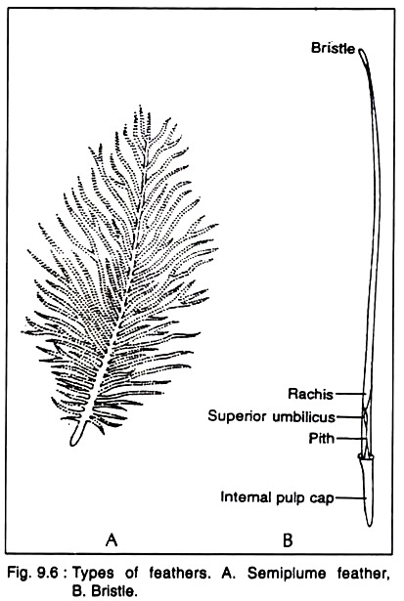](https://www.biologydiscussion.com/wp-content/uploads/2016/07/clip_image010-135.jpg)**

A small tuft of feathers is attached to the first digit of the wing, called alula or ala spuria or bastard wing.

**(ii) Coverts:**

These are smaller forms of contour feathers found at the bases of wings and tail filling the space between them and the covering acts as an thermal insulating layer.

b. Down feathers or Plumulae are short, soft, woolly feathers and without shaft, also present in between the contour feathers. The down feathers consist of a short quill or stem. The barbs are arranged in a circle at the top of the stem. Barbs are long and flexible with poorly developed barbules and without hooklets.

**There are several types of down feathers:**

(i) Nestling down or natal down,

(ii) Definitive down,

(iii) Powder down and

(iv) Uropygeal gland downs.

**(i) Nestling down or natal down:**

In the newly hatched birds there are short, soft, wooly and transitory feathers, called nestling- down or natal down. It has a short stalk with barbs at the tip and without interlocking arrangement. The nestling down provides thermal insulation very effectively. These down feathers remain attached to the region of apteria and develop before contour and semi plume.

**(ii) Definitive down:**

Definitive down feathers appear with the other perma­nent feathers.

**(iii) Powder down:**

The powder down feathers is difficult to classify struc­turally but the tops of the barbs con­tinuously break down as a white waxy powder that is non-wettable.

**(iv) Uropygial gland down:**

Uropygial gland downs occur at the base of the uropygium in most birds. These are modified brush-like down feathers.

c. Filo plumes (hair feathers or pin feath­ers) are small, delicate and hair-like feath­ers. Each filo plume has a long shaft carry­ing a few degenerated barbs and barbules at the tip and such barbs are without inter­locking apparatus.

The filo plumes are seen scattered on the body of the bird when it has been plucked. The feathers are pro­bably sensory in function. Each feather is provided with a muscle at its base, which controls the position of feather.

d. Semi plumes are lying beneath the contour feathers and are intermediate in structure in between contour and down feathers. They possess short calamus and long rachis with plumulaceous vanes (Fig. 9.6A). They provide warmth and fill up the space within the contour feathers.

e. Bristles are stiff rachis with partial or complete deletion of the vane (Fig. 9.6B). They occur mostly on the head, at the base of beak, and even on the toes of some birds. They may screen out foreign particles from the nostrils (hawks and black birds), increase the gape of the mouth to catch the insects (fly catchers).

[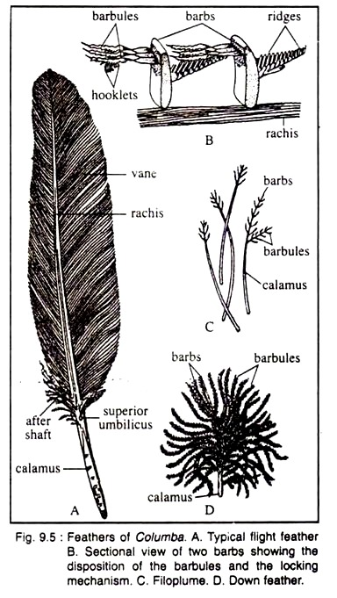](https://www.biologydiscussion.com/wp-content/uploads/2016/07/clip_image012-102.jpg)

These are the modified filo plumes and also may be called rictal bristles when it has a bristly hair-like appearance with a small calamus and a slender rachis with a few barbs at the base of the rachis.

**Uses of feathers:**

(i) The nerve fibres present at the base also help the feather to act as a sensory struc­ture.

(ii) The feathers produce a compact surface to resist air-current.

(iii) It retains heat and thus helps the bird from the temperature hazards.

(iv) It is light and, therefore, helps in flight.

(v) In some birds, a few feathers act as secon­dary sexual characters.

------------------------------------------------------------------------------------